UNITED STATES MARINE CORPS
Field Medical Training Battalion – East
Camp Lejeune
FMST 1402

Manage Burn Casualties

TERMINAL LEARNING OBJECTIVES
- Given a burn casualty in a combat environment and standard medical equipment and supplies, manage burn casualties, to prevent further injury or death. (FMST-HSS-1402)
ENABLING LEARNING OBJECTIVES
- Without the aid of references, given a description or list, identify the three layers of skin, within 80% accuracy, per Pre-Hospital Trauma Life Support, Military Edition, 6th Ed, Chapter 13. (FMST-HSS-1402a)
- Without the aid of references, given a description or list, identify the different types of burns, within 80% accuracy, per Pre-Hospital Trauma Life Support, Military Edition, 6th Ed, Chapter 13. (FMST-HSS-1402b)
- Without the aid of references, given a description or list, identify the degree of burns, within 80% accuracy, per Pre-Hospital Trauma Life Support, Military Edition, 6th Ed, Chapter 13 . (FMST-HSS-1402c)
- Without the aid of references, given a description, using the “Rule of Nines,” determine the percent of body surface area burned, per Pre-Hospital Trauma Life Support, Military Edition, 6th Ed, Chapter 13. (FMST-HSS-1402d)
- Without the aid of references, given a description or list, identify the appropriate treatment for burns, within 80% accuracy, per Pre-Hospital Trauma Life Support, Military Edition, 6th Ed, Chapter 13. (FMST-HSS-1402e)
- Without the aid of references, given a simulated burn casualty and standard field medical equipment and supplies, manage the casualty, per Pre-Hospital Trauma Life Support, Military Edition, 6th Ed, Chapter 13. (FMST-HSS-1402f)

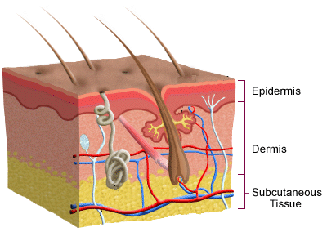
- ANATOMY OF THE SKIN
The most important function of the skin is to be a protective barrier against the outside environment. The skin also prevents fluid loss and helps regulate body temperature. Skin is composed of three layers: the epidermis, dermis, and subcutaneous tissue (see figure 1).
Epidermis - the outermost layer, is made up entirely of epithelial cells with no blood vessels
Dermis - a framework of connective tissues containing blood vessels, nerve endings, sebaceous glands, and sweat glands

Figure 1. Anatomy of the Skin

Subcutaneous Tissue - is a combination of elastic and fibrous tissue as well as fat deposits

- TYPES OF BURNS
Burn injuries have many causes on and off the battlefield. Burns are generated by exposure to extreme heat, a biologic reaction from chemicals, or energy transfer through cells from electrocution or radiation. Many weapons and munitions cause burn injuries. Some, such as incendiary and flame munitions, are designed to cause high heat and burning. Others, such as high explosives, bombs, and mines cause burns secondarily to their primary effect.
Thermal (see figure 2) - thermal burns are the most common type of burn on the modern battlefield. They can result from exposure to flame weapons, incendiary weapons, munitions or from explosions from fuel sources (gasoline, diesel, and jet fuel). These weapons are designed to burn at very high temperatures and incorporate napalm, thermite, magnesium, and white phosphorous.
- The primary effect of incendiary and flame munitions against personnel are to cause severe burns.
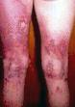
- Burns to the airway are also possible, particularly if the casualty is in an enclosed space (bunker, ship compartment, or armored vehicle). Airway burns may result in rapid, life-threatening swelling and obstruction of the upper airway. Monitor the casualty for the following signs and symptoms:
- Stridor
- Oropharyngeal swelling
- Hoarseness
- Difficulty swallowing
- Carbonaceous sputum (blackened sputum)
- Singed nasal or facial hair
Figure 2. Thermal burn to legs
- Dyspnea

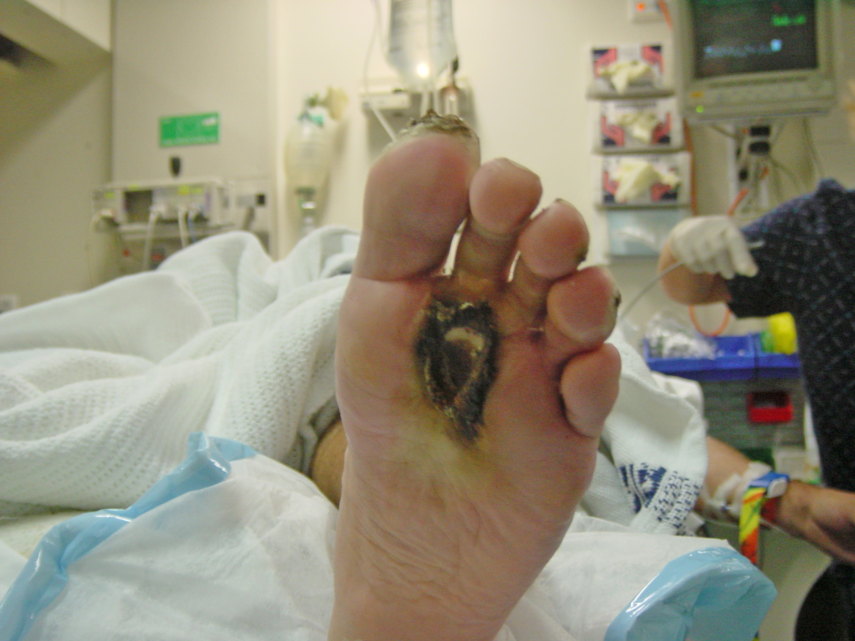
Electrical Burns (see figure 3) - electrical injuries are devastating injuries that can easily be underappreciated. In many cases the extent of tissue damage does not accurately reflect the magnitude of the injury. Tissue destruction and necrosis are excessive compared with the apparent trauma because most of the destruction occurs internally as the electricity is conducted through the casualty. The casualty will have external burns at the points of contact with the electrical source as well as grounding point. As the electricity courses through the casualty’s body, deep layers of tissue are destroyed despite seemingly minor injuries on the surface. Electrical and crush injuries share many similarities. In both injuries there is massive destruction of large muscle groups with resultant release of both potassium and myoglobin. The release of potassium from large muscles causes a significant increase in the serum level, which often results in cardiac arrhythmias. All electrical burns are considered a cardiac emergency and the casualty should be CASEVAC’ed to a higher echelon of care. Also, when myoglobin is released into the bloodstream in consderable amounts, it can be toxic to the kidneys and can cause kidney failure. Other signs and symtoms include:
Figure 3. Electrical burn to foot
- Tympanic membranes may rupture causing hearing loss.
- Intense muscle contractions (tetany) can result in fractures at multiple levels of the spine. Casualties with electrical injuries should have their spine immobilized.
- Intercranial bleeds and long bone fractures may also occur.
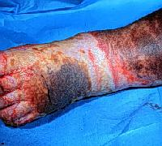
Circumferential Burns (see figure 4) - a circumferential burn is a burn that encircles the trunk of the body (chest) or an extremity (arm or leg). Circumferential burns are capable of producing a life or limb threatening condition. They can create a tourniquet-like effect that can render an arm or leg pulse-less. Circumferential burns of the chest can constrict the chest wall to such a degree that the casualty suffocates from inability to breath. Therefore, all circumferential burns should be handled as an emergency and casualties CASEVAC’ed immediately. Escharotomies are surgical incisions made through the burn eschar to allow expansion of the deeper tissue and decompression of previously compressed and often occluded vascular structures.
Figure 4. Circumferential burn to foot
Radiation Burns - burns associated with nuclear blasts. Radiation is a hazardous material. The initial priorities are to remove the casualty from the source of contamination, remove contaminated clothing, and irrigate the casualty with water.
- Skin that is exposed to an explosion is burned by the infrared rays emitted at detonation.
- Clothing or shelter can offer some protection.
- Secondary injuries will include first and second degree burns.
- The majority of burns are caused by contact with the secondary sources that ignited
such as buildings and clothing.
- If the doses of ionizing radiation are high enough to cause burns to the skin, systemic
effects may overshadow the burn itself.
Chemical - injuries from chemicals are often the result of prolonged exposure to the offending agent. This is contrasted with thermal injuries, where the duration of exposure is usually very brief. You may encounter casualties who have suffered chemical burns caused by weapons, chemicals used to fuel or maintain equipment, or chemical spills following damage to civilian installations. The severity of a chemical injury is determined by four factors: nature of the chemical, concentration of the chemical, duration of contact, and MOI of the chemical. Chemical agents are classified as:
Acids:
- chemicals with a pH between 7 (neutral) and 0 (strong)
- Found in cleaners and swimming pool acidifiers
Bases (alkali):
- chemical with a pH between 7 and 14
- found in fertilizer, industrial cleaners, the structual bonds of cement/concrete, and the most common cause of alkali burns in garrison are the batteries used in our radios
- Alkali burns are usually more serious than acid burns, because alkalis penetrate deeper and burn longer
Organic:
- Contains carbon
- Phenols, creosote and petroleum products such as gasoline

DEGREE OF BURNS

The severity of a burn is determined by the depth of the burn and the extent of the total body surface area (TBSA) burned. The severity of all burns will vary depending on the source of the burn, duration of exposure, and location of the burn.
Depth: The depth of the burn is related to how deeply the skin is damaged (see figure 5). Estimation of burn depth can be deceptively difficult. Often, a burn that appears to be a partial-thickness burn (second degree) will prove to be third degree burn in 24 to 48 hours. Therefore it is often wise to withhold final judgment of burn depth for up to 48 hours after injury.
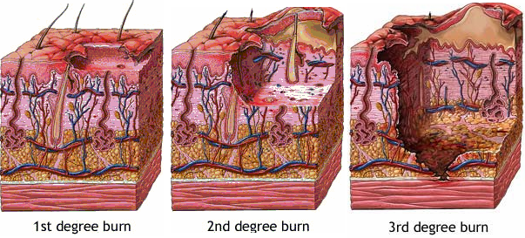

Figure 5. Depth of Burns
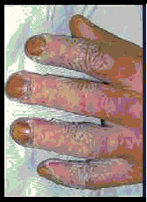
Superficial Burn/First-Degree Burn (see figure 6) - first-degree burns involve only the epidermis and are characterized as being red and painful. These wounds heal typically within a week and the casualty will not scar.
Signs and Symptoms:
- Dry, red and inflamed skin
- Painful to touch
- The burned area blanches with pressure
- Minimal swelling (if present)
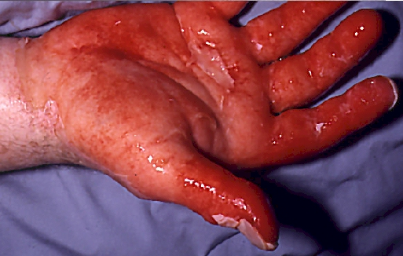

Figure 6. First Degree burn on hand

Partial Thickness Burns/Second-Degree Burn (see figure 7) - burns that involve the epidermis and varying portions of the underlying dermis. Second-degree burns will appear as blisters or as denuded, burned areas with a glistening or wet
appearing base. These wounds will be painful.
Figure 7. Second Degree Burn
Because remnants of the dermis survive, these
burns are often capable of healing in 2 to 3 weeks.
Signs and Symptoms:
- Skin is moist, with reddened areas
- Blisters or open weeping wounds
- Deep, intense pain
- Edema will be moderate
- Fluid loss may be significant depending on the extent of the burn
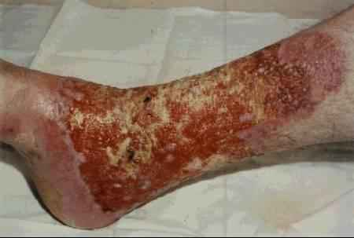
Full Thickness Burn/Third-Degree Burn (see figure 8) - third-degree burns involve all three layers of skin and may have several appearances. Most casualties will have pain because areas of third-degree burn are usually surrounded by second-degree burns.
- Signs ans Symptoms:
- Skin has a dry, leathery appearance
- The skin can range in color from white, yellow, cherry red, brown, or charred
Figure 8. Third Degree burn of lower leg
- Severe pain around periphery of burn, but little to no pain near center of burn.
- No capillary refill at affected area
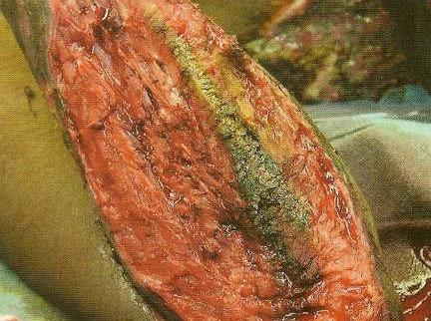
Fourth-Degree/Complete Burn (see figure 9) - fourth-degree burns are those that not only burn all layers of the skin, but also burn underlying fat, muscles, bone or internal organs.

- BURN SIZE ESTIMATION
Estimation of burn size is necessary to begin to resuscitate the casualty appropriately and prevent the complications associated with hypovolemic shock. The most widely applied method is known as the “Rule of Nines.”
Figure 9. Fourth Degree burn on arm

Rule of Nines: This method applies the principles that major regions of the body in adults are considered to be 9% of the total body surface area (TBSA) (see figure 10). The genital area and palms of the hand (not including the digits) represent 1%.

Front of head is 4.5% and back of head is 4.5% for a total of 9%
Front of arm is 4.5% and back of arm is 4.5% for a total of 9%

Figure 10. Rule of Nines

Rule of Palms: This method assumes that the palm size of the patient represents approximately 1% of the TBSA. TBSA is estimated by counting the number of the patient’s “palms” it takes to completely cover the burn area. The Rule of Palms is helpful for estimating the TBSA of small or irregular shaped burns and small children.

- FLUID RESUSCITATION
Administration of large amounts of IV fluids is needed to prevent a burn casualty from going into hypovolemic shock. After a burn, the casualty loses a substantial amount of intravascular fluid from the edema which results as well as the evaporative losses at the site of the burn. Massive fluid shifts will occur and evaporative losses can be enormous.
The resuscitation of burn shock is aimed at not only restoring the lost volume but also replacement of anticipated losses. When treating a burn casualty, the objective is to calculate and replace the fluids that it is anticipated the casualty will lose over the first 24 hours after the burn injury.
The use of LR solution is the best way to initially manage a burn casualty. The most frequently used formula for calculating fluid replacement is the “Parkland formula.” The Parkland formula delivers 4 ml/kg/% TBSA burned. Half this fluid will be administered in the first 8 hours after injury and the remaining half of the volume over the next 16 hours. It is important to remember the first half is administered with 8 hours from the time the casualty was injured, not from the point the provider started to resuscitate the casualty. This is especially important in the tactical situation where there may be an initial delay in treatment. If the casualty presents for emergency care 3 hours after the injury with no or little fluids administered, the first half of the calculated total needs to be administered over 5 hours. For example:
To Pop or Not to Pop, that is the Question?
The blister on a burn does not provide protection to the skin and limits the ability to apply topical antibiotics. So why don’t we pop them? Blisters should only be popped when you have the capabilities to debride the wound, provide pain medications, and apply antibiotic ointments. Do not open the blisters unless the above capabilities are available.

Parkland formula example = 4 mL X weight in kg X % TBSA burned

Parkland formula: 4 ml X 76 kg X 36%
76 kg casualty has sustained partial thickness burns to his anterior chest (9%) and abdomen (9%), entire right arm (9%), and anterior right leg (9%). The injury occurred 30 minutes ago.
In this case, the casualty who weighs 76 kg has sustained burns over 36% of his body. So, doing the math:
4 X 76 = 304; 304 X 36 = 10,944 mL (which can be rounded up to 11 liters)
Remember, half of this total should be administered in the first 8 hours following the burn, so, the casualty will need 5 ½ liters in the first 8 hours. Keep in mind, the injury occurred 30 minutes ago, so the entire 5 ½ liters should be administered over a period of 7 ½ hours.
The remainder is administered over the remaining 16 hours:
5,500 mL divided by 16 (time remaining in one day) equals 343 ml per hour for the
next 16 hours.
While you may not be completely responsible for the care of severely burned patients for 24 hours, this example illustrates the need for burn patients to receive quick attention and prompt evacuation to definitive care.
- TREATMENT OF BURNS
The initial step in the care of a burn casualty is to stop the burning process. The most effective and appropriate method of terminating the burning is irrigation with large volumes of room-temperature water. In the tactical environment however, access to large volumes of water is not always practical. You can also smother any flames with a jacket, blanket, or any other available material. Rolling the casualty on the ground is also effective. Remove all clothing and jewelry; these items retain residual heat and will continue to burn the casualty. However, DO NOT pull away clothing that is stuck to the wound.
Airway - the heat from the fire can cause edema of the airway above the level of the vocal cords and can occlude the airway, so be prepared for a possible surgical airway. Careful and continuous evaluation of the airway is required. O2 should be given, if available.
Breathing - as with any trauma casualty, breathing can be adversely affected by such problems as broken ribs, pneumothoraces (collapsed lung), and open chest wounds. In the event of circumferential chest wall burns, pulmonary compliance may decrease to such an extent that it inhibits the casualty’s ability to inhale. In such cases, prompt CASEVAC of casualty to higher level of care in order to perform escharotomies of the chest wall is critical.
Circulation - evaluation of circulation includes the determination of blood pressure, evaluation of circumferential burns, and establisment of intravenous access. Accurate measurement of blood pressure becomes difficult or impossible with burns to the extremities. Blood pressure can be estimated by palpating for distal pulses. Even if the casualty has adequate blood pressure, distal limb perfusion may be critically reduced because of circumferential injuries. Burned extremities should be elevated, when tactically prudent, during transport to reduce the degree of swelling in the affected limb.
Two large-caliber IV catheters are required for burns that cover more than 20% of the TBSA. Ideally, the IV should not be placed through or adjacent to burned tissue; however, placement through the burn is appropriate if no alternative sites are available or consider the intraosseous (IO) route.
Detailed Assessment - perform your assessment, keeping in mind that burns themselves are not immediately fatal and can wait until other priorities are addressed. Therefore, assess for additional injuries, such as associated blast, missile or fragment wounds and treat appropriately.
Hypothermia - burn casualties are not able to retain body heat and are extremely susceptible to hypothermia. Make every effort to preserve body temperature. Apply several layers of blankets. Keep passenger compartment of the CASEVAC vehicle or fuselage of the aircraft warm, regardless of the time of year. As a general rule, if you as the provider treating the burn casualty are not uncomforable, the ambient temperature is not warm enough.
Estimate the Depth and Extent of the Burn - use the “Rule of Nines” or the “Rule of Palms” noted above.
Dressing the burn - before CASEVAC, the wounds should be dressed. The goal of the dressing is to prevent ongoing contamination and prevent airflow over the wounds. Water-jel dressings, if available, are preferred as they help to cool the burn. If not, dry sterile dressings covering the entire burn are sufficient before CASEVAC of the casualty. Several layers of blankets are then placed over the casualty to prevent hypothermia.

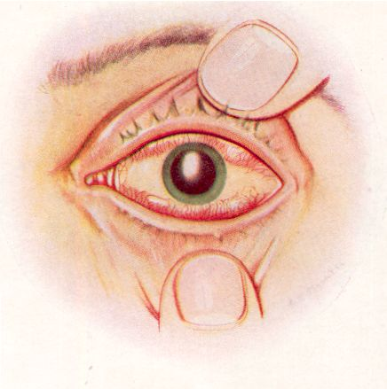
Burns to the Eyes (see figure 11)
Signs and Symptoms:
- Blurry vision
- Vision loss
- Pain
- Tearing
- Conjunctival erythema
Treatment:
- Thermal burn - irrigate with large amounts of water.
- Chemical burn:
- Acids - irrigate for 5 - 10 minutes
Figure 11. Burns to the eyes
- Alkalis - irrigate for 20 minutes
- Cover eyes with a dry sterile dressing. In a tactical situation, if the patient can partially see out of the affected eye and can otherwise ambulate, defer dressing the eye. Avoid dressing both eyes if only one eye is injured.
If evacuation is delayed
- Clean the burn area with diluted (1:10) betadine solution and then rinse with saline.
- Remove loose nonviable tissue during cleaning process (this is very painful, especially at the periphery of the burn so pain management should be considered).
- Apply Silvadene (or other bacteriostatic ointment) and cover with dry, loose, sterile dressing, if available
- Gently clean and reapply Silvadene and a fresh dressing every 24 hours.
Critical Burns Requiring Special Care - The American College of Surgeons Committee on Trauma developed a list of burn injuries that are considered critical regardless of depth or TBSA affected. Treatment in a specialized burn unit will improve the chances of survival and reduce complications or disabilities for casualties with any of the following injuries:
- Inhalation injuries.
- Partial-thickness burns over greater than 10% of the TBSA.
- Full thickness burns in any age group.
- Any burn involving the face, hands, feet, genitalia, perineum, or major joints.
- Electrical burns, including lightning injury.
- Chemical burns.
- All burns complicated by injuries of the respiratory tract, other soft tissue injuries, and musculoskeletal injuries.
Pain Management should be provided to burn victims, and small doses of narcotics should be titrated intravenously (see the medication appendix at the end of Block 2 for more information regarding pain medications). Vital signs and respiratory effort are monitored for potential adverse effects. (Note: The use of narcotics is contraindicated in head and spinal trauma.) Water immersion may be applied for 10-15 minutes for pain relief, however, caution should be used as it may intensify shock.

 CASUALTY ASSESSMENT AND BURNS
Care Under Fire Phase: Unless casualty also has life-threatening hemorrhage along with a burn, there is no care given for burns in this phase.

Tactical Field Care Phase: During this phase, you will be required to inspect the burned area. A burn can cause significant problems with the airway. If a casualty’s airway is jeopardized, securing an airway is vital before edema sets in. Consider a surgical airway, if needed. Don BSI. Complete a head to toe assessment using DCAP-BTLS noting and treating additional injuries. Determine if vascular access is required (see Tactical Fluid Resuscitation lesson) and give fluids if necessary. If the casualty is able to drink fluids, they should be encouraged to do so. Consider pain medications and give antibiotics if warranted. Reassess all care provided. Document care given, prevent hypothermia, and CASEVAC.

REFERENCE
Pre-Hospital Trauma Life Support, Military Edition, 6th Ed, Chapter 13
Burns Review
1. Identify three charicteristics of a second degree burn.

- Using the Rule of Nines, estimate the body surface area affected for a patient with burns to the upper and lower back.

- Using the Rule of Nines estimate the body surface area affected for a patient with burns to the chest, abdomen and right front arm.

4. Describe the appropriate treatment for burns, assuming no delay in casulty evacuation.

