UNITED STATES MARINE CORPS
Field Medical Training Battalion – East
Camp Lejeune

FMST 1604

Perform Care of the Feet

TERMINAL LEARNING OBJECTIVE
- Given the requirement in a tactical environment, necessary equipment and supplies, perform care of the feet, to prevent serious foot injuries. (FMST-FP-1604)
ENABLING LEARNING OBJECTIVE
- Without the aid of references, given a list, identify the types of foot disorders, per the student handout. (FMST-FP-1604a)
- Without the aid of references, given a description or list, identify the symptoms of foot disorders, per the student handout. (FMST-FP-1604b)
- Without the aid of references, given a description or list, identify the proper treatment for foot disorders, per the student handout. (FMST-FP-1604c)
- Without the aid of references, given a list, identify preventive measures for foot disorders, per the student handout. (FMST-FP-1604d)
ANATOMY OF THE FOOT

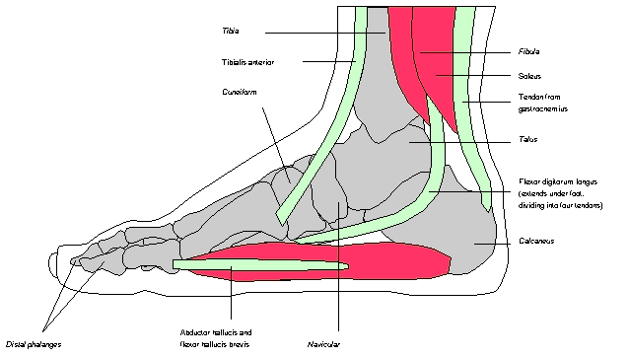
Tibia
Fibula
Soleus
Achilles tendon

Talus
Tibialis anterior muscle
First cuneiform
Flexor digitorum longus
Calcaneus

Distal phalanges
Plantar Navicular
Fascia

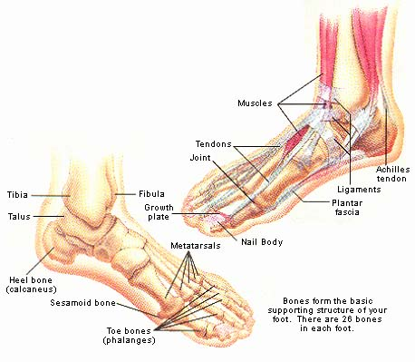

Figure 1. Anatomy of the Foot

- COMMON TYPES OF FOOT DISORDERS
Blister – a blister is a defense mechanism of the body. When the epidermis layer of the skin separates from the dermis, a pool of fluid collects between these layers while the skin re-grows from underneath. Blisters can be caused by chemical or physical injury. An example of chemical injury would be an allergic reaction. Physical injury can be caused by heat, frostbite, or friction.
Causes
- Improperly conditioned feet
- Heat and moisture
- Improperly fitting boots and/or socks
- Friction and pressure
Signs and Symptoms
- Fluid collection under the skin
- Mild edema and erythema around the site
- Sloughing of tissue exposing subdermal tissue layer
- Localized discomfort and/or pain

Treatment
Small blisters usually need no treatment
- Clean area with soap and water
- Monitor for signs and symptoms of infection
- Apply a protective barrier (moleskin bandage) around the blister, to prevent further irritation
Closed, Large blisters (if affecting individuals gait)
- Wash the area around the blister with Betadine solution or alcohol pad
- Drain as close to the edge of the blister as possible to allow for drainage, and then apply gentle pressure to the blister dome expelling the clear fluid
- Apply moleskin (donut) to skin surrounding the blister, using tincture of benzoin as an adhesive.
- DO NOT PUT ANY ADHESIVE DIRECTLY ON THE BLISTER
- Dust entire foot with foot powder to lessen friction and prevent adhesive from adhering to the socks
- Monitor for signs and symptoms of infection
Open blisters
- Wash with Betadine solution or clean with soap and water
- Remove any loose skin with a surgical blade or scissors
- Apply moleskin (donut) to cover skin surrounding the blister, using tincture of benzoin as an adhesive.
- Place a small amount of antibiotic ointment over wound
- Cut a telfa pad and place it inside the moleskin
- Apply moleskin over entire treated area to include surrounding skin
- Monitor for signs and symptoms of infection
Athletes Foot (Tinea Pedis) – tinea pedis is a chronic fungal infection of the feet, often referred to as athlete’s foot. Athlete’s foot is very common and usually begins in early adulthood. Men are more often affected than women. Once affected, recurrences are common.

Causes
- Hot humid weather, excessive sweating, and occlusive footwear
- Contact with contaminated footwear and floors
- Poor foot hygiene
Signs and Symptoms
- Reddened, cracked, and peeling skin
- Itching, burning and stinging sensation usually between the toes
- Sore, purulent, weeping rash
Treatment
- Apply anti-fungal foot powder daily during work hours – i.e. Miconazole
- Apply anti-fungal ointment daily during rest hours – i.e. Clotrimazole
- Treatment should be continued for 1 week after clearing has occurred
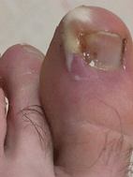
- If the patient fails to respond to treatment, refer patient to Medical Officer
Ingrown Toenails – an ingrown nail occurs when the nail border or corner presses on the surrounding tissue. This condition is painful and often results in an infection once the skin is broken (see figure 2).

Causes
- The most common causes are improper trimming of toenails and poor hygiene.
- Trauma to the nail plate or toe
- Improperly fitted footwear
- Abnormally shaped nail plate
Figure 2. Infected Ingrown Toenail
Signs and Symptoms
- Pain along the margin(s) of the toenail. The great toe is the most common toe affected.
- Localized edema
- There may be signs of infection (drainage of pus, blood, or watery discharge tinged with blood)

Treatment
- Trim a small point off the corner of the nail to relieve the pressure. Remove any dead skin that may have accumulated in the nail groove.
- Elevate the end of the nail to prevent further irritation of the soft tissue. Proper trimming should correct ingrown toenail. If not…
- Surgically correct a chronic ingrown toenail at the BAS, by complete or partial removal of toenail, under the supervision of a clinician.
- If there are signs of infection, antibiotics should be considered.

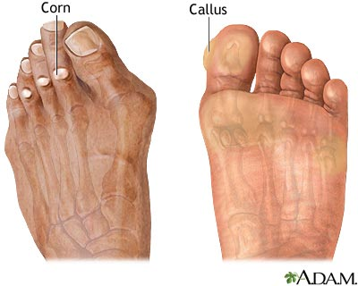
Corns and Calluses (see figure 3) – a callus is a thickening of the outer layer of skin, in response to pressure or friction that serves as a protective mechanism to prevent skin breakdown. A corn is similar to a callus except it involves a discrete pressure spot, typically over a bone, whereas a callus can form anywhere.
Causes
- Tight fitting shoes, due to chronic friction and sheering pressure
Figure 3. Corns and Calluses
- Deformed and crooked toes
- Prolonged walking on a downward slope
Signs and Symptoms
- Thickened, dry skin over prominent bones (corn)
- Large patches of thickened, dry skin over friction areas from walking (calluses)
- Pain on direct pressure against the corn
- Skin breakdown and possible infection with continued irritation
Treatment
- Debridement of excessive buildup of skin
- Apply various pads and devices to the toes to relieve pressure (mole skin, corn pads, etc.)
- Fix the cause (improperly fitted boots)
- In extreme cases, refer to a Medical Officer

Bunions (see figure 4) – a bunion is an enlargement at the 1st metatarsal head of the great toe, which deviates laterally. Often there is no bump, but rather an angulation of the first metatarsal that makes the head of this bone more prominent.
Causes
- A minor bone deformity, called hallux valgus, in which the joint at the base of the big toe projects outward while forcing the tip of the toe to turn inward toward the other toes. As a result of the pressure on the deformity, the surrounding tissue thickens.
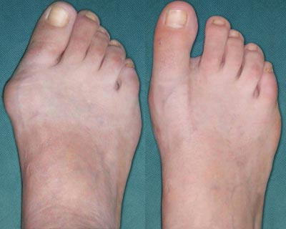
- This condition may be hereditary.
- Poorly fitted or excessively worn shoes.
Signs and Symptoms
- Thickened lump on the medial side of the foot at the base of the great toe
- Erythema
- Pain near first metatarsal head
- Joint stiffness
Treatment
- Wear comfortable, properly fitted shoes with plenty of room in the toe area
Figure 4. Bunion
- Use of a special toe pad or corrective sock that straightens the big toe
- Non-steroidal, anti-inflammatory medications (NSAIDS)
- Orthotics
- In severe cases, surgery may be required

Plantar Fasciitis (see figure 5) – also known as heel spurs or heel bursitis. Plantar fasciitis is one of the most common foot problems. The plantar fascia’s main function is to anchor the plantar skin to the bone, thus protecting the longitudinal arch of the foot. The plantar fascia is strained from overuse, causing pain along the sole of the foot, particularly where the fascia connects to the heel.
Causes
- Overuse in the physically active or a sudden increase in the volume or intensity of training
- Abnormal joint mechanics
- Tightness of the Achilles tendon
- Shoes with poor cushioning
- Abnormal foot anatomy
- Obesity
- Excess weight
- Improper shoes
- Bio-mechanical problems (mal-alignment of the heel)
Signs and Symptoms
- Tenderness along the medial fascia
- Constant pain that is worse in the morning upon rising or after physical activity
- Tearing and pulling sensation
- Altered gait
Treatment
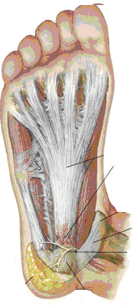
- Stretching and strengthening exercises (lower leg muscles)
- RICE (Rest, Ice, Compression, Elevation)
- NSAIDS
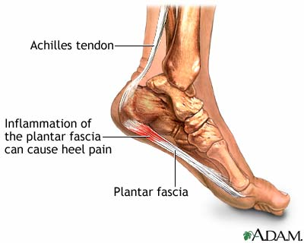
- Heel and arch supports (Orthotics)
Plantar Fascia with inflammation
Figure 5. Plantar Fasciitis
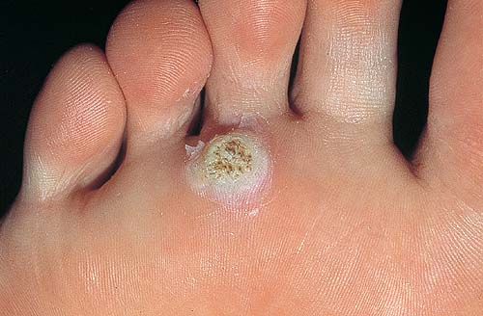
Plantar Warts (see figure 6) – warts that are located on the sole of the foot are called plantar warts. A plantar wart can be found as a single lesion or grouped together. Most common areas include the ball of the foot and heel, where increased pressure and irritation is common. Warts are often ignored until they become painful.

Cause
- Caused by the Human Papilloma Virus (HPV)

Signs and Symptoms
- Plantar warts have tiny dots in the center. These dots are often black from dried blood, due to irritation. Small plantar corns are sometimes mistaken
Figure 6. Plantar Wart
for warts.
- Tenderness
Treatment
- Shave down callus over wart and apply Salicylic Acid paste (Metaplast)
- Apply dressing to keep paste isolated over wart. Apply donut bandage to relieve pressure.
- Leave paste in place for 3 days.
- Repeat treatment in one week.
- Refer to medical officer if no improvement.

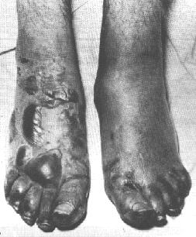
Trench Foot/Immersion Foot – a medical condition caused by prolonged exposure of the feet to damp and cold. Trench Foot was given its current name after it was found frequently among World War I troops who had been confined for long periods in trenches filled with standing water. Immersion foot describes a more severe variant of trench foot usually seen in downed pilots and shipwrecked Sailors (see figures 7a and 7b).
Causes
- Prolonged exposure to wet and cold conditions or outright immersion of feet in water at 32-50° F
- Condition can occur on hands due to damp or cold gloves

Signs and Symptoms (EARLY)
- Initially foot is pale, mottled, numb, pulseless, and immobile
Figure 7a. Immersion (Trench) Foot

- After rewarming, severe burning pain and return of sensation

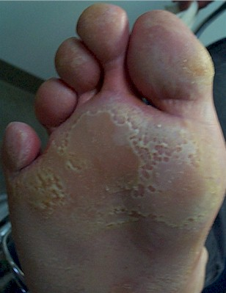
Signs and Symptoms (LATE 2-7days)
- Limb becomes hyperemic (increased amount of blood flow, skin will be warm and red). Numbness, edema, ulceration, and gangrene may develop.
Treatment
- Treatment is supportive
- Keep feet clean, warm, dry, and bandaged
- Gentle rewarming
- Elevate affected extremity to reduce edema
- Consider antibiotics if there are signs of infection
- Avoid wearing boots
Figure 7b. Immersion (Trench) Foot
- Do not drain blisters in the field
- Refer to Medical Officer
- CASEVAC severe cases
Metatarsal Stress Fracture (see figure 8) – a stress fracture is an incomplete break in the bone often seen in intense training programs around week four, when bone absorption exceeds bone-building activity. The most common stress fracture in the foot, known in the military as “March Fracture,” is the second and third metatarsals.
Causes
- Repetitive stress on a metatarsal due to malposition or abnormal foot structure or mechanics (i.e. Flatfoot)
- Increased levels of activity, especially without proper conditioning
- Obesity
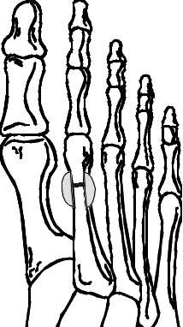
Signs and Symptoms
- Edema in dorsum of foot
- Tenderness at the top of the foot during and after exercise
Treatment
- Treat as a fracture
- RICE
- NSAIDS
- Rest for two or three weeks until the pain is gone
- Slow return to activity to avoid recurring injury
- Refer to Medical Officer

Fracture
Figure 7. March Foot (Metatarsal Stress Fracture)

Figure 8. March Foot (Metatarsal Stress Fracture)

- PREVENTIVE MEASURES
Before Marches
- Educate troops about proper foot care and wear
- Carefully fit new boots
- The toe box should be roomy enough so you can wiggle your toes
- Ball of your foot rests on the widest part of the sole
- The forefoot should not be wider than your shoe
- Determine the proper boot length. There should be a ½ inch between the end of the longest toe and the end of the boot.
- Keep feet clean and dry
- Wear clean, dry, un-mended, well fitting socks
- Socks should fit snugly on the foot without excess material over toes and heel
- If a person wants to wear two pair of socks, the outer pair should be ½ size larger to comfortably fit over the inner sock.
- Trim nails straight across, and not too short. Don’t cut out or dig at corners
- Use foot powder
- Early and immediate attention to pain around toenails

During Rest Periods
- Lie with feet elevated at rest points
- If time permits, massage the feet, apply powder, change to dry socks and treat blisters.
- Relief from swelling feet can be obtained by slight loosening of the bootlaces where they cross the arch.

After Marches
- EARLY ATTENTION IS ESSENTIAL! As soon as any discomfort is felt, take corrective action.
- Wash and dry feet
- Treat blisters, abrasions, corns, and calluses if they have occurred
- If red, swollen, or tender skin develops along the edges of the foot, the foot requires aeration, elevation, rest, and as a rule, wider footwear

REFERENCES
Foot Marches, FM 21-18
Wilderness Medicine, Pg 143
Special Ops Handbook, June 2001, Pgs. 5-6 through 5-7
REV: May 2009
Care of the Feet Review
1. Describe the appropriate treatment for large blisters.

2. Describe the difference between a corn and a callus.

- List the signs and symptoms of plantar fasciitis.

4. “March Foot” generally involves which two bones?

