UNITED STATES MARINE CORPS
Field Medical Training Battalion – East
Camp Lejeune
FMST 1420
Perform Casualty Assessment

TERMINAL LEARNING OBJECTIVE
- Given a casualty in a combat environment and the standard field medical equipment and supplies, perform casualty assessment to prioritize injuries for treatment, per the references. (FMST-HSS-1420)

ENABLING LEARNING OBJECTIVES
- Without the aid of references, given a description or list, identify the purpose of casualty assessment, within 80% accuracy, per Pre-Hospital Trauma Life Support, Medical Edition, 6th Ed, Chapter 21. (FMST-HSS-1420a)
- Without the aid of references, given a description or list, identify the three phases of combat casualty care, within 80% accuracy, per Pre-Hospital Trauma Life Support, Medical Edition, 6th Ed, Chapter 21. (FMST-HSS-1420b)
- Without the aid of reference, given a list, identify the sequence of steps for casualty assessment, within 80% accuracy, per Pre-Hospital Trauma Life Support, Medical Edition, 6th Ed, Chapter 21. (FMST-HSS-1420c)
- Without the aid of references, given a casualty in a simulated combat environment, standard field medical equipment and supplies, and individual combat equipment, perform casualty assessment, per Pre-Hospital Trauma Life Support, Medical Edition, 6th Ed, Chapter 21. (FMST-HSS-1420d)

OVERVIEW
Casualty Assessment is a systematic process for assessment of the trauma casualty and is essential for recognizing life-threatening conditions, identifying injuries, and determining priorities of care based on assessment findings. Using this systematic approach you will be able to assess, prioritize, and treat each trauma casualty and ensure injuries are not missed.
This lesson will focus on the assessment of the trauma casualty within the first two phases of the Tactical Combat Casualty Care management plan. The third phase, Casualty Evacuation (CASEVAC) Care, is performed during transportation of the patient to the next level of care and is covered in a separate lesson.

- PHASES OF TCCC
Phase 1 - Care Under Fire
During this phase, the Corpsman and casualty are still under hostile fire. The first step in saving a casualty is usually to control the tactical situation. Very limited medical care should be attempted while the casualty and the unit are under hostile fire. Suppression of hostile fire and moving the casualty to a safe position are major considerations at this point. Remember: “The best medicine on the battlefield is fire superiority.” Casualties who have sustained injuries that are not life threatening and have the ability to help should continue to assist in suppressing the hostile fire. It may also be critical for you to help suppress hostile fire before attempting to provide care.
Casualties whose wounds do not prevent them from moving to cover should do so to avoid exposing other care givers to unnecessary hazard. If the casualty is unable to move and is unresponsive, the casualty is likely beyond help. Risking the lives of rescuers is not advised. If a casualty is responsive and unable to move, a rescue plan should be developed as follows:
- Determine the potential risk to the rescuers. Did the casualty trip a booby trap or mine? Where is fire coming from? Is it direct or indirect? Are there electrical, fire, chemical, water, mechanical, or other environmental hazards?
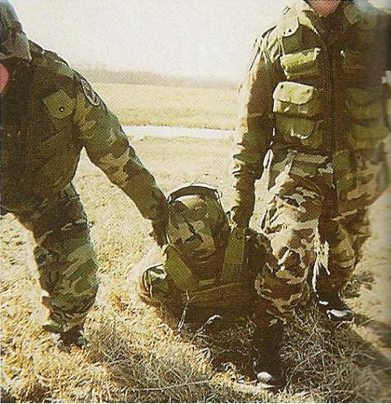
- Consider assets. What can rescuers provide in the way of covering fire, screening, shielding, and rescue equipment?
- Make sure all understand their role in the rescue and which movement techniques are to be used (i.e., drag, carry, rope, stretcher). The fastest method for moving a casualty in the Care Under Fire phase is the two person drag (see figure 1). This drag can be used in buildings, shallow water, snow, and down stairs.
- Management of an impaired airway is temporarily deferred until the casualty is safe, thereby minimizing the risk to the
Figure 1. Two person drag

rescuer and avoiding the difficulty of managing the airway while dragging the casualty. Early control of severe hemorrhage is vital. However, the tactical situation dictates that you must maintain firepower supremacy so only life-threatening bleeding warrants any intervention during Care Under Fire. (Refer back to the lesson on Hemorrhage Control for a review of the importance of this topic).

2. PHASE 2 - TACTICAL FIELD CARE
During this phase, the Corpsman and casualty are no longer under hostile fire. This also applies to situations in which an injury has occurred on a mission, but hostile fire has not been encountered. However, medical equipment is still limited. Medical care during this phase is directed towards more in-depth evaluation and treatment of the casualty, focusing on those conditions not addressed during the Care Under Fire phase of treatment. While the casualty and rescuer are now in a somewhat less hazardous situation, evaluation and treatment is still dictated by the tactical situation. Casualties who show signs of an altered mental status should be disarmed immediately.
Figure 2. Casualty Carries
Airway Assessment
Casualties that are conscious and can talk, scream, or yell can be presumed to have a patent airway. For unconscious casualties, initial attempts to open the airway should be done using the modified jaw thrust (for casualties whom you suspect C-spine injury) or Head Tilt-Chin Lift.
Once the airway is open, visually inspect for anything that may potentially cause obstruction. Examples include broken teeth, blood, vomit or tissue swelling. Remember the most common cause of airway obstruction in an unconscious casualty is the tongue.
Clear any obstructions with a finger sweep and insert a nasopharyngeal airway (NPA) to keep the airway open. Reassess your interventions to ensure the casualty has an open airway. The standard method of “Look, Listen and Feel” can be used to ensure the patient is breathing. If the previously mentioned methods fail to establish an airway, surgical cricothyroidotomy is indicated.
Remember to reassess any intervention performed to determine the effectiveness of the procedure performed. Regardless of the method used to establish an airway, you must also judge the quality and adequacy of the ventilations.
Breathing
FYI!!! If a casualty is found to be in cardiopulmonary arrest on the battlefield as a result of combat trauma, CPR is NOT recommended.
The goal of this step is to rule out chest wounds that either have become, or could potentially develop into, a tension pneumothorax. Needle thoracentesis is indicated if the casualty has difficulty breathing and penetrating trauma to the chest area.
The only way for you to identify penetrating trauma is to EXPOSE the area. This includes removing tactical gear such as flak jackets and uniform tops. Once exposed you may also discover larger wounds, such as sucking chest wounds, that will need to be treated with a three sided occlusive dressing before moving on to the next step in the casualty assessment process. Inspecting the area includes looking at the posterior. Based upon the MOI this may need to be done by log rolling the casualty.
Remember to reassess any treatment performed. Needle decompression should provide immediate relief. An occlusive dressing should not make a sucking sound upon inspiration.
Bleeding
Check for the presence and quality of pulses. Determining the presence and quality (weak / strong) of a radial pulse will affect decisions made later during casualty assessment.
Perform a blood sweep of the casualties entire body by gently sliding your hands underneath the casualty and pulling them back, feeling for any bleeding that was not controlled during “Care Under Fire”. Control it at this time.
Assess for the possibility of tourniquet conversion. Tourniquets that were placed due to the time constraints of “Care Under Fire” should be converted to a pressure dressing or HemCon as appropriate. (See Hemorrhage Control lesson if you need to review.)
Consider Fluid Resuscitation
Casualties that do not exhibit signs of shock do not require and should not be given IV or IO fluid. They should be encouraged to drink fluids by mouth.
All casualties who exhibit signs of tactically relevant shock (weak pulse and/or altered level of consciousness) should have IV access started using an 18-gauge catheter. Consider the IO route for casualties who require fluid resuscitation but IV access can not be obtained. Administer enough fluid to restore a radial pulse. If giving Hextend, give 500 cc’s, wait 30 minutes, and then give another 500 cc’s if needed. Do NOT give more than 1000 cc’s of Hextend to any patient.
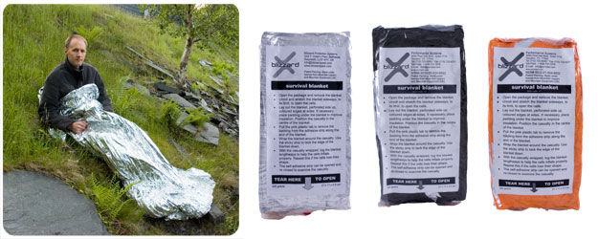
Prevent Hypothermia
At this point all life threatening issues should have been identified and treated. You should begin to take precautions against hypothermia. Preventing hypothermia is for more than just patient comfort, it is an important life saving step. Hypothermia interferes with the body’s blood clotting mechanism and increases mortality.
The Blizzard Rescue Blanket (NSN 6352-01-524-6932) comes in many colors, including tactical green. It is lightweight and extremely effective in preventing hypothermia.
As soon as all life-threatening injuries are addressed, the patient should have all of their wet clothing removed and replaced with dry clothes or a Blizzard Rescue Blanket. Unless prohibited by wounds, cover the head, as it is a prime source of heat loss. Good hemorrhage control and fluid resuscitation will also help restore the casualty’s ability to generate heat.
Monitor Vital Signs
Head to Toe Assessment (DCAP-BTLS)
Deformities Contusions Abrasions Punctures
Burns Tenderness Lacerations Swelling
Again, all life threatening injuries should have been identified and treated by this time. The goal at this stage is to identify and address any additional wounds. You may also identify signs or symptoms that will affect the long term evacuation or treatment of the patient as well. It is important that you carefully inspect the entire casualty. Using the head to toe method described below ensures you do not miss anything.
Head
Check the skull, eyes, ears, nose and mouth for any potential findings. At this time you should also reassess any treatments that have been performed.
Neck
Check the neck to include the C-spine for any irregularities. Jugular vein distension and tracheal deviation are very late signs of tension pneumothorax (a condition you should have treated earlier). If, however, these are encountered at this stage, perform a needle decompression immediately.
Chest
In addition to checking for DCAP-BTLS, you should also attempt to auscultate the chest if the tactical situation permits. Simple rib fractures and flail chest segments should be treated at this time. Reassess any previous treatments, including needle decompression or occlusive dressings, which may have already been performed.
Abdomen
In addition to inspecting for DCAP-BTLS you should also palpate for Tenderness, Rigidity or Distension. Abdominal eviscerations should be treated appropriately. Signs of internal hemorrhage, while not treatable on the battlefield, may effect your decision during casualty evacuation (Triage and Casualty Evacuation are covered in Block 3)
Pelvis
If the patient’s pelvic area is obviously deformed, DO NOT PALPATE IT, as you will likely cause further instability and damage.
Extremities
Since you are already at the pelvis, palpate the lower extremities first then the upper extremities using the same process (DCAP-BTLS)
Note and treat any minor injuries not already addressed. Reassess any major interventions already performed, especially tourniquets or pressure dressing.
Posterior (If not already done)
If the patient is unconscious or you suspect C-Spine injury (based on MOI) you should log roll the patient. Examining the posterior is not simply the back; remember that rectal bleeding is a sign of internal hemorrhage. This should be checked as well. Reassess ALL interventions following a log roll!

Pain Management
Conscious casualties who remain operationally engaged should be given Mobic (15mg PO qd) and Tylenol Bi-layer Caplet (650 mg 2 PO q8h).
Casualties who can not continue to remain operationally engaged but have no need for an IV should be given Oral Transmucosal Fentanyl Citrate (OTFC) provided as a “lozenge on a stick” taped to their finger. Reassess the patient every 15 minutes for respiratory depression.
Those who are out of the fight and require an IV should be administered morphine 5mg (IV or IO). This can be given every 10 minutes as necessary. The patient should be monitored for signs of respiratory depression. You should have Naloxone (Narcan) on hand before administering either OTFC or morphine.
Promethazine (Phenergan) 25 mg IV/IO/IM may be administered to counteract the nausea associated with Morphine or OTFC.
Immobilization
Splint any extremities that need it.
Antibiotics
If the patient can tolerate oral medications, administer Moxifloxacin 400mg, PO qd. If not, administer either cefotetan (2g IM/IV/IO) or ertapenum (1g IM/IV/IO). (For more information on giving medications, see the medication appendix at the end of this block.)
Patient Turnover
Document the patients initial wounds, treatments performed, and response to any treatments. Ensure this, along with the most recent set of vital signs, is transferred with the patient.

REFERENCE
Pre-Hospital Trauma Life Support, Medical Edition, 6th Ed, Chapter 21
Casualty Assessment Review
1. List and briefly describe the three phases of Tactical Combat Casualty Care (TCCC).

- Management of a compromised airway would be taken care of during what phase of TCCC?

- Briefly describe why prevention of hypothermia is so important for the casualty.

4. Describe why patients who can stay in the fight should not be given morphine.

