UNITED STATES MARINE CORPS
Field Medical Training Battalion – East
Camp Lejeune

FMST 1412

Manage Chemical Agent Casualties

TERMINAL LEARNING OBJECTIVE
- Given a chemical warfare agent casualty in a combat environment and standard field medical equipment and supplies, manage chemical agent casualities to prevent further injury or death. (FMST-HSS-1412)
ENABLING LEARNING OBJECTIVES
- Without the aid of references, given a description or title, identify the types of chemical agents, within 80% accuracy, per Medical Management of Chemical Casualties, July 2000. (FMST-HSS-1412a)
- Without the aid of references, given a description or list, identify the signs and symptoms of various chemical agents, within 80% accuracy, per Medical Management of Chemical Casualties, July 2000. (FMST-HSS-1412b)
- Without the aid of references, given a description or list, identify the appropriate treatments for chemical agent casualties, within 80% accuracy, per Medical Management of Chemical Casualties, July 2000. (FMST-HSS-1412c)
HISTORY OF CHEMICAL WARFARE (CW)

The use of chemical weapons dates from at least 423 B.C. when allies of Sparta used sulfur fumes during the Peloponnesian War. In World War I, German units released Chlorine and Mustard Gas which caused several thousand casualties and deaths at Ypres, Belgium. 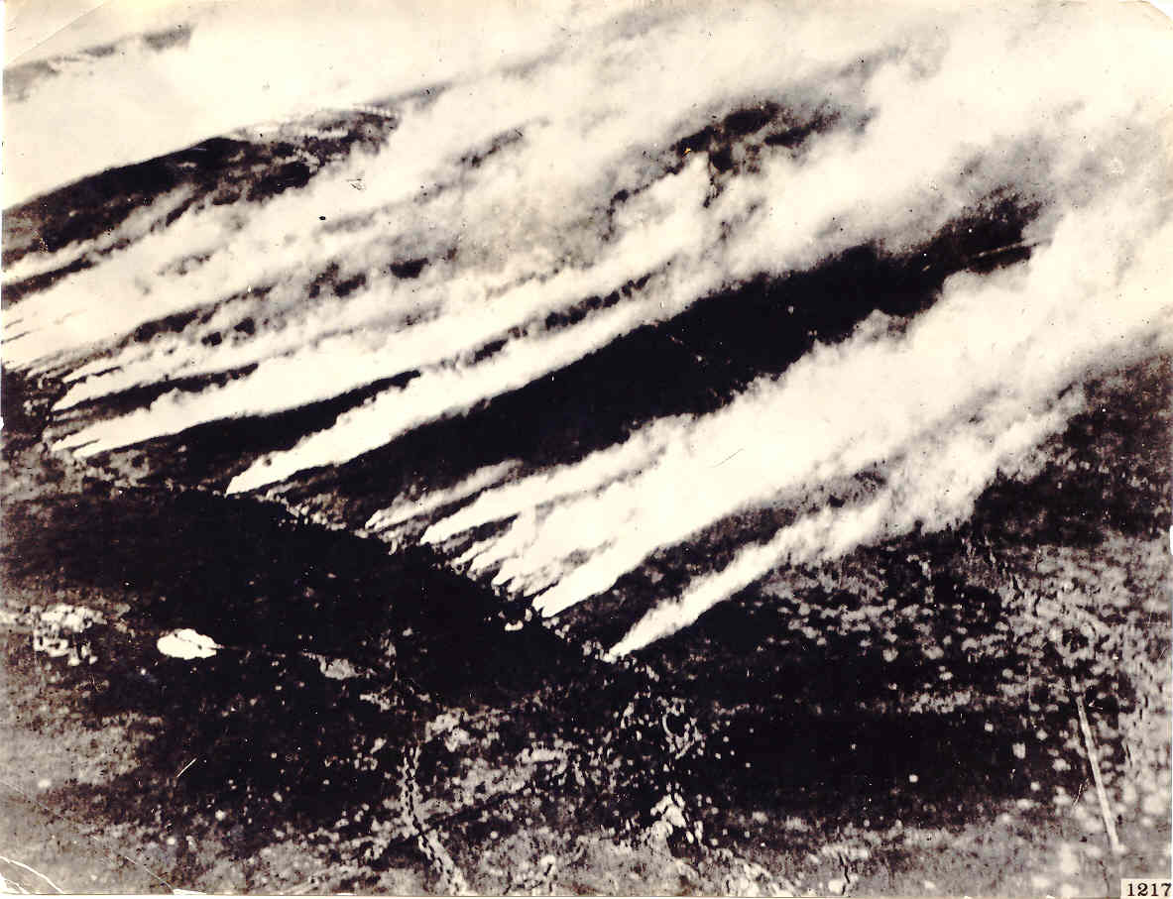
Chemical warfare in earnest: An aerial photograph of one of the first chlorine attacks on the Western Front in World War I. The photograph was taken from behind German lines and is from the US Chemical Warfare Service collection.

During World War II, Germany utilized cyanide gas and other chemical agents
in its concentration camps. Widely publicized reports of Iraqi use of chemical agents against Iran during the 1980's led to a United Nations investigation that confirmed the use of Sulfur
Mustard (HD) and Sarin (GB). During Operation Desert Storm, the United States destroyed several Iraqi chemical stockpiles both on air and land. Since Operation Desert Storm,
Congress has passed a bill mandating the destruction of all U.S. chemical agents.
Chemical Warfare - the use of chemical agents in military operations to kill, seriously injure or incapacitate personnel through physiological effects. They can be dispersed by missiles, rockets, bombs, mines, spray tanks or artillery rounds.
- TYPES OF CHEMICAL WARFARE AGENTS
Nerve Agents - nerve agents a primarily organophosphorus esters similar to those in insecticides. They inhibit the function of cholinesterase (the chemical that allows a message to travel from one nerve to another).
Nerve Agents:
Colorless/ Light Brown
Fruity Odor

Examples
GA - Tabun
GB - Sarin
GD - Soman
VX
Descriptions of Nerve Agents
- Colorless to light brown liquid
- Nonpersistent
- Faint fruity odor
- May be inhaled, ingested and absorbed through the skin
- Most toxic chemical agents
Signs/Symptoms of Nerve Agents
- Can appear in seconds to hours depending on the agent and amount of exposure
- Massive secretions (rhinorrhea, lacrimation, incontinence, diaphoresis, etc.)
- Chest tightness
- Headache above the eyes with blurred vision
- Localized muscle twitching (which can progress into convulsions)
- Constricted pupils
- Respiratory arrest
- Death will result if left untreated
Nerve Agent Treatment
MARK 1 Kit:
Atropine
2PAM-Chloride
Pretreatment:
Pyridiostigmine 30mg/PO/TID for 14 Days
Treatment of Nerve Agents
- Don protective mask
- Decontaminate exposed skin
- Intramuscularly, inject MARK I Kit:
- The MARK 1 Kit includes two autoinjectors, one of 2mg Atropine Sulfate and the other of 600 mg 2 PAM-Chloride. The steps for administering the MARK 1 Kit are as follows:

        - Grasp the Atropine autoinjector like a pen. Remove yellow cap. Press green tip against the meaty portion of the thigh and hold in place for 10 seconds
(See figure 1).

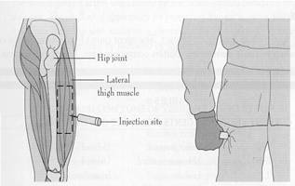

Figure 1. Injecting the MARK 1 Kit

        - Grasp the 2 PAM-Chloride autoinjector like a pen. Remove gray cap.
        - Press black tip against the meaty portion of the thigh and hold in place for 10 seconds.
        - If signs/symptoms are mild, member can administer their own kit.
        - One kit may be given every 10 minutes until improvement is seen or a total of three kits have been given.
        - If signs/symptoms are severe, (member is unable to inject themselve) give all three kits immediatley then inject 10mg Diazepam.
        - If symptoms continue after three kits have been administered, medical personnel may administer repeated Atropine (2mg) injections at three to five minute intervals and should be titrated to a reduction of secretions and to a reduction of ventilatory resistance (atropinization).

Prevention (Pretreatment) for Nerve Agents
- Pyridiostigmine is a drug that inhibits nerve agents from binding to 20-40% of the enzyme acetylcholinesterase. (See figure 2)
- Dosage -30 mg every eight hours not to exceed fourteen days. Comes in a blister pack with 21 tablets, each 30mg.
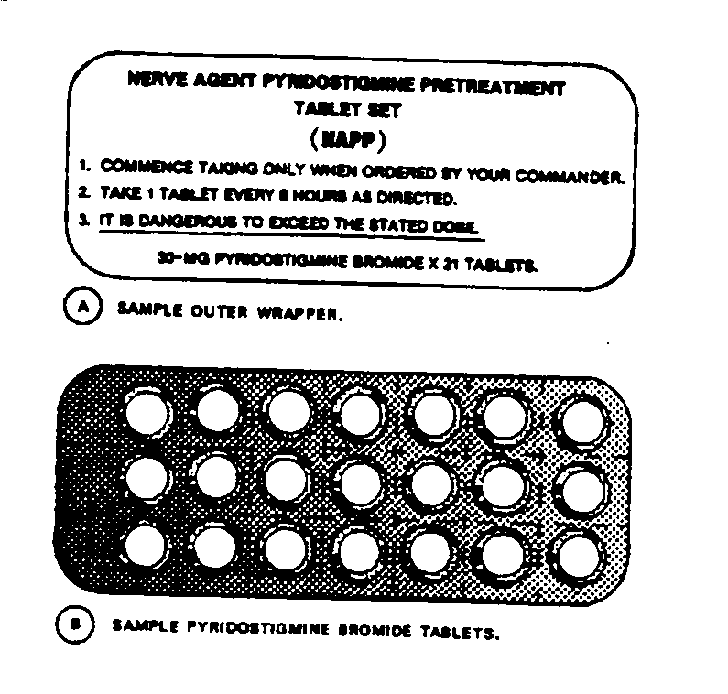
Figure 2. Pyridiostigmine Blister Pack

Vesicants (Blister Agents) - the exact mechanism by which they produces tissue injury is not known
Examples
HD - Distilled Mustard
HN - Nitrogen Mustard
Remember those “Fishy HNs”??? These memory tricks will help you! Be creative! Create your own!
Lewisite
Phosgene Oxide
Descriptions of Blister Agents
- Light yellow to brown oily liquid that becomes a vapor at high temperatures
- Persistent
- Odor:
- Distilled Mustard (HD) - smells of garlic or horseradish
- Nitrogen Mustard (HN) - smells fishy
- Lewisite (L) - smells like geraniums
- Phosgene Oxide - smells pepperish/ pungent odor
- Heavier than water
- May be absorbed through the skin (especially moist areas)
Signs/Symptoms of Blister agents
- Appear any where from 2 - 48 hours after contamination
- Erythemic skin with blisters, and necrosis where the agent touches
- Nausea and vomiting
- Edema of the eyes, eyelids, and corneal scarring
- If ingested or systemic, intense pain in the GI tract and diarrhea
Treatment for Blister Agents
- Don protective mask
- Decontaminate exposed skin
- Flush eyes with copious amounts of water to prevent scarring of the Cornea
- Apply Vasoline to the eyes to prevent adhesions
- Apply Calamine lotion to reduce burning and itching of skin
- Consider giving Morphine for pain if needed
- Use antibiotics and IV fluid replacement as required

Blood Agents - blood agents react with metal complexes of body to prevent intracellular oxygen utilization.
Examples
- AC - Hydrogen Cyanide
- CK - Cyanogen Chloride
Descriptions of Blood Agents
- Colorless liquids dispersed in gas form
- Smells like bitter almonds or peach pits
- Must be inhaled
Signs/Symptoms of Blood Agents
- Hyperpnea (Rapid Breathing)
- Anxiety, agitation, vertigo
- Weakness
- Nausea / Vomiting
- Cherry red skin, may be streaked
- Unconsciousness and seizures within 30 seconds of exposure
- Respiratory arrest and death within two to four minutes if treatment is delayed
Treatment of Blood Agents
- Don protective mask
- Decontaminate exposed skin. Move to fresh air
- Vigorously treat symptomatically
- Administer IV Sodium Nitrite (10ml) followed by IV Sodium Thiosulfate (50ml)
- Second treatment with each of the two antidotes may be given at up to half the original dose, if needed
Choking Agents - break down the alveolar capillary membranes resulting in pulmonary edema.
Examples
- CG - Phosgene
- DP - Diphosgene
- CL - Chlorine
Descriptions of Choking Agents
- Colorless liquid to white cloud which turns into a vapor
- Smells like freshly mown hay, grass, or corn
- Must be inhaled
- Contaminated food is of little consequence. Agent has no effect on body when ingested.
- Rapidly becomes nontoxic in water
Signs/Symptoms of Choking Agents
- Headache and eye irritation
- Coughing and choking / shortness of breath
- Substernal ache with sensation of pressure
- Two to six hours after exposure the following may appear:
- Dyspnea
- Cyanosis
- Pneumonia - late sign
- Pulmonary edema and frothy sputum may be observed
- Hypoxia
- Hypotention
- Death
Treatment of Choking Agents
- Don protective mask
- Establish a patent airway
- Provide rest, warmth, and sedation
- No known antidote for choking agents
- Give oxygen, if available
Vomiting Agents
Examples
- DA - Diphenylchlorarsine
- DC - Diphenylcyanarsine
- DM - Adamsite
Descriptions of Vomiting Agents
- Color:
- DA and DC have a white smoke color
- DM has a canary yellow smoke color
- Odor of burning fireworks / shoepolish
- Crystalline solids, dispersed as a gas
- Must be inhaled
Signs/Symptoms of Vomiting Agents
- Appear 30 seconds to 2 minutes after exposure
- Severe headache
- Intense burning in the throat / salivation
- Chest tightness and pain
- Lacrimation / irritation
- Coughing, sneezing, nausea, and vomiting
Treatment of Vomiting Agents: Treatment is symptomatic.
- Don Protective Mask
- Get to fresh air as soon as possible
- Lift mask only to vomit
- Untreated symptoms usually subside within 30 minutes to 3 hours. - - Vigorous exercise will lessen and shorten the symptoms.

Lacrimators/Tear Agents
‘CS’ gas is what you will be exposed to in the Gas Chamber!
Examples
- CS - Ochlorobenzylmalonitrile
- CN - Chloracetophenone
Descriptions of Lacrimators
- Crystalline solids or liquids dispersed in the air as vapors or white smoke
- Strong pepper odor for CS and apple blossom odor for CN
- Absorbed through the eyes, nasal passages and skin pores
Signs/Sypmtoms of Lacrimators
- Pain and burning to the eyes
- Profuse tearing and photophobia
- Rhinorrhea (snotty nose), epistaxis (nose bleed)
- Chest tightness, coughing and dyspnea
- Blepharospasm (spasm around the eye)
- CS can cause severe burns starting with stinging sensation, erythema and then blister formation
Treatment of Lacrimators
- Don protective mask
- Get to fresh air as soon as possiable
- Heavy contaminants should be flushed from the eyes with copious amounts of water

Incapacitating Agents – These agents produce their effects mainly by altering or disrupting the higher regulatory activity of the peripheral nervous system and central nervous system
Examples
- BZ - Buzz Gas
- Agent 15
Descriptions of Incapacitating Agents
- Odorless and non-irritating
- Highly potent
- Rate of action – delayed by 30 minutes to 4 hours
Signs/Symptoms of Incapaciating Agents
- Dry mouth and skin, “dry as a bone”
Dry as a Bone, Hot as a Hare, Red as a Beet, Mad as a Hatter, Blind as a Bat
- Hyperthermia, “hot as a hare”
- Skin red from cutaneous vasodilation, “red as a beet”
- Slowing of mental activity with slurred speech. Disorientation and hallucinations, “mad as a hatter”
- Dilated pupils, “blind as a bat”
Treatment of Incapacitating Agents: treatment is supportive in nature
- Clear the airway as needed
- Treat for heat stroke
- Give fluids only if the victim can drink unassisted
- Approach with caution, the individual could become dangerous
- Remove all weapons
- Restrain as needed
- Physostigmine 45mcg / kg IM. After one hour, perform mental status exam and repeat dose as needed

NATO CHEMICAL WARNING MARKER - a triangular sign measuring 11"x 8" x 8" with yellow background, and red letters spelling " GAS". (See figure 3)

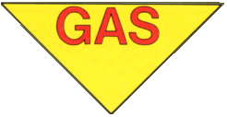

Figure 3. NATO Chemical Warning Marker

REFERENCE
Medical Management of Chemical Casualties, July 2000
Chemical Agent Review
1. List four Nerve agents.

- Describe how Blood agents effect the body.

- List three Vomiting agents.

4. Describe the signs and symptoms associated with a lacrimator agent.

