UNITED STATES MARINE CORPS
Field Medical Training Battalion – East
Camp Lejeune

FMST 1208

Construct a Fighting Position

TERMINAL LEARNING OBJECTIVE
- Given a tactical scenario in a combat environment, commander’s guidance, individual combat equipment, and prescribed weapon with ammunition, construct a fighting position to provide coverage of the sector of fire and sufficient protection from enemy fire per the references. (FMST-FP-1208)
ENABLING LEARNING OBJECTIVES
- Without the aid of references, given a list of associated terms, identify the two purposes of fighting positions, per the student handout. (FMST-FP-1208a)
- Without the aid of references, given a list of associated terms, identify the basic requirements for a fighting position, per the student handout. (FMST-FP-1208b)
- Without the aid of references, given a list of associated terms, identify the two types of fighting positions, per the student handout. (FMST-FP-1208c)
- Without the aid of references, given a list of associated terms, identify the common features of a fighting position, per student handout. (FMST-FP-1208d)
- Without the aid of references, given a list of associated terms, identify the advantages of a two-man fighting position, per student handout. (FMST-FP-1208e)
- Without the aid of references, given a list of associated terms, identify the disadvantages of a two-man fighting position, per student handout. (FMST-FP-1208f)
- Without the aid of references, in a field environment, construct the various types of fighting positions, per the student handout. (FMST-FP-1208g)
- PURPOSE OF THE FIGHTING POSITION
Defensive - fighting positions provide a base for protection of vital areas. They cause the attacker to mass and present a profitable target and to dissipate their combat power in the tasks of reducing the fortifications, thereby making them more vulnerable to counter-attack.
Offensive – while there is no offensive fighting position, there is an offensive purpose of a defensive fighting position. Fighting positions are used in support of offensive operations when making periodic halts to regroup, re-supply or consolidate a position gained, and where the enemy threat is known to include counter-attack capability (or probability).
Fighting Positions must:
- Allow you to fire
- Protect you from observation and direct and indirect fire (see figure 1)
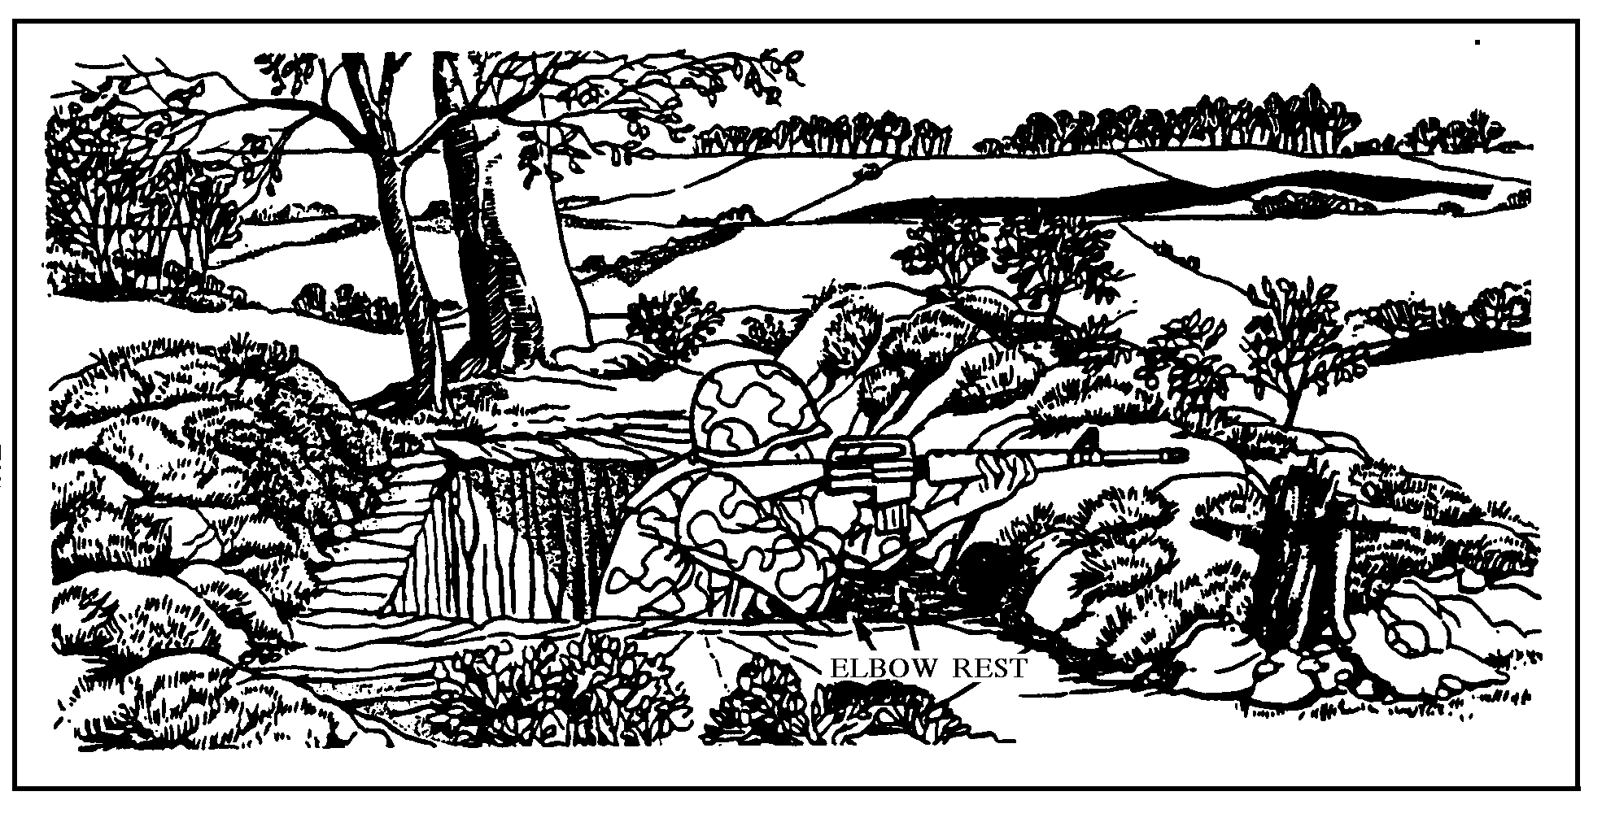
Figure 1. Fighting Position

- BASIC REQUIREMENTS FOR A FIGHTING POSITION
Cover - the cover of your fighting position must be strong enough to protect you from small arms fire, indirect fire, and the blast wave of a nuclear explosion.
Frontal cover must be:
- Thick enough to stop small arms fire (at least 18 in of dirt)
- High enough to protect your head when you fire from behind the cover
- Far enough in front of the hole to allow room for elbow holes and sector stakes so that you can fire to the oblique
- Long enough to give you cover and hide the muzzle blast of your weapon
Overhead - provides protection from indirect fragmentation. When possible, overhead cover is always constructed to enhance protection against airburst.
Simple and Economic - the position should be uncomplicated and strong. Should require as little digging as possible and be constructed with materials readily available.
Improvement and Development - should allow for continuous development to improve usefulness. Development can be accomplished in three steps:
- Dig in quickly. Speed is the principal consideration and no special tools or materials are required.
- Improve with materials available
- Refine, using stock materials
Camouflage - positions should be built so that all can be camouflaged. It may not be practical to conceal a defensive position completely, but it should be camouflaged enough to prevent the enemy from spotting the position by ground observation. If possible, dummy positions should be constructed around your area.

- BASIC TYPES OF FIGHTING POSITIONS
Hasty Emplacements - used when in contact with the enemy and when time and materials are limited. They are used when there is no natural cover; they are good only for short periods of time and only against direct fire.
Shell Crater - a crater made from a shell or bomb of adequate size offers immediate cover and concealment and can be quickly made into a hasty emplacement.
Improved Crater - a crater dug with a steep face on the side towards the enemy, which provides the occupant with a firing position.
Skirmisher Trench - the trench is a shallow pit type emplacement, which provides a temporary, open prone firing position. A low silhouette is presented, and it affords protection to a limited extent from small arms fire. It can be developed further into a prone emplacement.
Prone Emplacement - this is a further refinement of the skirmisher’s trench. It serves as a good firing position and provides better protection against small arms and direct fire weapons, than does the improved crater or skirmisher trench.
Rocks, Snow, and Ice - limited protection may be provided by piling up rocks, chunks of ice, or packed snow. Icecrete (mixture of dirt and water) is an effective arctic building material, which provides protection against small arms fire.
Deliberate Emplacements - deliberate positions are modified hasty positions, which are prepared during relaxed enemy pressure. Deliberate positions could be one of the following:
One Man fighting position (See figure 2)
Dimensions - the size and shape of the position are affected by certain considerations. It should be as small as practicable, exposing a minimum target to enemy fire; wide enough to accommodate the shoulders of a man; long enough to permit the use of an entrenching tool; and at least four feet deep to the fire step or chest high to the tallest man. Standing on the fire step, the Marine/Sailor should be able to aim and fire their weapon.
Advantages
- Unit can cover a wider perimeter close to the front line
Disadvantages
- When the occupant is resting, his portion of the perimeter is not covered
- Morale is lower
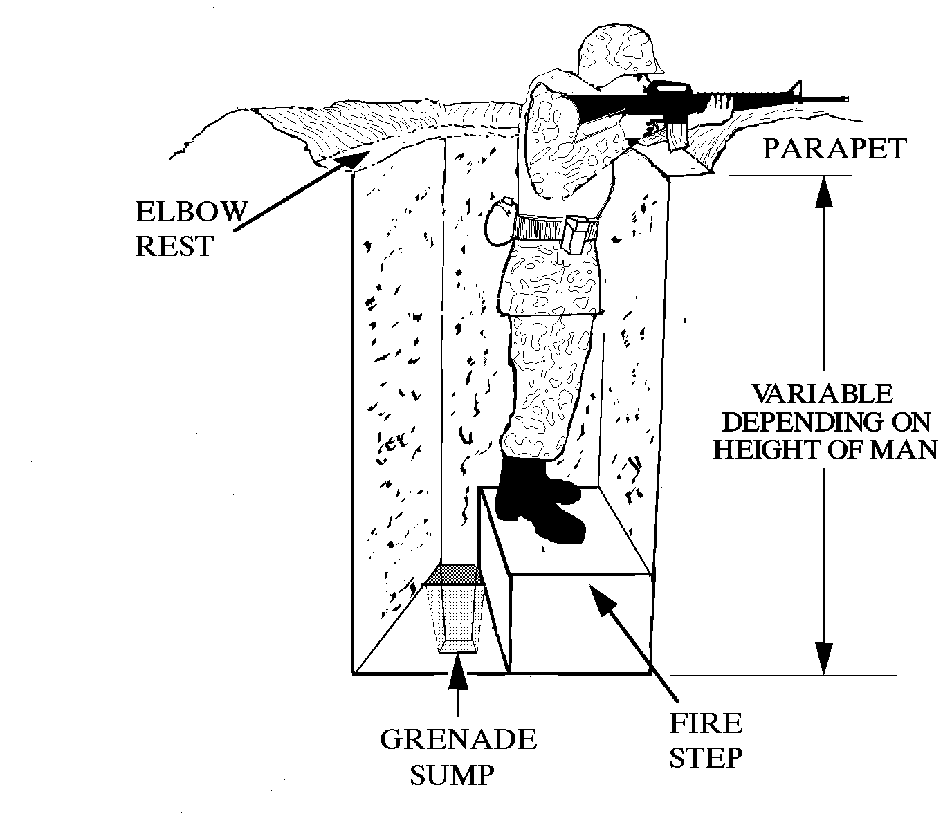
Figure 2. One Man Fighting Position
Two Man Fighting Position (See figure 3)
Dimensions - consists essentially of two adjacent one-man fighting positions.
Advantages
- One man can provide protection while the other man digs
- It affords rest and relief; as one man rests, the other observes
- Firing positions can be manned for longer periods of time
- If a man is hurt, the position is still occupied
- Morale is higher
Disadvantages
- A direct hit could cause two casualties
- Less protection against a tank crossing along the long axis
- Less protection against strafing, bombing, and shell fragments
- Decrease the fields of fire at the forward edge of the battle area
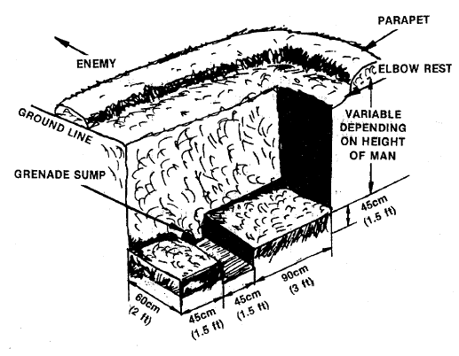
Figure 3. Two Man Fighting Position
- COMMON PARTS OF FIGHTING POSITIONS
Firestep - there is one fire-step for one-man fighting positions; there are two fire-steps for two-man fighting positions. The depth of the fire-steps vary, depending on the height needed to obtain a comfortable firing position by the occupant (three to five feet) when the occupant is crouching or sitting, there should be two feet of overhead clearance to provide protection against the crushing action of tanks.
Water sump - this is dug at one end of the fighting hole to collect water or accommodate the feet of a seated occupant. The water sump may simply provide a collection basin from which water can be bailed.
Grenade sump - this is a circular grenade sump large enough to accept the largest known grenade. It is dug under and at the lower part of the fire-step riser. Grenades thrown into the fighting hole are exploded in the sump. Fragmentation is restricted to the unoccupied end of the fighting hole.
Parapet - when the fighting hole is dug, soil is used for the parapet. The soil should be placed all around the fighting hole. If a top is used to camouflage the parapet, it should be removed from the fighting hole and parapet; and then when digging is completed, place it on top in a natural manner.
Elbow rest - when constructing the parapet, insure that an elbow rest of original earth next to the fighting hole is made available to provide the occupant with an effective and comfortable firing position.

REFERENCES
Marine Rifle Squad, MCRP 3-11.2, Ch 5: Pg 14
ITS, (May 2001), Pgs 1-15-3 through 1-15-4
Fighting Position Review

1. Identify the two types of deliberate fighting positions.

- Identify two disadvantages of a one man fighting position.

- List the disadvantages of a two man fighting position.

4. Define the term “parapet” as it relates to a two man fighting position.

