UNITED STATES MARINE CORPS
Field Medical Training Battalion – East
Camp Lejeune

FMST 1304

Ethical Considerations for the Hospital Corpsman

TERMINAL LEARNING OBJECTIVE
- In a military environment, identify the terms associated with ethical conduct on the battlefield, per the references. (FMST-HSS-1304)
ENABLING LEARNING OBJECTIVE
- Without the aid of references, given a description or list, identify the combatant status of individuals, within 80% accuracy, per the student handout. (FMST-HSS-1304a)
- Without the aid of references, given a description or list, identify the basic concepts of the Law of Armed Conflict, within 80% accuracy, per the student handout. (FMST-HSS-1304b)

Without the aid of references, given a description or list, identify the characteristics of Rules of Engagement, within 80% accuracy, per the student handout. (FMST-HSS-1304c)

Without the aid of references, given a classroom environment, discuss potential scenarios involving ethical decisions on the battlefield, per the student handout. (FMST-HSS-1304d)

OVERVIEW
“The idea is to end the day with fewer enemies than when it started.”
- General David Patraeus, United States Army

The quote above can mean many things. Although in many instances it means we must take the fight to the enemy in order to break their will to fight, it also has another, deeper meaning. The modern battlefield is populated by many groups of individuals and frequently involves operations in towns and villages. The support of the local populace is critical when battling an insurgency. Actions taken to kill a small group of individuals could inflame the passions of other groups in the area that beforehand were not openly hostile. The Geneva Conventions help us to determine an individual’s status on the battlefield. The Law of War and Rules of Engagement provide guidelines for our actions.

1. THE GENEVA CONVENTIONS
The Geneva Conventions were established to curtail the atrocities of war as much as possible. Among the many provisions in these conventions were the definitions of the various types of combatants. The three types of combatants are listed below:
Lawful Combatant
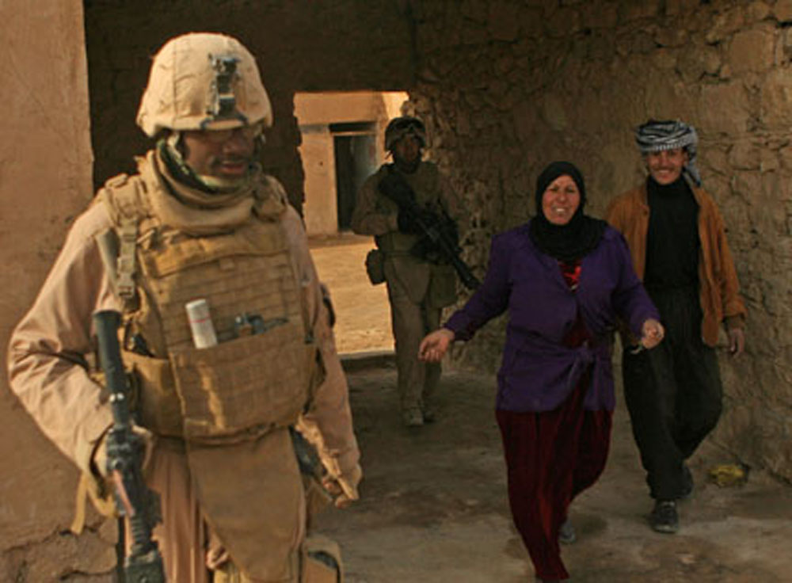
Lawful combatants are authorized by a government to engage in hostilities. As such, they wear uniforms and carry their arms openly. These units have fixed recognizable emblems and have a set chain of command. When the United States first entered Iraq, the Iraqi Republican Guard met the definition of Lawful Combatant.
Non-Combatant
Individuals not involved in hostilities are considered non-combatants. Operations in urban terrain are frequently conducted in areas that have many such individuals. Stabilization operations can also affect many non-combatants.
Marines escort two residents of a small town in the Western Anbar province of Iraq in early 2008. The residents unlocked doors for the Marines to search through buildings for any evidence of insurgent activity. Civilian cooperation has led to a much safer Anbar province due to the ability to efficiently gather intelligence.

Personnel formally in the status of lawful combatant become non-combatants once they are injured to the point they can no longer engage in hostilities. Prisoners of War are also considered non-combatants. Medical personnel and Chaplains are afforded non-combatant status under the Geneva Conventions as well.

Unlawful Combatants
Today’s battlefield involves many individuals who engage in hostilities without meeting the requirements of lawful combatants mentioned above. Unlawful combatants are commonly referred to as “insurgents”. Although they have no chain of command or recognized emblems, they become lawful targets once they engage in hostile actions. One of the most difficult aspects of Counter Insurgency Operations is the ambiguous nature of the enemy due to unlawful combatants “hiding” amongst innocent civilians.

2. LAW OF ARMED CONFLICT
The Law of Armed Conflict, (LOAC), also called the Law of War, is designed to prevent unnecessary suffering of civilians and to minimize damage to infrastructure such as electrical power, water and buildings during a conflict. LOAC requires the United States (and other countries) to conduct operations in a disciplined manner consistent with our national values. LOAC has the following fundamental principles:
Military Necessity
LOAC requires that any target destruction must be necessary to accomplish the mission. Destroying a bridge to disrupt military supply routes is acceptable, but an order to destroy all bridges throughout the theater of operations is not.
Distinction
This requires all attacks to be directed ONLY at combatants and military objectives. Shooting into a crowd of civilians to kill a single insurgent or destroying an entire village to destroy a single insurgent would violate this principle.
Proportionality
This principle should be employed whenever an attack has the possibility of affecting civilian populations or infrastructure. This calls for using only the amount of force necessary to destroy the target. Proportionality does not require the use of a similar amount of force in responding to an attack from the enemy.
Unnecessary Suffering
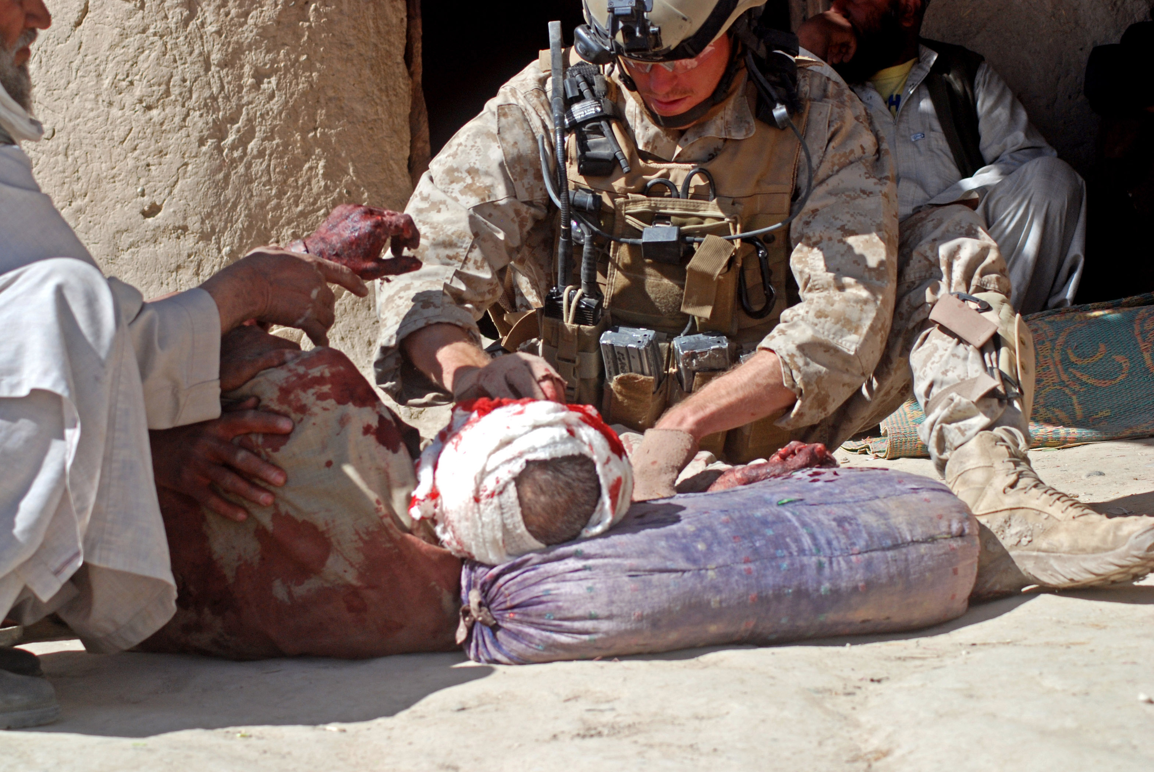
LOAC prohibits the use of otherwise lawful arms in a manner that causes unnecessary suffering and prohibits the engineering of arms to cause unnecessary suffering.

Treatment of wounded
Sailors and Marines have a duty to collect and care for the wounded. Prioritize treatment according to injuries. Make NO treatment distinction based on nationality. All soldiers, enemy or friendly, must be treated the same.
A Navy Hospital Corpsman treats a wounded Afghan in a Helmand Province village in February, 2008.

- RULES OF ENGAGEMENT
(ROE)
ROE is a set of directives issued by competent military authority to delineate circumstances and limitations under which naval, air, and ground forces will initiate and/or continue combat engagement with other forces encountered. ROE can change based upon the theater or the mission. Before every operation each unit is briefed on the ROE. When discussing ROE the following terms are useful:
Positive Identification (PID) - The reasonable certainty that the object of attack is a legitimate military target. NOTE: Reasonable certainty means far more than “maybe” or “might be” and is greater than “probably.” “Very Likely” or “Highly Probable” better describes the term “reasonable certainty.” Identifying someone as a military aged male (MAM) is not PID and this term should NOT be used.
Hostile Act (HA) - An attack against coalition forces or property.
Hostile Intent (HI) - The threat of imminent use of force. Imminent is based on an assessment of all the facts known at the time and may be made at any level including the Marine or Sailor. Imminent does not necessarily mean immediate or instantaneous. It does require the individual to honestly believe that a HA will occur unless he or she intervenes.

SITUATIONS TO PONDER
Goat Thieves
Question: Your squad is on a joint dismounted patrol (US and Iraqi forces together, walking around). You approach a house with many goats in the yard. Members of the Iraqi Army (IA) throw ropes around the necks of the goats and begin to walk off with them. The owner of the house begins protesting asking the Marines to stop them from taking his goats. The IA’s tell him to shut up and tells you that the man is probably an insurgent anyway. They also tell you (and you know this to be true) that they (the IA’s) have not been paid or had food delivered in several weeks. What do you do?

Released Detainee
Question: During a dismounted patrol your squad is engaged with small arms fire from the rooftop of a house. After the ensuing firefight you clear the house and find bodies of several enemy killed in action (KIA) and one enemy who is slightly wounded (the injury is not life threatening). As you are taking him into custody, you recognize him as a detainee you had captured a month previously for being an IED triggerman in an attack that killed two of your Marines. The squad leader recognizes him as well as says the right thing to do is finish him off since he will just be released again to kill more Marines. What do you do?

REFERENCES
Law of War, Rules of Engagement, and Escalation of Force Guide, Marine Corps Center for Lessons Learned. 31 August 2007.
DODINST 2310.08E, Medical Program Support for Detainee Operations
Ethical Considerations Review
1. List the characteristics of a Lawful Combatant as defined by the Geneva Conventions.

2. List the four fundamental principles of the Law of Armed Conflict.

3. Describe your role in treating enemy casualties.

4. Define Positive Identification.

