UNITED STATES MARINE CORPS
Field Medical Training Battalion – East
Camp Lejeune
FMST 1410
Identify Hemorrhage Control Techniques

TERMINAL LEARNING OBJECTIVE
- Given a casualty with life-threatening hemorrhage in a tactical environment and standard field medical equipment and supplies, identify hemorrhage control techniques, to prevent further injury or death, per the references. (FMST-HSS-1410)
ENABLING LEARNING OBJECTIVE
- Without the aid of references, given a description or list, identify the types of hemorrhage, within 80% accuracy, per Pre-Hospital Trauma Life Support, Military Edition, 6th Edition, Chapter 7. (FMST-HSS-1410a)
- Without the aid of references, given a description or list, identify the signs and symptoms of internal hemorrhage, within 80% accuracy, per Pre-Hospital Trauma Life Support, Military Edition, 6th Edition, Chapter 7. (FMST-HSS-1410b)
- Without the aid of references, given a description or list, estimate the amount of blood loss, within 80% accuracy, per Pre-Hospital Trauma Life Support, Military Edition, 6th Edition, Chapter 7. (FMST-HSS-1410c)
- Without the aid of references, given a description or list, identify the methods of hemorrhage control, within 80% accuracy, per Pre-Hospital Trauma Life Support, Military Edition, 6th Edition, Chapter 7. (FMST-HSS-1410d)
- Without the aid of references, given a description or list, identify the principles of bandaging, within 80% accuracy, per Pre-Hospital Trauma Life Support, Military Edition, 6th Edition, Chapter 7. (FMST-HSS-1410e)
- Without the aid of references, given a description or list, state the purpose of hemostatic agents, within 80% accuracy, per Pre-Hospital Trauma Life Support, Military Edition, 6th Edition, Chapter 7. (FMST-HSS-1410f)
- Without the aid of references, given a description or list, identify the indications for use of hemostatic agents, within 80% accuracy, per Pre-Hospital Trauma Life Support, Military Edition, 6th Edition, Chapter 7. (FMST-HSS-1410g)
- Without the aid of references, given a description or list, identify the precautions for use of the CoTCCC approved hemostatic agent(s), within 80% accuracy, per Pre-Hospital Trauma Life Support, Military Edition, 6th Edition, Chapter 7. (FMST-HSS-1410h)
- Without the aid of references, given a description or list, identify the components of the individual first aid kit (IFAK), within 80% accuracy, per the MCRP 3-02G and the User’s Instructions for the IFAK. (FMST-HSS-1410i)
- Without the aid of reference materials, given a casualty with life-threatening hemorrhage and standard field medical equipment and supplies, manage hemorrhage, to prevent further injury or death, per Pre-Hospital Trauma Life Support, Military Edition, 6th Edition, Chapter 7. (FMST-HSS-1410j)
OVERVIEW
Historically, 20% of all injured combatants die on the battlefield. Of that 20%, approximately 65% will die of massive, multiple trauma and are probably not salvageable. Based on the data from the Vietnam conflict, over 60% of battlefield casualties died of exsanguination (bleeding out) within 3 to 5 minutes and could have been saved with timely intervention. In order to continue to decrease these statistics, you must be able to rapidly identify and manage internal and external hemorrhage. You must also recognize the type of bleeding, apply the appropriate hemorrhage control techniques, understand the varying degrees of risk associated with types of hemorrhage, and how to estimate blood loss.
- TYPES OF HEMORRHAGE
Hemorrhage is defined as blood escaping from arteries, veins or capillaries.
Arterial - if an artery near the surface is damaged, bright red blood will gush out in spurts that are synchronized with the heartbeat.
Venous - blood from the veins is dark red. Venous bleeding is characterized by a steady, even flow.
Capillary - capillary blood is usually brick red in color. If capillaries bleed, the blood oozes out slowly.
External Hemorrhage - loss of blood from wounds that damage the large vessels of the extremities are a common source of massive external hemorrhage in combat. The cause of external hemorrhage can be varied depending on the setting in which the injury has taken place. Some of these causes include, but are not limited to, gunshots, stabbings, shrapnel, vehicle accidents and blasts. The importance for you lies in the identification of life threatening hemorrhage versus non-life threatening hemorrhage. The difference between life threatening and non-life threatening exists in the amount of blood loss and the class of shock of the patient.
Internal Hemorrhage - blood loss into the chest or abdomen cannot be controlled in the field. Despite aggressive treatment and fluid resuscitation, casualties with major internal vascular injuries frequently die in the field. The patient with severe internal hemorrhage may develop hypovolemic shock before the extent of the blood loss is realized. Internal hemorrhage requires immediate surgical intervention at a higher capability of care. Bleeding, however slight, from any body orifice is serious, as it usually indicates an internal source of hemorrhage that may not be readily evident. Signs that may indicate serious internal injury (or disease) would include bleeding from the mouth, rectum or blood in the urine. Nonmenstrual bleeding from the vagina is always significant. Internal hemorrhage can be caused by the following examples of injuries: blunt trauma, concussion injuries from blasts, vehicle accidents, falling from heights, collapsing buildings and closed fractures (bones or bone fragments lacerate arteries or large veins).

2. Signs and Symptoms of External and Internal Hemorrhage
External hemorrhage
- Massive blood loss
- Obvious signs and symptoms of shock (Class III or IV shock)
Internal hemorrhage
- Hematemesis (vomiting bright red blood)
- Hemoptysis (coughing up bright red blood)
- Melena (black tarry stools)
- Hematuria (blood in the urine)
- Ecchymosis (bruising)
- Rapidly forming hematoma and edema
- Rigidity with or without rebound tenderness upon palpation in the abdomen
- Signs of shock
- ESTIMATING BLOOD LOSS (EBL) (see figure 1)

Gather a quick estimation of blood loss based on the following factors:
- Look for blood surrounding the patient.
- Inspect clothing for blood saturation.
- Inspect bandage saturation for associated blood loss. See figure 1 for amount of blood each dressing will hold when fully saturated.
- Determine level of shock

 | Small Battle Dressing | Medium Battle Dressing | Large Battle Dressing | Abdominal Battle Dressing
Amount of estimated blood | 300 ml | 750 ml | 1000 ml | 2500 ml
*EBL | About 6% | About 15% | About 20% | About 50%
*Amounts are based on the average adult blood volume of about 5 liters.
Figure 1. Estimating Blood Loss Based On Saturation of Dressings

- METHODS OF HEMORRHAGE CONTROL
Massive hemorrhage may be fatal within 60 – 120 seconds. Treatment should not be delayed and controlling major hemorrhage should be the first priority over securing the airway.

Direct Pressure
Direct pressure, applied over a bleeding site, is the initial technique used to control external hemorrhage. Most external hemorrhage is readily controlled by direct pressure at the bleeding site, even carotid and femoral bleeding! To perform direct pressure correctly requires two hands pushing against the casualty’s wound laying on a flat and hard surface. You must lean into delivery of direct pressure and never let up on it to check the wound. If you need to perform other procedures, a pressure dressing can be made using bandages and ace wraps. If direct pressure fails to control extremity hemorrhage, the next step is to use a tourniquet. The only time a tourniquet will be the first step in controlling hemorrhage is in the Care Under Fire phase.
5. BANDAGES AND DRESSINGS
A bandage is any material used to hold a dressing in place. It can be applied to wrap or bind a body part or dressing. The bandage also provides additional pressure to the dressing or splint and protects and covers the dressing completely.
Things to keep in mind about bandages/dressings
- Ensure the dressing is tight enough.
- Provide pressure over the entire wound.
- Dressings must cover the entire wound, bandages must cover entire dressing.
- Leave the fingers and toes exposed
- Assess circulation and neurological status using PMS:
Pulse (check pulses in extremities)
Motor (movement)
Sensation (can the patient feel you touching them?)
- If hemorrhage continues:
DO NOT remove the first pressure dressing; apply a second one over the first
The following provides brief information regarding the types of bandages and dressings that you may encounter:
Kerlix gauze
Advantages:
- Extremely absorbent
- Weave of material makes roll stretchable
- Sterile
- Good for packing cavities
Disadvantages:
- Looses bulk when wet
- Catches debris and snags very easily
Ace wrap
Aspirin use on the battlefield?
The use of aspirin or any other blood thinner while in a combat setting can lead to increased blood loss not only during surgical procedures, but also when injured on the battlefield. Aspirin is not sold over the counter at exchange outlets while deployed, nor should it be given to Marines or Sailors without a doctor’s order. Be sure to educate your Marines and other Sailors on this topic.
Advantages:
- Can be applied quickly
- Gives pressure to the entire affected area
- Provides excellent support for sprains and strains
Disadvantages:
- Can decrease peripheral circulation

Cravats or Triangular Bandages (37”x37”x52”)
Advantages:
- Versatile
- Come in small packages with safety pins
- Can be used as a tourniquet
Disadvantages:
- Has very little absorbency

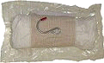
Combination Dressing/bandage (see figure 2 & 3)
Cinch Tight, Sterile Compression Bandage (8” x 10”)
These pressure dressings are four-inch wide elastic wraps with an 8”x10” absorbent cotton pad attached close to the end of one side of the elastic wrap. On the other side of the absorbent pad, in the middle on the elastic wrap side, is a steel S-hook that allows for self-application of the dressing and gives it the ability Figure 2. Cinch tight dressing
to be applied tightly. Finally, at both ends of the elastic wrap are
velcro strips that allow for ease of securing the dressing.
Instructions for use
- Open and remove bandage.
- Unroll the bandage and place absorbent pad on wound with hook on top.
- Anchor elastic wrap onto Velcro strip at bandages edge.
- Feed elastic bandage through hook and pull to secure absorbent pad in place.
- Wrap the elastic bandage tightly in the direction through which it was pulled.
- Press the velcro strip at the very end onto the bandage to secure it.
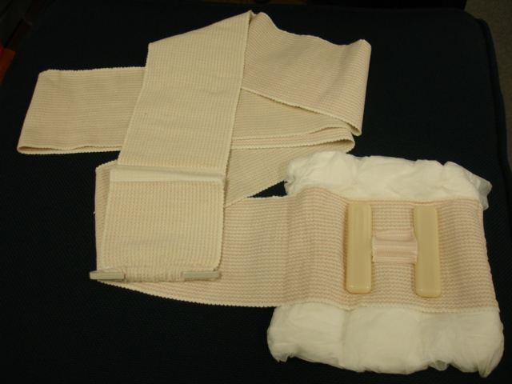
“H” Bandage Combat Dressing
These pressure dressing bandages are 4” wide elastic wraps with 8” x 10” absorbent cotton pad attached close to the end of one side of the elastic wrap. On the other side of the absorbent pad, in the middle on the elastic wrap side is a hard plastic H-anchor that allows for wrapping the dressing around the anchor to apply pressure directly over wound. It also gives it the ability for self-application. Pressure dressings can be applied to extremity, chest, abdominal, and head wounds.
Figure 3. “H” Bandage
Instructions for use
- Open and remove pressure dressing.
- Place pressure dressing over injury with steady pressure, isolating velcro end.
- Pull draped elastic end and secure to velcro end.
- Feed wrap through lower leg of H anchor, pulling firmly.
- Wind wrap back around injury site and feed wrap through upper leg of H –anchor, pulling firmly.
- Continue wrapping elastic wrap around injury site, keeping the wrap tight.
- Firmly attach velcro end of wrap and secure with plastic hooks on sides of wrap.
- For fractures of the arm, the elastic wrap can be used as a sling or swathe.
Expedient (Improvised) Dressing and Bandages
- Patients clothing.
- Patients equipment.
- Your only limitation is YOUR imagination!!!!
Tourniquets: (for more information see the PHTLS, 6th Ed, pages 501-513).
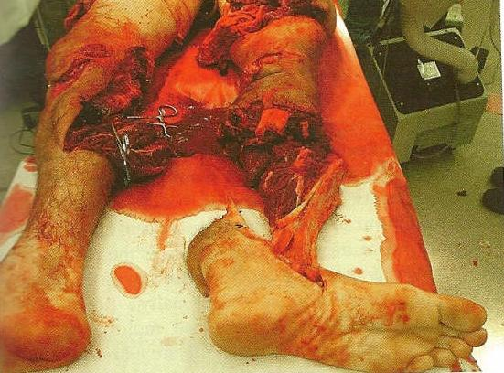
In civilian trauma care the use of a tourniquet is reserved for when direct pressure fails, this is not the case in Care Under Fire. The initial treatment for an extremity hemorrhage in a tactical setting is a tourniquet. A pressure dressing can be used later in the care process of a combat casualty.
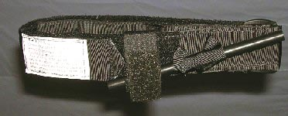
The standard “web belt through the buckle” tourniquet issued by the military during Vietnam was not highly regarded by the combat medic community. The U.S. Army Institute of Surgical Research identified the Combat Application Tourniquet (CAT) as the one best suited for battlefield use and is the CoTCCC recommended tourniquet. This tourniquet can be rapidly applied with one hand to one’s own or another’s extremities. This tourniquet is issued throughout all U.S. combatant forces. If the CAT is not available the provider should be able to make a “field expedient” tourniquet. The use of the tourniquet in a combat setting is not limited to solely the CAT, there may be other brands of tourniquets. While it may have a different name, the principles of use are similar. The goal is to stop arterial bleeding in an extremity to prevent loss of life. Imagine trying to control the bleeding of the casualty in figure 4 without a tourniquet!
Figure 4. Casualty who was saved using a tourniquet
Characteristics of the CAT (see figure 5)
- US Army Institute of Surgical Research and
CoTCCC recommended
- Lightweight
- Easy to apply and use
Figure 5. CAT Tourniquet
Field Expedient Tourniquet (see figure 6)
- If CAT is unavailable, choose a material about two inches (2”) wide.
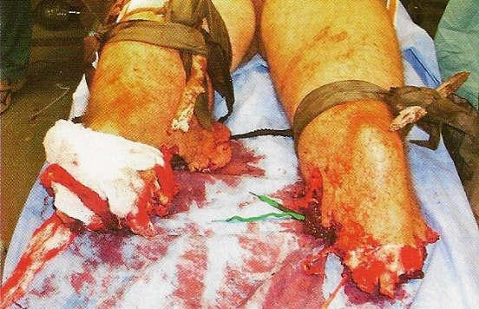
- Material such as rope, wire and string should NOT be used because they can cut into flesh.
- Tie a strong windlass (stick) to a cravat or other strong material.
- Slide one or two rings on each side of the cravat.
- Tie the cravat around the affected limb, two to four inches above the wound, loosely. (This will allow the windlass to turn, creating circumferential pressure to stop the bleed.)
Figure 6. Improvised Tourniquets
- Twist the windlass until the hemorrhage is controlled.
- Slide the ring to the windlass and secure windlass to the ring(s).

Tourniquet Application
Application site - a tourniquet should be applied approximately 2-3 inches above the hemorrhaging wound. During the Care Under Fire phase, there is no need to expose the site before tourniquet application, it can be applied over the uniform. However, once out of the Care Under Fire Phase, reassess tourniquet application by exposing site. Do NOT place a tourniquet below the knee or elbow or over a joint due to there being two bones, i.e., Tibia/Fibula below the knee, and Radius/Ulna below the elbow, which can splint the hemorrhaging vessel and make it impossible to control the bleed.
What about those Rings???
Examples of good rings to use:
- Key chain rings
- Sport drink rings
- Boot laces tied into a ring
- Anything that is in a ring shape with the
approximate diameter of 1-2 inches
Application tightness - apply tourniquet tight enough to block arterial flow. Generally, the bigger the limb, the tighter the tourniquet. So a leg will require more pressure to control bleeding than an arm will. If injured limb is still present, check distal pulse to ensure it is occluded.
Other considerations - it may be necessary to use more than one tourniquet to control severe bleeding. A second tourniquet should be applied just proximal to the first, if needed. Another thing to remember is that a tourniquet will be painful for the conscious casualty to tolerate but don’t stop tightening until the hemorrhage is controlled. Pain management should be considered provided the casualty does not have signs of Class III or IV shock. You must document placement of a tourniquet by placing a “T” and the time of application on the casualty’s forehead or other conspicuous spot. After application, do not cover a tourniquet under any condition, leave it exposed to ease monitoring for continued hemorrhage.
Converting a Trouniquet to a Dressing
Tourniquet use is the first line of hemorrhage control while in the Care Under Fire Phase. Only when in the Tactical Field Care Phase should you even consider converting a tourniquet to a pressure dressing. Do NOT convert a tourniquet to a pressure dressing under the following conditions:
- The casualty is in Class III or IV shock (you will learn what this is in the Shock lesson).
- There has been a complete amputation below the tourniquet.
- There is no one to monitor the casualty for rebleeding.
- Tourniquet has been in place for more than 6 hours.
- Short transport time to surgical intervention.
- HEMOSTATIC AGENTS
The only hemostatic agent approved by the CoTCCC is QuikClot Combat Gauze (see figure 7). A hemostatic agent causes the wound to develop a clot that stops the flow of blood and will remain within the wound until removed by medical personnel. It is applied to wounds with moderate to severe bleeding (venous or arterial). Hemostatic agents have strengths and liabilities and carry with them the requirement for specific training for all members of the combat team. QuikClot Combat Gauze is the first line treatment of uncontrolled hemorrhage in a tactical setting.

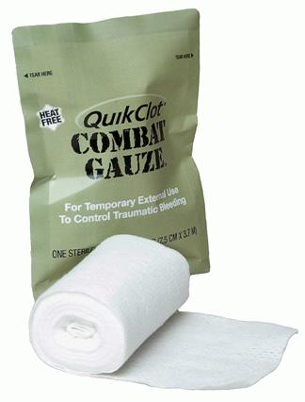
QuikClot Combat Gauze
Combat Gauze is tailored to the needs of combat and tactical medical personnel. It combines surgical gauze with an inorganic material that stops arterial and venous bleeding in seconds. It creates no heat, is inert and non-allergenic. It can be fit to any size or shape wound, including penetrating wounds. Combat Gauze comes in rolls four yards long by three inches wide. Remember, hemostatic agents are only to be used when in the Tactical Field Care Phase of TCCC.
Figure 7. Combat Gauze
Application Procedures: (see figure 8)
- Expose injury by opening or cutting away clothing.
- Remove excess blood from wound while preserving any clots that may have formed, if possible.
- Locate the source of the most active bleeding.
- Remove Combat Gauze from package and pack it tightly into the wound directly over the site of the most active bleeding. (More than one roll of Combat Gauze may be required to control the hemorrhage.)
- Combat Gauze may be re-packed or adjusted in the wound to ensure proper placement.
- Apply direct pressure quickly with enough force to stop the bleeding.
- Hold direct pressure for a minimum of 3 minutes.
- Reassess for bleeding control.
- Once applied, Combat Gauze is not to be removed (except by proper medical authority). If bleeding continues, reinforce would with another roll of Combat Gauze and hold pressure.
- Leave Combat gauze in place and secure with a pressure dressing.
- Document, place empty package near wound, and transport patient.
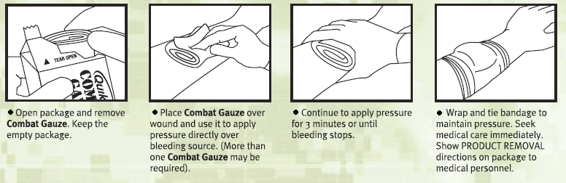
Figure 8. Application Procedures

7. COMPONENTS OF THE INDIVIDUAL FIRST AID KIT (IFAK)
The IFAK is designed to be more compact and have greater life saving capability than its predecessors. The IFAK is issued to every Marine and Sailor. Your Corpsmen Assault Pack will have more medical gear than the IFAK but this section is designed to introduce its contents and characteristics so you may better educate your Marine Corps personnel.
Bleeding to death is the leading cause of preventable death on the battlefield. As such, each Marine's IFAK contains many of the items discussed in this chapter. It is essential that all Marines are properly trained in their use. Training is one of the many responsibilities of the FMST.
Contents
- Adhesive Bandages (10)
- Packet of Combat Gauze (1)
- Bulky Gauze Rolls (2) - these are used for the protection of minor wounds. They can also be wrapped loosely around the burn dressing to secure it over the burn area. They are also used for direct pressure of medium and severe wounds and to wipe away excess blood prior to the application of the hemostatic agent.
- Package of Burn Dressing (Water-Jel) (1)
- Bottle of Iodine Water Purification Tablets (1)
- Bottle of Wound Disinfectant (Betadine Solution) (1)
- Tourniquet (1)
- Pressure Dressings (2) - either Cinch Tight or H-bandage

In summary, there is one important factor in hemorrhage control: There is no single, best
method to control hemorrhage. Each situation is different. Factors such as the amount of
blood lost, proximity to surgical care, number of other casualties, and resources
available(medical and transport) will affect your decision.

 CASUALTY ASSESSMENT AND HEMORRHAGE CONTROL
Care Under Fire Phase: Hemorrhage control is the only intervention performed during this phase! You must be able to recognize “life-threatening” hemorrhage. For extremity hemorrhage, use a tourniquet. For non-extremity hemorrhage, use direct pressure. NO HEMOSTATE AGENT USED DURING THIS PHASE!

Tactical Field Care Phase: During this phase, reassess your treatment performed during Care Under Fire Phase to control the hemorrhage. Don BSI. Assess the airway and intervene if necessary. Complete a head to toe assessment using DCAP-BTLS (deformities, contusions, abrasions, punctures, burns, tenderness, lacerations, and swelling) noting and treating additional injuries. Determine if vascular access is required (see Tactical Fluid Resuscitation lesson) and give fluids if necessary. If the casualty is able to drink fluids, they should be encouraged to do so. Consider pain medications and give antibiotics if warranted. Reassess all care provided. Document care given, prevent hypothermia, and CASEVAC.

References:
Pre-Hospital Trauma Life Support, Military Edition, 6th Edition, Chapter 7
Committee on Tactical Combat Casualty Care Meeting Minutes, 22-24 July 2008
MCRP 3-02G
User’s Instructions for the IFAK
Hemorrhage Review

1. List four signs or symptoms of internal hemorrhage.

- Identify the appropriate treatment for life threatening hemorrhage during “Care Under Fire”.

- Where on the extremities should a tourniquet NOT be placed?

4. During which phase of TCCC is the use of hemostatic agents authorized?

