UNITED STATES MARINE CORPS
Field Medical Training Battalion – East

Camp Lejeune

MCCS 1001/1002

Improvised Explosive Device (IED)

TERMINAL LEARNING OBJECTIVES
1. Given a tactical scenario with an Improvised Explosive Device (IED) threat training aids and an IED lane, visually identify IEDs to ensure identification of ground emplaced IEDs, Suicide Vehicle-borne IEDs (SVIEDs), and Suicide Bomber attack IEDs are confirmed in accordance with the references. (MCCS-IED-1001)

2. Given a tactical scenario with an IED threat training aids and an IED lane, conduct immediate actions in response to an IED to ensure the tactical effects of IED(s) on mission accomplishment are mitigated, in order to meet the concept of operations and the commander's intent, in accordance with the mission order and the references. (MCCS-IED-1002)

ENABLING LEARNING OBJECTIVES
1. Given a list of choices, select the definition of an IED in accordance with the reference. (MCCS-IED-1001a)
2. Given a list of choices, identify primary indicators of an IED in accordance with the reference. (MCCS-IED-1001b)
3. Given a list of choices, identify likely locations of an IED in accordance with the reference. (MCCS-IED-1001c)
4. Given a list of choices, identify common employment techniques of IEDs, in accordance with the JIEDDTF 05-23. (MCCS-IED-1002a)
5. Given a list of choices, identify mitigating tactics that can be employed in an IED environment, in accordance with JIEDDTF 05-23. (MCCS-IED-1002b)
6. Given a list of choices, identify non-lethal deterrents that can be employed in an IED environment, in accordance with JIEDDTF 05-23. (MCCS-IED-1002c)
7. Given a list of choices, identify the procedures for conducting 5 to 25 meter checks, in accordance with JIEDDTF 05-23. (MCCS-IED-1002d)
8. Given a list of choices, identify the 5 C's and their definitions, in accordance with the JIEDDTF 05-23. (MCCS-IED-1002e)
9. Given an operational environment containing IEDs, react to an IED detonation, in accordance with JIEDDTF 05-23. (MCCS-IED-1002f)

INTRODUCTION
Improvised explosive devices (IEDs) account for the majority of wounded and killed military personnel in combat situations. As an emergency provider you are one thousand times more likely to encounter injury from conventional explosives than from a chemical, biological, or nuclear attack. It is important to consider some basic tactics, techniques, and procedures (TTPs). Understanding the TTPs will allow you to survive in an IED environment.
Knowing what to look for and where to look is a starting point. Understanding how to move, as part of a patrol or resupply element, for example, will give you an edge on the battlefield. It is important to remember IEDs are not the enemy; the people using the IEDs are the enemy. They can be defeated by being observant and looking for IED indicators. IEDs can be produced in varying sizes and can have different types of containers, function, and delivery methods. IEDs become more difficult to detect and protect against as the enemy becomes more sophisticated.
1. IED TERMINOLOGY AND COMPONENTS
Terminology
Improvised Explosive Devices are those devices that are placed or fabricated in an improvised manner incorporating destructive, lethal, noxious, pyrotechnic, or incendiary chemicals and designed to destroy, incapacitate, harass, or distract. They may incorporate military weapons, but are normally devised from non-military components.
Booby Traps are explosive or non-explosive devices or other materials, deliberately placed to cause casualties when an apparently harmless object is disturbed or a normally safe act is performed.
Mines are explosives or materials, normally encased, designed to destroy or damage ground vehicles, boats, or aircraft, or designed to wound, kill, or otherwise incapacitate personnel. They may be detonated by the actions of its victims, by the passage of time, or by controlled means.

Components - IEDs can vary widely in shape and form. IEDs share a common set of components that consist of the casing, initiating system, and main charge.
Casings can range in size from a cigarette pack to a large truck or airplane. The container is used to help hide the IED and to possibly provide fragmentation. Countless containers have been used as casings including soda cans, animal carcasses, plastic bags, and vests or satchels for suicide bombers.
Initiating systems cause the main charge to function. It can be a simple hard wire (for command detonation), or a radio frequency (RF) device such as a cell phone or a toy car remote control. The initiator almost always includes a blasting cap and batteries as a power source for the detonator. Any type of battery can be used (9-volt, AA, or car batteries). Initiating systems are triggered in three ways – over time, on command, and by the victim.
Time - timed IEDs are designed to function after a preset delay, allowing the enemy to make his escape or to target military forces which have created a pattern.
Command - command-initiated IEDs are a common method of employment and allow the enemy to choose the optimal moment of initiation. They are normally used against targets that are in transit, or where a routine pattern has been established. The most common types of command-initiated methods are with command wires or radio-controlled devices, such as cordless telephones and remote car openers.
Victim - victim-actuated IEDs are initiated by the actions of the victim(s). There are various types of initiation devices to include pull or trip, pressure, pressure release, movement-sensitive, light-sensitive, proximity, and electronic switches.
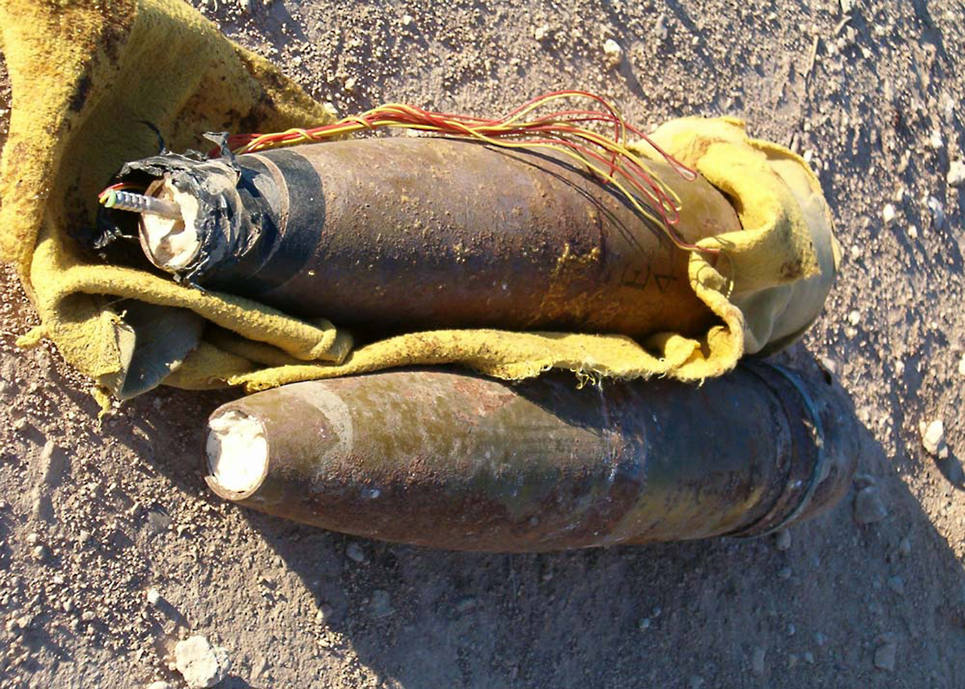
Main Charge
High Explosive main charges are the most common encountered in theater. Common explosives used are military munitions, usually 122mm or greater. These items are the easiest to use and provide a ready-made fragmentation effect and multiple main charges together over long or short distances for simultaneous detonation. Common hardware, such as ball bearings, bolts, nuts, or nails can be used to enhance the fragmentation. Propane tanks, fuel cans, and battery acid can, and have been added to IEDs to propagate their blast and thermal effects.
Artillery shells have become a common form of improvised explosive devices used by insurgents.
Chemical - a chemical IED is a main charge with a chemical payload in conjunction with an explosive payload. Chemical IEDs are fabricated to kill or incapacitate victims with a chemical, rather than explosive, effect. Some indicators for chemical IEDs are smaller blasts, odor, gas cloud, and liquid on or near the suspected IED.
2. PRIMARY INDICATORS
There are many ways to detect IEDs. The best means of detection is your situational awareness. The primary indication of an IED will be a change in the baseline (something new on the route that was not there the previous day). Vigilant observation for these subtle indicators can increase the likelihood of IED detection. Some examples of possible roadside IED indicators may include:
- Unusual behavior patterns or changes in community patterns, such as noticeably fewer people or vehicles in a normally busy area, open windows, or the absence of women or children.
- Vehicles following a convoy for a long distance and then pulling to the roadside.
- Personnel on overpasses.
- Signals from vehicles or bystanders (flashing headlights).
- People videotaping ordinary activities or military actions. Enemies using IEDs often document their activities for use as recruitment or training tools.
- Suspicious objects.
- Metallic objects, such as soda cans and cylinders.
- Markers by the side of the road, such as tires, rock piles, ribbon, or tape that may identify an IED location to the local population or serve as an aiming reference for the enemy triggering the IED (such as light poles, fronts or ends of guardrails, and road intersections).
- New or out of place objects in an environment, such as dirt piles, construction, dead animals, or trash.
- Graffiti symbols or writing on buildings.
- Signs that are newly erected or seem out of place.
- Obstacles in the roadway to channel traffic.
- Exposed antennas, detonating cord, wires, or ordnance.
- Wires laid out in plain site; these may be part of an IED or designed to draw friendly force attention before detonation of the real IED.

3. LOCATIONS OF IEDS
IEDs may be placed anywhere enough space exists or can be created to hide or disguise the IED. Whenever possible, devices are located where they can exploit known US patterns, such as the use of a main supply route, or vulnerabilities, such as soft-skinned vehicles or chokepoints. Common areas of IED placement may include:
- Previous IED sites.
- Frequently traveled or predictable routes, such as roads leading to bases and along common patrol routes.
- Boundary turnaround points (pattern).
- Medians, by the roadside (usually within 10 feet), or buried under the surface of any type of road, often in potholes and covered with dirt or reheated asphalt.
- Trees, light posts, signs, overpasses, and bridge spans that are elevated.
- Unattended vehicles, carts, or motorcycles (attached or installed in them).
- Hidden inside guardrails or under any type of material or packaging.
- Potential incident control points (ICPs).
- Abandoned buildings or structures (sometimes partially demolished).
- Hidden behind cinder blocks or piles of sand to direct blast into the kill zone.
- Animal carcasses and deceased human bodies.
- Fake bodies or scarecrows in coalition uniforms.
- At the edge of town.
Vehicle Borne IED (VBIED)/Suicide VBIED (SVBIED) – a VBIED is a parked vehicle in a high traffic area with the intent of causing the most damage. An SVBIED is when the driver is willing to give their own life in the process of detonating his explosives. These are very successful because the enemy is mobile and is able to choose a time and place with great flexibility. This unpredictability makes them difficult to identify.

Driver Indicators:
- A lone male driver is the historical standard for VBIED operations; however, there could be any number of people in the vehicle if an unsuspecting person is driving the VBIED. Some VBIEDs have two to three people and females are sometimes used as a distraction.
- Ignoring orders to stop, attempting to circumvent a security checkpoint, or attempting to maneuver too close to coalition assets.
- Unusual appearance. The enemy may be uncharacteristically clean-shaven and have very short haircuts. Cutting the hair is part of the purifying ritual that many follow prior to an attack.
- Age in mid-twenties. The average Middle Eastern suicide terrorist is about 24-25 years old, but this may vary in each unique situation.
- Driving erratically; driving too slow or too fast.
- Wearing inappropriate dress for the environment.
Vehicle Indicators:
- Noticeable sagging of the vehicle.
- An additional antenna for radio-controlled devices.
- Darkened or covered windows to conceal either the vehicle's contents or actions of the driver.
- Recent painting of vehicle to cover body alterations.
- Crudely covered holes made in the vehicle to hide explosives.
- New welding marks.
- No license plates.
- Escorted by unusual security detail for type of vehicle.
- New tires on an old vehicle.
- Anything unusual in factory-build compartments.
- New or shiny bolts and/or screws.
- Unusual scratches, possibly made by screwdrivers, wrenches, or similar tools.
- Signs of tampering, such as broken parts or bent sheet metal.
- Areas and components cleaner or dirtier than surrounding areas.
- Wire and tape stored in the vehicle.
Situation Indicators:
- Camera crew in the area.
- Observing the same vehicle more than once.
- Absence of normal routine for the Area of Operation (AO).
- Odd traffic patterns.
- Person(s) observed conducting reconnaissance.
- Vehicle testing local defenses (i.e., drives at a high speed towards traffic control point and then breaks off).
Suicide Bombers (Personal Borne IED (PBIED)) – most suicide attacks involve SVBIEDs, and include casualty rates from tens to hundreds. There has been an increasing trend for suicide bombers to attack with an explosive vest, belt, or baggage. U.S. and Coalition Forces have been attacked within the perimeter of a base; civilians have been attacked at polling stations and police recruitment drives. With better techniques being used to reduce the effectiveness of VBIEDs, the potential for the enemy to adapt to using suicide bombers increases.
PBIED Design (see figure 1) – if the charges used by bombers are effectively packaged and concealed, a suicide bomber could carry up to 45 pounds of explosives; however, most suicide belts are designed to hold smaller amounts, up to 12 pounds. It should be noted that fragment producing materials are often incorporated into the design of these belts/vests.
Indicators of a potential PBIED attack include individuals who deliberately ignore orders to stop or attempt to circumvent a security checkpoint, those wearing too much clothing for the prevailing weather conditions, one with suspicious bulges in his/her clothing, carrying packages/bags or wearing satchels/backpacks, and an individual handling wires, switches, an actuator, or a "dead man's" switch.
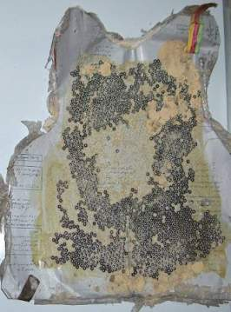
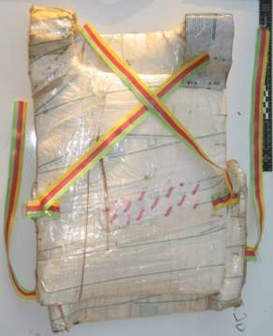
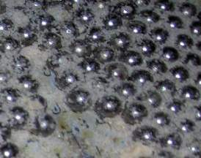

Figure 1. PBIED Design

4. EMPLOYMENT TECHNIQUES
IEDs can be used in a variety of ways. There are some TTPs that the enemy has used in order to hinder the mobility efforts of coalition forces, though enemy TTPs constantly change and adapt in an effort to stay ahead of coalition TTPs. The enemy also incorporates the use of small arms fire in conjunction with the IED attack to harass forces and increase the lethality of attacks.
Disguised static IEDs have been concealed with a variety of things (trash, boxes, tires, etc.) and placed in, on, above, or under where potential targets appear. Multiple IEDs have also been daisy chained, or linked together with detonation cord or electrical wire so that all charges detonate simultaneously, in order to achieve simultaneous explosions.
Thrown or projected IEDs (improvised grenades or mortars) have also been used against coalition forces. One TTP targets convoys as they drive under an overpass, attempting to drop IEDs in the back of vehicles as the pass under. Convoys must be aware of the 360-degree threat while traveling. Changing speeds and dispersion will help mitigate the threat to some extent.
Another example of how IEDs have been used is the hoax IED. These include something that resembles an actual IED, but has no charge or fully functioning initiator device. A fake IED along a given route and seen by the lead vehicle in a convoy will cause the convoy to come to a stop. Stopping for the hoax IED may leave the convoy in the kill zone of the real thing. Hoax IEDs are also used to learn coalition procedures, monitor time, delay or harass activities in support of the mission.
Other techniques used that are less specific include:
The Basic IED Attack - in the basic attack, the enemy will place IEDs along routes on either side of the road awaiting foot patrols or convoys to approach in order to cause the most damage to personnel or vehicles.
The "Broken-down" Vehicle Attack - this attack uses a simulated broken down vehicle placed on the side of the road to cause convoys to change their intended route. The broken down vehicle is staged along either side of the road, blocking one or all of the trafficable lanes. This causes the convoy to be directed between the broken down vehicle and an emplaced IED.
Coordinated Attack - numerous enemies work together to emplace an IED along a route, usually in an urban area. The enemy is usually located where they have the best escape route to not be seen or caught. Once the IEDs have been detonated, the enemy breaks contact and blends in with the population.
Ramming Convoys - the enemy has been known to ram their vehicle (possibly an SVBIED) in the rear of a convoy or to the side as they pass in order to get the convoy to slow or come to a complete stop.
Motorcycles - motorcycles are used by the enemy in areas of decreased mobility in order to harass convoys and possibly throw IEDs or grenades in the rear of vehicles.
5. OPERATIONS IN AN IED ENVIRONMENT
In order to counter the effects of an IED, there are several things that can be done. Wearing all personal protective gear available, to include ballistic eye protection, Kevlar helmets, body armor with plates, and hearing protection is the most basic. Other simple, but critical, force protective measures include wearing seatbelts when moving and ensuring all personnel have as much of their body inside the vehicle as possible to reduce the possibility of being struck by shrapnel or being exposed to the initial blast.
Pre-movement Rehearsals - operating units must be prepared to react quickly and efficiently to any attack. Study updated maps, as a significant number of IEDs are set up in the exact same location of previous attacks. Remember that IED attacks may be just one part of a complex attack. The unit must be prepared to react to any threat after the IED detonates and move out of the kill zone as quickly as possible.
Patrolling - one of the most important things you can do to protect yourself and your unit is to limit your predictability. Vary routes, movement techniques, and your TTPs for dealing with different situations. Never forget that the enemy is always watching. Patrols should change direction and speed at seemingly random intervals, especially in areas of previous IED attacks.
6. MITIGATING TACTICS TO COUNTER ATTACKS
There are certain things every member of the unit can do to counter specific attacks. Every member of the patrol should be alert and constantly aware of the situation around them. They should also know the authorized Escalation of Force (EOF) and Rules of Engagement (ROE). The actions listed below will help limit your vulnerability in specific situations:
Counter VBIED/SVBIED Techniques - the key to surviving a VBIED/SVBIED attack is standoff and cover. Know that an SVBIED can come from any direction. Units have been attacked by vehicles turning into a patrol from oncoming traffic, moving in a convoy, or in firm base attacks. Maintain an aggressive security posture and have a plan for dealing with civilian traffic. When dealing with VBIED/SVBIED attacks, it is important to:
- Have a plan to deal with approaching vehicles. Decide if they will be allowed to pass or not and have a plan for the EOF.
- Be aware of danger areas/choke points such as turnoffs that force patrol to slow down.
- Watch merging traffic as VBIEDs have been used near on and off ramps to get close to coalition vehicles.
Counter Suicide Bomber Techniques
- Evacuate the area immediately. Safe distances will depend on the mass of explosives carried by the bomber and the amount and type of fragmentation used.
- “Close and negotiate” tactics should not be attempted, as suicide bombers are usually trained to avoid surrender at all costs.
- A “fail safe” cell phone or radio-controlled initiator could be used in the event that the bomber is incapacitated or hesitates. This tactic would normally involve a second suspect with a line-of-sight view of the bomber and should always be considered.
- If a “deadly force” response is taken, bullet impact may initiate/detonate the explosive charge(s). Firing on the suspect should only be undertaken from protective cover.
- If the suspect is neutralized and there is no explosion, do not administer first aid. Wait for EOD to render safe the explosive charge.
7. ACTIONS AT HALTS
If a patrol or convoy must stop during movement avoid clustering vehicles and vary the vehicle interval between elements; establish your own local security and employ techniques to create standoff. Most importantly, do not remain at one site too long and conduct 5 to 25 meter checks as described below.
5 to 25 meter checks – depending on the length of time of the halt, the area to clear varies from 5 to 25 meters. At every halt, no matter how short, the crew must clear 5 meters around the vehicle while still inside the vehicle. For extended halts, teams must clear 25 meters around the patrol or convoy.
5 meter checks:
- Identify a position to halt.
- Visually check the area 5 meters around your vehicles.
- Look for disturbed earth and suspicious objects, loose bricks in walls, and security ties on streetlights or anything out of the ordinary.
- Start your search at ground level and continue up above head height. Then conduct a physical check for a radius of 5 meters around your position. Be systematic, take your time, and show curiosity. If the tactical situation permits, use a white light or infrared (IR) light at night.
- If in an armored vehicle, remain mounted during your 5 meter check to take advantage of the vehicle’s protection.
25 meter checks:
- Add to the 5 meter check when the patrol or convoy leader decides to occupy an area for any length of time.
- Once 5 meter checks are done, continue visually scanning out to 25 meters.
- Conduct a physical search for a radius of 25 meters around your position.
- Look for IED indicators and anything out of the ordinary.
8. ACTIONS ON CONTACT
Should you be part of a patrol or convoy that finds an IED, the five "Cs" will help to ensure that the situation can be dealt with quickly and safely. Remember, an IED that is found is still an IED attack. By finding the IED, you have just disrupted the enemy’s attack. Do not forget about the enemy’s other forms of attack, RPGs, small arms fire, mortars, and secondary IED. Enemy IED site = Enemy ambush site. You are in the kill zone!
IED’s Found Before Detonation - a simple set of guidelines that you should use when you encounter a suspected IED are the five "Cs":
Confirm - you should always assume the device will explode at any moment. From a safe distance, look for IED indicators while attempting to confirm the suspected IED. Use all tools at your disposal, to include moving to a better vantage point and using optics to look for tell-tale signs of an IED. Never ask civilians to remove an IED and do not attempt to do the job of Explosive Ordnance Disposal (EOD) or engineers.
Clear - evacuate the area to a safe distance (terrain will dictate) but do not set a pattern. Keep in mind some threats require more standoff than others. Assess whether your distance and cover is adequate and direct people out of the danger area. Sweep the area for any secondary devise or trigger person. Once scene is safe, question, search, and detain as needed. Do not allow anyone to enter your cordon other than those responsible for rendering the IED safe (EOD).
Call/Check - let your higher headquarters know what you have found. When you move to a new location, all personnel should conduct 5 and 25 meter checks for secondary IEDs. Always assume a found IED is bait and the real IED is near your “secure” location.
Cordon - establish blocking positions to prevent vehicle and foot traffic from approaching the IED. Establish 360 degree inner and outer cordon to secure and dominate the area. Most likely, the enemy is watching and waiting to make his move.
Control - control the area until EOD arrives. Clear and set up an entry control point (ECP) for first responders. Do not let others go forward to “inspect” the IED. Make contingency plans for coordinated attacks.
IED Detonation - immediate actions differ when an IED is actually detonated. The enemy may often combine the IED attack with a direct fire ambush to increase the lethality of the attack. If an ambush does accompany an IED attack, the priority shifts to address the direct fire and then conducting the 5 “Cs”. It is important to keep several things in mind when dealing with IED detonation:
- Respond quickly and aggressively in accordance with ROE
- Immediately scan outward. The biggest mistake Marines can make is focusing inwards toward the site of the IED detonation and forgetting about the enemy.
- Move out of kill zone
- Search for additional IED’s
- Treat/Evacuate casualties
- Report situation
- Expect follow-on attacks
Chemical IED - coalition forces have had several encounters with IEDs also having chemical filler in conjunction with the explosive. Due to the complexity of manufacturing exact payloads, the chemical effect is difficult to achieve. Units must be aware of the capabilities and know what to do in the event of a chemical attack. Specifically:
- Move upwind, to high ground at least 240 meters away from release point.
- Normal combat uniform provides some protection; individual protective suits, masks and gloves will provide additional protection.
Detectors will alarm, but best warning comes from your sense of sight and smell.
What NOT to do with Suspected IEDs
- Never approach a suspected IED. Establish standoff by using binoculars and spotting scopes from multiple angles to confirm the presence of an IED. When in doubt, back off and call EOD.
- Do not pick up detonation cord. Detonation cord is an explosive and the presence of it alone is enough to call EOD. Do not trace or pull on det cord.
- Do not directly trace command wire (CW). The enemy has placed trip wires and other IEDs under/in the vicinity of command wires. When a CW is located, rather than walking parallel to or over the wire to locate the initiation point, work in an “S” pattern, crossing the CW until the initiation point is located.
- Do not focus on the “found” IED. An IED, once found, is not going to move. Conduct secondary sweeps (5 to 25) and set in cordons. Always think a couple steps ahead and have a plan for any possible encounters that may arise. Again, once positive IED indicators are found, move to safe distances and call EOD.

REFERENCES
MCIP 3-17.01 Improvised Explosive Device Defeat
JIEDDTF 05-23 Joint IED Defeat Task Force Counter IED TTP
GTA 90-01-001 IED and Vehicular Borne IED Smart Card
MCWP 3-11.2 Marine Rifle Squad
IED Defeat Review

- List the three types of initiating systems found on IEDs.

- What is the primary indication of an IED?

- What is a 5 meter check? When is it performed?

4. List the five Cs relating to IED defeat.

