UNITED STATES MARINE CORPS
Field Medical Training Battalion – East
Camp Lejeune

FMST 1221

Employ the M-40 Field Protective Mask

Terminal Learning Objectives
- Given the current M-40 series field protective mask and carrier, spare parts, and cleaning materials, maintain the M-40 Field Protective mask, to ensure serviceability. (FMST-FP-1221)
- Given a tactical scenario in any combat environment, the current M-40 series field protective mask in its carrier and an NBC alert or an order to mask, don the M-40 field protective mask, to provide timely NBC protection. (FMST-FP-1222)
Enabling Learning Objectives
- Without the aid of references given a description or list, identify the components of the M-40 field protective mask, within 80% accuracy, per Unit Maintenance Manual for Chemical-Biological Mask M-40. (FMST-FP-1221a)
- Without the aid of references, given a description or list, identify the masking procedures of the M-40 Field Protective Mask, within 80% accuracy, per Unit Maintenance Manual for Chemical-Biological Mask M-40. (FMST-FP-1222a)
- Without the aid of references, given an M-40 field protective mask and exposure to irritant gas in a chamber or simulated combat environment, don and clear the mask, per Unit Maintenance Manual for Chemical-Biological Mask M-40. (FMST-FP-1222b)
- Without the aid of references, given a description or list, identify proper care techniques of the M-40 Field Protective Mask, within 80% accuracy, per Unit Maintenance Manual for Chemical-Biological Mask M-40. (FMST-FP-1221b)

- M-40 FIELD PROTECTIVE MASK (FPM)
Characteristics of the M-40 FPM
- The M-40 FPM is used to protect the individual’s face, eyes and lungs against field concentration of chemical and biological (CB) agents, toxins and radioactive fallout particles.
- The M-40 FPM will not protect the wearer against industrial gases such as ammonia or carbon monoxide. It is not effective in confined spaces, where the oxygen content of the air is low.
- The M-40 FPM allows the wearer the capability of drinking water while worn.
- The M-40 FPM comes in three sizes: small, medium and large. The size mark is located on the top left portion of the mask.
Components of the M-40 FPM
When you receive a FPM you should inspect the following components for serviceability (see figure 1):
Face-piece Assembly - foundation of the protective mask. Everything else is attached to it. The face-piece fits closely against your face to form a seal. It is made of silicone rubber. Visually inspect interior and exterior surfaces of face-piece for dirt, mud and greasy or oily substances. Check face-piece for holes, tears and splits by holding it in front of a light source. Look closely at edges of face-piece. Check for soft or sticky spots. Check silicone rubber next to eye lenses to be sure they will not pull away from the face piece. Also check all face-piece housings to be sure silicone is not pulling away.

Head Harness - these adjustable straps are attached to the face-piece. When adjusted properly, they will secure the face-piece to your face creating an airtight seal. It consists of a head pad; forehead straps, temple straps, cheek straps and donning tab. Check the head harness for loss of elasticity and dirt. Check straps for cuts, tears, missing parts or deterioration such as mildewing or fraying. Look at the buckles for bends, cracks or corrosion. Check for missing or broken buckles. Make sure finish on buckles is not chipped or scratched exposing bare metal.

Eye-lenses, Eye-rings and Out-serts - made of clear plastic or ballistic glass and enable you to see clearly while wearing the mask. Check eye-lenses for cracks, scratches, or discoloration that affect vision. Check eye-rings for distortion or corrosion. Clear and neutral gray eye lenses out-serts are provided with the mask. The purpose of the out-sert is to protect the eye-lens from damage and to reduce fogging in cold weather, neutral gray out-serts reduce glare. There are separate out-serts for left and right eye-lenses. To install the out-sert, fold back the rubber apron, place it over the eye-lens and fold the apron back into place. Check both sets of out-serts for cracks, chips or discoloration that affects your vision. Check rubber aprons for tears, looseness, brittle spots, soft or sticky spots or cracked rims.

Canister - filters chemical and biological agents and other particles from contaminated air. It can be quickly and easily replaced and may be installed on either side of the face-piece to allow use by left-handed or right-handed shooters. Do not allow the inside of the canister to become wet. A wet canister is useless. Check the canister, especially around the seams, for cracks, dents, or holes and damaged threads. Ensure the air intake is not clogged with dirt. Shake the canister and listen for any signs of loose absorbent particles. The canister is installed into the side port of the face piece, over the inlet valve. Tighten the canister hand tight by turning clockwise.

Outlet Valve Disk and Outlet Valve Cover - releases exhaled air and prevents unfiltered air from entering the face-piece. Do not use the mask if the outlet valve disk is missing or damaged because the face-piece will leak. The outlet valve cover protects the outlet valve disk and secures the external drinking tube. To check the outlet valve disk, grasp the tab on the bottom of the outlet valve cover and lift. Check to see if the outlet valve disk is present and is not curled or distorted. Place your thumb on the disk and rotate it to make sure it is not sticking. Do not remove the outlet valve disk from the outlet valve. Look at the disk for nicks, tears, or rips. Wipe off any moisture with a clean cloth. Check the outlet valve seat for dirt. Smooth the outlet valve disk so it lies flat on the outlet valve seat. Check the outlet valve cover for cuts, tears, or holes. Look at the inside of the outlet valve cover for dirt or moisture.

Internal/External Drink Tubes - the M-40 Field Protective Mask is equipped with a system which allows the wearer to drink while wearing the face-piece. The internal tube is grasped by the person’s mouth. The external tube has a quick disconnect coupling which connects the face-piece to the NBC Canteen Cap. Check that both tubes are present and are free of cracks or cuts. Ensure the internal drink tube has proper alignment and the external drink tube has solid connections. Connect the coupling to the canteen cap and blow air through the system to ensure it is not clogged.

Airflow Deflector - located on the inside of the face-piece below either the left or right eye lens depending on the canister location. It directs inhaled air over the eye lenses to prevent fogging. Check that the airflow deflector is securely mounted inside the face-piece and that both flanges are in the mounting holes of the face- piece and are not broken. Check the mounting holes for cuts or tears.

Inlet Valve Disk - allows filtered air to enter the face-piece and prevents moist exhaled air from entering the canister. Do not use the mask if the valve body or inlet valve disk is missing. Check that the inlet valve disk and valve body are properly mounted on the airflow deflector post. Blow on the disk to make sure it is not stuck to the valve body. Ensure the disk is free of cuts, holes, tears or dirt.

Nose-cup Assembly - inside the face-piece is the nose-cup. It has one nose-cup valve disk on each side. The nose-cup allows filtered air to pass through the nose-cup valve disks and into your respiratory system from the upper part of the face-piece and directs exhaled air out through the outlet valve in the bottom of the face-piece. This ensures good airflow, which prevents moist exhaled air from fogging the eye lenses in cold weather. Check that the nose-cup and nose-cup valve seats are free of dirt, cracks, cuts, holes, or tears. Check that the nose-cup is securely attached to the back of the face-piece by gently pulling it away. Rotate the nose-cup valve disks to be sure they are not stuck and check them for curling or tears. Smooth the nose-cup valve disks over the nose-cup valves.

Voicemitter - the face-piece is equipped with a front voice-mitter, which transmits the user’s voice outside the face-piece and a side voicemitter, located opposite the inlet valve, which aids in the use of communications equipment. Check the retaining rings around both for corrosion, cracks, or nicks. Try to tighten the retaining rings by hand to check for looseness. Ensure both voicemitters are free of dents, cracks, punctures, or dirt and that the four beads in the center of each voicemitter are facing outward.

Carrier - provides for storage, protection, and carrying of the mask and additionally authorized items. Check carrier for dirt, sharp edges, torn straps, broken stitches on seams, or missing hardware. Make sure there are no pencil or pen markings on the carrier. Mildew, solvents, or abrasive materials on carrier may harm the face-piece. Check the Velcro for dirt or debris. Check metal hooks and D-rings for bends or breaks that make them unusable.

Waterproof Bag - keeps the mask dry when required by climate or mission. It includes rubber bands for sealing and instructions for use. Storage of the mask in waterproof bag can degrade the protective capabilities of the face-piece. You must remove the face-piece as soon as protection of the mask is no longer required. Check the waterproof bag for cracks, tears, holes, and brittleness. Food should not come in contact with the waterproof bag because of possible toxic effects. It is stowed in the left end pocket of the carrier.

Face form - maintains mask shape 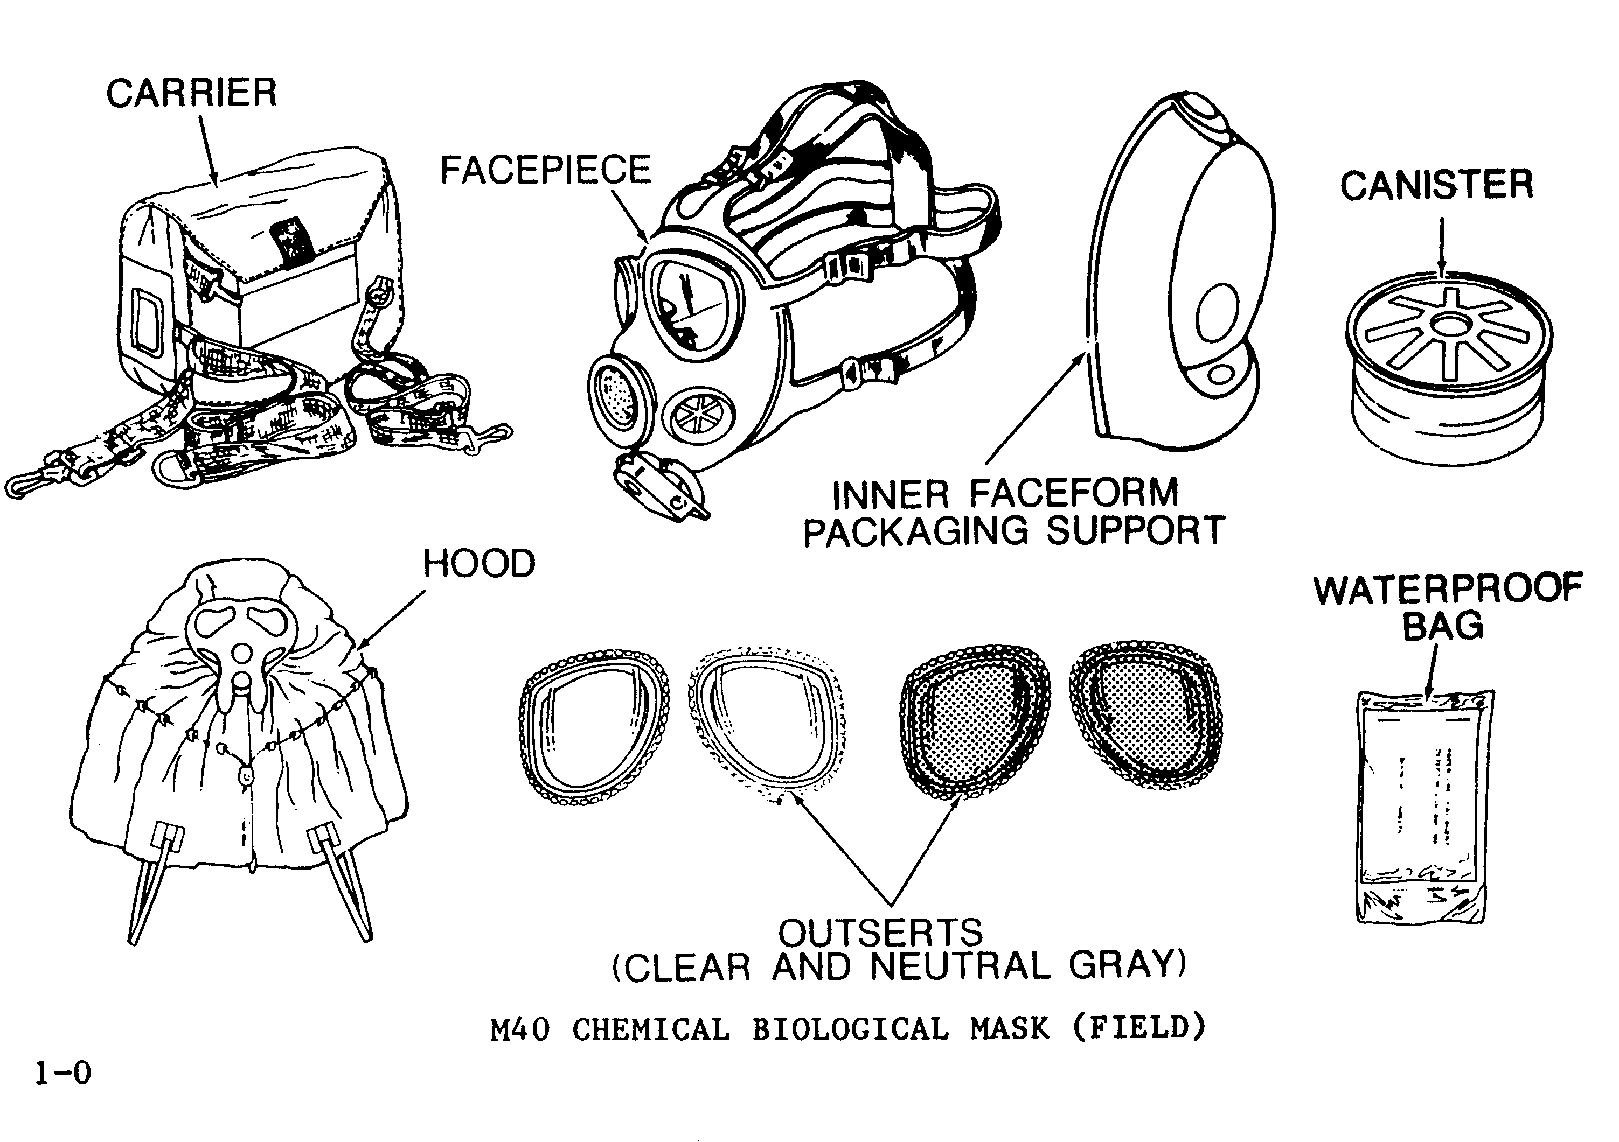
Figure 1. Components of the M-40 FPM

Accessories of the M-40 FPM
M1 canteen cap - contains a hole that allows the external drinking tube to be connected to the canteen. Always check that the surfaces are free of contamination before connecting the drinking system.
M291 decontaminating kit - used for personal decontamination. It will be discussed further during the lesson covering MOPP Gear (FMST 1223).
Optical inserts - available by medical prescription for personnel who must wear glasses. Do not wear eyeglasses or contact lenses with your mask. Check you inserts for broken lenses, frame, loose screws, or becoming disconnected from the face-piece.

2. USING THE DRINKING SYSTEM OF THE M-40 FPM

Prior to using the drinking system, use M8 chemical agent detector paper to check for contamination. If contamination is detected, decontaminate the drinking tube and the M1 canteen cap with the M291 decontamination kit. After decontamination, recheck the surfaces with M8 chemical agent detector paper.

- By pressing in on the top of the outlet valve, the internal drinking tube can be grasped between your teeth (See figure 2a)

- Pull the quick connect coupling out of the outlet valve cover (See figure 2b)

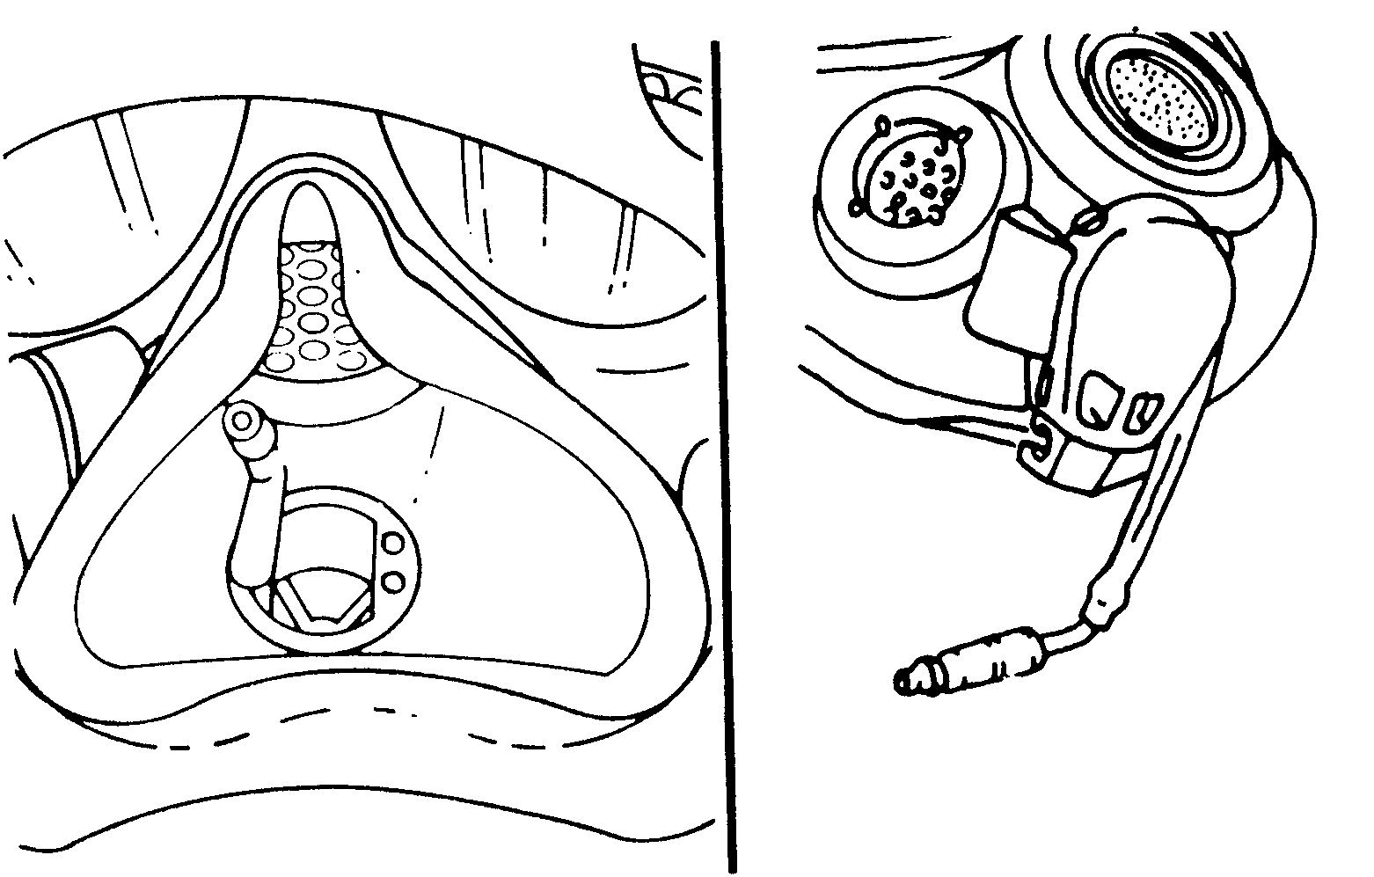
Figure 2a Figure 2b
- Remove the cap cover from the canteen cap (decontaminate if necessary)

- With the canteen right side up, insert the quick connect coupling into the M1 canteen cap and blow air into the drinking system to create positive pressure within the canteen (See figure 3)

- Raise and invert the canteen and begin drinking water

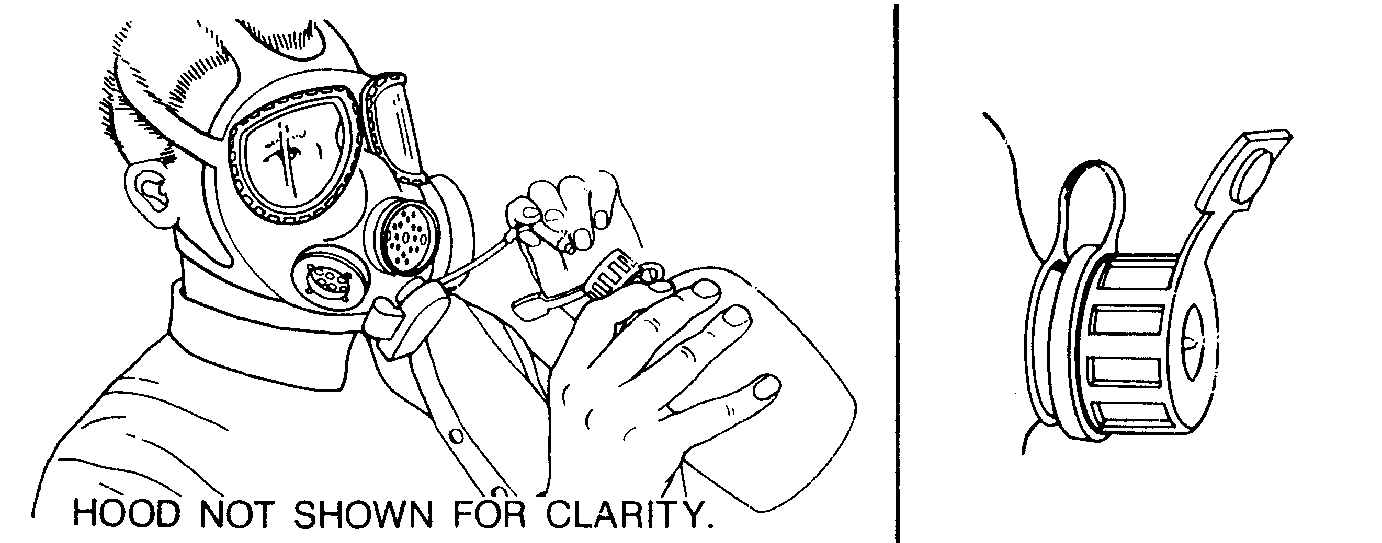
Figure 3
3. FITTING THE M-40 FIELD PROTECTIVE MASK
Before the mask can be donned and cleared, adjustments must be made to the head harness so that it fits properly. The adjustment steps are:
- Completely loosen all head harness straps and pull the head harness over the front of the face-piece.
- Put your chin in the pocket and hold the face-piece against your face.
- Grasp the donning tab and pull the head harness over your head. Be sure your ears are between the temple and cheek straps.
- Be sure that the head harness pad is centered at the back of your head. Straps should lie flat against your head.
- Tighten the straps with short-jerky pulls to the rear in the following sequence: forehead straps, cheek straps, and temple straps. Ensure the head harness pad stays centered at the back of your head.
- Cover openings at bottom of the outlet valve with palm of one hand. Breathe out hard so that air escapes around edges of face-piece.
- With the palm of your free hand, cover the inlet port of the canister and breathe in. The face-piece should collapse against your face, and remain so while you hold your breath. If it does, the face-piece is airtight. If the face-piece does not collapse, check for hair, clothing, or other matter between the face-piece and your face. Check that the head harness straps are not twisted or that the head pad is not centered.
- Clear your face-piece again and recheck for leaks.
- To remove your face-piece, loosen the cheek straps only. Place one hand on front of voicemitter to hold face-piece on face with the other hand grasp the donning tab and pull the head harness over the front of the face-piece and remove face-piece.
Masking Procedures - when the verbal “GAS! GAS! GAS!” or visual signal sign for an NBC attack has been given, you must follow these procedures in a time limit of 9 seconds without hood or 15 seconds with hood or risk becoming contaminated.
- Stop breathing and close your eyes.
- Open carrier and grab the face-piece. The mask is stored with the head harness pulled over the front of the mask.
- Place your chin in chin-pocket of the face-piece.
- Clear the field protective mask
- Cover the outlet valve with the palm of one hand.
- Exhale sharply so that the air escapes around the edges of the face-piece
- Cover the air inlet port of the canister with the palm of your free hand, and breathe in. The face piece should collapse against your face and remain there while holding your breath. If the face piece collapses consider it airtight.
- Grasp the tab and tighten straps and adjust. Make sure the square harness patch is centered in the rear of your head.
- Resume breathing.
- After completing these steps the following actions should be taken:
(1) Put on your helmet. Be sure not to upset the seal between your face-piece and the side of your face when putting on helmet.
(2) Close the carrier.
(3) Continue your mission.

Unmasking - remove your mask only when competent authority issues the “UNMASK” command. The following steps accomplish this:
- Hold your rifle between your legs; remove your helmet placing it on the ground next to you.
- Loosen cheek straps.
- Place one hand on the front of the voice-mitter-emitter to hold the face-piece on your face and with the other hand grasp the donning tab and pull the head harness over the front of the face-piece and remove the face piece. Put your helmet back on your head.
- Continue your mission.
- CARE OF THE GAS MASK
Stowing the M-40 FPM - properly stowing the mask will ensure that it remains serviceable and easily accessible when your life depends on it. The following steps will be used when stowing the mask in the M-40 Carrier:
- Check that the eye-lens out-serts are installed on the face-piece. Abrasives, such as sand and grit, will scratch the eye lenses.
- Check that your face-piece is dry and free of oils and solvents before stowing.
- Check that the interior of the carrier is free of dirt and trash or other unauthorized items.
- Hold face-piece in a horizontal position.
- Pull head harness over front of face-piece.
- Hold the face-piece upright and put it in the carrier with the lenses facing away from your body.
- Stow your other out-serts, waterproof bag, and operator’s manual in the inside pockets of the carrier.
- Close the carrier.
- Store your face-piece in its carrier and put it in a cool, dry, dark place, preferably hooking it on the short strap.
Wearing Your Carrier
There are three ways to carry the M-40 Field Protective Mask and Carrier:
- The shoulder carry.
- The leg carry. The following steps will be used:
- Put waist strap D-ring around waist and attach to hook on carrier. Adjust strap.
- Bring leg strap from back and around inside of leg.
- Pass leg strap through round ring, hook to D-ring, and adjust strap.
- The pistol belt carry.
Cleaning the M-40 FPM
- Wash mask anytime it needs cleaning. A white or rust colored waxy film is not dirt; it is from the preservatives built in the rubber. It will bleed off as long as the face-piece is good.
- Required materials: soft cloths, soft bristle brushes, warm soapy water, and warm clear water.
- Procedural Steps:
-Remove the canister by unscrewing it from mask.
- Dip clean, soft cloth in warm soapy water and wring it out. Wash mask inside and out. Wash voicemitter, outlet valve cover, and inlet valve assemblies. Be careful with rubber disks.
- Rinse cloth in clear, warm water and wring it out. Wipe all washed parts.
- Dry all parts and mask with dry, soft cloth. Use brush in hard to reach areas.
- Replace parts taken off. Make sure rubber disks are snug and flat. Clean the lenses using polish or warm, soapy water.
Canister Replacement
Replace the canister if:
- It has been immersed in water.
- Canister has splits, or cuts, a bent or split thread connector, or has been crushed.
- You feel excessive resistance to breathing and inspection shows that the canister is clogged with foreign matter.
- After removing the face-piece you see charcoal dust on your face.
- Your unit commander directs replacement of canister.
- The filter lot becomes unserviceable.
- Every 30 days after initiation to toxic chemical operations and after each confirmed blood agent attack.

REFERENCES
Unit Maintenance Manual for Chemical-Biological Mask M-40, TM 09204A/09205A-20&P/4
M-40 Review

1. Describe the problem with allowing water to get inside the canister.

- List three accessory items associated with the M-40 Field Protective Mask.

- Identify the first step in donning your gas mask once you have received word of possible contamination.

4. Once the order is given to don mask, how long do you have to don your gas mask without a hood. What about with a hood?

