UNITED STATES MARINE CORPS
Field Medical Training Battalion – East
Camp Lejeune
FMST 1407
Manage Musculoskeletal Injuries

TERMINAL LEARNING OBJECTIVES
1. Given a casualty with musculoskeletal injuies in a combat environment and standard field medical equipment and supplies, manage musculoskeletal injuries, to prevent further injury or death. (FMST-HSS-1407)

ENABLING LEARNING OBJECTIVES
- Without the aid of references, given a description or list, identify the anatomy of the musculoskeletal system, within 80% accuracy, per Pre-Hospital Trauma Life Support, Military Edition, 6th Ed, Chapter 12. (FMST-HSS-1407a)
- Without the aid of references, given a description or list, identify types of musculoskeletal injuries, within 80% accuracy, per Pre-Hospital Trauma Life Support, Military Edition, 6th Ed, Chapter 12. (FMST-HSS-1407b)
- Without the aid of references, given a description or list, identify treatments for musculoskeletal injuries, within 80% accuracy, per Pre-Hospital Trauma Life Support, Military Edition, 6th Ed, Chapter 12. (FMST-HSS-1407c)
- Without the aid of references, given a description or list, identify the general rules for splinting, within 80% accuracy, per Pre-Hospital Trauma Life Support, Military Edition, 6th Ed, Chapter 12. (FMST-HSS-1407d)
- Without the aid of references, given a description or list, identify types of splints, within 80% accuracy, per Pre-Hospital Trauma Life Support, Military Edition, 6th Ed, Chapter 12 . (FMST-HSS-1407e)
- Without the aid of references, given a simulated casualty with musculoskeletal injuries and standard field medical equipment and supplies, manage the casualty, per Pre-Hospital Trauma Life Support, Military Edition, 6th Ed, Chapter 12. (FMST-HSS-1407f)

- ANATOMY
The Skeletal System - composed of all the bones, joints and muscles of the body, as well as cartilage, tendons and ligaments. Bones are formed of dense connective tissue. As components of the skeleton, they provide the body’s framework. They are strong in order to provide support and protection for the internal organs, but they are also flexible to withstand stress.
Axial Skeleton - consists of the skull, spinal column, and rib cage.
Appendicular Skeleton - consists of the upper extremities to include the scapula and bones of the lower extremities to include the pelvic girdle
Appendages:
Upper extremities - made up of the humerus, ulna, radius and bones of the wrist and hand
Lower extremities - made up of the femur, tibia, fibula and bones of the ankles and feet
Types of Bones - there are four types of bones that are classified by shape (see figure 1):
Long bones - such as the femur and humerus
Short bones - such as the wrist and ankle bones
Irregular bones - such as vertebrae, mandible and pelvic bone
Flat bones - such as the sternum and skull

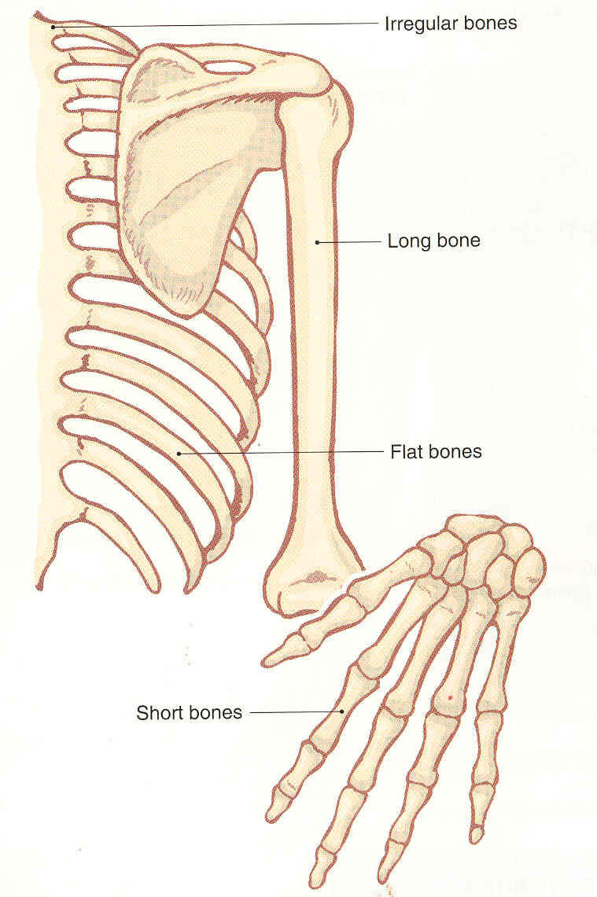

Figure 1. Bones Classified By Shape

Muscular System

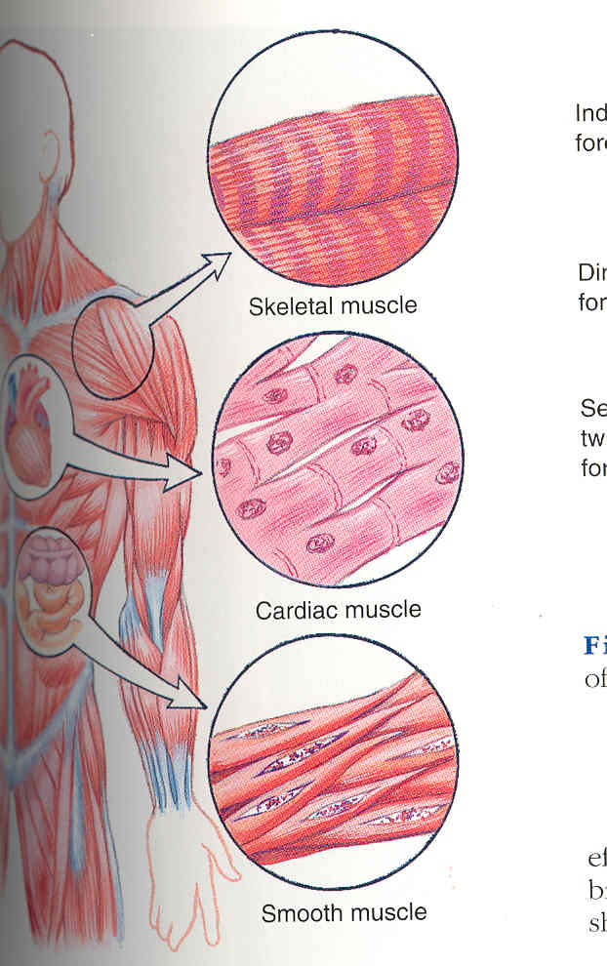
Muscles - tissue fibers that cause movement of body parts or organs. There are three kinds of muscles (see figure 2).

Skeletal (voluntary)
Smooth (involuntary)
Cardiac (myocardium)

Figure 2. Three Types Of Muscle

Cartilage - connective tissue covering the outside of bone ends and act as a surface for articulation
Tendons - bands of connective tissue that bind the muscle to bones
Ligaments - connective tissues that support joints by attaching the bone ends and allowing for stable range of motion (see figure 3)

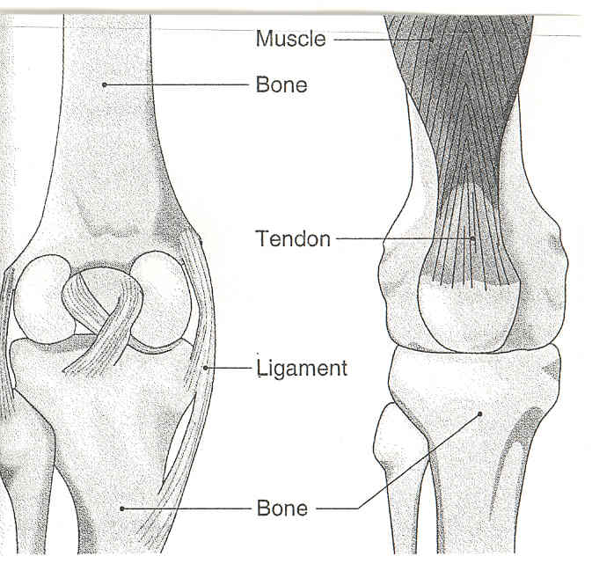

Figure 3. Tendons and Ligaments

- TYPES OF MUSCULOSKELETAL INJURIES

Soft Tissue Injuries - involve the skin and underlying musculature, commonly referred to as either a closed or open wound.

Closed - an injury where there is no open pathway from the outside to the injured site (see figure 4)

Open - an injury in which the skin is interrupted or broken, exposing the tissues underneath (see figure 5). Open wounds include abrasions, lacerations, avulsions and amputations.

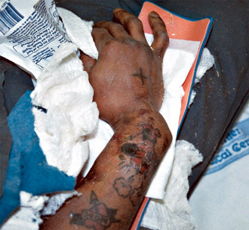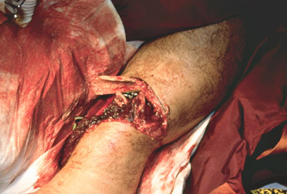

Figure 4. Closed Wound Figure 5. Open Wound

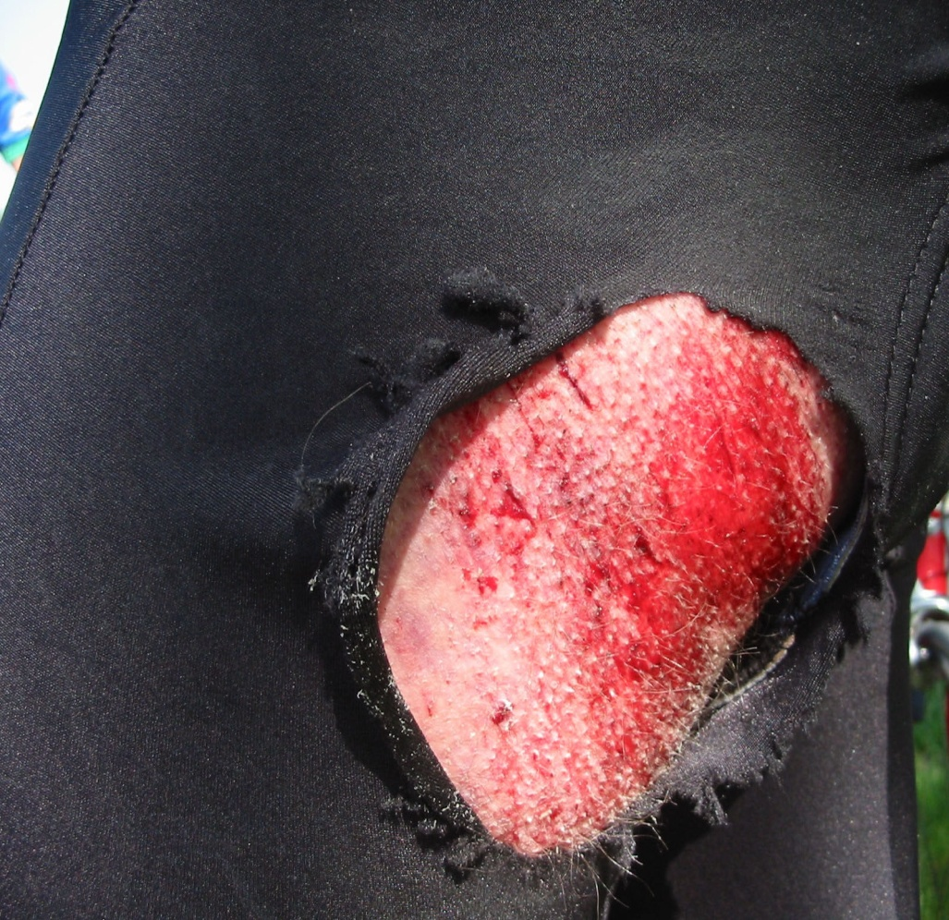
Abrasions

Figure 6. Abrasion

Definition - superficial scratches of the skin’s surface. Also called "brush burns," "mat burns," and “road rash." Some bleeding may result, but usually oozes from injured capillaries. Extremely painful because nerve endings are involved (see figure 6).
Treatment:
- Hemorrhage is usually so minimal that primary treatment may only require cleansing of the wound.
- Small bandages may be applied but tactical situations will usually preclude applying field dressings that are needed for more serious injuries.
Figure 6. Abrasion
- A large amount of dirt may be ground into the wound, therefore secondary treatment measures should focus on preventing or stopping infections.

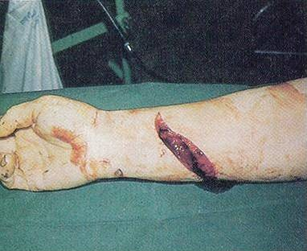
Lacerations
Definition - a laceration is a cut. It may be smooth or jagged and can be caused by an object with a sharp edge or may result from a severe blow or impact with a blunt object (see figure 7).
Treatment - treatment is generally the same as for abrasions:
- Control hemorrhage
- If major tendons and muscles are completely severed, immobilize limb to prevent further damage.

Figure 7. Laceration of the Lower Arm

- Treat for shock
- Consider CASEVAC

Avulsion

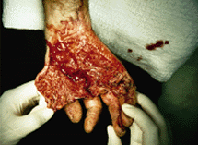
Definition - an injury in which flaps of skin are torn loose or completely pulled off (see figure 8).
Treatment
- Control bleeding
- Apply field dressing to avulsed area (For extremely large or deep avulsions, several pressure dressings may be necessary or an air splint and dressing).
- Prevent further contamination
- Ensure avulsed flap is lying flat and that it is aligned in its normal position
Figure 8. Avulsion of the palm
- If the avulsed part is completely pulled off, make every effort to preserve it. Wrap the part in a saline or water soaked field dressing, pack wrapped part in ice, and whenever possible be careful to avoid direct contact between the tissue and ice.
- Transport the avulsed part to the BAS with the patient but keep it well-protected from further damage and out of view of the patient
- Immobilize extremity or body part as indicated by the severity of the avulsion

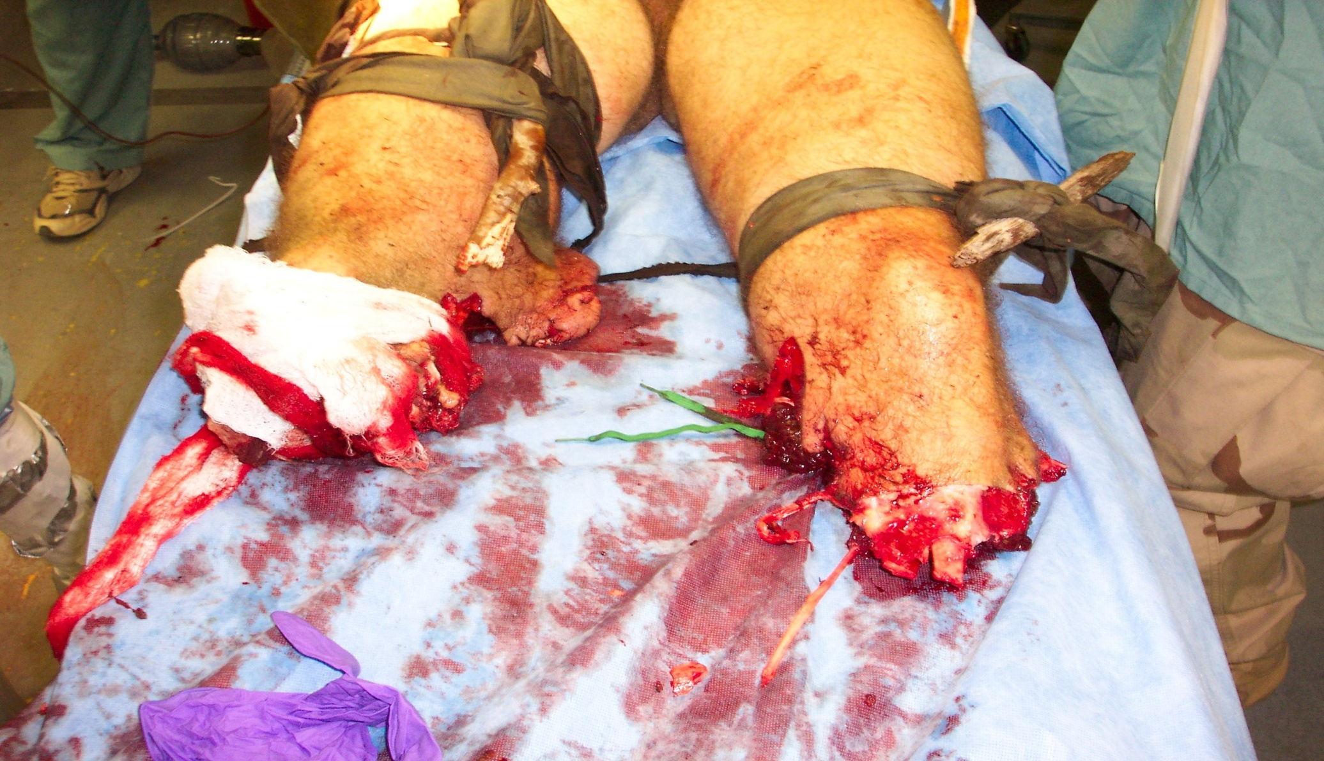
Amputations
Definition - removal of a limb or other appendage of the body. May be removed surgically or traumatically. Because blood vessels are elastic, they tend to spasm and retract into surrounding tissue. With complete amputations there is less bleeding then with partial or degloving cases (see figure 9).

Figure 9. Traumatic amputation of the lower legs.

Treatment
- Hemorrhage Control - Apply a tourniquet. If a tourniquet is applied, mark the patient's forehead with a "T" (indicating the time it was applied)
- Place the patient in shock position (Head down, feet elevated)
- Make every effort to preserve the amputated part and evacuate the patient as soon as possible
- Wrap amputated part in sterile dressing, place in ice and send with patient. When possible, prevent direct contact between tissue and ice.

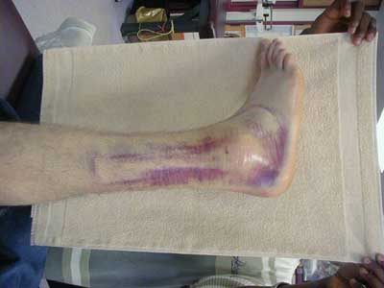
Strains, Sprains and Dislocations
Strain - injury to a muscle or tendon resulting from over stretching or overexertion
Sprain - a joint injury resulting in partial
tearing or stretching of supporting ligaments (see figure 10)
Dislocation - the displacement of bone ends at the joints resulting in an abnormal stretching of the ligaments around the joints. Sometimes causes tearing or complete ligament separation (see figure 11)
Signs and Symptoms
- Point tenderness or burning sensation
- Marked deformity of joint
Figure 10. Ankle Ligament Sprain

- Pain and edema
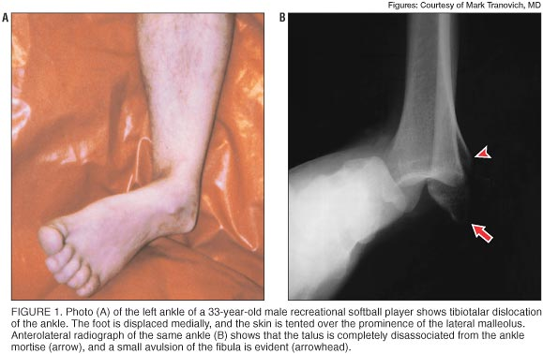
- Complete or near complete loss of movement of joint
Treatment

Strains Sprains:
- Supportive strapping or bandaging
- Immobilize by splinting so that affected muscle is in relaxed position, if injury is severe
-R.I.C.E. (Rest, Ice, Compression, Elevation)

Dislocations:

Figure 11. Ankle Dislocation

- Attempt to reduce only if no pulse is present in the extremity. If patient can be CASEVAC’ed quickly, the better decision may be to transport rather than attempt manipulation.
- Splint, as found, to immobilize injured part.
- Pain management
- CASEVAC
Complications
Hemorrhage - caused by separated bone ends tearing muscle tissue and laceration of blood vessels
Nerve Damage - due to the cutting or pinching of nerves by seperated bone ends or muscle injury

Fractures

Definition - a break in the continuity of the bone. This may result in partial or complete disruption of the bone. May be classified as either open or closed (see figure 12):
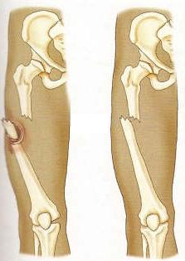
Open fracture - initial injury or bone end has produced an open wound at or near the fracture site.
Closed fracture - the bone is broken with no skin penetration
Signs and Symptoms
Open
Closed
- Discoloration
- Deformity
- Edema
- Crepitus/grating
- Point tenderness
- Limited range of motion
- Direct or indirect pain
Figure 12. Open/Closed Fracture
- Exposed bone fragments (open fractures)
General Principles of Treatment for Fractures - the following
guidelines can be applied to any type of fracture, regardless of location:
- Treat associated injuries

- Control hemorrhage
- Treat for shock
- Check distal pulses before and after splinting
- Immobilize the fracture using splints
- Recheck PMS (pulse, motor, and sensation)
- Relieve pain (see medication appendix at the back of Block 2 for more information)
- DO NOT reduce fractures in field unless distal pulses are not present
- Monitor and CASEVAC

- SPLINTS AND SPLINTING

Definition - an appliance made of wood, metal or plaster used for the fixation, union or protection of an injured part of the body.
Purpose
- To immobilize the injured body part
- To prevent further damage to muscles, nerves, or blood vessels caused by broken ends of bone
- To prevent a closed fracture from converting to an open fracture
- To decrease pain

General Rules for Splinting
- Control hemorrhage. Direct pressure and/or pressure dressings will control virtually all external hemorrhage encountered in the field.
- Expose fracture site. Remove jewelry and watches.
- Before splinting, establish distal pulse.
- Splint in the position found unless limb is pulse-less.
- An attempt should be made to straighten a SEVERELY deformed limb with gentle traction only if there are no distal pulses, if resistance is felt, stop and splint as it lies.
- Move the fractured part as little as possible while applying the splint.
- DO NOT retract the exposed bone of an open fracture back into the body.
- Pad splint at bony prominence points (elbow, wrist and ankle).
- Splint the joints above and below the fracture site.
- Reassess circulation and neurological status after splinting.
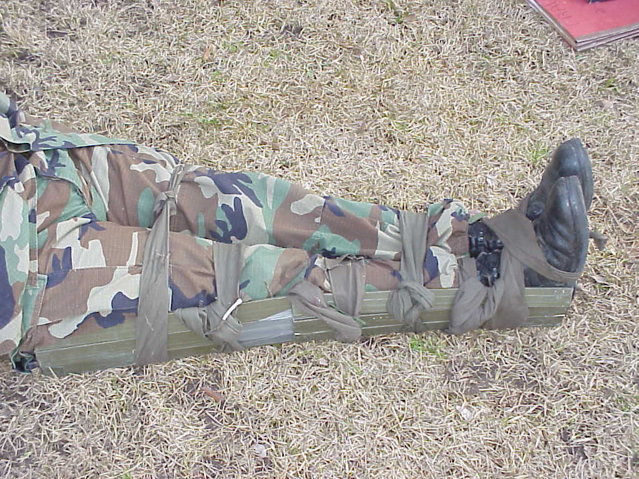
- When in doubt treat as a fracture.

Anatomical Splints - use of the patient's body as a splint (see figure 13).
- Strap legs together
- Secure arm to chest
- Secure arm to the body (for fractured arm/ribs)
- Tape fingers together
Figure 13. Anatomical Splint
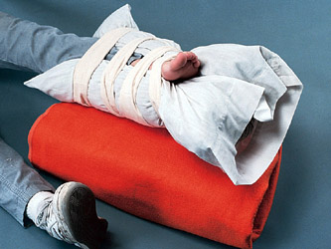
Improvised Splints - made from any available material that can be used to stabilize a fracture. The only limitation to improvised splinting is your imagination and creativity (i.e. sticks/branches, blankets, tent poles, see figure 14)
Manufactured Splints - manufactured splints are generally designed for specific injuries, thus they are applied in specific ways

Soft Splint - the soft splint can be used to splint various fractures throughout the body (see figure 14)
Purpose - used to immobilize fractures and suspected fractures of the neck, back, arms, and legs
Figure 14. Improvised/ Soft Splint
Description - a wrap around, non-rigid splint that limits motion in the area applied
commonly made from items such as pillows, ponchos, and blankets
Rigid Splint/ SAM Splint
Purpose - used to immobilize suspected fractures
Description - a rigid splint that prohibits motion in the area applied
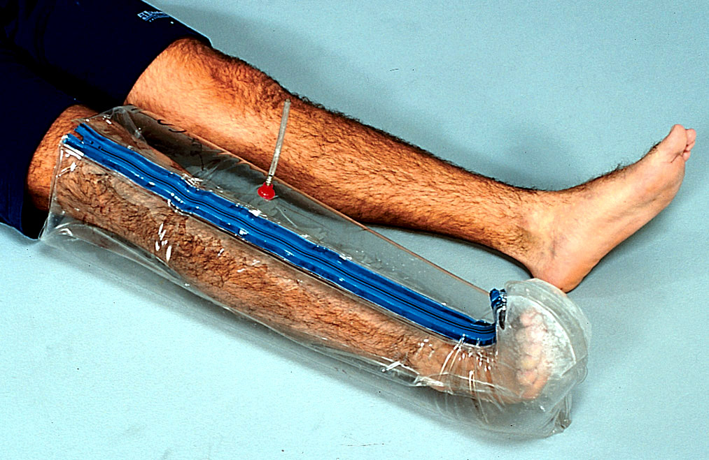
Air Splints
Purpose - used to immobilize arms and legs (see figure 15)
Description - a pre-formed, one piece, clear plastic, balloon-like envelope with a zipper, string, velcro or combination of these for closure
- If splint is used in aircraft, some air may have to be released as plane gains altitude
- This splint is inflatable (be careful not to over inflate the splint)
Figure 15. Air Splint

Splinting for Specific Types of Fractures

Fractured Clavicle - immobilize using a figure eight bandage

Fractured Humerus - splint to body using full arm wrap leaving elbow exposed

Fractured Radius/Ulna
- Splint from wrist to elbow
- Place patient's hand in top of jacket for elevation and support
- Sling arm using a cravat to cradle elbow and tie around neck for immobilization

Fractured Wrist/Hand
- Splint in position of function, leaving fingers exposed to check circulation
- Place patient's hand in top of jacket for elevation and support
Fractured Ribs
- Single closed rib fractures - do not bind or strap around chest
- Multiple fractures - immoblize flailed segments, do not hinder breathing. Sling and swathe arm to injured side of chest to reduce motion and pain. Do not hinder breathing!

Fractured Pelvis - consider wrapping bed sheet tightly around lower aspect of pelvis and tying it as a sling
- Strap knees and ankles together
- Place pad around bony prominences and soft pad under knees

Fractured Femur - immobilize fractured leg by splinting one leg to the other with five ties
- One above wound
- One below wound
- One above the knees
- One below the knees
- One around feet to secure ankles/boots

Fractured Patella - splint to other leg using four ties:

- One around the thighs

- One above the knee

- One below the knee

- One around the ankles

Fractured Tibia/Fibula - splint one leg to the other with four cravats or improvised ties:
- One above wound.
- One below wound.
- One around the thighs
- One around feet to secure ankles/boots

Fractures of Ankle/Foot - immobilize using soft splint or uninjured extremity and four cravats:

- One above the ankle

- Figure eight bandage around the ankles

- One below the knee

- One above the knee

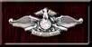 CASUALTY ASSESSMENT AND MUSCULOSKELETAL INJURIES
Care Under Fire Phase: If the casualty has a life-threatening hemorrhage, use a tourniquet for extremity injury or direct pressure for non extremity injuries.

Tactical Field Care Phase: During this phase, you will be required to inspect the injury using DCAP-BTLS for any signs of injury. Don BSI. Note and treat all musculoskeletal injuries. Complete a head to toe assessment using DCAP-BTLS noting and treating additional injuries. Determine if vascular access is required (see Tactical Fluid Resuscitation lesson) and give fluids if necessary. If the casualty is able to drink fluids, they should be encouraged to do so. Consider pain medications and give antibiotics if warranted. Reassess all care provided. Document care given, prevent hypothermia, and CASEVAC.

REFERENCE
Pre-Hospital Trauma Life Support, Military Edition, 6th Ed, Chapter 12
Musculoskeletal Injuries Review
1. Define an open injury and list four examples.

- Describe the differences between a complete amputation and a partial amputation.

- List the first four general rules of splinting.

4. Identify the appropriate treatment for a fractured pelvis.

