UNITED STATES MARINE CORPS

Field Medical Training Battalion – East

Camp Lejeune

FMST 1211

Land Navigation

TERMINAL LEARNING OBJECTIVES
- Given a minimum of a 1:50000 military map, a coordinate scale, protractor, paper, and pencil in a field environment, perform basic map reading, to meet mission requirements. (FMST-FP-1211)
- Given a tactical scenario in any combat environment, a lensatic compass, and a minimum of a 1:50000 military map, navigate with a map and compass to meet mission requirements. (FMST-FP-1212)
ENABLING LEARNING OBJECTIVES
- Without the aid of references, given a list, identify the purpose of a military map, per the student handout. (FMST-FP-1211a).
- Without the aid of references, given a list, identify the purpose of the five basic colors on a map, per the student handout. (FMST-FP-1211b).
- Without the aid of references, given a list, identify the purpose of contour lines on a military map, per the student handout. (FMST-FP-1211c).
- Without the aid of references, given a list, identify the parts of a lensatic compass, per the student handout. (FMST-FP-1211d).
- Without the aid of references, given a military map, protractor, and compass, and a set of eight-digit grid coordinates, locate a position on a map, per the student handout. (FMST-FP-1211e)
- Without the aid of references, given a list to choose from, compute a back azimuth, per the student handout. (FMST-FP-1211f)
- Without the aid of references, given a description, identify methods used to hold a lensatic compass, per the student handout. (FMST-FP-1211g)
- Without the aid of references, given a military map, a lensatic compass, and a minimum of an eight-digit grid coordinate, locate specific points on the land navigation course, per the student handout. (FMST-FP-1212a)
- Without the aid of references, given a description, identify the methods used to orient a military map, per the student handout. (FMST-FP-1212b)
- THE MAP
Purpose - the purpose of a map is to provide information on the existence, the location, and the distance between ground features.
Definition - a geographic representation of the earth’s surface drawn to scale as seen from above.
- Shows us what an area actually looks like without being there
- A clear and handy reference tool
Characteristics of a Map
- Designed to show us common information
- Location of ground objects
- Populated areas
- Routes of travel
- Communication Lines
- Extent of vegetation cover
- Elevation and relief of the earth's surface
Care and Importance
Maps are printed on paper and require protection from water, mud and tearing. When you mark on your map, use lighter lines, which are easily erased, without smearing. If trimming the map, be careful not to cut any of the marginal information. Maps must be protected because they can hold tactical information, such as:
- Friendly positions
- Friendly supply points

Map Illustrations

Symbols

- The mapmaker uses standard symbols

- They represent natural and manmade features

- Resemble as closely as possible, the actual features but as viewed from above

Map Colors - to ease the identification of features on the map, the topographic symbols are usually printed in different colors, with each color identifying a class of features. The colors vary with different types of maps, but on a standard, large scale, topographic map, there are five basic colors.

Black - used to identify the majority of cultural or man-made features, such as buildings, bridges, and roads not shown in red

Red - main roads built up areas, and special features such as dangerous or restricted areas

Blue - is for water features: lakes, rivers, swamps, and streams

Green - identifies vegetation such as woods and orchards

Red Brown - all landforms such as contours, fills, and cuts
NOTE: Occasionally other colors may be used to show special information. These, as a rule, will be indicated in the margin of information.

Marginal Information - instructions that are placed around the outer edges of the map are known as margin of information. All maps are not the same, so every time a different map is used, you must examine the margin of information carefully:
Sheet Name - found in two places: The center of the upper margin and the lower right margin
Contour Interval - appears in the center lower margin and states the vertical distance between adjacent contour lines on the map
Grid Box - gives basic instruction on reading grids in determination

Declination Diagram - located in the lower margin and indicates the angular relationship of true north, grid north and magnetic north (see figure 1):

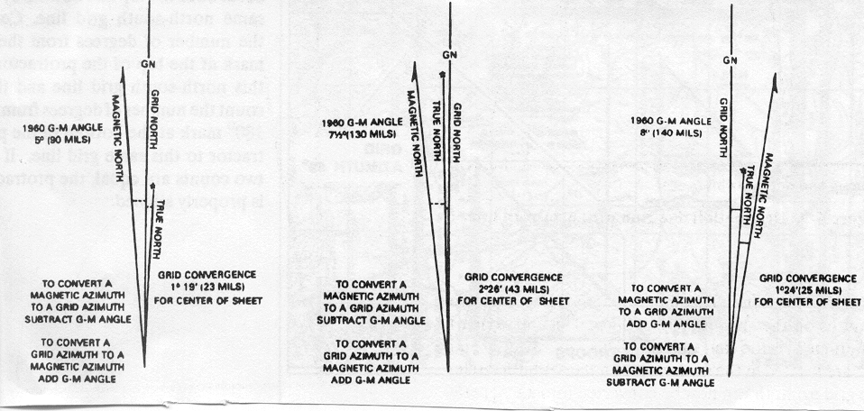
Figure 1. Declination Diagram

- True North - a line from any position on the earth's surface connects at the North Pole. Unlike grid lines, all lines of longitude are true north lines.

- Magnetic North - direction to the North Magnetic Pole, as indicated by the north-seeking needle of a magnetic compass. The North Magnetic Pole is located in Canada at Hudson Bay.

- Grid North - north that is established by the vertical grid lines on the map. The variation between grid north and true north is due to the curvature of the earth.

Grid Magnetic (GM) Angle - the GM angle is an important factor in map reading. The GM angle is used to convert magnetic azimuth to grid azimuth and vice versa:

Grid azimuth - determined with a protractor and is measured from grid north.

Magnetic azimuth - taken from a compass and measured from magnetic north.

Legend - located in the lower left margin. Illustrates and identifies some of the symbols on the map. Every time a map is used, refer to the legend to prevent errors in symbol identification (see figure 2). Other information found in the legend is the Sheet Name, Sheet Number, Series Name, Edition Number, Index to Boundaries, Index Adjoining Sheets, and Series Number.

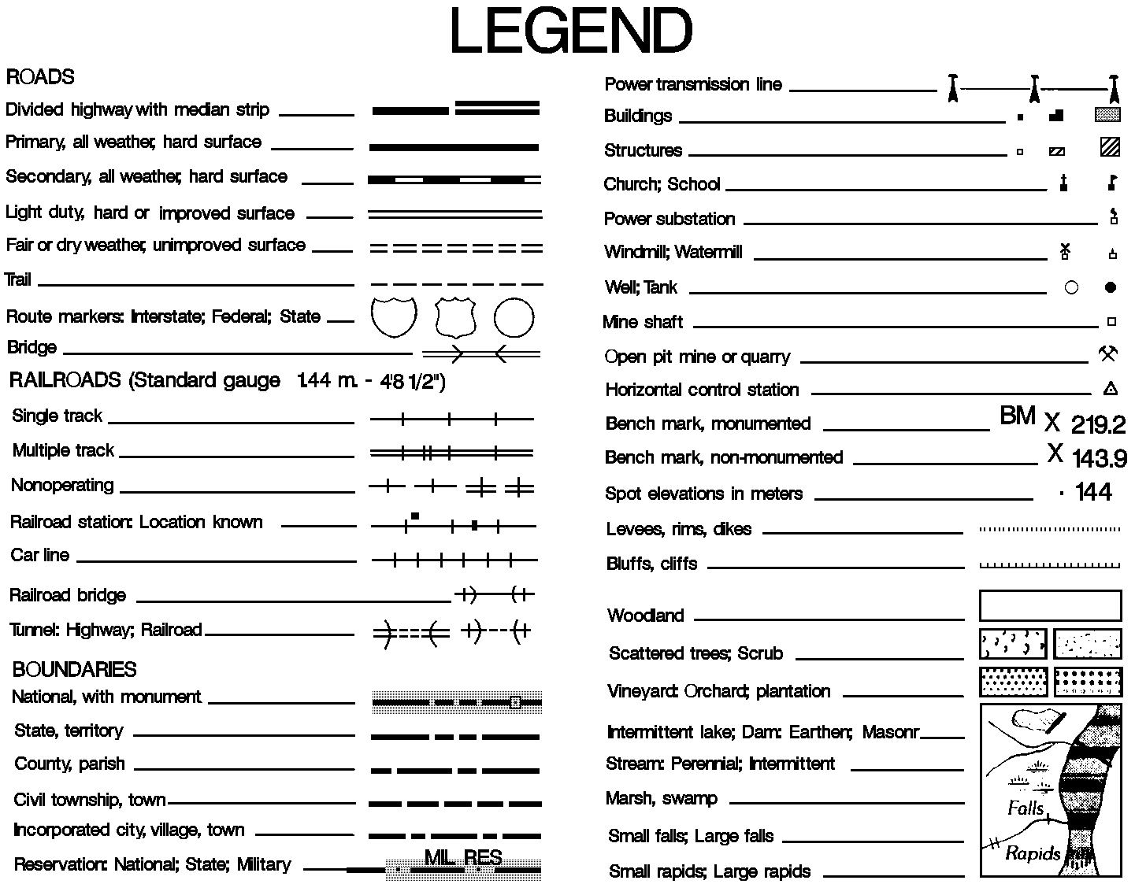
Figure 2. Legend

Bar Scale - located at the center bottom of the margin, below the map face. Special "rulers,” ground distance may be measured directly without having to convert the map scale ratio. Normally, the scale for meters, yards, statute miles (land) and nautical miles (sea). Easy to use, but notice that "zero" is not at the end of the scale (see figure 3).
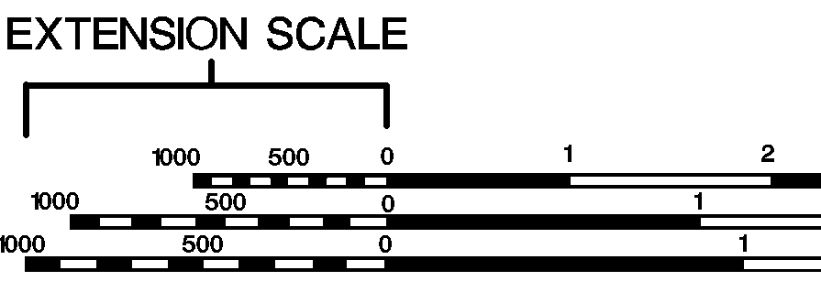
Figure 3. Bar Scale

MEASURING DISTANCE

Straight Line Distance - to measure line distance between two points:

- Lay a straight strip of paper on the map so the edge touches the center of both points.

- Make a tick mark on the edge of the paper at each point.

- Lay the paper strip along the scale that corresponds to the unit of measure you are working with.

- Place the right tick mark of the paper strip on the largest full unit on the primary scale (to the right of zero), allowing the remainder to fall on the extension of the scale (to the left of zero).

Curved or Irregular Distance - to measure distance along a winding road, stream, or any other curved line:

- Make a tick mark near one end of the irregular line to be measured.

- Align the paper strip along the center of the first straight portion of line.

- Make a tick mark at the other end of that portion on both the paper strip and the map.

- Keeping both tick marks together, pivot the strip at the second tick mark until another straight portion of that line is aligned.

- Continue this process until the measurement is completed, then place the paper strip on the appropriate bar scale and determine the distance measured.

PROTRACTOR (see figure 4)

There are several types of protractors. All of them divide the circle into units of angular measure, and each has a scale around the outer edge and an index mark.

- The index mark is the center of the protractor circle from which all directions are measured.

- The military protractor contains two scales; one in degrees (inner scale) and one in mils (outer scale).

- This protractor represents the azimuth circle.

- The degree scale is graduated from 0° to 360°; each tick mark on the degree scale represents one degree. A line from 0° to 180° is called the base line of the protractor. Where the base line intersects the horizontal line, between 90° and 270°, is the index or center of the protractor.

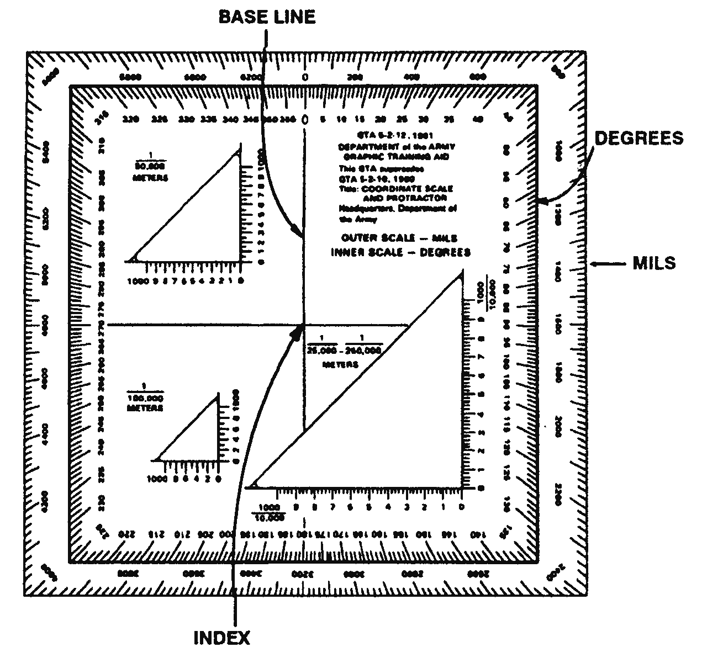
- When using the protractor, the base line is always oriented parallel to a north-south grid line. The 0° or 360° mark is always toward the top or north on the map and the 90° mark is to the right.

Figure 4. Protractor

4. THE GRID SYSTEM
Figure 11. Protractor

System which tells the reader where specific locations or points are (see figure 5). A network of lines, in the form of squares, placed on the face of the map. These squares are somewhat like the blocks formed by the street system of a city. The "streets" in a grid all have very simple names. The names are all numbers. Every tenth line is made heavier in weight. This will help you find the line you are looking for. Each grid line on the map has its own number. These numbers appear within the map on the line itself. Four digit numbers identify a 1000 square meter grid square. Six digits identify a 100-meter grid square. Eight digits identify a 10-meter grid square. To locate a point by grid reference is a simple matter. We follow a simple rule of map reading: READ RIGHT AND UP
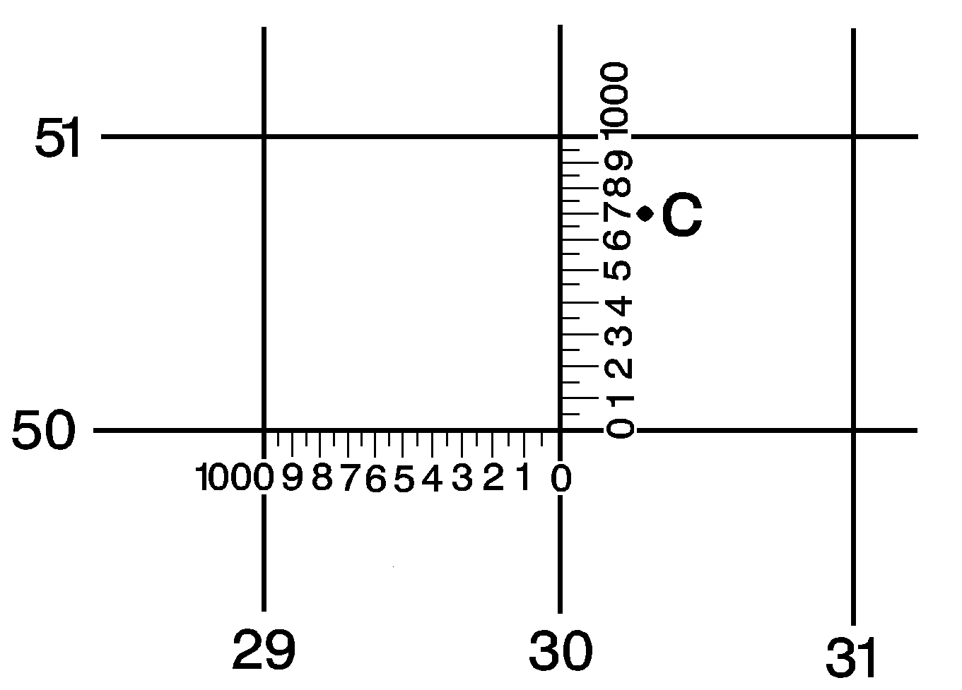
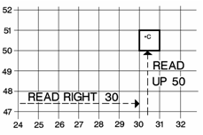

4 Digit Step 1
4 Digit Step 2

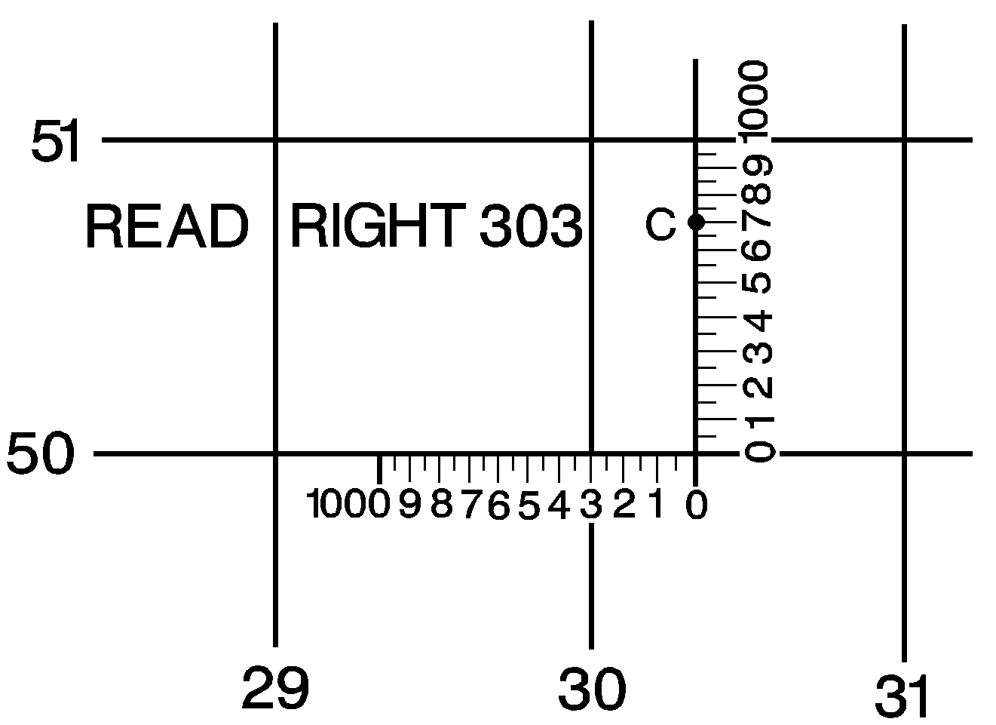
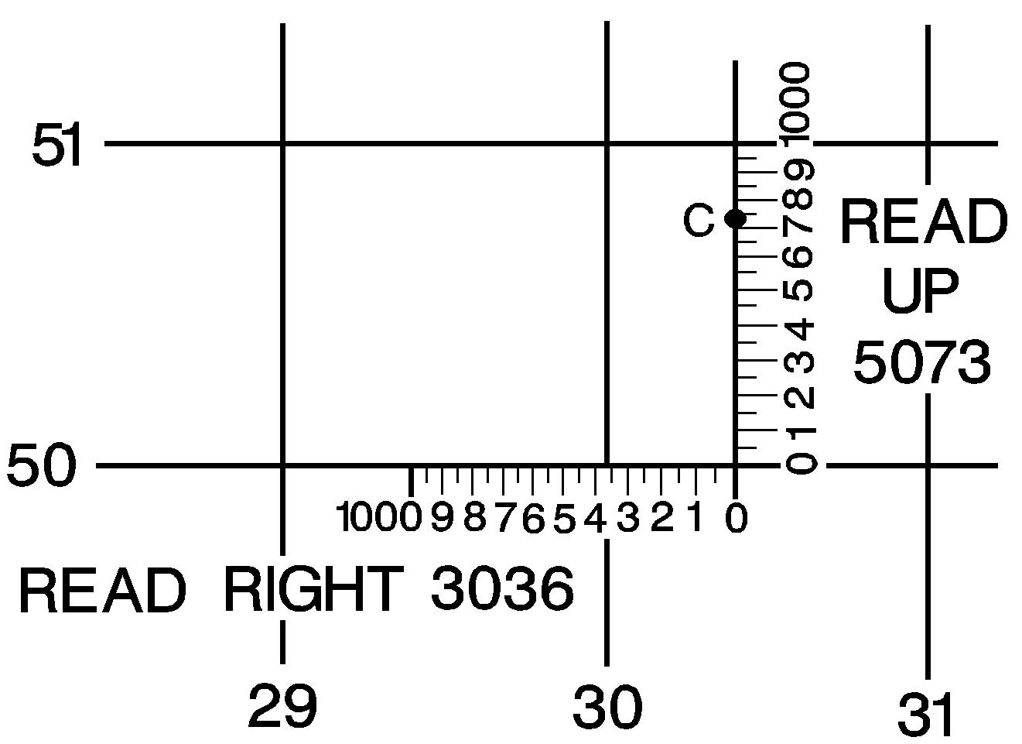
READ UP
507

6 Digit Step 3
8 Digit Step 4

Figure 5. Grid System

5. COMPASS TERMS AND CONCEPTS

Azimuth - an angle measured in a clockwise direction from a north base line.

Grid Azimuth

- The heading due east is an azimuth of 90°

- South - 180°

- West - 270°

- North - 360 or 0°. When using an azimuth, the point from which the azimuth originates is imagined to be the center of the azimuth circle.

Obtaining a Grid Azimuth

- On your map draw a line connecting two points

Point A represents your present location

Point B represents your destination

- Place the index of the protractor on point A.

- Ensure the 0° and the 180° base line is parallel with the vertical grid lines on your map.

- Read the azimuth from the degree (inside) scale; this is the grid azimuth from point A to point B.

Back Azimuth

- Back azimuth is the reverse direction of a forward azimuth.

- It is comparable to doing an about face. To obtain a back azimuth from an azimuth less than 180°, add 180°. If the azimuth is 180° or more, subtract 180.

Lensatic Compass

The primary instrument used to determine and maintain direction during land navigation.

Parts of the Compass (see figure 6)

- Thumb loop - Graduated straight edge

- Short luminous line - Lens

- Luminous sighting dots - Fixed index line

- Luminous magnetic arrow, "Magnetic North" - Bezel ring

- Sighting slot - Cover

- Sighting wire - Rear sight

- Floating Dial – in both mils and degrees - Base

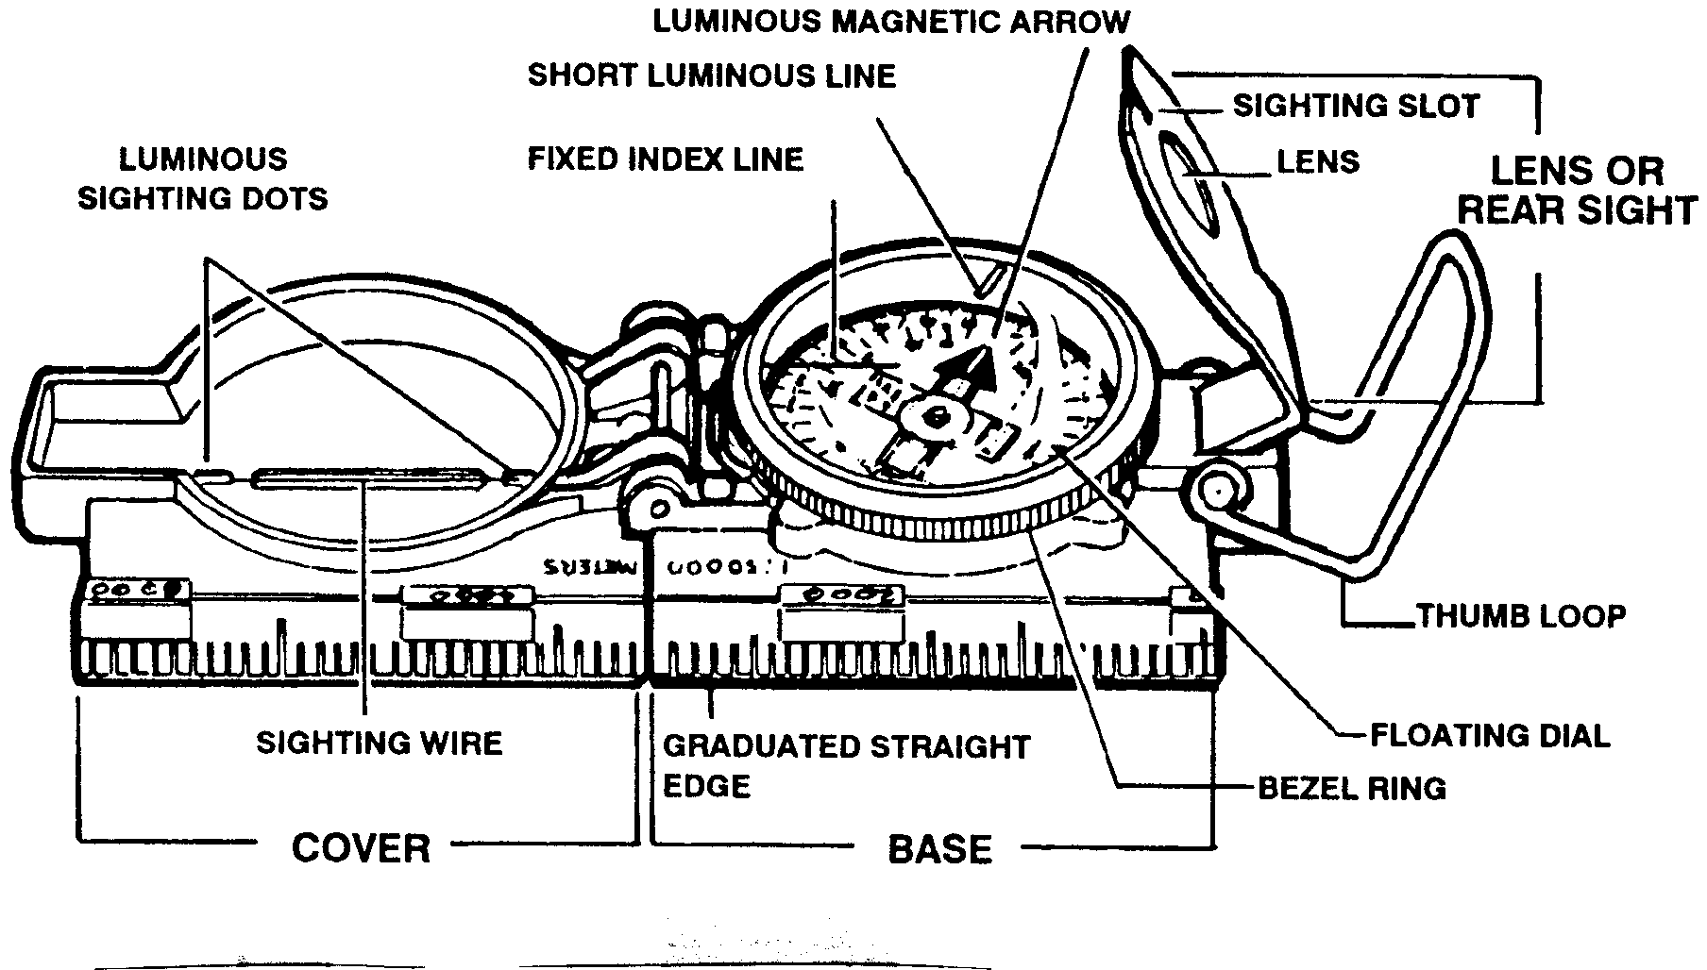
Figure 6. Lensatic Compass

Compass Precautions

- Handle the compass with care. The dial is set with a delicate balance and shock could damage it.

- Reading should never be taken near visible masses of metal or electrical circuits.

- In cold weather, always carry the compass in its carrier outside your outer layer of clothing. If it is carried inside your clothing close to your body, it will fog when exposed to the cold air.

Methods For Holding The Compass - the lensatic compass is used to determine or follow magnetic azimuth both day and night. There are two recommended positions for holding the compass when navigating:

Compass-to-Cheek Method - recommended when determining the azimuth to a distant object.

- Raise the cover (with the sighting wire) straight up and raise the sight (lens) to an angle about 45° above the compass glass.

- Turn the thumb loop all the way down and put your thumb through it. Form a loose fist under the compass to steady it with your other hand, and raise up to eye level.

- Look through the sighting slot, and align the compass by centering the sighting wire in the sighting slot.

- Keeping the compass level and the sights aligned, rotate your entire body until the sighting wire is aligned on a distant object.

- Now glance down through the lens and read the magnetic azimuth under the fixed index line on the glass.

Center-Hold Position (see figure 7)

- Recommended holding position for a predetermined azimuth, both during the day and night (you do not need to remove your helmet, weapon, grenades, or magazines as long as they are not near the compass).

- Open the cover until it forms a straight edge.

- Pull the eyepiece to the rear most position.

- Next, place your thumb through the thumb loop.

- Form a steady base with your remaining fingers.

- Using your other hand, form a solid base for your compass.

- To measure an azimuth, simply turn your entire body toward the object. While pointing the compass cover directly at the object, look down and read the azimuth from beneath the black index line.

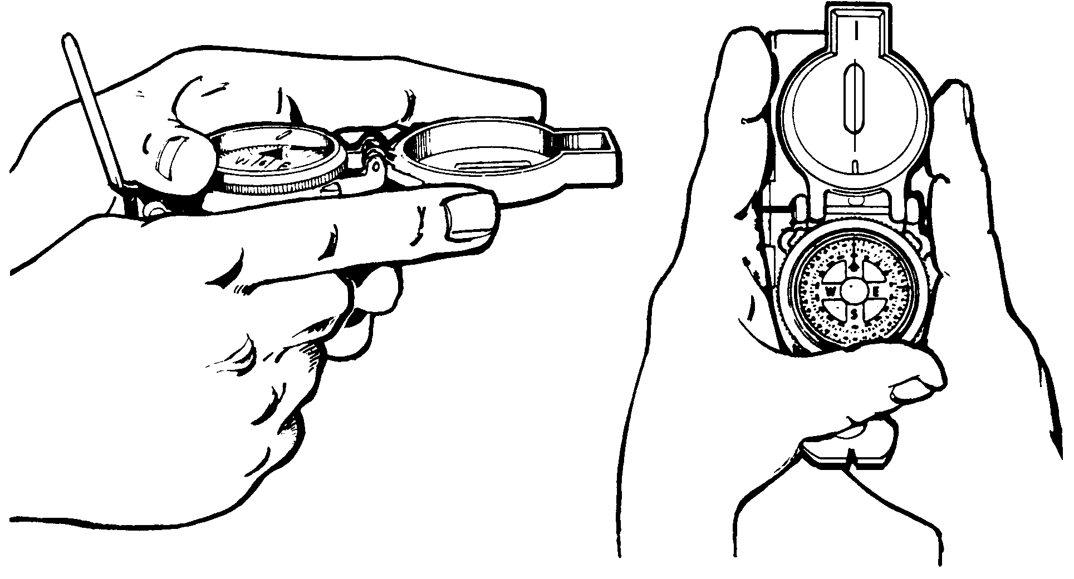
Figure 7. Center-Hold Position

Compass Use at Night

- All the luminous features on the compass will be used.

- The lensatic compass has two glass faces, one under the other. The top glass (bezel ring) rotates; each click means it has turned three degrees.

- Turn the bezel 30 clicks to the left (counter clockwise); this is a total of 90°.

- Using the center-hold method, rotate your body and compass until the magnetic north seeking arrow is directly aligned under the short luminous line on the bezel ring. Your compass is now set on magnetic azimuth of 90°.

- Now all you have to do to march on this azimuth line at night is keep the magnetic north seeking arrow and the short luminous line aligned and follow the direction of the luminous dots on the cover of the compass.

7. ORIENTATION OF A MAP

A map is oriented when it is in position with north and south corresponding to north and south on the ground.

Orienting a map with a compass

- With the map in a horizontal position, the compass straight edge is placed parallel to a north-south grid with the cover of the compass pointing toward the top of the map.

- This will place the black line on the dial of the compass parallel to grid north.

- Since the needle on the compass points to magnetic north, we have a declination diagram on the face of the compass formed by the index line and the compass needle.

- Rotate the map and compass until the direction on the declination diagram formed by the black index line and the compass needle match the directions shown on the declination diagram printed on the margin of the map. The map is then oriented.

- If the magnetic north arrow on the map is to the left of grid north, the compass reading will equal the GM angle (given in the declination diagram).

- If the magnetic north is to the right of the grid north, the compass reading will equal 360 minus the GM angle.

Orienting Without A Compass: Terrain Association

- When a compass is not available, map orientation requires a careful examination of the map and the ground to find linear features common to both, such as roads, railroads, fence lines, power lines, etc.

- By aligning the feature on the map with the same feature on the ground, the map is oriented.

- Orientation by this method must be checked to prevent the reversal of directions that may occur if only one linear feature is used. Aligning two or more of these features may prevent this reversal.

Determining Location by Map and Compass

Basic method for determining locations on a map

Inspection and Estimation

- Usually the easiest and most simple

- Carefully survey road systems and topographical features in the immediate vicinity.

Orient the map to the ground

- Identify some prominent characteristic such as a road, junction, bridge, stream etc., which you can see on the ground and unmistakably identify on your map.

90° Offset Method

To bypass enemy positions or obstacles and stay oriented, detour around the obstacle by moving at right angles for specified distances. Use this formula:

Right add 90°; Left subtract 90° (RALS) (see figure 8)

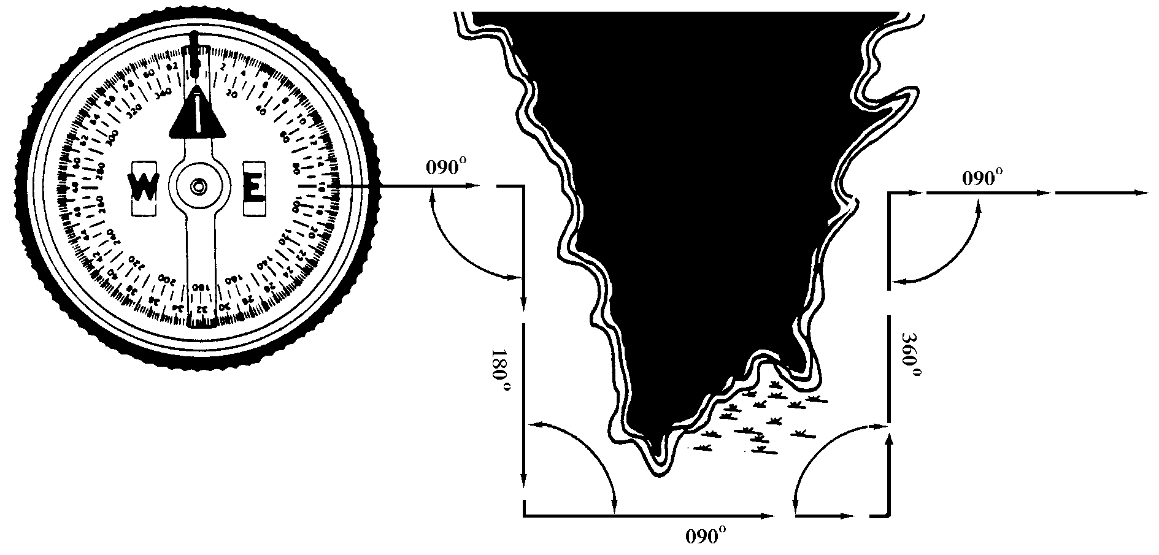
Figure 8. 90º Offset Method

- PACE COUNT
Used to keep a record of ground distance:

- Record your count in 100-meter increments.

- Step off with your left foot and count every time it hits the deck.

- Record your 100-meter increments by putting a knot in a rope or piece of string. (Example: A student is walking an azimuth of 25°. That person must travel in this direction for 500 meters. The students pace count is 65 paces for 100 meters. To figure out how many paces the student must take – multiply your pace count by the distance.) DISTANCE divide by 100 x Pace Count (65).

11. ELEVATION AND RELIEF

Contour Lines - indicates elevation and relief on maps. A line representing an imaginary line on the ground, along which all points are at the same elevation. Each contour line represents an elevation above sea level and the amount of the contour interval is given in the marginal information. On most maps, the contour lines are printed red-brown, starting at zero elevation. Every fifth contour line is a heavier brown line. These heavy lines are known as index contour lines. Also, the elevation will be given along this heavy brown line.

- The spacing of the lines indicates the nature of the slope. This has important military significance.

- The closer the contour lines the steeper the terrain

Land Formations

Hill - a point or small area of high ground (see figure 9).

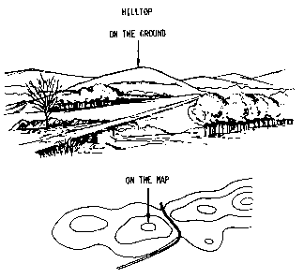
Figure 9

Valley - a stream course, which has at least, a limited extent of level ground bordered on the sides by higher ground. Contours indicate a valley that is a “U" shape, and the curve of the contour crossing always points up (see figure 10).
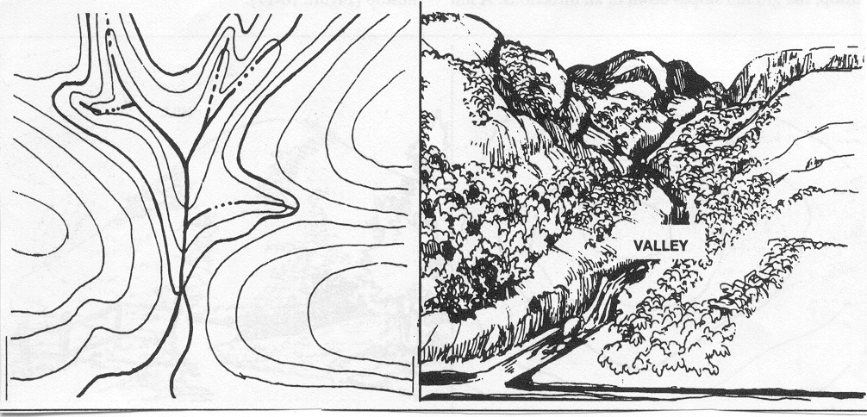
Figure 10

Draw - a less developed stream in which there is essentially no level ground and therefore, little or no maneuver room within its confines. The ground slopes upward on each side and towards the head of the draw. Contour lines indicating a draw are 'V" shaped, with the point of the "\/" toward the head of the draw (see figure 11).
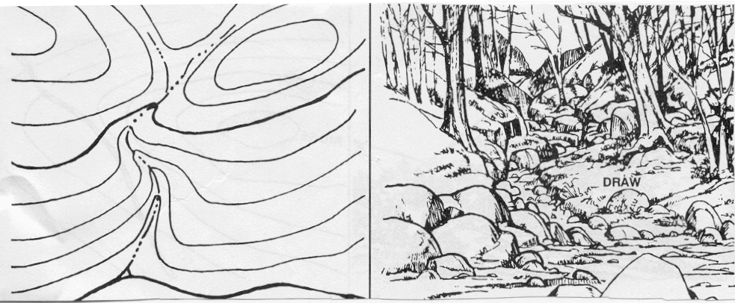
Figure 11

Ridge - a line of high ground, normally with minor variations along its crest. The ridge is not simply a line of hills but rather the ridge crest are higher than the ground on both sides of the ridge (see figure 12).

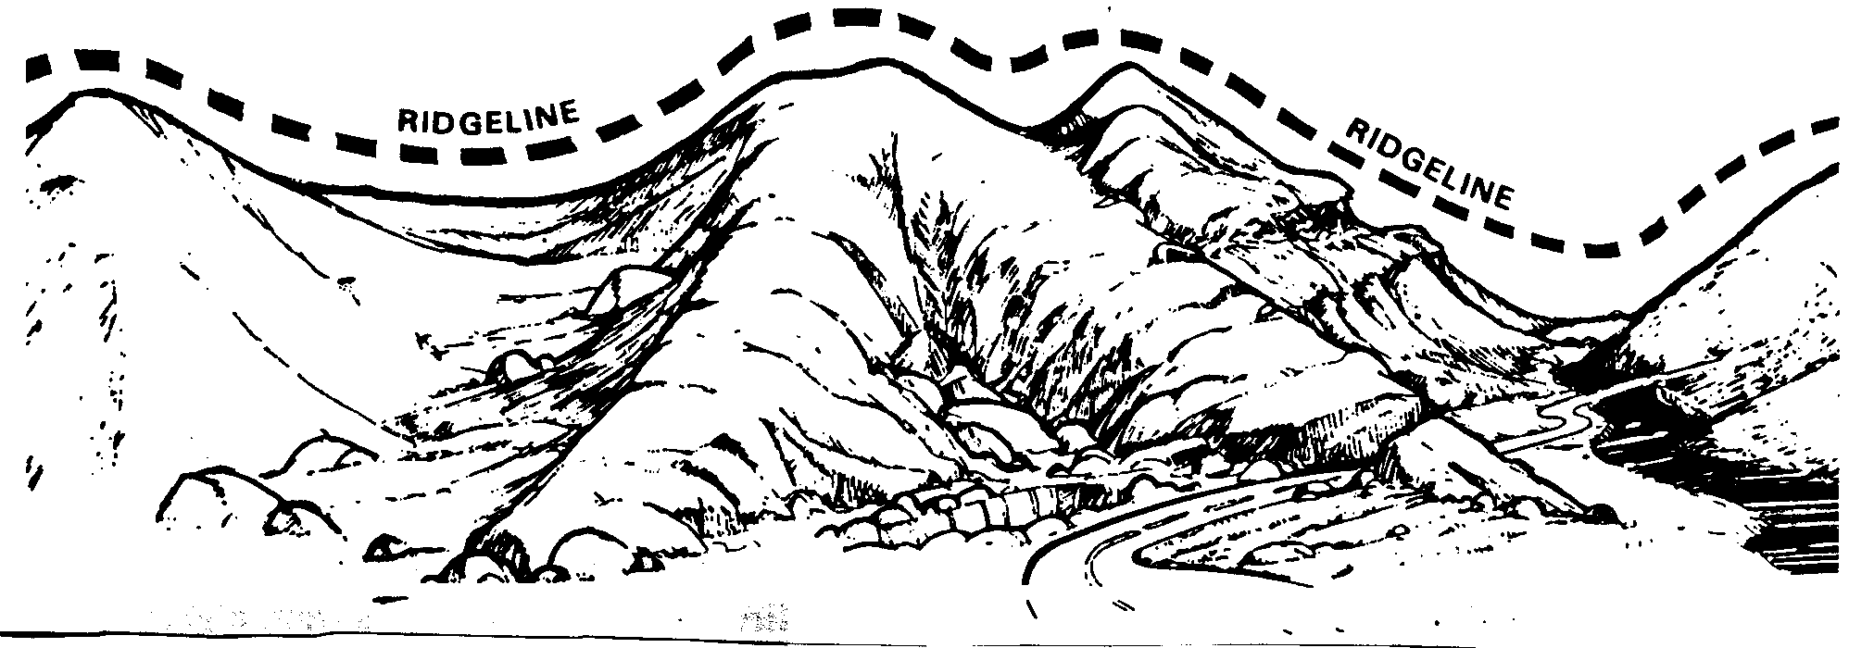
Figure 12

Saddle - a dip or low point along the crest of a ridge. A saddle is not necessarily the lower ground between two hilltops; it may simply be a dip or break along an otherwise level ridge rest (see figure 13).
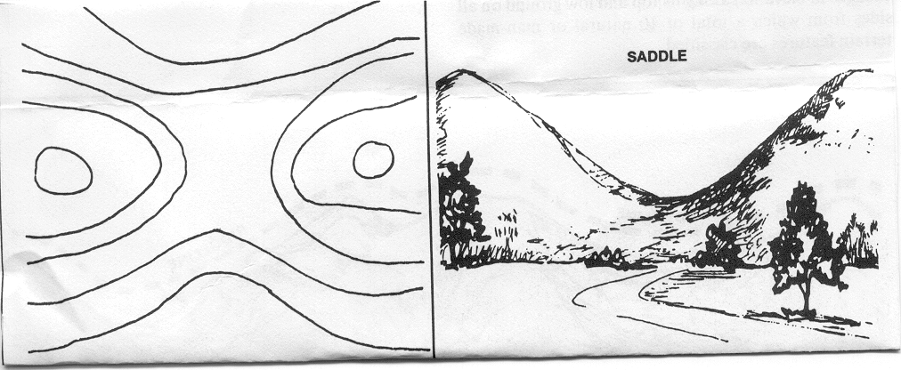
Figure 13

Depression - a low point or sinkhole surrounded on all sides by higher ground (see figure 14).
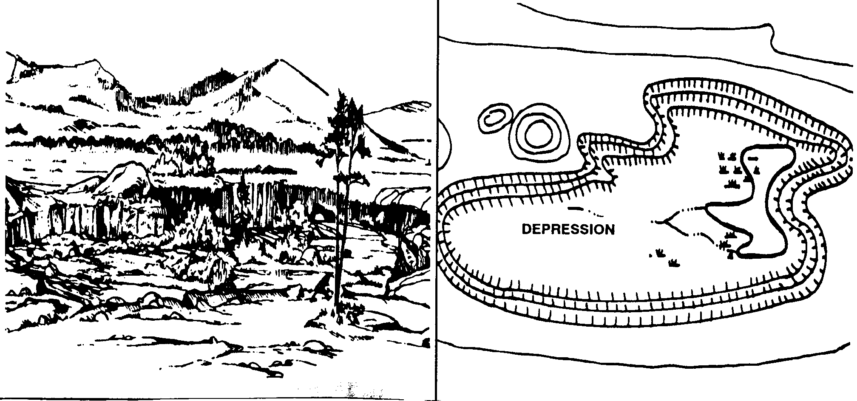
Figure 14

Cliff - a vertical, or near vertical, slope. When a slope is so steep that it cannot be shown at the contour interval, it is shown by a ticked line carrying contours. The ticks always point toward lower ground (see figure 15).
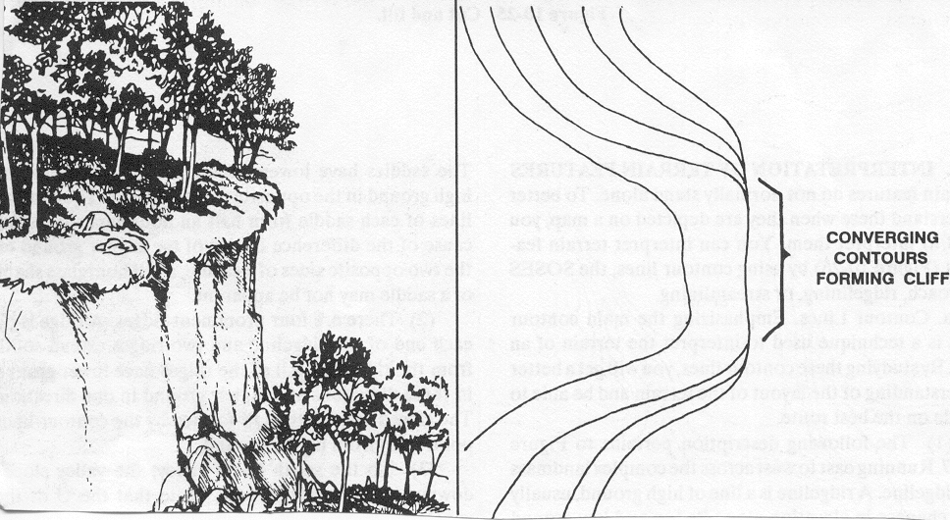
Figure 15

REFERENCES

Map Reading and Land Navigation, FM 3-25.26, Ch 2, 6, 9, 10, 11
ITS, (May 2001), Pgs 1-18-1 through 1-18-42

Land Navigation Review

1. List and describe the three different types of north.

- A six digit grid coordinate gets you to within how many meters of your intended target?

- Identify the two methods for holding a compass.

4. Describe the purpose of a contour line.

