UNITED STATES MARINE CORPS
Field Medical Training Battalion – East
Camp Lejeune
FMST 1409
Manage Respiratory Trauma

TERMINAL LEARNING OBJECTIVES
- Given a casualty with respiratory trauma in a tactical environment and standard field medical equipment and supplies, manage respiratory trauma to prevent further injury or death. (FMST-HSS-1409)

ENABLING LEARNING OBJECTIVES
- Without the aid of references, given a description or list, identify standard medical terminology related to the respiratory system, within 80% accuracy, per the Taber’s Cyclopedic Medical Dictionary, current edition. (FMST-HSS-1409a)
- Without the aid of references, given a description or title, identify the anatomy of the respiratory system, within 80% accuracy, per Pre-Hospital Trauma Life Support, Military Edition, 6th Ed, Chapter 6 and 10. (FMST-HSS-1409b)
- Without the aid of references, given a description or list, identify signs and symptoms of respiratory trauma, within 80% accuracy, per Pre-Hospital Trauma Life Support, Military Edition, 6th Ed, Chapter 6 and 10. (FMST-HSS-1409c)
- Without the aid of references, given a description or list, identify treatments for open chest injuries, within 80% accuracy, per Pre-Hospital Trauma Life Support, Military Edition, 6th Ed, Chapter 6 and 10. (FMST-HSS-1409d)
- Without the aid of references, given a description or list, identify treatments for closed chest injuries, within 80% accuracy, per Pre-Hospital Trauma Life Support, Military Edition, 6th Ed, Chapter 6 and 10. (FMST-HSS-1409e)
- Without the aid of references, given a simulated casualty with an open respiratory injury and standard field medical equipment and supplies, manage the casualty, per Pre-Hospital Trauma Life Support, Military Edition, 6th Ed, Chapter 6 and 10. (FMST-HSS-1409f)

1. RESPIRATORY SYSTEM TERMINOLOGY
Dyspnea - difficult or labored breathing
Wheeze - a form of rhonchus, characterized by a whistling respiratory sound. It is caused by the movement of air through a narrowed airway.
Stridor - a harsh shrill respiratory sound
Hyperventilation - an increase in the rate and depth of normal respirations. Responsible for increasing oxygen levels and decreasing carbon dioxide levels.
Tachypnea - abnormally rapid rate of respiration
Bradypnea - an abnormally slow rate of respiration, usually less than 8 breaths per minute
Hypoxia - an insufficient concentration of oxygen in the tissue in spite of an adequate blood supply.
Apnea - total cessation of breathing, also known as respiratory arrest
Subcutaneous Emphysema - the presence of free air or gas in the subcutaneous tissues. The face, neck, or chest may appear swollen with painful skin and produce a crackling sound (“rice crispies”).
Trachea - also called the windpipe, it is the main trunk of the system of tubes by which air passes to and from the lungs. It is located in the front of the neck, descending from the lower larynx and is continuous with the bronchus.
Larynx - a structure superior to the trachea that encompasses the vocal cords also known as “voice box.”
Epiglottis - lid like structure overhanging the larynx that prevents food from entering the respiratory tract.
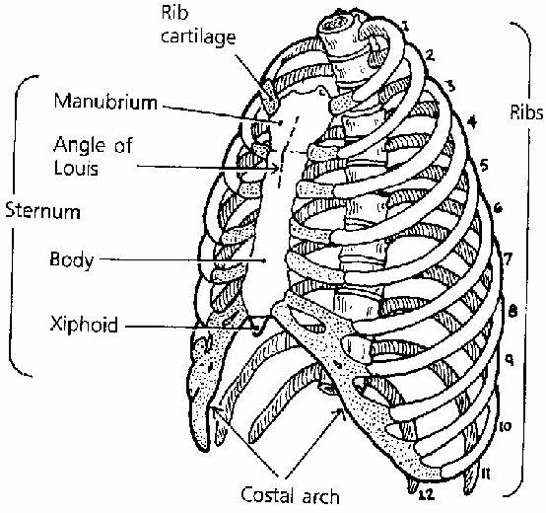
- ANATOMY OF THE RESPIRATORY SYSTEM
Thorax (Chest Cavity) (see figure 1)
Definition - skeletal portion of the thorax is a bony cage formed by the sternum, costal cartilages, ribs and the bodies of the thoracic vertebrae.
Ribs
- Joined in the posterior with the thoracic spine and anterior with the sternum via the costal cartilage.
- A nerve, an artery and a vein are located along the underside of each rib.
Figure 1. Thorax
- Intercostal muscles connect each rib with the one above.
Diaphragm - The primary muscle of respiration.
Pleura (see figure 2)
Definition - thin membranes separated by a small amount of fluid, which creates surface tension and causes them to cling together, counteracting the lung’s natural tendency to collapse.
Parietal pleura - a thin membrane that lines the inner side of the thoracic cavity
Visceral pleura - a thin membrane that covers the outer surface of each lung

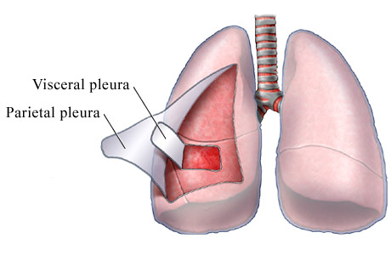

Figure 2. Pleura

Lungs (see figure 3)
- Occupy the right and left halves of the thoracic cavity
- The left lung is divided into two lobes
- The right lung is larger than the left lung and is divided into three lobes
- Alveoli- the smallest components of the lungs. They are small saclike structures through which the exchange of carbon dioxide and oxygen take place.
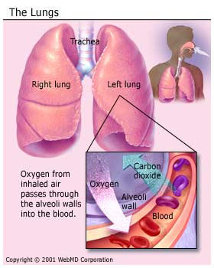

Figure 3. Lungs
Mediastinum
Definition - area in the middle of the thoracic cavity in which all the other organs and structures of the chest cavity lie. It encases the:
- Heart
- Great vessels (aorta, superior/inferior vena cava)
- Trachea (windpipe)
- Mainstem bronchi (there are two bronchi- a right and left)
- Esophagus (lies directly behind the trachea)
- RESPIRATORY TRAUMA
Chest injuries are the second leading cause of trauma deaths each year, although the vast majority of all thoracic injuries (90% of blunt trauma and 70 to 85% of penetrating trauma) can be managed without surgery. Traumatic chest injuries can be caused by a variety of mechanisms; however, these injuries are usually classified as either blunt or penetrating.
Penetrating Injuries - caused by forces distributed over a small area (i.e., gunshot wounds or stabbings). Most often, the organs injured are those that lie along the path of the penetrating object.

Blunt Trauma - caused by forces distributed over a larger area, and many injuries occur from deceleration, bursting, or shearing forces. Conditions such as pneumothorax, pericardial tamponade, flail chest, pulmonary contusion and aortic rupture should be suspected when the mechanism of injury involves rapid deceleration, including motor vehicle collisions, falls, sport injuries and crush injuries.
Management of Specific Injuries
Rib fracture - occurs when pressure is applied with enough force to exceed the strength of the rib. Remember that any fractured rib can cause associated injuries to nearby structures.
Causes - blunt trauma, crushing injuries to the chest.
Signs and Symptoms
- Pain at the site with inhalation/exhalation
- Shortness of breath
- Deformity
- Crepitus
- Bruising to area
Treatment
- Anticipate potential complications such as tension pnuemothorax, pericarditis, or cardiac tamponade.
- Simple rib fractures usually require no treatment other than analgesics.
- Multiple rib fractures may require immobilization of the arm on affected side to protect the ribs.
- Encourage coughing and deep breathing despite associated pain. This is to prevent the collapse of the lung tissue and preventing the exchange of CO2 and O2 (atelectasis).
- Avoid any taping or bandaging that encircles the chest.
- Monitor and CASEVAC as necessary.
Flail chest - a condition of the chest wall due to two or more adjacent ribs being fractured in at least two or more places. The flail segment moves paradoxically in with inspiration and out during expiration (see figure 4)
Causes - blunt trauma to the chest wall, especially an impact into the sternum or the lateral side of the thoracic wall.
Signs and Symptoms
- Localized chest pain, aggravated by breathing or coughing
- Rapid shallow respirations
- Tenderness and/or bony crepitus with palpation
- Subcutaneous emphysema
Treatment
- Immobilize flail segments upon inhalation using strips of tape.
- If you suspect respiratory failure, give positive pressure ventilation using a bag valve mask.
- Administer analgesics (small doses of morphine can be given, see medication appendix at end of Block 2).
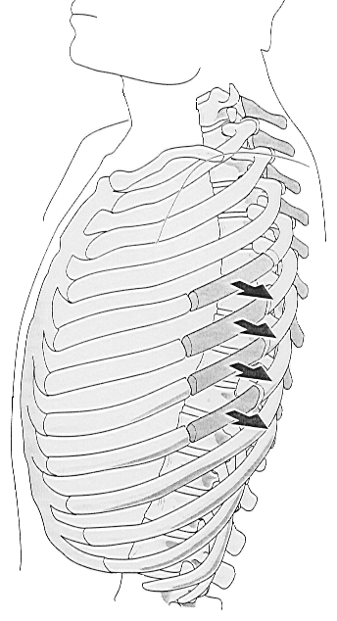
- Administer oxygen if available.
- CASEVAC to the next capability of care.

Paradoxical chest wall movement during inspiration, the flail segment of the rib cage moves inward (instead of outward), which results in reduced air intake.

Figure 4. Flail Chest

Pneumothorax - a simple pneumothorax is caused by the presence of air in the pleural space. The air separates the two pleural surfaces, causing the lung on the involved side to collapse as the separation expands. As air continues to build up and pressure in the space increases, the size of the lung on the affected side continues to decrease. Eventually, the lung may partially or totally collapse.
Causes
- Penetrating trauma from either chest wall injury or abdominal injuries that cross the diaphragm.
- Blunt trauma
- Spontaneous (with no apparent cause)

Signs and Symptoms
- Pleuritic chest pain
- Tachypnea/dyspnea
- Decreased or absent breath sounds on the injured side
- Decreased chest wall motion
Treatment
- Place patient in sitting up or Semi-Fowlers position
- Administer oxygen if available
- Bag-valve-mask assisted breathing may be necessary if RR is less than 8 BPM, greater than 20 BPM, or signs of hypoxia
- If caused by a wound, apply an occlusive dressing to the site
- Monitor for signs and symptoms of a tension pneumothorax
- CASEVAC ASAP
Tension Pneumothorax (see figure 5) - a type of pneumothorax in which air can enter the pleural space but cannot escape via the route of entry. This is the second leading cause of preventable death on the battlefield. This leads to an increase of pressure in the pleural space and eventual collapse of the lung. This pressure forces the mediastinum to the opposite side, which results in two serious consequences: (1) breathing becomes increasingly difficult and (2) cardiac blood flow is severely decreased.
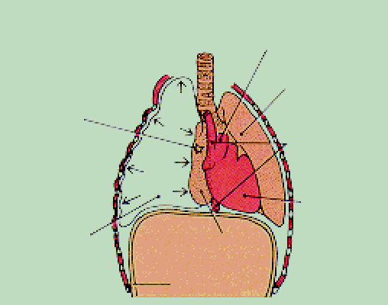
Compressed vessels
Compressed lung
Compressed superior vena cava
Compressed heart
Wound site
Pleural space filled with air
Collapsed lung
Diaphragm

Figure 5. Tension Pneumothorax

Cause - chest injuries.
Signs and Symptoms
In some cases, the only signs of a developing tension pneumothorax are compromised oxygenation, tachycardia, tachypnea, and unilateral decreased or absent breath sounds.

Early signs
- Unilateral (one sided) decreased or absent
breath sounds
- Dyspnea
- Tachypnea
Progressive signs
- Increased dyspnea
- Increased tachypnea
- Increased difficulty ventilating
Late signs
- Jugular vein distention (JVD)
- Tracheal deviation
- Signs of acute hypoxia
- Narrowing pulse pressures
- Signs of uncompensated shock
Treatment
- Treat all chest injuries
- Perform needle thoracentesis
- Administer oxygen therapy if available
- Pain management
- Monitor and CASEVAC to next capability of care
Open Pneumothorax (Sucking Chest Wound) - a collection of air or gas in the pleural space causing the lung to collapse. An open wound allows air to enter when the intrathoracic pressure is negative and blocks the air’s release when the intrathoracic pressure is positive; creating a “sucking chest wound,” that has the potential to cause a tension pneumothorax.
Causes - most often the result of gunshot wounds, but they can also occur from impaled objects.
Signs and Symptoms
- Pain at the injury site
- Chest wall trauma
- Shortness of breath
- Tachypnea
- Subcutaneous emphysema
- Decreased chest wall motion
- May hear a moist sucking or bubbling sound as air moves in and out of the chest wall defect.
Treatment
- Cover the wound with an occlusive dressing. Tape entrance wound on three sides to allow trapped air to exit pleural space while stopping air from entering. If an exit wound is present tape it on all four sides.
- Assess both anterior and posterior torso for penetrating trauma.
- Monitor for signs and symptoms of tension pneumothorax. If signs of increasing respiratory distress develop, the dressing over the wound should be removed to allow for decompression of any accumulating tension. If this is ineffective, needle decompression and positive pressure ventilation (if available) should be considered if not already employed.
- Administer oxygen if available
- Place patient on affected side
- Pain management
- Monitor and CASEVAC
Hemothorax - the accumulation of blood in the pleural space caused by a laceration of the great vessels within the chest that can significantly compromise respiratory efforts by compressing the lung and preventing adequate ventilation.
Causes - Penetrating or blunt trauma
Signs and Symptoms
- Shortness of breath
- Chest pain
- Tachypnea
- Signs of shock (pallor, confusion, tachycardia, hypotension)
- Decreased breath sounds on affected side
- Hemoptysis (coughing up blood)
- Decreased chest wall motion
Treatment
- Place patient in the Fowler’s position
- Treat any chest injuries
- Treat for shock
- Administer O2, if available
- Pain management
- Monitor and CASEVAC
Hemopneumothorax - often with penetrating trauma, a pneumothorax is associated with a hemothorax, and an accumulation of air, blood, and fluid within the pleural cavity.
Causes - penetrating trauma to the chest wall, the great vessels, or the lung.
Signs and Symptoms
- Tachypnea
- Decreased breath sounds
- Signs of shock
Treatment
- Place patient in Fowler’s position
- Perform needle thoracentesis to relieve pressure. If blood is withdrawn, immediately remove needle and catheter.
- Administer oxygen, if available
- Treat for shock
- Monitor and CASEVAC
- AIRWAY ADJUNCTS
Nasopharyngeal Airway (see figure 6) – the nasopharyngeal airway (NPA) is a soft, rubberlike device that is inserted through one nostril along the curvature of the posterior wall of the nasopharynx and oropharynx. The NPA is used on casualties who are unable to maintain their own airways. It should NOT be used if there is no need for an airway adjunct. Use of an NPA can potentially cause bleeding during insertion.

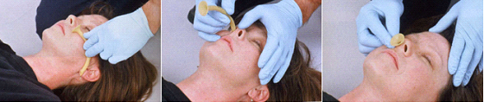
Figure 6. Inserting a Nasopharyngeal Airway

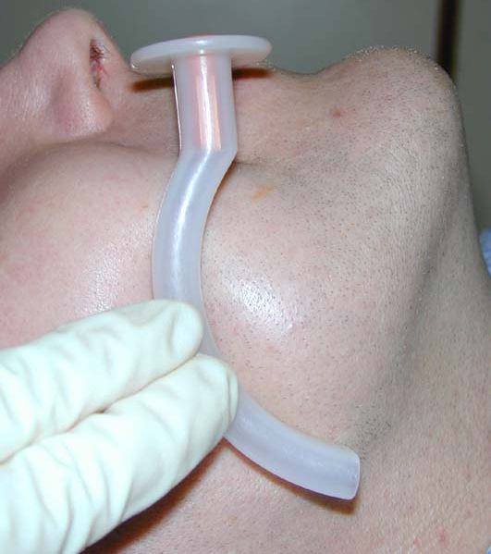
Oropharyngeal Airway (see figure 7) – the oropharyngeal airway (OPA) is the most frequently used artificial airway. It is inserted in either a direct or an inverted manner. The OPA is used on casualties who are unable to maintain their own airways, as well as to prevent intubated casualties from biting ET tubes. The OPA should NOT be used on casualties who are conscious or semiconscious as it’s use may lead to gagging, vomiting, or laryngospasms in conscious casualties because of its stimulation of the gag reflex.
Figure 7. Oropharyngeal Airway

King LT
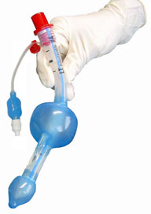
The King LT (see figure 8) is a reusable airway created as an alternative to tracheal intubation or mask ventilation. Allowing maximum versatility as an airway management tool, the King LT is designed for positive pressure ventilation as well as for spontaneously breathing patients. It is easily inserted and results in minimal airway trauma. The King LT is latex-free and can be autoclaved up to 50 cycles.

Figure 8. King LT

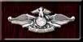

CASUALTY ASSESSMENT AND RESPIRATORY TRAUMA
Care Under Fire Phase: In the absence of life-threatening hemorrhage from the respiratory system, the material in this section is unlikely to be addressed in the Care Under Fire Phase.

Tactical Field Care Phase: During this phase, you will be required to assess the quality of breathing, which will require you to expose the casualty’s chest. Consider needle thoracentesis if warranted. Don BSI. Note and treat all respiratory injuries. Complete a head to toe assessment using DCAP-BTLS noting and treating additional injuries. Determine if vascular access is required (see Tactical Fluid Resuscitation lesson) and give fluids if necessary. If the casualty is able to drink fluids, they should be encouraged to do so. Consider pain medications and give antibiotics if warranted. Reassess all care provided. Document care given, prevent hypothermia, and CASEVAC.

REFERENCE
Pre-Hospital Trauma Life Support, Military Edition, 6th Ed, Chapter 6 and 10
Respiratory Trauma Review
1. Identify five structures found in the mediastinum.

- Identify the appropriate treatment for a simple rib fracture.

- Identify the two serious consequences of a tension pneumothorax.

4. Identify the treatment for a sucking chest wound.

