UNITED STATES MARINE CORPS
Field Medical Training Battalion – East
Camp Lejeune

FMST 1105

USMC Utility Uniform and Individual Combat Equipment

TERMINAL LEARNING OBJECTIVES
- Given individual combat equipment and cleaning materials, maintain combat equipment, with no uniform violations, per the reference. (FMST-FP-1108)
- Given individual combat equipment, prepare individual combat equipment for tactical operations, to support mission requirements, per the reference. (FMST-FP-1215)
- Without the aid of references, given a list of uniform items and ownership marking locations, identify the proper wear and location markings of the USMC combat utility uniform, per the references. (FMST-HSS-1105)

ENABLING LEARNING OBJECTIVES

Without the aid of references, given the prescribed combat equipment, maintain all items with no uniform violations, per MCO P1020.34G. (FMST-FP-1108a)

Without the aid of references, given combat equipment, assemble gear, to make ready for tactical operations, per MCO P1020.34G. (FMST-FP-1215a)

Without the aid of references, given assembled gear, wear combat equipment, to make ready for tactical operations, per MCO P1020.34G. (FMST-FP-1215b)

Without the aid of references, given lists of uniform items and ownership marking locations, identify the proper marking location for each uniform item, within 80% accuracy, per MCO P1020.34G. (FMST-HSS-1105a)
- Without the aid of references, given a list of uniform items and ownership marking locations, identify the proper wear for each item, within 80% accuracy, per MCO P1020.34G. (FMST-HSS-1105b)
- MARINE CORPS COMBAT UTILITY UNIFORM (MCCUU)

The Marine Corps prides itself with exceptional adhearance to uniform standards. Marines are expected to always present a sharp, well maintained, squared away image. All Navy personnel assigned to Marine units are expected to present the same image. Wearing of the utility uniform requires complete compliance with Marine Corps uniform regulations.

Items issued - standard issue to Navy personnel serving with Marine Corps units.
Infantry combat boots | 1 pair
Hot weather boots | 1 pair
Utility cover (without Marine emblem) | 1 Woodland 1 Desert
Booney/field cover | 1 Woodland 1 Desert
Combat utility blouse | 2 Woodland 2 Desert
Combat utility trousers | 2 Woodland 2 Desert
Cushion sole socks | 6 pairs
HM/RP collar insignia | 2
Name tapes | 4 sets each
Sweat shirt | 1
Sweat pants | 1
Web belt | 1
Belt buckle | 1
Glowbelt | 1
Shorts (green) | 1
Sweater | 1
Green undershirt | 6 (3 cotton and 3 synthetic)

- WEAR
Proper wear of the MCCUU
Design - the utility uniform is designed for field wear and should be loose-fitting and comfortable. The size selected should fit loosely to allow for some shrinkage without rendering the garment unusable.
Blouse - the utility blouse will not be tucked into the trousers. At the option of local commanders, sleeves may be rolled up or down depending on time of year or weather. The woodland uniform will be worn in the winter with sleeves unrolled. The desert uniform will be worn in the summer months with sleeves rolled up. When sleeves are worn “up” they will have a three inch fold terminating about two inches above the elbow. The utility blouse should always be kept buttoned. Large or heavy objects should not be carried in the pockets.
Trousers - when combat boots are worn, the trousers will be bloused in a neat and uniform manner. In garrison, the cargo pockets on the trousers will not be used.
Cover - all personnel, E-4 and above, will wear a subdued (black) cover device. Navy personnel are to use the cover without the embroderied Eagle, Globe and Anchor. If unable to obtain a cover without the Eagle, Globe and Anchor, nothing will be placed over the emblem.
Belt - all personnel will wear the tan khaki web belt or a Marine Corps Martial Arts Belt. The Marine Corps Martial Arts Program (MCMAP) has a designated belt ranking system. Only those individuals who attend the MCMAP course and qualify are authorized to wear the appropriate belt.
Sweater - Navy officer and enlisted personnel may wear the green (wooley pully) or black service sweater with the combat utility uniform. The sweater will be worn underneath the utility blouse with sleeves down.
Raingear - Navy personnel will wear the Navy issued black raincoat or organizational rainwear as issued by the Marine Corps with the combat utility uniform.
Insignia
The rating insignia is worn on the left collar, bisecting the angle of the point of the collar, and equally spaced ½ inch from either side of the collar (see figure 1).

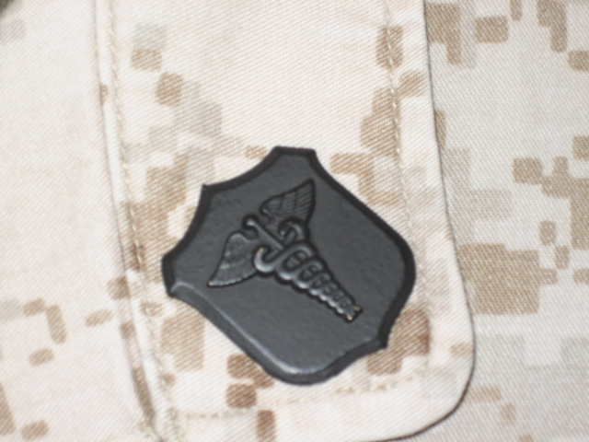
Figure 1. HM Rating Insignia

The rank insignia is worn on the right collar, bisecting the angle of the point of the collar, and equally spaced ½ inch from either side of the collar (see figures 2, 3, and 4).
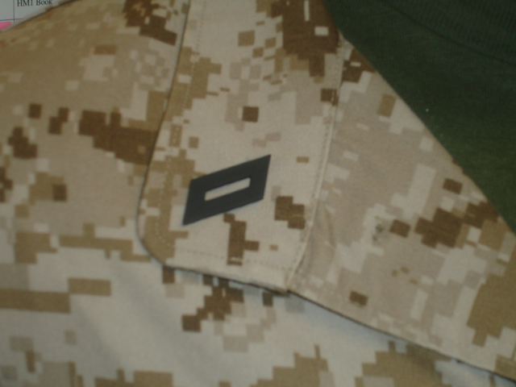
Figure 2. E-2 through E-3 Rank Insignia
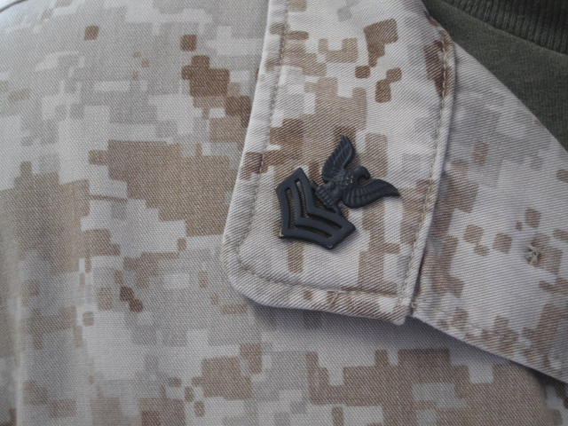
Figure 3. E-4 through E-6 Rank Insignia
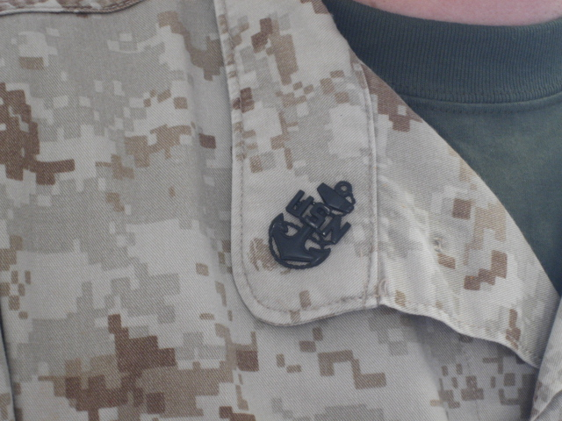
Figure 4. E-7 through E-9 Rank Insignia
The bottom edge of the warfare device will be centered over the left pocket on a horizontal line (parallel to the ground), even with the highest point of the service tape. If a second device is authorized, it will be worn 1/8 inch above the first device (see figure 5).
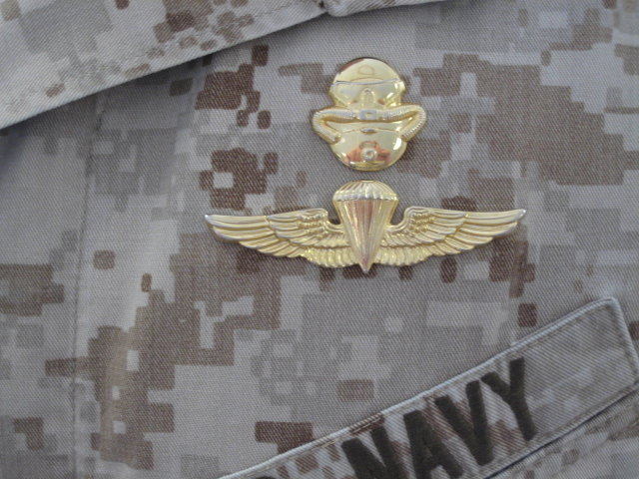
1/8 INCH

CENTERED

Figure 5. Warfare Device

.

3. UNAUTHORIZED WEAR OF THE MCCUU
The wearing of the MCCUU and its policies are much like the Navy’s utility uniform (Dungarees). Members are prohibited from wearing the utility uniform off base with the following exceptions:
- to and from work while in a vehicle
- during medical emergencies
- circumstances that are beyond your control (vehicle breakdown)
- while visiting drive-thrus that do not require you to exit the vehicle

- CARE OF THE MCCUU
The MCCUU is designed for easy care. These uniforms are designed as a wash-and-wear uniform. If needed, a hand iron on a low heat setting may be used. The use of starch, sizing and any process that involves dry cleaning or a steam press will adversely affect the treatments and durability of the uniform and is NOT recommended.

- MARKING
Enlisted Sailors will plainly and indelibly mark every article of uniform clothing with the owner’s name (except for organizational clothing).
Size - letters will be of a size appropriate to the article of clothing and the space available for marking and will consist of block leters not more than ½ inch in size. Marking machines, stencils, name tapes or stamps may be used.
Color - names are marked in black, on light colored material and utilities, and in white on dark material. Marks will be placed so that they do not show when the clothing is worn.
Location - the precise location for marking the following gear is as follows:
Duffel bag - on the outside of the bag on the bottom
Web belt - on one side only, as near to the buckle end as possible
Cover - inside, on the sweatband
Coats and overcoats - inside, on the neckband
Drawers - outside immediately below the waistband, near the front
Gloves - inside, at the wrist
Shoes and boots - inside, near the top
Socks - outside, on top of the foot
Utility blouse - name-tape sewn above right breast pocket, service tape sewn above left breast pocket; mark inside of blouse as well
Trousers - name-tape sewn above right rear pocket; mark inside of trousers as well
Undershirt - inside back, near the neck-band

- GROOMING STANDARDS/PERSONAL APPEARANCE
Members will present the best possible image at all times and continue to set the example while in and out of uniform. Members are prohibited from:
- Mutilation of the body or any body parts in any manner
- Attaching, affixing or displaying objects, articles, jewelry, or ornamentation to, through or under skin, tongue or any other body part. Female members may not wear earrings in combat utility uniform.
- Tattoos or brands on the neck and head. On other areas of the body, tattoos or brands that are prejudicial to good order, discipline and morale or are of a nature to bring discredit upon the Marine Corps are also prohibited. Sleeve tattoos are likewise prohibited. A sleeve tattoo is a very large tattoo, or a collection of smaller tattoos, that covers or almost covers a person’s entire arm or leg. Half-sleeve or quarter-sleeve tattoos that are visible to the eye when wearing standard PT gear (t-shirt and shorts) are likewise prohibited. A half-sleeve or quarter-sleeve tattoo is defined as a very large tattoo, or a collection of smaller tattoos that covers, or almost covers, the entire portion of an arm or leg above or below the elbow or knee. Tattoos or brands that are prejudicial to good order, discipline and morale, or are of a nature to bring discredit upon the Marine Corps are also prohibited. Prejudicial to good order, discipline and morale, or are of a nature to bring discredit upon the Marine Corps may include, but are not limited to, any tattoo that is sexist, racist, vulgar, anti-American, anti-social, gang related, or extremist group or organization related.
- Having eccentric or faddish styles of hair, jewelry or eyeglasses. The good judgement of all members at all levels is key to enforcement of Marine Corps standards with this issue.
- Chewing gum, chewing tobacco, cigarettes or the consumption of food while in formation or walking in uniform.
- Articles that are not authorized for wear as a part of a regulation uniform will not
be worn with the uniform such as: pens, watch chains, backpacks/bags (over the shoulder), CD/MP3 players or other similar items.
- For females, barrettes, combs, rubber bands, etc. are authorized, if concealed by the hair.
- Cellular phones (personally owned and organizationally issued) and other electronic
equipment will not be worn exposed on Marine Corps uniforms.
- Sunglasses will be conservative in nature and will not be worn indoors or in formations unless authorized by a medical representative.
- The wearing of clothing articles not specifically designed to be normally worn as headgear (e.g. bandanas, doo rags) is strictly prohibited in civilian attire and while in uniform.
- No part of a prescribed uniform, except those items not exclusively military in
character, will be worn with civilian clothing.
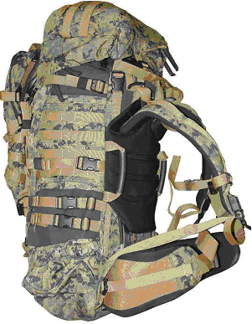
- INDIVIDUAL COMBAT EQUIPMENT
- Improved Load Bearing Equipment (ILBE) (see figure 6) : the ILBE is a load carrying system designed to provide a durable and lightweight means for the deployed Marine/Sailor to transport their individual combat clothing and equipment. It is an integrated load bearing system that is light, durable and can easily be configured for the mission at hand and to maximize the mobility, survivability and lethality of the Marine/Sailor in combat environments.
Figure 6. ILBE Sideview

- Fighting Load Vest (to include belt) - the vest is designed to reduce heat build up on the back with minimum area of coverage with the H-Harness design. The wide shoulder straps of the vest help distribute the load without the need for excessive padding that can hinder mobility and sighting a weapon.
- Corpsman Configuration - will receive four zippered medical pockets, the vest and two double 30 round magazine pockets. In addition to the configuration worn, the individual will also receive two single 30 round magazine pockets and two fragmentation grenade pockets.
- Sleep System Carrier - designed to carry the sleeping system.
- Patrol Pack - utilized to sustain an individual for 24-48 hour period. It is also known as the day pack.
- Sustainment Pockets - attached to outside of the pack as needed for additional load capability.
- Butt Pack - holds extra gear such as socks, one MRE, foot powder, note taking gear and may be worn separately.
- Hydration Bladder - used to drink on the move.
- Repair Kit - utilized to repair the equipment as needed.
- Additional Pockets - pockets can be added and removed as mission requires.
- Additional Equipment

Small Arms Ammunition Cases.
- M16M/4 Rifle Case - holds two magazines of 30 rounds.
- M9 Service Pistol Case - holds one magazine of 15 rounds.
- Canteen Cover - the canteen covers are used to carry the plastic water canteens and metal cup. The covers have two small pockets attached for carrying water purification tablets.
- Flak Jacket - it is designed to be worn as a jacket by an individual to stop shrapnel, it is not bullet proof.
- Helmet With Cover - it is designed to be worn on the head by the individual to stop shrapnel; again, it is not bullet proof.
- ISO Mat - a foam padding used to support the sleeping system.
- Cleaning and Maintenance
- Scrape dirt and dust from the item using a brush that will not cut the fabric.
- Hose or wash the item in a pail of water. Rinse thoroughly with clean water.
- Do not use chlorine bleach, yellow soap, cleaning fluids or solvents that will discolor or deteriorate the item.
- Dry item in the shade or indoors. Do not dry in direct sunlight, direct heat or open flame.
- Do not launder or dry item in home or commercial washers and dryers. Do not attempt to dye or repair. Turn in for repair or replacement.
- Remember, extremely dirty or damaged equipment can eventually fail to perform its intended function. Clean it or turn it in for repair or replacement.

REFERENCES
Marine Corps Uniform Regulations, MCO P1020.34G: Ch 2, 3, 4, 8, 10
ALMAR 035/07
MARADMIN 198/07
Uniform Review
1. Rating devices (HM/RP insignia) are worn on which collar?

- What type of device is worn by all personnel E-4 and above on their cover?

- Warfare devices are worn on which side of the blouse?

4. List two places where the wearing of sunglasses is specifically prohibited.

