UNITED STATES MARINE CORPS
Field Medical Training Battalion – East
Camp Lejeune

FMST 1219

M16/M4 Carbine Service Rifle Familiarization

TERMINAL LEARNING OBJECTIVES
- Given an M16/M4 Carbine Service Rifle with a magazine and small arms maintenance equipment case, maintain the M16/M4 Carbine Service Rifle, to meet mission requirements. (FMST-FP-1219)
- Given a tactical scenario in any combat environment, an M16/M4 Carbine Service Rifle, individual combat equipment and ammunition, engage targets with the M16/M4 Carbine Service Rifle, to meet mission requirements. (FMST-FP-1220)

ENABLING LEARNING OBJECTIVES
- Without the aid of references, given a list, identify the four safety rules for the M16/M4 Carbine Service Rifle, per the student handout. (FMST-FP-1219a)
- Without the aid of references, given a description or title, identify the weapon conditions for the M16/M4 Carbine Service Rifle, per the student handout. (FMST-FP-1219b)
- Without the aid of references, given a description or title, identify the parts of the M16/M4 Carbine Service Rifle, per the student handout. (FMST-FP-1219c)
- Without the aid of references, given an M16/M4 Carbine Service Rifle, perform field stripping of the weapon, per the student handout. (FMST-FP-1219d)
- Without the aid of references, given a description or title, identify the safety features of the M16/M4 Carbine Service Rifle, per the student handout. (FMST-FP-1219e)
- Without the aid of references, given an M16/M4 Carbine Service Rifle, maintain the M16/M4 Carbine Service Rifle, per the student handout. (FMST-FP-1219f)
- Without the aid of references, given an M16/M4 Carbine Service Rifle, a loaded magazine and the necessary equipment at an approved rifle range, fire the M16/M4 Carbine Service Rifle without safety violations, per the student handout. (FMST-FP-1220a)
- OVERVIEW

All Marines share a common war fighting belief: “Every Marine a rifleman.” This simple credo reinforces the belief that all Marines are forged from a common experience, share a common set of values, and are trained as members of an expeditionary force in readiness. As such, there are no “rear area” Marines and no one is very far from the fight during expeditionary operations. The unit is only as strong as its weakest link. As the Corpsman stationed along side the Marines, you must be intimately familiar with the service rifle and be able to defend yourself and assist your unit during engagements with the enemy.

The standard weapon issued to every Sailor is in the process of being changed. The new weapon being issued to all Navy E5 and below is the M4 Carbine service rifle. This lesson will familiarize you with both the M16 and the M4 Carbine so no matter what weapon you come across, you will be familiar with it.

- CHARACTERISTICS
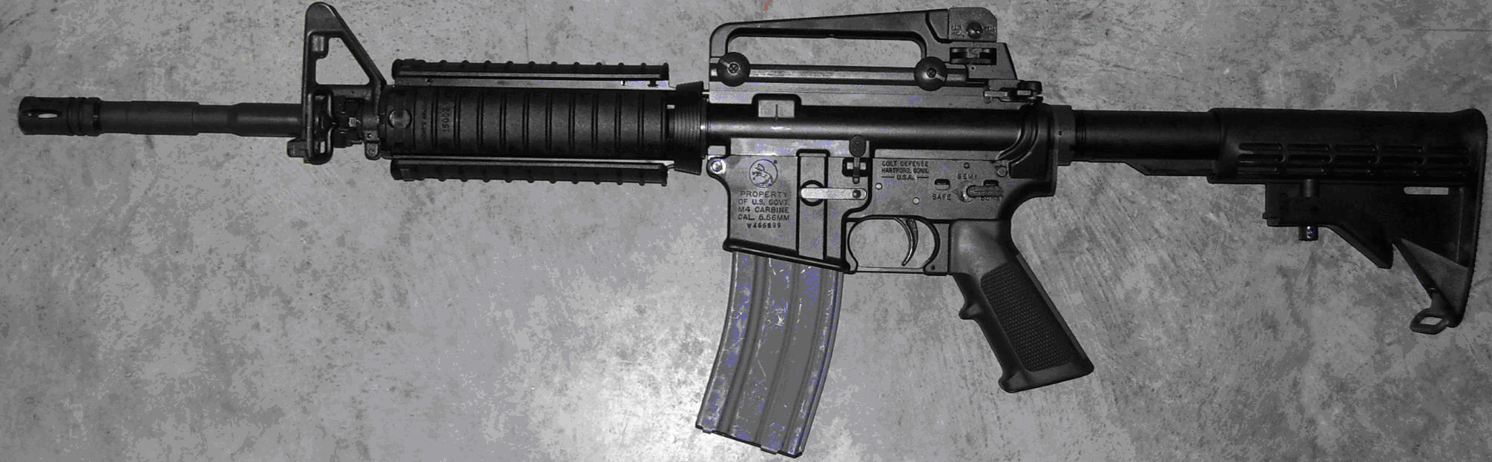
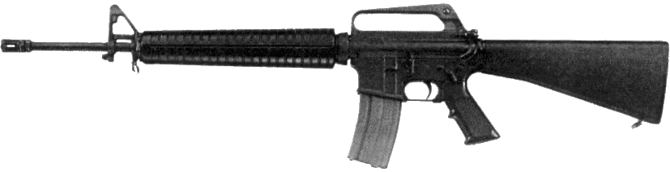
The M16/M4 Carbine rifle (see figures 1 and 2) is a 5.56mm, magazine-fed, gas-operated, air-cooled, shoulder-fired weapon that can be fired either in automatic three-round bursts or semiautomatic single shots as determined by the position of the selector lever.
M16 Figure 1. M4 Carbine
M16 |  | M4 Carbine
5.56 mm | Caliber | 5.56 mm
8.79 pounds | Weight (w/30 round magazine) | 7.5 pounds
39 5/8 inches | Length (w/compensator) | 29.75 inches w/butt stock closed  33 inches w/butt stock open
1 / 7 twist | Rifling | 1 / 7 twist
3,100 feet per second (approximately) | Muzzle velocity | 2,970 feet per second (approximately)
52,000 PSI | Chamber pressure | 52,000 PSI
800 rounds per minute (approximately) | Cyclic rate of fire | 800 rounds per minute (approximately)
 | Maximum effective rates of fire:
45 RPM | Semiautomatic | 45 RPM
90 RPM | Burst | 90 RPM
12 – 15 RPM | Sustained rate of fire | 12 – 15 RPM
 | Maximum effective range:
550 meters | Individual/point targets | 500 meters
800 meters | Area targets | 600 meters
3534 meters | Maximum range | 3600 meters
Figure 2. Characteristics of each service rifle

3. FIREARM SAFETY RULES

The following rules apply to all weapon systems.

Treat every weapon as if it were loaded
Never point a weapon at anything you do not intend to shoot
Keep your finger straight and off the trigger until you are ready to fire
Keep the weapon on safe until you intend to fire

- WEAPON CARRYING CONDITIONS
Condition Four
Magazine removed
Chamber empty
Bolt forward
Ejection port cover closed
Weapon on safe
Condition Three
Magazine inserted
Chamber empty
Bolt forward
Ejection port cover closed
Weapon on safe
Condition Two
Not applicable for the M16/M4
Condition One
Magazine inserted
Round in the chamber
Bolt forward
Ejection port cover closed
Weapon on safe

5. MAJOR PARTS OF AN M16/M4 CARBINE RIFLE
Before taking your rifle apart, you should know the nomenclature (names) of all externally visible parts. Using your own rifle, find and learn the nomenclature of all outside parts. Then, as you disassemble the rifle, learn the nomenclature of all internal parts (see figure 3).

Spent Brass Deflector
Front Sight Assembly
Rear Sight Windage Knob
Charging Handle
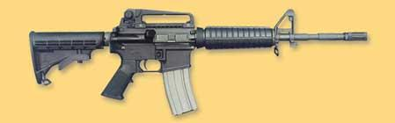
Ejection Port Cover
Bayonet Stud
Rear Sling Swivel
Magazine Release Button
Rear Sight Elevation Knob
Carrying Handle
Collapsible Butt stock

Selector Lever
Compensator
Slip Ring
Bolt Catch
Front Sling Swivel
Rear Sling Swivel

Hand guards

Figure 3. Nomenclature of External Parts

6. SAFETY FEATURES AND DISASSEMBLY OF THE M16/M4 CARBINE RIFLE
Clearing the M16/M4 Carbine Service Rifle (Safety Features/Precautions)
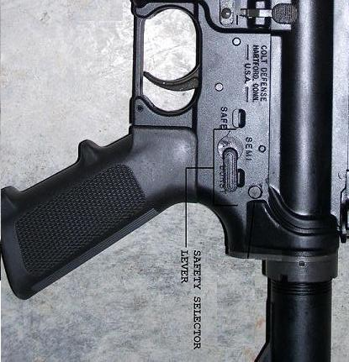
    - Before you disassemble the rifle ensure the weapon is on safe (see figure 4).
    - Attempt to point the selector lever to safe. If the weapon is not cocked, the selector lever cannot be pointed to safe.
    - Remove the magazine from the weapon by grasping it with the left hand, press the magazine release button with your right index finger, and pull the magazine straight down (see figure 5).
    - Lock the bolt carrier to the rear by grasping the charging handle, pressing the charging handle latch, and pull the charging handle all the way to the rear. Press in on the bottom of the bolt catch with the thumb or forefinger. Allow the bolt carrier to move slowly forward until the bolt engages the bolt catch. Return the charging handle to its forward position.
Figure 4. Selector Switch on Safe
    - Inspect the receiver and chamber by looking through the ejection port to ensure these areas do not contain ammunition. 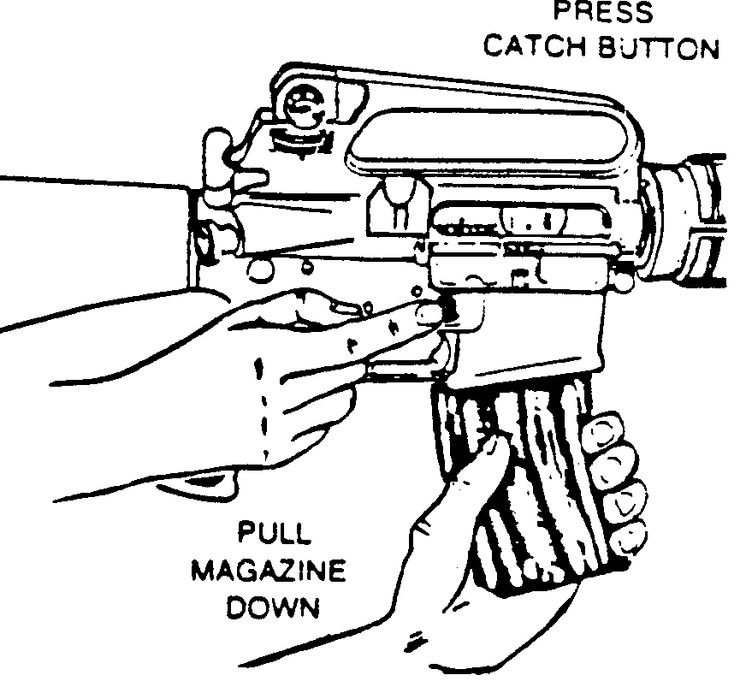
Figure 5. Removing the magazine

    - Check the selector lever to ensure that it points safe. The rifle is clear and safe only when:
- There is no round in the chamber
- The magazine is out
- The bolt carrier is locked to the rear

- The selector lever is in the safe position
Disassembly - when the weapon is clear you can disassemble the weapon by doing the following:
Allow the bolt carrier to go forward by depressing the upper portion of the bolt catch.
Remove the sling and place the rifle on the table or a flat surface, muzzle to the left, weapon on the right side.
Remove the hand guards
Place the butt of the weapon against a flat surface and pull down on the slip ring until the lower lip of one hand guard is clear.
Pull out and down on the hand guard until the upper lip is cleared of the hand guard cap.
Repeat the same operation to remove the other side of the hand guard. Considerable pressure is required to remove the hand guard from the slip ring.
Detach the upper receiver from the lower receiver
Press out the take down pin from left to right until the upper receiver swings free of the lower receiver.
Press out the receiver pivot pin.
Separate the upper and lower receiver groups.
Place the lower receiver group on the table.
Removing the charging handle and the bolt carrier group
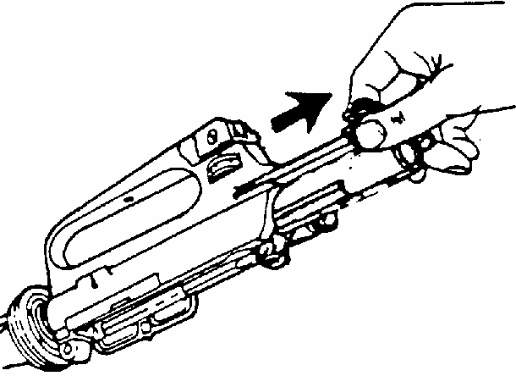
Hold the upper receiver group with the muzzle and carrying handle up. Grasp the charging handle.
Press the charging handle. Latch and pull the charging handle three inches to the rear to withdraw the bolt carrier from the receiver (see figure 6).
Grasp the bolt carrier and pull it out from the receiver. When the bolt carrier is removed, the charging handle can be removed from its groove in the receiver.
Figure 6. Removing the bolt carrier

Place the upper receiver on the table.
Figure 6. Removing the bolt carrier

Disassemble the bolt carrier group (see figure 7)
Press out the fire-retaining pin from right to left.
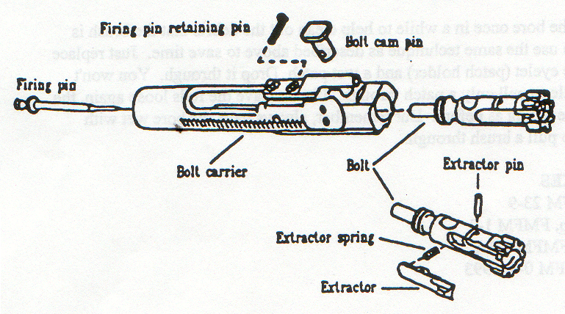
Elevate the front of the bolt carrier and allow the firing pin to drop free from its recess in the bolt. Rotate the bolt until the cam pin is clear of the bolt carrier key and remove the cam pin by rotating the head 90 degrees (1/4 turn) in either direction. Lift out of well in the bolt and bolt carrier. After the cam pin is removed, the bolt can be removed from its recess in the bolt carrier and disassembly of the bolt carrier group is complete.
Remove the buffer assembly
Push down on the buffer retainer. Allow the buffer assembly to move forward slowly until it is clear of the buffer retainer.
Figure 7. Bolt Carrier Group
Depress the hammer to the rear (downward) to allow the buffer assembly to clear the hammer. Remove the buffer assembly and the action spring.

- CLEANING AND LUBRICATION OF THE M16/M4 CARBINE SERVICE RIFLE
Normal care and cleaning will result in proper functioning of all parts of the weapon. Improper maintenance causes stoppages and malfunctions. Only "issued" cleaning materials should be used. These cleaning materials are carried in the compartment provided in the stock of the weapon on the M16 or in the cleaning kit for the M4 Carbine. Do not use any abrasive material to clean the rifle. Cleaner Lubricant and Preservative (CLP) is the only authorized lubricant for the M16/M4 Carbine rifle.
Cleaning and lubrication of the upper receiver
Clean the upper receiver until free of powder.
After cleaning, coat the interior surfaces of the upper receiver with CLP. Pay particular attention to shiny surfaces which indicate areas of friction.
Cleaning and lubrication of the barrel
Attach a bore brush to the cleaning rod, dip it in CLP, and brush the bore thoroughly.
Brush from the chamber to the muzzle using straight-through strokes.
Push the brush through the bore until it extends beyond the muzzle compensator.
Continue this process until the bore is free of carbon and fouling (never reverse the direction of the brush while in the bore).
Remove the brush from the cleaning rod and dry the bore with clean patches.
Do NOT attempt to retract the patch until it has been pushed all the way out of the muzzle compensator.
CAUTION: The cleaning rod is to be supported by hand, one section at a time, to prevent flexing and damage to the bore.
Cleaning the chamber
Attach the chamber-cleaning brush to a section of the cleaning rod.
Dip it in CLP, and insert it in the chamber.
Scrub in a circular motion.
Remove the brush and dry the chamber thoroughly with clean patches.
Clean the locking lugs in the barrel extension, using a small bristle brush dipped in CLP to remove all carbon deposits.
Clean the protruding exterior of the gas tube in the receiver with the bore brush attached to a section of the cleaning rod.
After cleaning, lubricate the bore and locking lugs in the barrel extension by applying a light coat of CLP to prevent corrosion and pitting. If the hand guards have been removed, rub a light coat of CLP on the surface of the barrel.
Place one or two drops of CLP on the front sight post.
Cleaning and lubrication of the bolt carrier group
Thoroughly clean all parts with a patch or an all-purpose brush dipped in CLP.
Clean the locking lugs of the bolt, using an all purpose brush and CLP.
Ensure that all carbon and metal filings are removed; then wipe it clean with dry patches and lubricate lightly.
Use an all-purpose brush dipped in CLP to scrub the extractor to remove carbon and metal filings; also clean the firing pin recess and the firing pin.
When dry and before final assembly, apply a coat of CLP to the bolt body, rings and carrier key.
When bolt carrier group is reassembled, apply a liberal amount of CLP to all exterior surfaces with particular emphasis to the friction points (i.e., rails and cam area). Put one drop of CLP in the cam pin track and two drops in the gas ports.
Cleaning and lubrication of the lower receiver group
Wipe any particles of dirt from the trigger mechanism with a clean patch or brush and place a drop of CLP on each of the pins for lubrication.
Components of the lower receiver group can be cleaned with CLP and a brush.
Use a scrubbing action to remove all carbon residue and foreign material and then drain the CLP from lower receiver and wipe dry.
Cleaning and lubrication of the magazine
Disassemble the magazine, being careful not to stretch or bend the spring.
Scrub the inside of the magazine with a bristle brush, dipped in CLP, and wipe it dry.
The magazine is made of aluminum and does not need any lubrication.
Scrub the spring clean of any foreign material using an all-purpose brush dipped in CLP.
Wipe dry and apply a very light coat of CLP to the spring.

- ASSEMBLY OF THE Ml6/M4 CARBINE RIFLE
Lower receiver group assembly
Press hammer to the rear (downward).
Insert the buffer assembly into the recess in the stock of the weapon.
Depress the buffer retainer so that the buffer assembly will insert into the recess completely.
Release the pin so the buffer assembly is locked into place.
Set the bolt carrier group down on the table.
Bolt carrier group assembly
Insert the bolt through the front end of the carrier with the extractor facing at the 11 o’clock position.
Insert the cam pin into the carrier and rotate it ¼ turn.
Insert the firing pin through the rear of the carrier and let it drop into the recess for the firing pin.
Insert the firing pin retainer pin into the carrier from left to right.
Set the bolt carrier group down on the table.
Upper receiver group and charging handle assembly
Replace the charging handle by placing the charging handle inside the upper receiver. This is done by lining up the grooves on the charging handle with the slots in the upper receiver and pushing it in about one inch.
Then insert the bolt carrier group, with the carrier key resting in the charging handle, into the upper receiver until they lock into place.
Assembly of major parts
Align the upper receiver with the lower receiver together, push in the pivot, and take down pins to lock the receivers together.
Insert the top of each hand guard cap and pull down on the slip ring so the bottom lip of the hand guard will slip in and lock in place when you release the slip ring.
Lock the bolt to the rear by pulling on the charging handle and pressing the bolt catch and letting the carrier go forward slowly until the bolt catch engages the bolt carrier group.
Return the charging handle to the original position. Place the selector lever on safe

Replace the sling on the weapon.

- FUNCTION CHECK
A function check of the rifle consists of checking the operation of the rifle while the selector lever is in each position; Safe, Semi, and Burst
Pull charging handle to the rear and release.
Place selector lever on “Safe”.
Pull trigger - Hammer should not fall.

Place selector lever on “Semi”.
Pull trigger and hold to the rear - hammer should fall.
Pull charging handle to the rear and release.
Release the trigger and pull to the rear again - hammer should fall.

Place selector lever on “Burst”.
Pull charging handle to the rear and release.
Pull trigger and hold to the rear - hammer should fall.
Pull charging handle to the rear three times and release.
Release trigger and pull again - hammer should fall.

REFERENCE

Rifle Marksmanship MCRP 3-01A

M16/M4 Review

1. Describe the characteristics of the M16/M4 Service Rifle.

2. Describe the difference between weapons condition 3 and condition 1.

3. List the differences between the M16 and the M4 Carbine.

4. What product is used to clean the service rifle?

