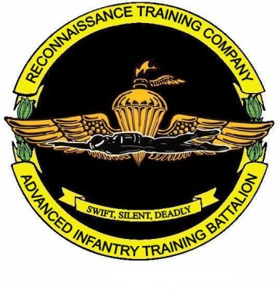
Student Required Gear List

3 | MARPAT, green utilities with name and service tapes (Minimum)
3 | MARPAT, desert utilities with name and service tapes (Minimum)
2 | Bush covers; (1) Desert (1) Green
4 | Soft covers; (2) Desert (2) Green
1 | Appropriate color martial arts belt
15 | Boot/ Hiking socks; must be subdued color
2 | Pairs of boots (USMC issue only)
8 | Skivvy shorts
6 | Green T-shirts
2 | Green PT shorts for physical fitness training (no silkies authorized)
8 | Pairs of white athletic socks (ankle or calf height)
1 | Set of green sweat pants and sweat shirt (USMC Running Suit is NOT  Authorized)
1 | Pair of running shoes (NO minimalist – Must be appropriate for trail running over rocky terrain)
1 | Set of ID tags
1 | ID card
2 | Wrist watches (waterproof; second is inexpensive backup)
2 | Sets of rank insignia (Minimum)
2 | Sets of hearing protection
1 | Flashlight with red lens and spare batteries
1 | Set of hygiene gear to include sun block
1 | Pair of shower shoes
2 | Combination locks
2 | Black ink pens
2 | Highlighters
2 | Mechanical pencils
1 | 8 ½ x 11 Notebook
1 | Set Camouflage Paint
1 | Sea Bag / Kit Bag

Special Notes:
Unit PT gear is not authorized for wear while attending training at the BRC.
The initial screening for all students on Training Day One (TD-1) will be a 1st Class PFT and a swim screening in utilities (no boots), as follows:

- 500 meter un-timed swim utilizing breast stroke or sidestroke ONLY.
(2) 25 meter underwater swim (Sub-Surface swim requires that the student CANNOT break the surface).
(3) 12 - 15 feet deep weapon (rubber rifle) retrieval and 10 meter tow.
(4) Enter water from a height of 8 to 15 feet using the abandon ship technique, tread water for 30 minutes.

