# C:\Users\stevan.perez1\Pictures\AITB1.jpg C:\Users\stevan.perez1\Pictures\AITB2.jpg.png

# COMBAT HUNTER TRAINER COURSE

* Purpose: To provide a Marine with the knowledge and skills required to train, lead, and employ combat hunter and combat policing skills. The Marine receives training in planning, conducting, and evaluating training events to include classes on: unit training readiness, training standards, designing training plans, and developing a training event. The desired end-state is a Marine able to integrate combat hunter and combat policing skills into their unit training program.
* Task List:
  + 2000 Level:
    - Analyze spoor and profile an anomaly
    - Perform individual actions in a tracking team
    - Lead a combat tracking team in a follow-up
    - Develop an integrated observation plan
    - Establish and maintain a relationship
    - Conduct combat policing
* Methodology: The course covers: enhanced observation, combat tracking, combat profiling, combat policing, and the hunter mindset. Areas of instruction emphasize overall situational awareness of unit leaders, proactively identifying threats and making sound and timely decisions. The scenarios are executed as tactical decision games, decision-forcing cases, and field training.

# Course Length: 3 Weeks / 15 Training Days

[FY 13 Course Dates](http://www.tecom.marines.mil/Portals/127/Docs/AITB/FY14/Det%20HI/CHTC%20Course%20Dates.docx)

[FY 14 Course Message](http://www.tecom.marines.mil/Portals/127/Docs/AITB/FY14/Det%20HI/FY14%20CHTC%20Course%20Dates.docx)

[Command Screening Check List](http://www.tecom.marines.mil/Portals/127/Docs/AITB/FY14/Det%20HI/CHTC%20Screening%20Checklist.docx)

[Gear List](http://www.tecom.marines.mil/Portals/127/Docs/AITB/FY14/Det%20HI/CHTC%20Gearlist.docx)

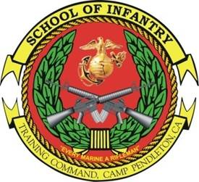 NON-GCE 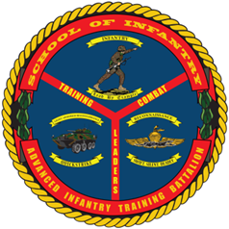  
COMBAT HUNTER  
6-DAY COURSE

* Purpose: To provide a more ethically minded, tactically cunning, and lethal Marine better prepared to succeed across the range of military operations. The desired end-state is a Marine with enhanced combat hunter and combat policing skills.
* Task List:
  + 1000 Level:
    - Conduct observation
    - Identify anomalies
    - Explain the decision cycle (OODA) process
    - Utilize tactical questioning
* Methodology: The course covers: enhanced observation, combat tracking, combat profiling, combat policing, and the hunter mindset. Areas of instruction emphasize overall situational awareness of the individual Marine proactively identifying threats and making sound and timely decisions. The scenarios are executed as practical application and field training.
* Course Length: 1 Week / 6 Training Days