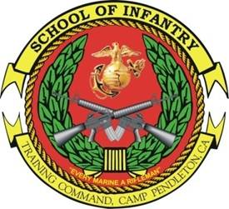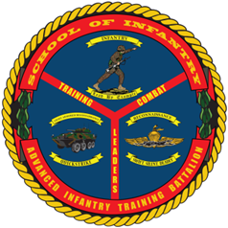

MARTIAL ARTS
INSTRUCTOR COURSE
- Purpose: To prepare and certify all Marines as Martial Arts Instructors (MOS 0916). The course provides instructional knowledge and techniques necessary for training and certifying personnel at the tan, gray, and green belt user levels.
- Task List:
  - 2000 Level:
    - Prepare for instruction and conduct a lesson
    - Reinforce core values through values-based mental and character tie-ins
    - Supervise free sparring
    - Conduct sustainment and integration training
    - Conduct user level belt certification and maintain MCMAP records
- Methodology: The course covers: instructor skills, green belt techniques and tie-ins, implementation of a MCMAP combat conditioning program, conduct of sustainment and integration training, and tan, gray, and green belt instructor skills. Areas of instruction emphasize all three disciplines (mental, character, and physical) of MCMAP, relevant to the student’s professional development both as an instructor and practitioner of MCMAP. The mental and character disciplines are addressed through student instruction and evaluation on guided discussions, warrior studies, and martial culture studies. The physical discipline is developed through student instruction and evaluation in rifle and bayonet techniques, ground fighting, throws, chokes, knife techniques, weapons of opportunity, and elements of anatomy and physiology.
- Course Length: 3 Weeks / 15 Training Days

FY 13 Course Dates
FY 14 Course Message
Command Screening Check List
Gear List

