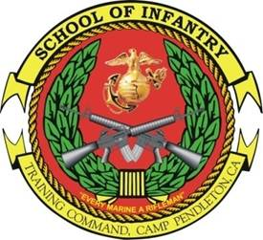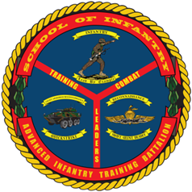

LAV CREWMAN
COURSE
Purpose: To provide training and education to entry level 0313s and lateral-movers that will serve as Light Armored Vehicle Drivers within a Light Armored Reconnaissance platoon/company. Upon completion of the course, students will possess the technical skills requisite of a 0313 Driver as well as basic knowledge regarding vehicle operation and maintenance. Graduates of LAV Crewmen Course will receive the MOS of 0313 LAV Crewmen and will be issued a LAV operator’s permit.
- Task List:
  - 1000 Level:
    - Perform Preventive Maintenance Checks and Services (PMCS) on a LAV & Turret
    - Drive the LAV
    - Introduction to Weapons Operations and Maintenance
    - Vehicle Recovery Operations
  - 2000 Level:
    - Execute tactical formation and movement techniques
- Methodology: The course provides detailed instruction on 1st echelon maintenance, driving techniques, LAV turret operations, and preparation for water operations. Through a combination of lecture, demonstration, practical application, and field training, the course prepares students to operate and maintain an LAV-25. To become certified LAV operators, all students must pass the driver skills test and execute an on-base road march as part of a unit.
- Course Length: 6 Weeks / 30 Training Days

FY 13 Course Message
Command Screening Check List
Gear List
Date Change

