Messing and Billeting Instructions
- Students assigned to Combat Instructor School from outside the Camp Pendleton area are required to maintain a room, and will draw partial per diem (M&IE). Students assigned from the local travel area (MCAS Miramar) will not be assigned a room nor receive partial per diem.

- Student billeting is located in building 52609. During normal working hours students will check in with Combat Instructor School staff located in building 520592, room 115. Check in will be in Service Alphas. After hours check in will be located in building 520523, with the regimental AOOD/SDNCO. Let them know you are checking into Combat Instructor School and they will provide barracks for you until you check in the following day with Combat Instructor School staff.
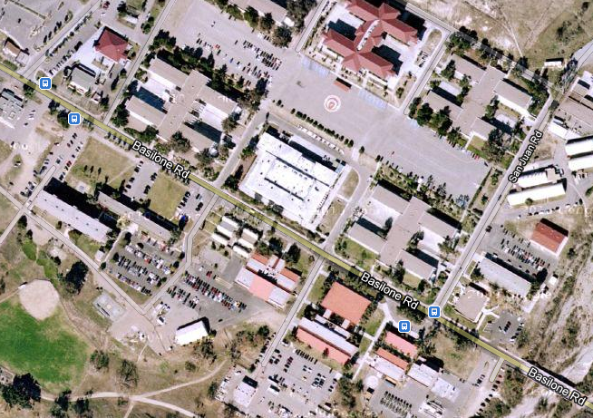
NEW
CP
Bldg. 520599, Rm 113 CIS classroom located in hallway.

Dining Facility

Enlisted Dining Facility Meal prices are as follows:
Weekday
- Breakfast , 0500-0700 $2.50
- Breakfast Burrito, 0730-0930 $2.50
- Submarine Line, 1100-1300 $4.60
- Dinner, 1600-1800 $4.60
Weekends and Holidays
- Brunch, 0800-1100 $5.25
- Dinner, 1500-1700 $6.45
Mail
If you want to receive mail while attending Combat Instructor School use the following address:
(STUDENT RANK AND NAME)
School of Infantry (West)
Combat Instructor School
Box 555061
Camp Pendleton, California 92055-5061

Directions and MCCS Information

If traveling by air, schedule your flight to arrive at the San Diego, or Los Angeles International Airports. You will be required to take public transportation to Camp Pendleton (52 Area). Estimated cost from San Diego for a taxi is $50.00, and from Los Angeles the cost estimated at $80.00 (save your receipts for reimbursement).

