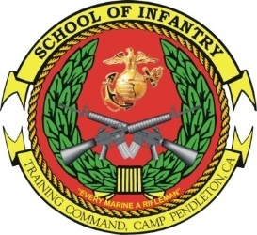RECONNAISSANCE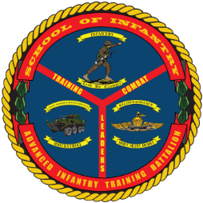
TEAM LEADERS
COURSE
- Purpose: To train students in the advanced skills associated with the billet of team leader within a Reconnaissance Platoon.
- Task List:
  - 2000 Level:
    - Ground Reconnaissance Operations
    - Amphibious Reconnaissance Operations
    - Reconnaissance and Surveillance
    - Airborne and Combatant Dive Operations
    - Fire Support
    - Methodology: Reconnaissance Team Leader Course provides the students with the required knowledge and skills needed to effectively perform duties as a reconnaissance team leader. This course emphasizes planning and leading teams in patrolling, training, motorized operations, amphibious insert/extraction skills, urban operations, combat conditioning, and offensive and defensive operations. The course combines lecture, demonstration, and practical application in tracking, fire support planning, organic and non-organic weapons employment, demolitions, small unit training, mounted operations, surveillance, patrolling, and amphibious operations.
- Course Length: 9 Weeks / 44 Training Days

FY 13 Course Dates

FY 14 Course Dates

Gear List

Command Screening Checklist

