SCOUT SNIPER BASIC 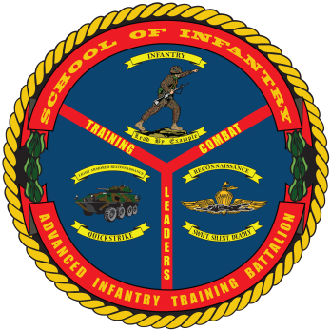 COURSE
- Purpose: To train students in the basic skills associated with being a Scout Sniper in order to qualify them for the MOS of 0317 and follow-on service in a Scout Sniper Platoon, Reconnaissance Platoon, Marine Special Operations Team or as required.
- Task List:
  - 2000 Level:
    - Combat Marksmanship
    - Patrolling, Reconnaissance and Surveillance
    - Sniper Operations
- Methodology: Scout Sniper Basic Course provides Marines with the required knowledge and skills needed to perform duties of a Scout Sniper in the operating forces. This course provides instructions in the fundamentals of marksmanship ballistics, cold bore shots, range cards, range estimation, and duties as a scout sniper observer. Marines qualify at known and unknown distances at various ranges using a limited visibility device with the M40 series Sniper Rifle; qualify at known and unknown distances with the Semi Automatic Sniper System (SASS) and zero the .50 Cal series Special Application Scoped Rifle (SASR). Marines also engage targets at unknown distances using alternate positions, engaging moving and multiple targets using mil hold and max point blank techniques. Tactical instruction includes land navigation, camouflage, surveillance, photograph, patrolling, individual actions in a final firing position and practical application, operating from a hide, call for fire, field communications, and reporting of information.
- Course Length: 12 Weeks / 54 Training Days

FY 13 Course Dates
FY 14 Course Dates
Gear List
Command Screening Checklist

