COMBAT INSTRUCTOR SCHOOL OVERVIEW
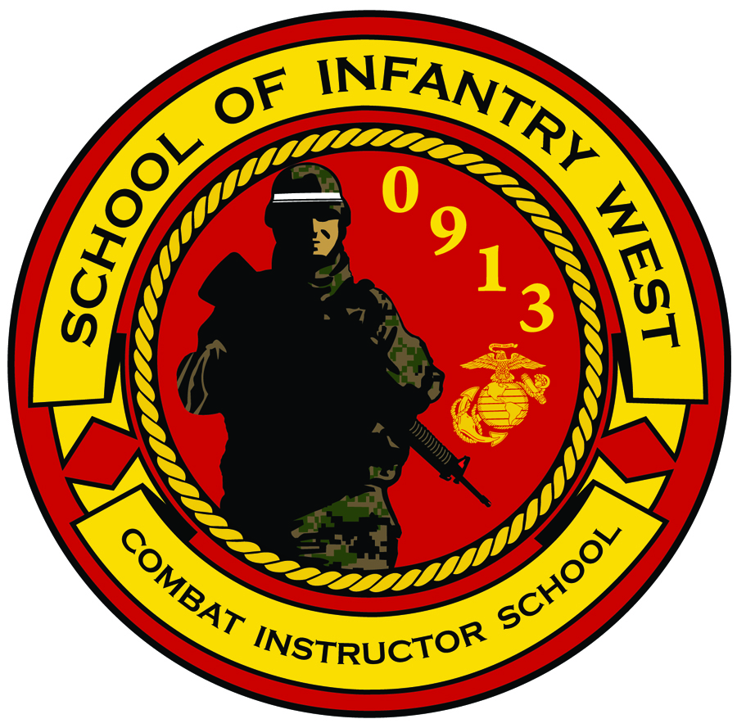
Combat Instructor School
Camp Pendleton, CA

1. ORGANIZATION OF COMBAT INSTRUCTOR SCHOOL (CIS). The school staff consists of a Director, First Sergeant, Chief Instructor, Academics Coordinator and five Squad Instructors. The Instructors are current combat instructors who have distinguished themselves from their peers throughout the School of Infantry. They are closely screened and individually selected.
a. Mission. To develop Marines' leadership, character, knowledge, and fitness in order to fortify them with the values, strength, and skills required to succeed as Combat Instructors in a challenging environment.
b. Scope. The scope and content of the School’s training syllabus is four-fold:
(1) First and foremost, it is a LEADERSHIP SCHOOL. Although an initial, comprehensive review of the Marine Corps Common Skills is provided, the focus is on the further development of the Marine’s leadership abilities.
(2) This course is designed to provide Marines with the knowledge, skills and ability to instruct entry-level Marines in Marine Corps Common Skills and Marine Corps Values.
(3) Provides the students with thorough knowledge of the rules, regulations and procedures which govern SOI(W) training.
(4) Prepares students to lead and instruct entry level Marines during combat training.

c. Course Overview. Upon successful completion of the course a Marine is capable of performing the Special Duty Assignment, Combat Instructor at the school of infantry.
(1) Length of Course: 9 Weeks
(2) Maximum Class Capacity: 60 Students
(3) Minimum Class Capacity: 15 Students
(4) Classes per fiscal year: 4
(5) Academic Hours: 458
(6) Physical Training Hours: 60
(7) Kilometers of Hikes: 50 (100 total with remedial hikes)
(8) Written Evaluations: 8
(9) Performance Evaluations: 103
d. Academic Subjects.
(1) Leadership Program. Designed to further develop the student’s practical leadership abilities and broaden their perspectives in order to better prepare them for the challenges of SOI and other challenges that they will face throughout their careers. Positive leadership is highly emphasized. Additional classes will analyze case studies and historical events in SOI training in order to provide an appreciation of the tremendous responsibilities that students will accept as Combat Instructors. The leadership program provides the student with the leadership tools necessary to validate the mental, moral and physical transformation of each U.S. Marine into a war fighter. Here, Combat Instructor School students learn to evaluate Marines in a series of physical, mental, and moral hardships designed to emphasize the importance of teamwork and adherence to our Core Values in overcoming adversity.
(2) Standard Operating Procedures (SOP) for Entry-Level Marine Training. The SOP provides students with a complete understanding of the rules, regulations, policies, and procedures governing SOI-West. Refer to SOI-W School Order P1510.1F Student Training SOP for more information.
(3) Combat Conditioning. Combat Conditioning is one of the most visible illustrations of leadership by example. Accordingly, preparations in becoming a Combat Instructor must be designed to ensure confidence through endurance and agility. The schools’ conditioning program is designed to develop four components of physical fitness: strength, endurance, agility and coordination. Further, it provides the ability to instruct entry-level Marines during the conduct of the SOI physical training program. Students may refer to MCO 6100.13 W/CH 1 Marine Corps Physical Fitness Program for more information.
(a) Students are required to achieve a first class PFT for their age group on the final PFT. Students will also be required to pass the CFT in order to graduate the course.
(b) All students must be within height and weight standards when you arrive.

(c) It is highly recommended that students run in boots and utility trousers and hike with loads approximately 60 pounds prior to arrival as most of the training sessions will be conducted in that uniform. Marines are highly encouraged to focus on running on terrain that includes hills.

(d) Marines will conduct a 5, 10, 15 and 20 kilometer hike. All Marines will be required to complete the conditioning hike program which culminates with a 20-kilometer hike. These hikes will be conducted with all issued gear to include flak jacket, SAPI’s and a personal weapon. The pack will weigh about 60 pounds.

(4) Basic Instructor Course (BIC). This develops the student’s individual skills, experience and confidence in the preparation and presentation of periods of instruction. Each student will be required to pass a 50-minute presentation on selected infantry subjects. Those students that report to Combat Instructor School with a BIC or Formal Schools Instructor Course (FSIC) certification will receive a Faculty Advisor certification at the end of the course.
(5) Marine Corps Common Skills. Students will be exposed and tested on the Marine Corps Common Skills of the subjects they will be required to teach, mentor, and remediate entry-level Marines. Students may reference NAVMC 3500.41 for a list of the skills that they will be required to master.
(6) Weapons/Marksmanship. Develops student’s ability to provide instruction on the characteristics, nomenclature, disassembly, assembly, cycle of operations and maintenance of various Marine Corps weapons. The course will focus on the following weapon systems: M16A4, M9, M203, M249, M240, AT4 and the M67. It also familiarizes students with basic fundamentals of marksmanship and weapons handling procedures. It is HIGHLY RECOMMENDED that prospective students complete the Combat Marksmanship Course prior to attending Combat Instructor School. Refer to MCO 3574.2K Marine Corps Marksmanship Programs for more information.
(7) Values Based Training. Values Based Training is how Combat Instructors thread and tie in Core Values, Leadership Traits, Leadership Principles and the Warrior Ethos in every subject we teach. Our values Based Training package is designed to provide the students with an appreciation how personal and professional values affect the Marine Corps and the American society. Most importantly, Combat Instructors will continue to enhance the Core Values with entry-level Marines.
e. Non-Academic Subjects
(1) Information Program. A variety of support agency briefs are scheduled to familiarize the students with the policies and procedures of those school activities and facilities
f. Daily Routine. Refer to enclosure (7) for a detailed schedule. The normal daily routine for students is as follows:
Event Time
Morning BDR 0530-0630
Physical Training 0630-0900
Classroom Instruction 0900-1200
Noon Meal 1200-1300
Classroom Instruction 1300-1630
Evening Clean-up/Remediation 1630-TBD
2. Uniforms. Students reporting to Combat Instructor School must have their basic military issue as set forth in Marine Corps Bulletin 10120 (Fiscal Year Individual Clothing Allowances for Enlisted Personnel). Use this series of bulletins for information concerning uniform changes and requirements. All clothing must be serviceable (that is, no frayed collars or cuffs; no spots or mending on any part of the uniform) and clothing must fit properly. Every article of uniform clothing must be plainly marked in accordance with MCO P1020.34G (Marine Corps Uniform Regulations). Students reporting to Combat Instructor School will not be required to bring their own Consolidated Issue Facility (CIF) gear. That gear will be issued upon arrival to Combat Instructor School. Refer to enclosure (3) for a complete list of required uniform items for Combat Instructor School.
3. Completion of training. Upon successful completion of CIS, students will have the opportunity to check-in to the company and battalion that they have been assigned to at SOI-W. All students regardless of how they reported to CIS will have the opportunity to take up to 30 days of leave prior to beginning their tour as a Combat Instructor. Special Duty Assignment Pay will start once that Marine checks into their respective battalion at SOI (W).
a. Temporary Duty Under Instruction (TEMINS). Students that reported to CIS as TEMINS will be given the opportunity to take 30 days of leave prior to beginning their tour in their respective company.
b. Temporary Additional Duty (TAD). Students in a TAD status will have to report back to their unit and finish their check-out process. Once their check-out process is complete, they will afforded the opportunity to take up to 30 days of leave prior to reporting back to SOI(W).
c. Housing. Approximately three to four weeks prior to graduation, students will be afforded the opportunity to apply for base housing.
d. Uniform Issue. Upon completion of Combat Instructor School students will be given a (604 Form). The form will include (1) pair of boots, (2) sets of desert marpat utilities, (2) sets of woodland marpat utilities, (1) desert garrison cover, (1) desert boonie cover, (1) woodland garrison cover, and (1) woodland boonie cover.

4. Preparing of Combat Instructor School. CIS is a very demanding course. You must be prepared both physically and mentally for this course. Marines reporting to this course with personal or legal problems will have difficulty with the course. Resolve all issues prior to reporting to CIS.

a. Mental Preparation. Review your basic infantry skills outlined in Fleet Marine Force Manual (FMFM) 6-5 w/Ch 1 Marine Rifle Squad. Students reporting to CIS should also complete the following on-line courses:

(1) Systems Approach to Training (SAT)

(2) Operational Risk Management (ORM)

(3) Anti-Terrorism Level 1 Training

(4) Range Safety Course

(5) Marine Marksmanship

b. Physical Preparation. Marines may report to CIS with a second class PFT but must be able to achieve a first class PFT by the end of the course.

If you have any questions concerning the course or this material, please contact any of the Combat Instructor Staff at (760) 763-7622.

