COMBAT INSTRUCTOR SCHOOL OVERVIEW
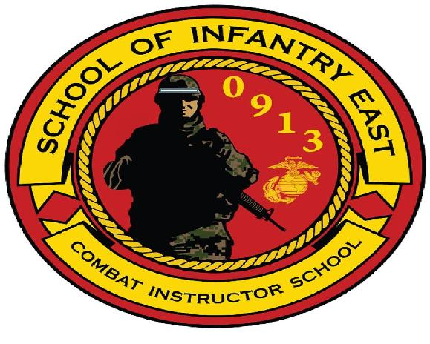

Combat Instructor School
Camp Geiger, NC

1. ORGANIZATION OF COMBAT INSTRUCTOR SCHOOL. The school staff consists of a Director (Major), First Sergeant (1stSgt), Chief Instructor (GySgt), Squad Instructors (GySgt/SSgt), and a Training NCO (Sgt). The Instructors are current combat instructors who have distinguished themselves from their peers throughout the School of Infantry. They are closely screened and individually selected.

a. Mission. The purpose of this course is to screen and develop Marines in leadership, character, knowledge, and fitness in order to fortify them with the values, strength, and skills required to succeed as Combat Instructors in a challenging environment.

b. Scope. This course is designed to train and educate instructors in the leadership, character, knowledge and skills required to formally train entry-level Marines. The Marine receives training and is evaluated on tactics and techniques associated with offensive, defensive, patrolling, and urban operations and
in individual weapons and associated optics; land navigation skills; combat conditioning; communications; cardiopulmonary resuscitation; Tactical Combat Casualty Care (TCCC); combat
marksmanship; combat hunter techniques; and leading value based guided discussions. Upon successful completion of this course, a Marine is awarded the MOS 0913 and is capable of performing the duties of a Combat Instructor at the School of Infantry.

c. Academic Subjects

  - Leadership Program. Designed to further develop the student's practical leadership abilities and broaden their perspectives in order to better prepare them for the challenges of SOI and other challenges that they will face throughout their careers. Positive leadership is highly emphasized. Additional classes will analyze case studies and historical events in SOI

Training in order to provide an appreciation of the tremendous responsibilities students will accept as Combat Instructors. The leadership program provides the student with the leadership tools necessary to validate the mental, moral, and physical transformation of each U.S. Marine into a war fighter. Here, the students learn to evaluate Marines in a series of physical, mental and moral, friction, and hardship designed to emphasize the importance of teamwork and adherence to our Core Values in overcoming adversity.

  - Standing Operating Procedures (SOP) For Entry-Level Marine Training. The SOP provides students with a complete understanding of the rules, regulations, policies, and procedures governing SOI-East.

  - Combat Conditioning. Combat Conditioning is one of the most visible illustrations of leadership by example. Accordingly, preparations in becoming a Combat Instructor must be designed to ensure confidence through endurance and agility. The school's conditioning program is designed to develop four components of physical fitness: strength, endurance, agility, and coordination. Further, it provides the ability to instruct entry-level Marines during the conduct of the SOI physical training program. All Marines, both male and female will be required to complete the Obstacle Course, and the conditioning hike program which culminates with a 20k. It is highly recommended that students run in boots and utility trousers on occasion prior to arrival as many training sessions will be conducted in that uniform. Therefore, future students should begin a progressive conditioning program that focuses on total body and core strength prior to reporting to ensure they are physically and mentally prepared for physical training program while attending Combat Instructor School. Students will be required to run a 1st class PFT and CFT in order to graduate the course.

  - Instructional Techniques. This develops the student's individual skills, experience, and confidence in the preparation and presentation of periods of instruction. The student's progress is evaluated by graded 50 minute presentations on selected infantry subjects.

  - Marine Corps Common Skills. Students will be exposed and tested on the Marine Corps Common Skills representative of the subjects they will be required to teach, mentor and remediate entry-level Marines.

  - Weapons/Marksmanship. Develops student’s ability to provide instruction on the characteristics, nomenclature, assembly, disassembly, cycle of operations, and maintenance of all infantry squad organic weapons used within the Marine Corps. It also familiarizes students with basic fundamentals of marksmanship and weapons handling procedures.

  - Values Based Training. Values Based Training is how Combat Instructors thread and tie in Core Values, Leadership Traits, Leadership Principles, and Warrior Ethos in every subject we teach. Our Values Based Training package is designed to provide the students with an appreciation of how personal and professional values affect the Marine Corps and American Society. Most importantly, Combat Instructors will continue to enhance the Corps' values. We establish Core Values in our lessons, not lessons in our Core Values.

d. Non-Academic Subjects

  - Information Program. A variety of support agency briefs are scheduled to familiarize the student with the policies and procedures of those school activities and facilities which directly support the School of Infantry.

e. Daily Routine. The normal daily routine for students is as follows:

Routine | Daily
PT/Instruction | 0600-1100
Noon Meal | 1100-1300
Instruction | 1300-1800
Evening clean-up/Remediation | 1800

2. Uniforms. Students reporting to Combat Instructor School must have their basic military issue as set forth in Marine Corps

Bulletin 10120 (Fiscal Year Individual Clothing Allowances for Enlisted Personnel), refer to this series of bulletins for information concerning uniform changes and requirements. All clothing must be serviceable (that is, no frayed collars or cuffs; no spots or mending on any part of the uniform) and

clothing must fit properly. Every article of uniform clothing must be plainly marked in accordance with MCO P1020.34G (Marine Corps Uniform Regulations).

3. Preparations Prior to Reporting for Special Duty Assignment training as a Combat Instructor. PREPARATION IS THE KEY TO
SUCCESS!

a. Combat Conditioning/Physical Training. The CC/PT program is demanding and progressive in nature. Students should prepare themselves for this program by increasing their upper/lower body strength while developing a high level of cardiovascular endurance. Historically, students experience problems negotiating obstacles due to a lack of upper body strength and maintaining proper interval during formation runs in boots. In order to reduce lower leg injuries, at least one pair of solid running shoes (not court shoes or cross-trainers) is required.

b. Gear and Equipment. The gear list on the website identifies items that are required prior to the first training day. The MCX aboard Camp Geiger stocks the items specifically required by Combat Instructor School students. It is recommended that students have at least $50.00 on hand to purchase miscellaneous items. It is also recommended that students bring a pair of AUTHORIZED broken in boots for conditioning hikes.

