UNITED STATES MARINE CORPS
ENGINEER EQUIPMENT INSTRUCTION COMPANY
MARINE CORPS DETACHMENT
686 MINNESOTA AVE.
FORT LEONARD WOOD, MO 65473-8963

LESSON PLAN

PUBLICATIONS

EEO/EEC-A01

ENGINEER EQUIPMENT OFFICER/CHIEFS COURSE

A16ACN1/A1613E1

REVISED 07/22/2011

APPROVED BY ___________________ DATE ___________________

INTRODUCTION (5 MIN)

(ON SLIDE #1)

1. GAIN ATTENTION.
At what RPMs is the 624KR supposed to be when testing the output pressure of the steering pump? The fact that most of us cannot remember this kind of information makes publications necessary.
________________________________________________________________
________________________________________________________________
________________________________________________________________

(ON SLIDE #2)

2. OVERVIEW. Good morning/afternoon class. My name is _______. The purpose for this period of instruction is to provide you with knowledge and skills required to properly maintain required publications in support of maintenance and to identify directives necessary to manage a maintenance facility.

(ON SLIDE #3)

INSTRUCTOR NOTE
Introduce learning objectives.

3. LEARNING OBJECTIVES.

a. Terminal Learning Objective.

1. Provided engineer equipment, appropriate records/forms, and references, manage engineer equipment records and forms, to support mission requirements per the references. (1310-ADMN-2005) (1349-ADMN-2005)

2. Provided maintenance-related reports (MIMMS-AIS), appropriate equipment-related publications, and references, manage engineer equipment section supply support program, to support mission requirements per the references. (1310-ADMN-2007) (1349-ADMN-2007)

3. With a unit Publications Listing (PL) and Table of Organization and Equipment (T/O&E), access to publications websites and management systems, and references, manage publications program ensuring required publications are available to maintain the section's operational capabilities and readiness per the references.(1310-ADMN-2008) (1349-ADMN-2008)

b. ENABLING LEARNING OBJECTIVES.

1. Without the aid of references, identify the types of publications per the MCO 5215.1_, and NAVMC 2761. (1310-ADMN-2008a) (1349-ADMN-2008a)

2. Given a publication short title, and without the aid of references, identify the elements per the MCO 5215.1_, MCO P5215.17_, SECNAV M 5210.2_, and NAVMC 2761. (1310-ADMN-2008b) (1349-ADMN-2008b)

3. Given a publication control number, and without the aid of references, identify the elements per the MCO 5215.1_, MCO P5215.17_, and NAVMC 2761. (1310-ADMN-2008c) (1349-ADMN-2008c)

4. Without the aid of references, identify the purpose of the SL-1-2 per the MCO P4790.2_, and PLMS V3 UG. (1310-ADMN-2008d) (1349-ADMN-2008d)

5. Without the aid of references, identify the purpose of the SL-1-3 per the MCO P4790.2_, and PLMS V3VCUG. (1310-ADMN-2008e) (1349-ADMN-2008e)

6. Without the aid of reference, identify the purpose of the Publication Library Management System (PLMS) per the MCO P4790.2_. (1310-ADMN-2008f) (1349-ADMN-2008f)

7. Provided access to the USMC website SL-1-2/1-3, a list of equipment data, publication short titles, and publication control numbers, identify the publications required to support each item of equipment per the PLMS V3 UG, MCO P4790.2_, MCO 5215.1_, MCO P5215.17_, and NAVMC 2761. (1310-ADMN-2008g) (1349-ADMN-2008g)

8. Without the aid of references, identify the four functional areas of a publication control system per the MCO P4790.2_, MCO 5215.1_, and MCO P5215.17_. (1310-ADMN-2008h) (1349-ADMN-2008h)

9. Without the aid of reference, identify the purpose of the Marine Corps Publication Distribution System (MCPDS) per the UM-MCPDS 5605. (1310-ADMN-2008i) (1349-ADMN-2008i)

10. Without the aid of reference, identify the two parts of the NAVMC 10772 per the TM 4700-15/1. (1310-ADMN-2005h) (1349-ADMN-2005h)

11. Without the aid of reference, validate a NAVMC 10772 per the TM 4700-15/1_. (1310-ADMN-2005i) (1349-ADMN-2005i)

12. Without the aid of reference, identify information contained in FEDLOG per the UM 4400-124. (1310-ADMN-2007a) (1349-ADMN-2007a)

13. Without the aid of reference, identify the purpose of the SL-6-1 per the UM 4400-124. (1310-ADMN-2007b) (1349-ADMN-2007b)

14. Without the aid of reference, identify the purpose of the SL-6-2 per the UM 4400-124. (1310-ADMN-2007c) (1349-ADMN-2007c)

15. Given equipment identification information, and access to the FEDLOG, identify associated information per the UM 4400-124. (1310-ADMN-2007d) (1349-ADMN-2007c)

(ON SLIDE #4)

4. METHOD/MEDIA. I will present this information using the lecture method, aided by a detailed outline, your student outline, computer generated slides, a demonstration, and a practical application.

INSTRUCTOR NOTE
Explain Instructional Rating Forms to students.

(ON SLIDE #5)

5. EVALUATION. There will be a written and performance examination at the time indicated on your training schedule.

6. SAFETY/CEASE TRAINING (CT) BRIEF. Explain inclement weather route, safety area, and procedures; as well as fire evacuation route and procedures to students.

TRANSITION: Are there any questions on what information will be presented? Are there any questions on how this lesson will be presented? Are there any questions on how you will be evaluated? Are there any questions on safety or cease training issues? If not, let’s move to the Index of Publications.
________________________________________________________________
________________________________________________________________
________________________________________________________________

BODY (21 HRS 45 MIN)

(ON SLIDE #6)

1. Index of Publications. (30 MIN)
The Marine Corps has two types of publications: Technical and Non-Technical. Technical publications are divided into two types.

(ON SLIDE #7)

a. Technical Publication (Equipment Associated). These publications apply to a specific item of equipment. They are listed in the SL-1-2 under the Item Designator (ID) number of the equipment or component.

(ON SLIDE #8)

b. Technical Publication (Non-Equipment Associated). These publications apply to equipment in general, but not to one specific item of equipment. An example is TM 4700-15/1H, Ground Equipment Record Procedures, which pertains to all items of ground equipment within the Marine Corps inventory.

(ON SLIDE #9)

c. Non-Technical Publications. Directives published by all levels of command. An example is MCO P4790.2C, MIMMS Fields Procedures Manual. Non-Technical Publications are listed in the SL-1-3 & NAVMC 2761 (Catalog of Publications). Non-Technical Publications are numbered by Standard Subject Identification Codes (SSIC), which are found in the SECNAV M-5210.2.

(ON SLIDE #10)

(1) Standard Subject Identification Codes (SSIC). Is a four or five digit number that identifies the document subject. These are required for all Marine Corps and Navy letters, messages, directives, forms and reports. Use of these codes provides a method for filing and retrieval of the document quickly.

(ON SLIDE #11)

TRANSITION: So far we have discussed the Index of Publications. Are there any questions over the material we have discussed to this point? I have a couple of questions for you. (Q1) What are the two types of publications? (A1) TECHNICAL AND NON-TECHNICAL. (Q2) What are the two types of Technical publications (A2) EQUIPMENT-ASSOCIATED AND NON-EQUIPMENT-ASSOCIATED. Now we will address identifying Publication Identification Numbers (Short Titles).
________________________________________________________________
________________________________________________________________
________________________________________________________________

(ON SLIDE #12)

2. PUBLICATION IDENTIFICATION NUMBER. (30 MIN)
(Short Title, consist of four or five elements).

a. First element. This will be the publication type.

(1) Computer Disk-Read Only Memory (CD-ROM). – Digitalized
publication.

(2) Electronic Technical Manual (ETM). – Digitalized Technical Manual (TM) on CD-ROM.

(3) Lubrication Instructions (LI) and Lubrication Orders (LO). - Furnishes technical information and instructions on the service, lubrication, and related preventive maintenance checks and service requirements for equipment or material.

(ON SLIDE #13)

(4) Marine Corps Bulletins (MCBUL). – Is a directive of a one time or brief term, has the same force/effect as an order, may require a one time report, and must have a self canceling provision. Normally remains in effect for up to 12 months, but may not remain in effect any longer.

(ON SLIDE #14)

(5) Marine Corps Orders (MCO). – Is a directive of continuing authority of information, a permanent reference, and/or requires continuing action. They are directed to the command’s overall functions rather than to individualized office functions.

(ON SLIDE #15)

(6) Modification Instructions (MI). – Authorizes the modification of equipment or material and furnishes technical instructions on how to accomplish the modification.

(7) Rebuild Standard (RS). – Is information for depot maintenance repair procedures will henceforth be incorporated into one manual and titled “Depot Maintenance Manual.” Depot maintenance manuals will be developed for all previously fielded Marine Corps equipment for which depot maintenance is required and for which equipment manuals were not in a 1st through 5th EOM & Parts format (15&P).

(ON SLIDE #16)

(8) Stock Lists (SL). - Provides all levels of the Marine Corps supply and maintenance operations with essential, up to date information for Marine Corps-managed items.

(9) Supplement. – Is a subsidiary document which compliments/augments information contained in a technical publication, primarily a TM.

(ON SLIDE #17)

(10) Supply Instructions (SI). – Furnishes supply support information on specific supply problems or procedures for specific equipment or classes of material.

(11) Support Concepts (SC). - Establishes the support policies developed for the logistic support of specific items of equipment.

(ON SLIDE #18)

(12) Technical Instructions (TI). – Furnishes technical advice or information on equipment or material.

(ON SLIDE #19)

(13) Technical Manuals (TM). – Furnishes technical information, instructions, and procedures of a permanent nature on the operation, maintenance, and handling of equipment or material. The importance of these publications cannot be stressed enough. The information contained within a TM will vary according to the specific equipment or material and the echelon coverage intended.

(ON SLIDE #20)

(14) Fielding Plan (FP). – Advises the FMF and other selected commands of the plan to field and logistically supports new items of equipment or systems being procured by the Marine Corps.

(15) Users Manual (UM). – Provides procedures for formatting and entering information into the Automated Information System (AIS).

(ON SLIDE #21)

b. Second element. This will be the basic number. One of three kinds of basic numbers will be assigned as described below:

(1) ID Number: Is a Numeric-Alpha character

(2) Federal Supply Classification (FSC) Number

(3) Standard Subject Identification Codes (SSIC)

(ON SLIDE #22)

c. Third element. This will be the maintenance echelon number. The EOM indicator is a significant information number provided to show the user the echelon of maintenance covered.

(1) –10. First echelon only.

(2) –20. Second echelon only.

(3) –30. Third echelon only.

(4) –40. Fourth echelon only.

(5) –50. Fifth echelon only.

(6) –12. First through second echelons.

(7) –23. Second through third echelons.

(8) –34. Third through fourth echelons.

(9) –45. Fourth through fifth echelons.

(10) The letter “P” will follow the maintenance indicator number when the manual is a parts list. When parts are incorporated into the manual with text, the TM shall be designated “-12&P, -20&P, -34&P” as applicable.

(ON SLIDE #23)

INTERIM TRANSITION: Up to this point we have discussed the first three elements of publication short titles. Are there any questions over this material? If not let’s move on to the remaining elements of short titles and Marine Corps Order short titles.
________________________________________________________________
________________________________________________________________
________________________________________________________________

(ON SLIDE #24)

d. Fourth element. This will consist of a sequence number. The sequence number follows the basic number or maintenance echelon indicator, as appropriate. The maintenance echelon indicator is not considered as part of the assigned sequence number. A virgule (/) separates the sequence number from the preceding element. The sequence number indicates a manual as being one of a series for specific equipment.

(ON SLIDE #25)

e. Fifth element. This will consist of an edition designator. The edition designator, if applicable, is an alphabetical character, starting with a capital suffix “A,” that indicates each revision of a publication after its initial printing. The edition designator appears as the last element of the total identification number; thus, it immediately follows the maintenance of echelon number or sequence number, as appropriate. Below are some examples:

(ON SLIDE #26)

TM 10050A 14

Technical Manual
Item Designator for Ditch Witch Mod 2300
Echelon of Maint.
1st–4th

(ON SLIDE #27)

FP / 11503A

Fielding Plan
850JR Medium Crawler Tractor (MCT)

(ON SLIDE #28)

TI – 11240 - 25/15A
VOLUME 1

Technical
Instruction
SSIC for
“Automotive”
Echelons of Maint.
2nd – 5th
Publication Sequence No. (15th in the Series, First Revision)
Vol. Designator
(1st in Sequence)

(ON SLIDE #29)

TM 3825 – 12/1

Technical Manual
FSC Group (Road Clearing, Cleaning, and Marking Equip.)
Echelons of Maint.
1st – 2nd

Publications Sequence No.
(1st in the Series

(ON SLIDE #30)

SI – 4400 – 15/6

Supply Instruction
SSIC (“Supply-General”) Prep. of Equip. for Shipment to Supply Center
Echelons of Maint.
1st – 5th
Publication
Sequence No. (6th Instruction in the Series

(ON SLIDE #31)

TM 08900A – CD

Technical
Manual
Item Designator No. Scraper, Earth Moving, 621B
Computer Disk
(CD-ROM)

(ON SLIDE #32)

f. Short Title assignments for Marine Corps Orders. These are slightly different from the examples previously mentioned.

(1) First segment. The same as previously mentioned.

(2) Second segment. This will be a Standard Subject Identification Code (SSIC).

(a) When a letter “P” precedes the SSIC, this identifies the order is a manual type order which is a directive whose content is best suited to a manual format; i.e., divided into chapters, sections, parts, etc. It is a directive in nature and contains details and information that is used in day-to-day functions; i.e. MCO P4790.2_.

(ON SLIDE #33)

(3) Third segment. This will be a consecutive number, which indicates only the sequence of issue within each SSIC; it has no relation to the subject of the directive.

(4) Fourth segment. This will be a capital letter, which indicates the revision. Below are some examples:
(ON SLIDE #34)

MCO 4400 . 16 G
MARINE CORPS
ORDER
SSIC “4400”
SUPPLY/MATERIAL
GENERAL
CONSECUTIVE
NUMBER
REVISION
CANCELLED
“F”

(ON SLIDE #35)

MCO P 4790 . 1 B
MARINE CORPS
ORDER
SSIC “4790”
MAINT/MATERIAL
MANAGEMENT
CONSECUTIVE
NUMBER
REVISION
CANCELLED
“A”
MANUAL
TYPE
ORDER

(ON SLIDE #36)

MCO P 4790 . 2 C
MARINE CORPS
ORDER
SSIC “4790”
MAINT/MATERIAL
MANAGEMENT
CONSECUTIVE
NUMBER
REVISION
CANCELLED
“B”
MANUAL
TYPE
ORDER

(ON SLIDE #37-41)

TRANSITION: During this period we discussed how to interpret publication short titles. Are there any questions over the material we have just covered? I have a couple questions for you. (Q1) How many elements are there in a publication short title? (A1) FOUR OR FIVE. (Q2) What information does each element of a publication short title provide? (A2) 1ST = PUBLICATION TYPE, 2ND = BASIC NUMBER (ID, FSC, OR SSIC), 3RD = ECHELON, 4TH = SEQUENCE (SERIES), 5TH = EDITION (REVISION). (Q3) What does the letter “P” represent when it is found at the end of the short title? (A3) THE PUBLICATION IS A PARTS MANUAL. (Q4) What does the letter “P” represent when it precedes the SSIC? (A4) THE PUBLICATION IS A MANUAL TYPE DIRECTIVE. At this time we will take a ten minute break.
________________________________________________________________
________________________________________________________________
________________________________________________________________

(BREAK – 10 MIN)

INTERIM TRANSITION: Prior to the break we discussed the first publication short titles. Now we will now address how to interpret each element of a publication control number. ________________________________________________________________
________________________________________________________________
________________________________________________________________

(ON SLIDE #42)

3. Publication Control Numbers (PCN) Assignment. (30 MIN)
An eleven-digit number that is used to order a publication. HQMC Administration and Resource Management Division (ARD) assigns PCNs for Non-Technical Publications and MARCORSYSCOM Program Support, Technical Documentation Branch (PSD) assigns PCN’s for Technical Publications.

(ON SLIDE #43)

a. The First Three Digits of a PCN. These are referred to as a PCN prefix and are listed in appendix C of the NAVMC 2761 (Catalog of Publications).

b. The Next Five Digits. These are assigned using ID, SSIC, or Federal Supply Class (FSC), whichever applies.

(ON SLIDE #44)

c. The Ninth Digit. This is assigned to identify the publication sequence of the particular ID, SSIC or FSC, and used by MARCORSYSCOM (PSD) for internal use.

(ON SLIDE #45-46)

d. The Last Two Digits. These are assigned designating basic/change/supplement/errata/etc. as follows:

MARINE CORPS MANUALS

Basic 00
Change 001 01
Change A 50 or 51
Binders 60
Supplements 70
Errata 80
Interim Change 90

ARMY MANUALS

Erratum 10
MC Change to Army Publications 50
Addendum 60
Supplements 70

e. Example. Breakdown for PCN 50011412100:

(ON SLIDE #47)
500 11412 1 00

PCN Prefix:
Manuf. Technical Manuals and Instruction Book/Medical Handbooks
ID# for a 624KR TRAM
2nd Pub. in the series. Internal use by MARCORSYSCOM (PSD)
Basic, Change, Supplement or Errata

(ON SLIDE #48-50)

TRANSITION: During this period we discussed publication control number assignment. Do you have any questions about the material we have covered to this point? I have some questions for you. (Q1) How many digits does a PCN have? (A1) ELEVEN. (Q2) What are the first three digits of a PCN called? (A2) PCN PREFIX. (Q3) Where can you find the definition of a PCN prefix? (A3) NAVMC 2761, CATALOG OF PUBLICATIONS. Now we’ll discuss the SL-1-2. ________________________________________________________________
________________________________________________________________
________________________________________________________________

(ON SLIDE #51)

4. SL-1-2. (30 MIN)

a. Purpose. The SL-1-2 is a listing for all equipment-associated publications authorized for supply and maintenance support and is updated monthly. Included are publications prepared by other services and commercial contractors that have been adopted for use by the Marine Corps.

(ON SLIDE #52)

b. Use. All echelons of command use this to identify essential
technical publications in support of their mission.

(ON SLIDE #53)

c. Access. Using PLMS, the user can scroll through this index in ID number sequence, locate the nomenclature and TAM number of the equipment; then, by using the assigned PCN, identify all publications titles associated to particular ID number. This feature enables a unit to identify all publications to support each item of equipment based on their echelon of maintenance.

(ON SLIDE #54)

d. Direction. In cases where publications required to perform specific echelons of maintenance cannot be determined, MCO P5215.17_ establishes a system of related publications covering all aspects of operation, maintenance, and supply for all Marine Corps items of equipment.

(ON SLIDE #55)

e. Superseded Publications. These publications are identified when a quarterly reconciliation is conducted. During the quarterly inventory, PLMS will only print a listing of superseded publications that have been identified as a requirement to the unit. If a technical manual cannot be found within PLMS program, the end user can conclude that it is superseded. This usually occurs when the associated equipment item becomes obsolete.

(ON SLIDE #56-58)

TRANSITION: During this period we discussed the SL-1-2. Are there any questions over this stock list? I have a couple questions for you. (Q1) What type of publications are listed in the SL-1-2? (A1) ALL EQUIPMENT-ASSOCIATED TECHNICAL PUBLICATIONS AUTHORIZED FOR SUPPLY AND MAINTENANCE SUPPORT. (Listed by ID#) (Q2) How is the SL-1-2 used by commands? (A2) USED BY ALL ECHELONS OF COMMAND TO IDENTIFY ESSENTIAL TECHNICAL PUBLICATIONS IN SUPPORT OF THEIR MISSION. After we take a 10 min break we’ll move to another stock list used in support of publications; the Sl-1-3.
________________________________________________________________
________________________________________________________________
________________________________________________________________

(BREAK – 10 MIN)

TRANSISTION: Before the break we discussed the SL-1-2, now let’s take a look at the SL-1-3.
________________________________________________________________________________________________________________________________________________________________________________________________

(ON SLIDE #59)

5. SL-1-3. (30 MIN)

a. Purpose. The SL-1-3 is a listing for all publications authorized for use by the Marine Corps and stocked at the publications stock control point (MCLB Albany, GA). Included are publications adopted for Marine Corps use that have been prepared by other DOD activities and by commercial contractors. This stock listing is updated monthly.

(ON SLIDE #60)

b. Use. All echelons of command use this to identify essential Non-Technical Publications in support of their mission.

(ON SLIDE #61)

c. Access. Using PLMS, the user can scroll through this index by the PCN or Short Title. The publication short title, long title, and PCN are displayed to provide a cross reference to these publications.

(ON SLIDE #62)

d. Superseded Publications. These are identified when a quarterly reconciliation is conducted. During the quarterly inventory, PLMS will only print a listing of superseded publications that have been identified as a requirement to the unit. If a publication cannot be found within the PLMS program, the end user can conclude that it is probably superseded.

(ON SLIDE #63-65)

TRANSITION: During this period we discussed the SL-1-3. Do you have any questions about the material we have just covered? I have some questions for you. (Q1) The SL-1-2 and SL-1-3 are updated how often? (A1) MONTHLY. (Q2) What type of publications are listed in the SL-1-3? (A2) ALL PUBLICATION TYPES AUTHORIZED FOR USE BY THE MARINE CORPS AND ARE STOCKED AT MCLB, ALBANY GA. (Q3) How is the SL-1-3 used by commands? (A3) USED BY ALL ECHELONS OF COMMAND TO IDENTIFY ESSENTIAL NON-TECHNICAL PUBLICATIONS IN SUPPORT OF THEIR MISSION. We will now discuss where to locate the stock lists and the program used to manage publications once we receive them; the Publication Library Management System (PLMS).
________________________________________________________________
________________________________________________________________
________________________________________________________________

(ON SLIDE #66-68)

6. PUBLICATIONS LIBRARY MANAGEMENT SYSTEM (PLMS). (30 MIN)

a. PLMS is a logistics system, intended to assist the heads of staff agencies and activity commanders in complying with the requirement to establish an effective internal publications distribution and retrieval program that ensures publications received and maintained are essential and not duplicated. The PLMS is not a portion of Marine Corps Publications Distribution System (MCPDS). It is a system that allows the user with an automated method of establishing and maintaining a library. It facilitates the filing, maintenance and control of a publication library. It is essential that a backup copy of the library be maintained. Failure to do this may result in the loss of your library. The unit/section will be maintaining the library on the computer’s C: drive.

(ON SLIDE #69)

b. Sponsor. All official Marine Corps Class I, II, and III Logistic Systems PLMS are sponsored by Administration and Resource Management Division, Headquarters Marine Corps (HQMC (ARD)). The Printing Management and Logistics Branch (ARD) are responsible for the continued distribution and use of PLMS.

(ON SLIDE #70)

c. Updated. Updated and distributed monthly, the PLMS data source is the Stock List 1-2 and 1-3 (SL1-2/1-3). The SL1-2/1-3 and are updated monthly by Marine Corps Logistics Base (MCLB), Albany Ga. MCLB then writes the updated SL1-2/1-3 to a magnetic tape and forwards that tape to the Marine Corps Computer and Telecommunications Activity (MCCTA), at Marine Corps Base, Quantico VA. Upon receipt MCCTA runs the tape against PLMS in an update process wherein PLMS extracts all the SL1-2/1-3 data and writes it into its internal files. The updated PLMS is then made available to the field via the distribution process.

(ON SLIDE #71)

d. Output. PLMS provides the capability to automatically conduct and print an update (monthly) inventory upon installation of the current SL 1-2/1-3. Ensure you backup your library.

(ON SLIDE #72-75)

TRANSITION: During this period we discussed Publication Library Management System update and output. Are there any questions over this material? I have some questions for you. (Q1) What is the purpose of PLMS? (A1) IT IS AN AUTOMATED SYSTEM DESIGNED TO FACILITATE THE FILING, MAINTENANCE, AND CONTROL OF PUBLICATIONS. (Q2) How often is PLMS updated? (A2) MONTHLY. Now we will discuss how to accomplish various tasks required for managing our publication library. At this time we will take a ten minute break.

________________________________________________________________
________________________________________________________________
________________________________________________________________

(BREAK – 10 MIN)

INTERIM TRANSITION: Prior to the break we discussed what PLMS. Now let’s move on to the PLMS menu.
________________________________________________________________
________________________________________________________________
________________________________________________________________

(ON SLIDE #76)

7. PLMS Menus. (1 HR 30 MIN)
There are several menus to PLMS. All PLMS functionality is accessed through these menus.

a. Main Menu. Like most information systems, PLMS has a Main Menu or starting point. Like most menus, the user selects the desired option, and then selects “continue.” The Menu will be similar to Figure 1 following:

(ON SLIDE #77)

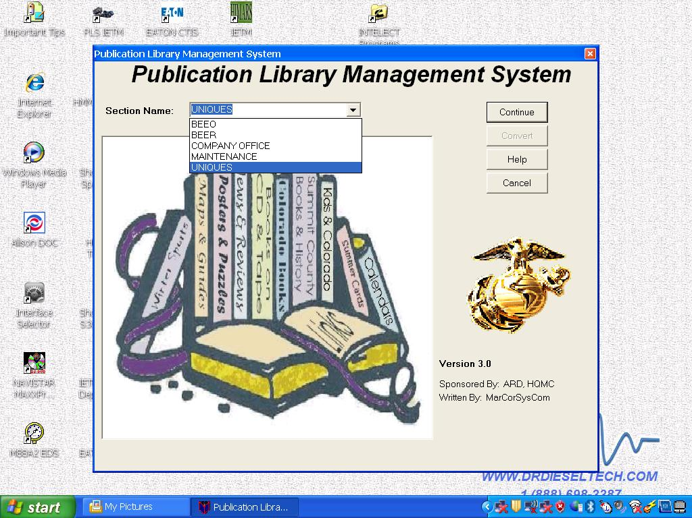
Figure 1: PLMS Menu
(ON SLIDE #78)

- Sub-Menu for Edit Data. The first option on the PLMS Main Menu is for “File.” This option allows you to save PLMS, Backup PLMS to CD or PSD, Delete section library and Exit PLMS. PLMS Main Menu is Figure 2:

(ON SLIDE #79)
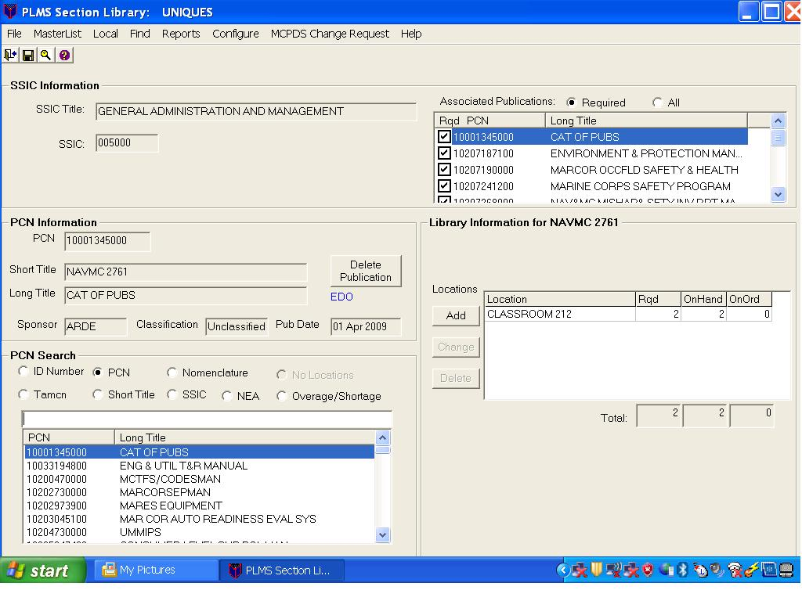
Figure 2: PLMS Main Menu

(ON SLIDE #80)

c. Master List. This file contains all of the USMC publications and ID Numbers along with any other related information. This file is distributed periodically by HQMC via their web site and you need to download it and save it you your PC in the /Data subfolder of PLMS.

(ON SLIDE #81)

(1) If you do not have this file when you start PLMS, a ‘Load Initial PLMS Shared Database’ popup will appear instructing you to download and save the file.

(2) If your Master List file is more than 60 days old a ‘Shared Library is Old’ popup message will appear reminding you that you need to obtain the latest copy of the Master List file.

(ON SLIDE #82)

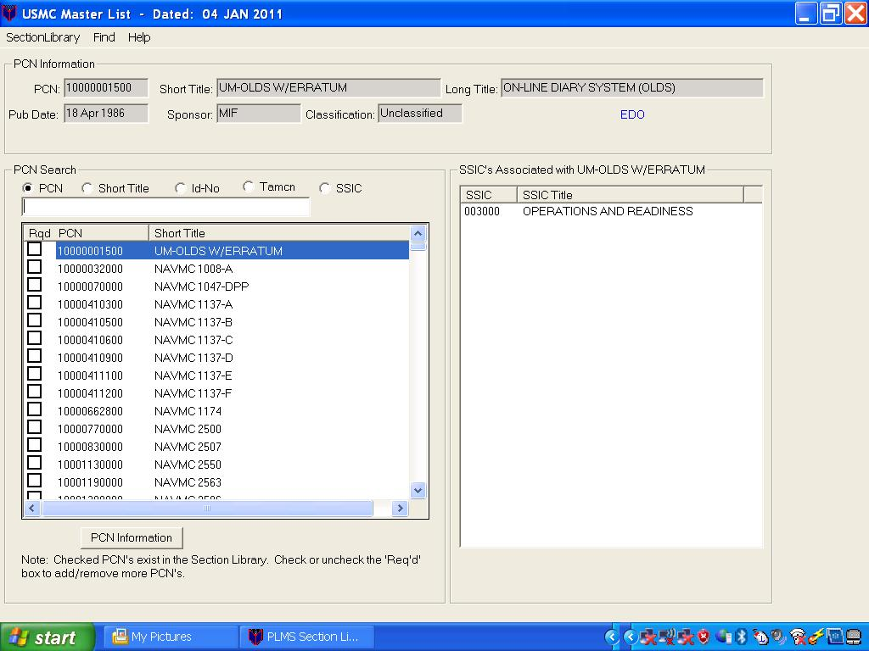
Figure 3: MASTER LIST

(ON SLIDE #83-84)

d. Local. PLMS provides the capability to add and track local publications (i.e. BN Orders, commercial books, other service manuals, etc.). These local publications are managed similar to the PCN based publications provided via the Master List.

(ON SLIDE #84)

(1) When in the Section Library screen, click on ‘Local’ in the menu bar.

(2) Click on ‘Add’ to add a local publication, enter the Short Title or Long Title. These are required field and must be unique. Enter a Pub Date. If none, click in the No Pub Date box Enter a Sponsor. This field is Optional.

(ON SLIDE #85)

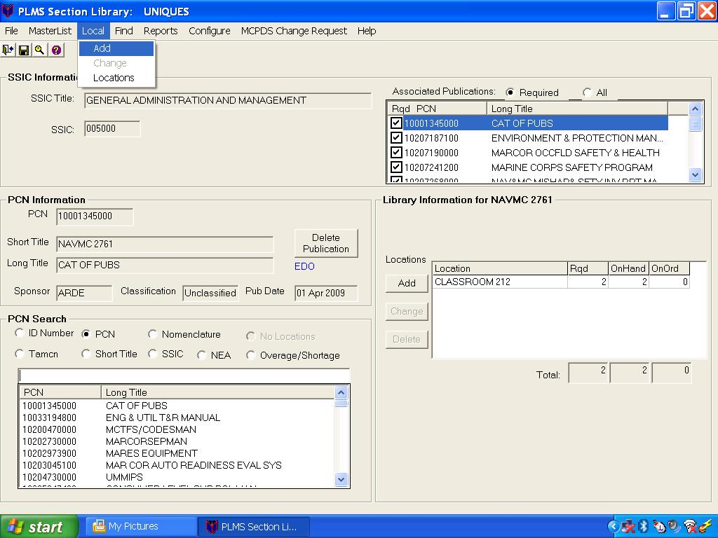
Figure 4: LOCAL (ADD)

(ON SLIDE #86)

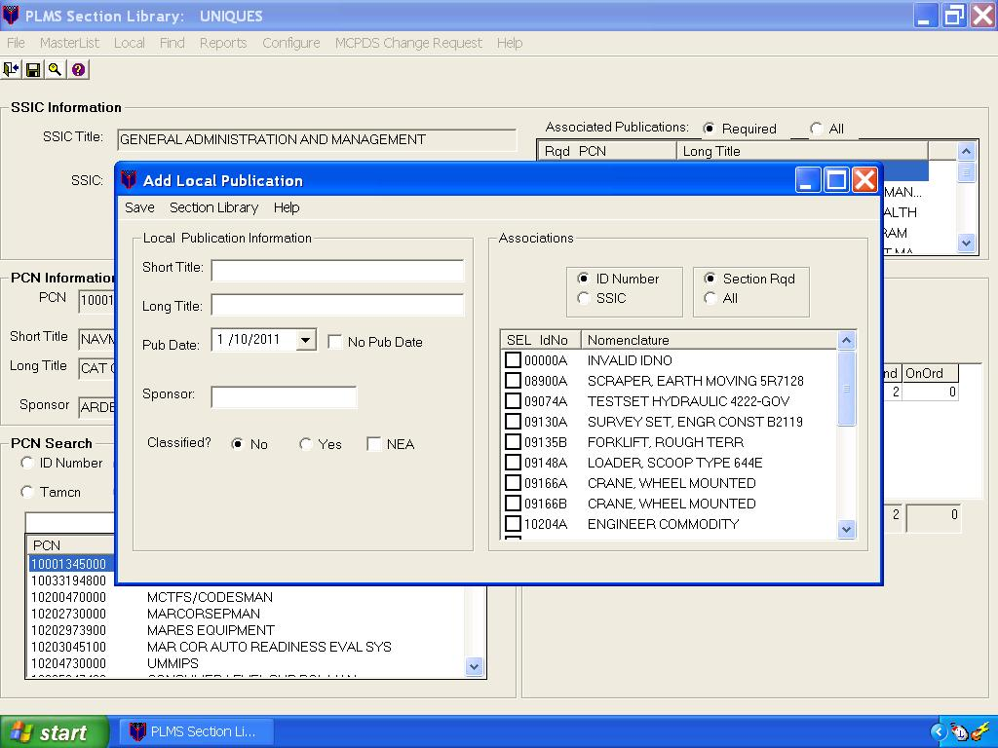
Figure 5: LOCAL (ADD)

(ON SLIDE #87)

(3) From the Section Library screen click on Locals on the menu bar and then Locations. A list of all your existing locations will appear and allow you to add new location, rename section location, cut, delete, expand or collapse all, section library and help menu.

(ON SLIDE #88)

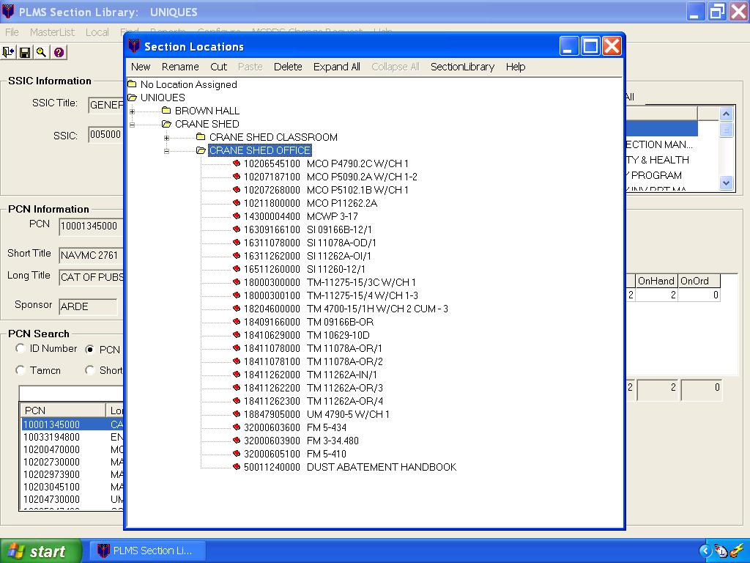
Figure 6: LOCAL (LOCATIONS)
(ON SLIDE #89)

e. Find. From the Section Library screen click on Find on the menu bar. Search menus will popup allowing you to search by PCN, Id Number, TAMCN, Short Title, Long Title and Nomenclature.

(ON SLIDE #90)
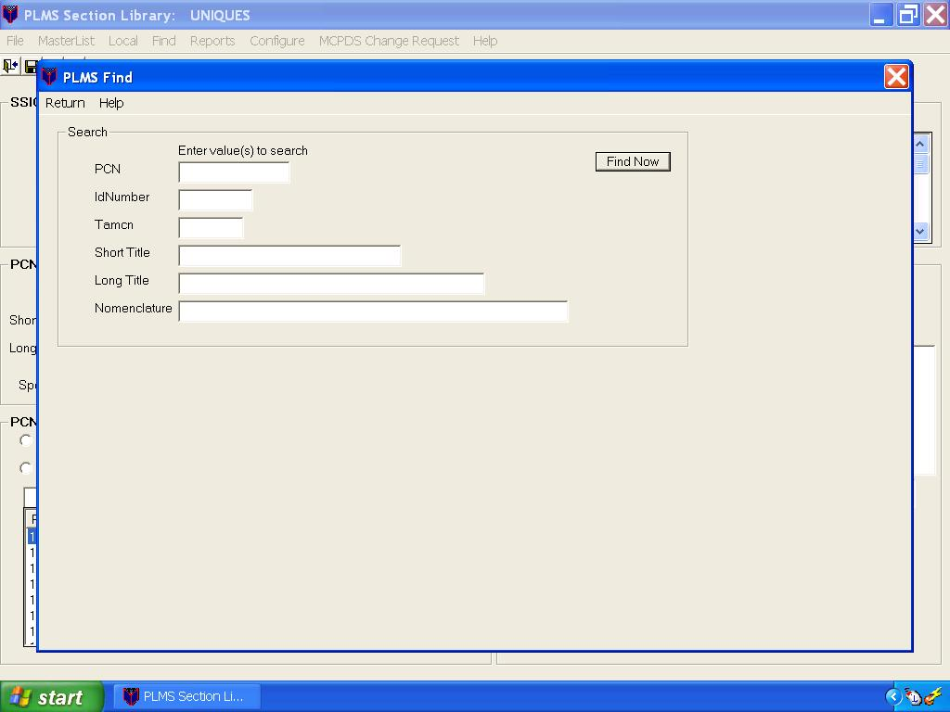

Figure 7: FIND
(ON SLIDE #91)

f. Reports. Use this procedure to select and view a report in PLMS. Whenever you select and open a PLMS report, you actually generate the report. Once opened, you can print, copy, save (export), and mail reports.

(ON SLIDE #92)

(1) There are four major types of reports in PLMS.

(a) Section - These reports are based on your individual Section Library and provide a means for you to list your library inventory fully or partially in many different ways.

(b) Shared – These reports are based on the USMC Master List and provide general information such as a list of New or Deleted publications since the previous Shared file was downloaded.

(c) Unit - These reports are used by the DCP to list Unit level information

(d) Miscellaneous – Various reports.

(ON SLIDE #93)

(2) From the Section Library screen click on Reports on the menu bar. This allows you to create a report by PCN, Short Title, Id Number, Locations, Commodity Extracts, Shortages / Overages and Non Equipment Associated (NEA).

(ON SLIDE #94)

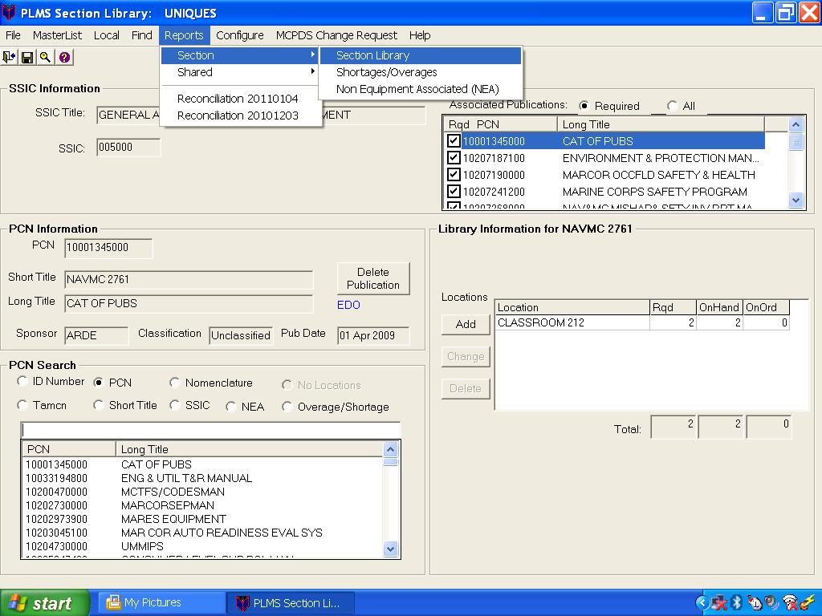
Figure 8: REPORTS

(ON SLIDE #95)

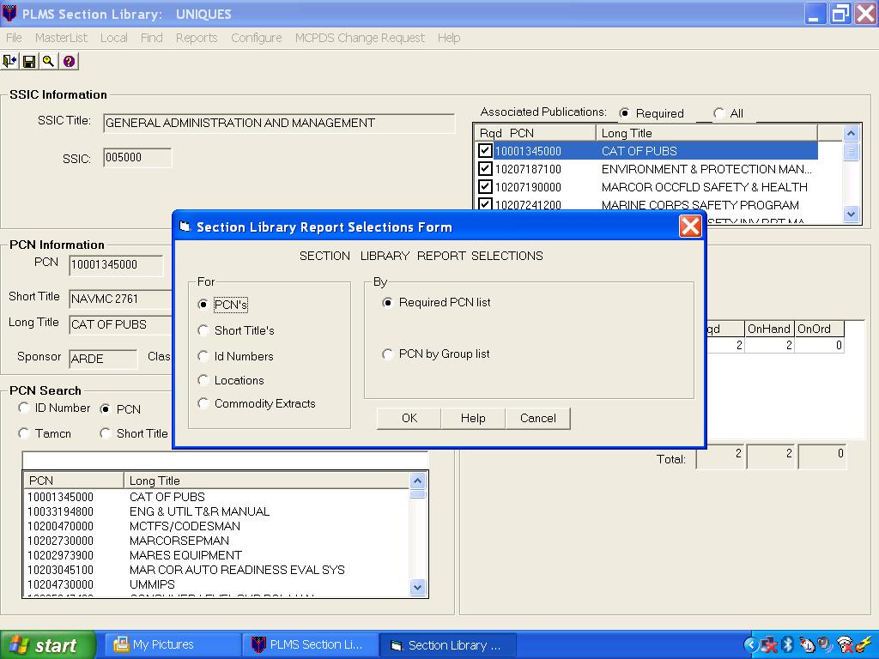
Figure 9: REPORTS SELECTIONS

(ON SLIDE #96)

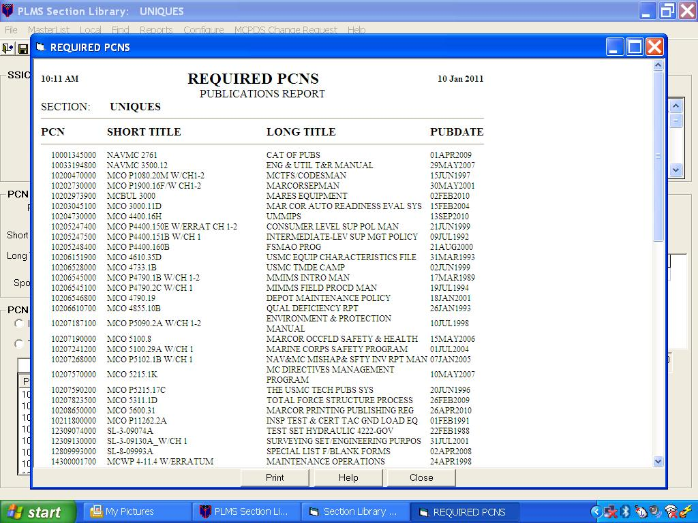
Figure 10: REPORTS SELECTIONS (PCN)

(ON SLIDE #97)

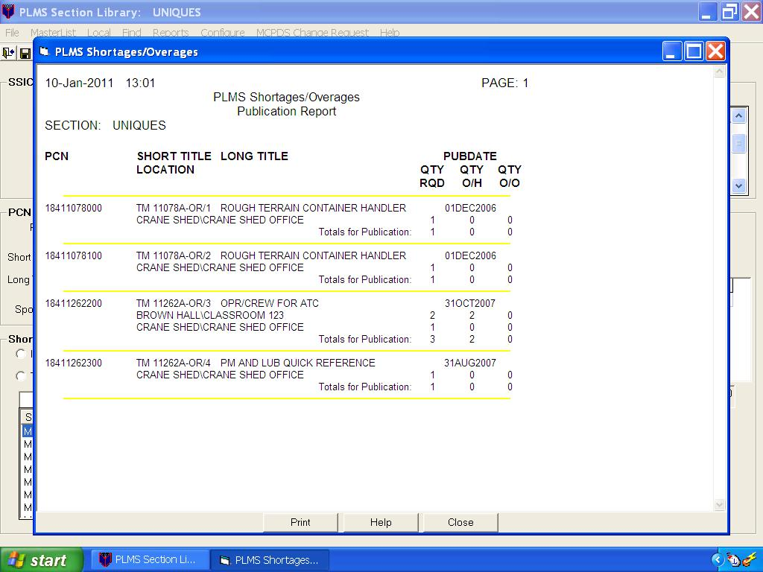
Figure 11: REPORTS SHORTAGE/OVERAGES
(ON SLIDE #98)

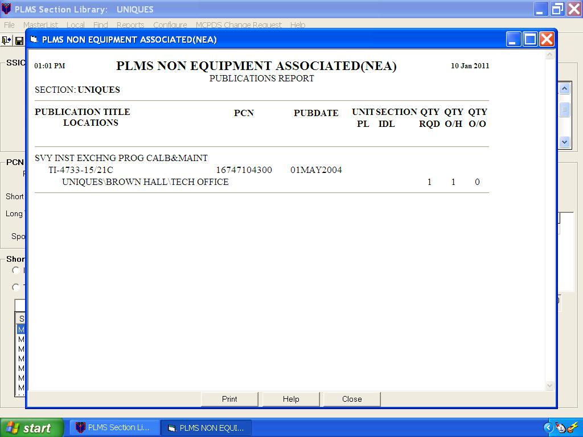
Figure 12: REPORTS (NEA)

(ON SLIDE #99)

(3) Shared reports for new publications lists all new PCNs published by HQMC sponsors. Review this list and decide if your Section requires any of these publications. Your unit and in turn your section may already have been identified as being included in the initial issue of any of these new publications by the publication’s sponsor so you may want to first check with your MCPDS clerk before taking action on requesting any of these new PCNs.

(ON SLIDE #100)

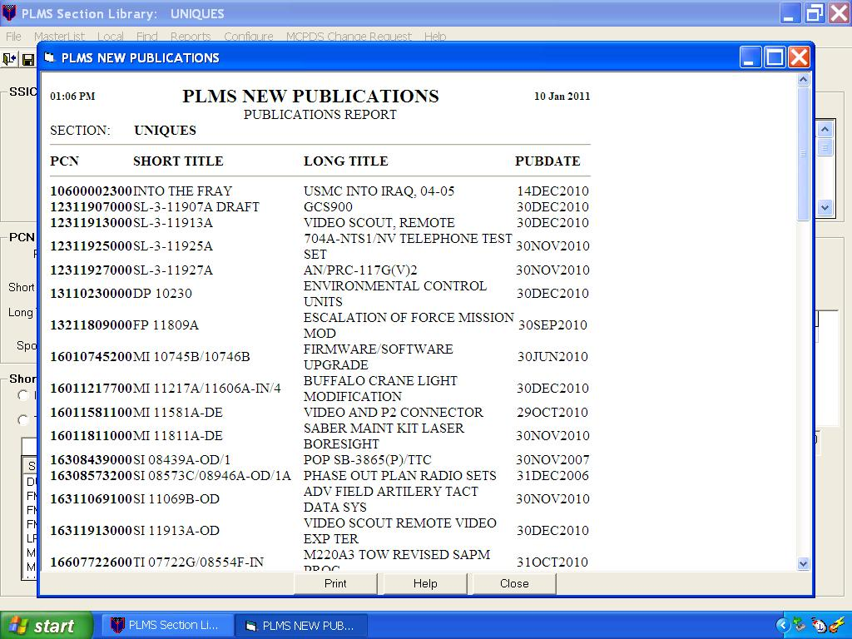
Figure 13: REPORTS SHARED (NEW)

(ON SLIDE #101)

(4) Shared reports for deleted publications list all of the PCNs deleted since your last Master List. PLMS automatically deleted these publications from your Section Library if you had any as was noted on the Reconciliation Report. When PCNs that are in your Section Library are deleted, there are several potential actions that you were directed to take. These were also noted on your Reconciliation Report.

(ON SLIDE #102)

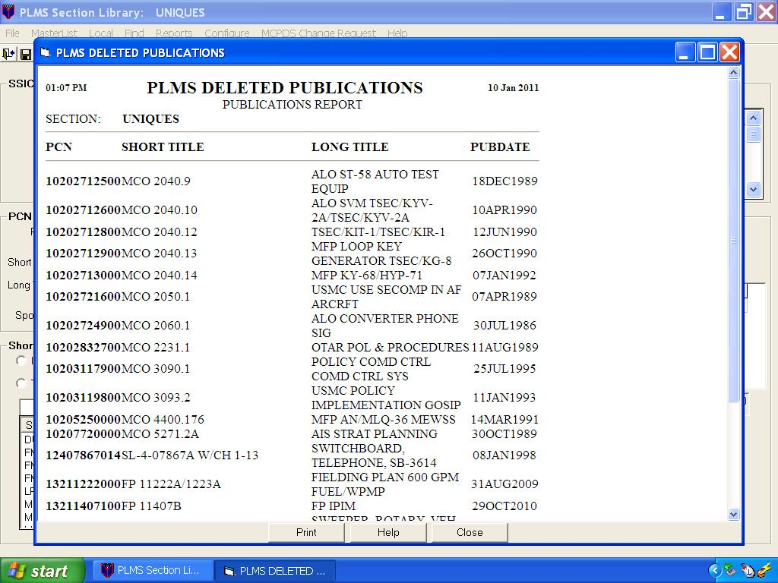
Figure 14: REPORTS SHARED (DELETED)

(ON SLIDE #103)

(5) To review your Reconciliation Report. On your PLMS Section Library screen click ‘Reports’ on the menu bar. On the dropdown list you will see listed at the bottom your available Reconciliation Reports. They are listed as ‘Reconciliation yyyymmdd’ where the date is the date of the downloaded PLMS Shared File. Click on the most recent date.

(ON SLIDE #104)

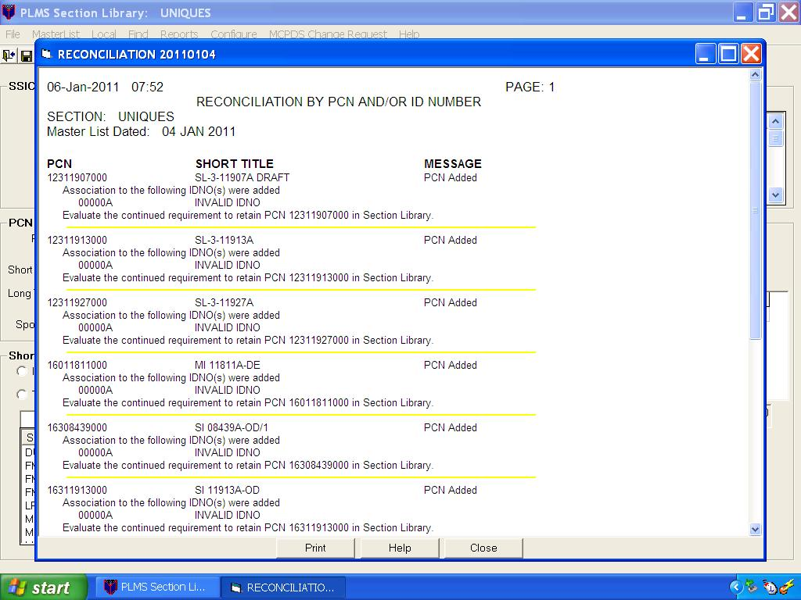
Figure 15: RECONCILIATION REPORT

(ON SLIDE #105-106)

INTERIM TRANSITION: Up to this point we have discussed local publications, finding publications, and reports available in PLMS. Are there any questions over this material? At this time we will take a ten minute break.
________________________________________________________________
________________________________________________________________
________________________________________________________________

(BREAK – 10 MIN)

INTERIM TRANSITION: Prior to the break we discussed local publications, finding publications, and reports available in PLMS. Now let’s move on to configuration settings and MCPDS change requests.
________________________________________________________________
________________________________________________________________
________________________________________________________________

(ON SLIDE #107-108)

g. Configuration. Is used to determine which type of PLMS user you are in order to provide the appropriate features and options to you. PLMS has four different configurations.

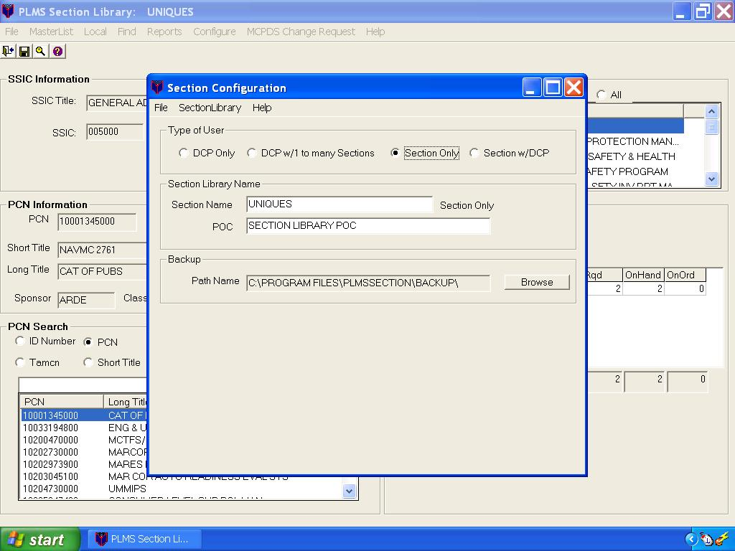
Figure 16: CONFIGURATION

(ON SLIDE #109)

(1) DCP Only. If you are only responsible for your own Section Library, deciding which and how many publications your section rates, you have the capability to order your own PCNs directly using the Marine Corps Publication Distribution System (MCPDS) and you have no subordinate Section Libraries to manage, you are a Section Only type PLMS user.

(ON SLIDE #110)

(2) DCP with/Sections. If you manage subordinate Sections who also use PLMS to maintain their own individual Section Libraries, you are a DCP with/Sections type PLMS user. As a DCP you coordinate determining publications requirements and consolidating ordering of pubs across your unit. Optionally you can have your own Section Library.

(ON SLIDE #111)

(3) Section Only. If you are only responsible for your own Section Library, deciding which and how many publications your section rates, but you must submit a request to someone else to actually order the PCNs and you have no subordinate Section Libraries to manage, you are a Section Only type PLMS user.

(ON SLIDE #112)

(ON SLIDE #113)

(4) Section with/DCP. If you are only responsible for your own Section Library, managing the physical locations of all your publications, determining which and how many publications your section needs, but to order a PCN or change how many you rate you must send a request up to a unit level (DCP) publications clerk who also uses PLMS then you are a Section with/DCP. Dependant of which type user you are will determine what your "Configure" screen will look like.

(ON SLIDE #114)

h. MCPDS Change Request. Once you request this report a ‘Reset Inventory Order Quantity baseline’ confirmation popup screen will appear. Here you must decide if you want to simply preview your report or you want to commit those changes and create the ‘MCPDS Section Change Request’ report to give to your MCPDS clerk. If you want to just look at the report without sending it up the chain, click [No]. If you are creating it to give it to your MCPDS clerk, click [Yes].

(ON SLIDE #115)

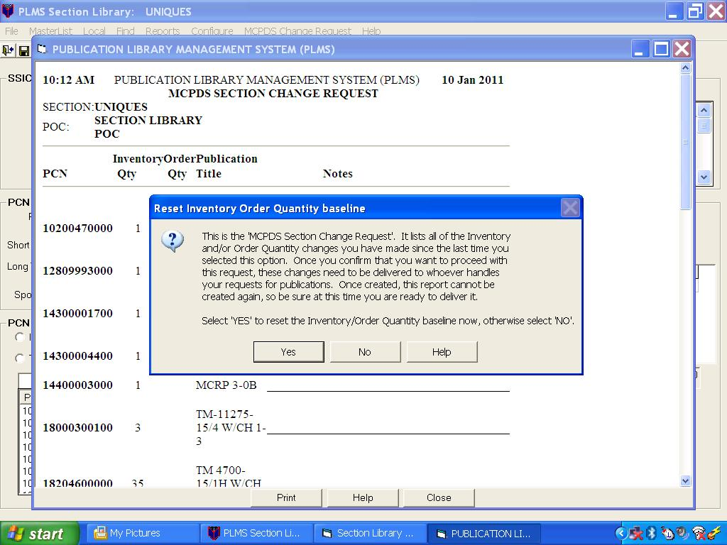
Figure 17: MCPDS CHANGE REQUEST

(ON SLIDE #116-119)

TRANSITION: During this period we have discussed PLMS menus. Are there any questions over this material? I have some questions for you. (Q1) Can you add local publications to your PLMS library? (A1) YES. (Q2) What are the four configurations that can be established in PLMS? (A2) DCP ONLY, DCP WITH SECTIONS, SECTION ONLY, AND SECTION WITH DCP. (Q3)What do you do if you want to check on a publication, but don’t want to take the time to track down the Marine that has access to your unit PLMS? (A3) YOU CAN PERFORM THE SEARCHES UTILIZING THE SL-1-2 AND SL-1-3 STOCK LISTS ON THE MARINE CORPS WEBSITE. Take a ten minute break.
________________________________________________________________
________________________________________________________________
________________________________________________________________

(BREAK – 10 MIN)

INTERIM TRANSITION: Prior to the break we discussed PLMS menus. Now let’s move on to internet SL-1-2/1-3 Resources. ________________________________________________________________
________________________________________________________________
________________________________________________________________

(ON SLIDE #120-121)
8. Internet SL-1-2/1-3 Resources. (30 Min)
Marine Corps Logistics Base, Albany, GA is the sole repository for, and provider of technical and non-technical publications to United States Marine Corps activities. The Publications Branch will continue to provide publications in paper format to commensurate with demand. This website is available to United States Marine Corps activities to view and down load as required reducing the need for paper publications. Internet access to publications is intended to augment the Marine Corps Publications Distribution System (MCPDS). The library of available technical and non-technical publications will be continuously expanded. Another advantage to using this resource is that this site is updated weekly, vice the quarterly downloads of PLMS. Currently three-fourths of all Marine Corps publications are available.

(ON SLIDE #122-123)

INTERIM TRANSITION: During this period we discussed the internet-based SL-1-2 and SL-1-3 resourses. Do you have any questions? If not, we’ll move into the demonstration.
________________________________________________________________________________________________________________________________________________________________________________________________

INSTRUCTOR NOTE
Perform the following demonstration.

DEMONSTRATION. (30 MIN) Demonstrate how to access and use the online SL-1-2/3 located on the USMC website. The purpose of this demonstration is to build publication library management knowledge. This skill will be evaluated by performance examination.

STUDENT ROLE: Students will record the mapping instructions to gain access to the SL-1-2/3 on the USMC website. Students are to observe the demonstration only. They are to ask questions or make comments for clarification. Students will not attempt to perform the steps along with the instructor.

INSTRUCTOR ROLE: Demonstrate how to perform searches using the internet-based SL-1-2/3.
1. Safety Brief: N/A
2. Supervision and Guidance: Utilize the instructor computer to display demonstration on the screens. Demonstrate how to access SL-1-2/3 located on the USMC website. Demonstrate the application of each tab located in the SL-1-2 screen. Demonstrate the application of each tab in the SL-1-3 screen.
3. Debrief: Allow students the opportunity to ask questions and comment on the demonstration. Answer student questions and provide feedback on student comments. Review mapping instructions for access to SL-1-2/3 screens located on the USMC website.

1. Safety Brief: N/A
2. Supervision and Guidance: Utilize the instructor computer to display demonstration on the screens. Demonstrate how to access SL-1-2/3 located on the USMC website. Demonstrate the application of each tab located in the SL-1-2 screen. Demonstrate the application of each tab in the SL-1-3 screen.
3. Debrief: Allow students the opportunity to ask questions and comment on the demonstration. Answer student questions and provide feedback on student comments. Review mapping instructions for access to SL-1-2/3 screens located on the USMC website.

(ON SLIDE #124)

INTERIM TRANSITION: We have discussed the internet SL-1-2/SL-1-3 and observed a demonstration of how to perform searches using it. Before we perform a practical application to develop this skill, let’s take a ten minute break.
________________________________________________________________
________________________________________________________________
________________________________________________________________

(BREAK – 10 MIN)

INTERIM TRANSISTON: Before the break we demonstrated how to perform searches using the internet SL-1-2/SL-1-3. Now let’s move into the practical application.
INSTRUCTOR NOTE
Introduce the following practical application.

(ON SLIDE #125)

PRACTICAL APPLICATION. (2 HR 30 MIN)Each student will accomplish the assignment on their own. There is one instructor required. Distribute one copy of Publications Practical Application “A” to each student. Read each question to the students to ensure they understand the requirements of
the assignment. Handouts are located in the classroom filing cabinet. Demonstrate how to access the online SL-1-2/3 screens located on the USMC website. Provide assistance, as required, to ensure each student accesses the SL-1-2/3 screens located on the USMC website on the computer at their desk. The purpose of this exercise is to build publication library management knowledge. This skill will be evaluated by performance examination.

PRACTICE: Each student will access and utilize the SL-1-2 and SL-1-3 screens located on the USMC website to answer each question on the practical application. Students will raise their hand to gain the attention of the instructor if they have a question. Students will not talk, except to ask the instructor a question.

PROVIDE HELP: Instructor will walk around the classroom and observe student performance. Instructor will be available to answer student questions throughout the entire practical application time period.
1. Safety Brief: N/A
2. Supervision and Guidance: Instructor will walk around the classroom and observe student performance. Instructor will be available to answer student questions throughout the entire practical application time period.
3. Debrief: Inform students they are allowed to use their practical application exercise as a reference during the performance examination. Advise students to take notes on their practical application handout. Review each question on the practical application exercise. Show the Practical application handout answer key on the “A” screens, and demonstrate how to find the answer on the “B” screens.

PRACTICE: Each student will access and utilize the SL-1-2 and SL-1-3 screens located on the USMC website to answer each question on the practical application. Students will raise their hand to gain the attention of the instructor if they have a question. Students will not talk, except to ask the instructor a question.

PROVIDE HELP: Instructor will walk around the classroom and observe student performance. Instructor will be available to answer student questions throughout the entire practical application time period.
1. Safety Brief: N/A
2. Supervision and Guidance: Instructor will walk around the classroom and observe student performance. Instructor will be available to answer student questions throughout the entire practical application time period.
3. Debrief: Inform students they are allowed to use their practical application exercise as a reference during the performance examination. Advise students to take notes on their practical application handout. Review each question on the practical application exercise. Show the Practical application handout answer key on the “A” screens, and demonstrate how to find the answer on the “B” screens.

INTERIM TRANSITION: During this period you performed searches utilizing the internet-based SL-1-2 and SL-1-3. Are there any questions over the practical application? At this time we will take a ten minute break.
________________________________________________________________
________________________________________________________________
________________________________________________________________

(ON SLIDE #126-127)

(BREAK – 10 MIN)

TRANSITION: Prior to the break we discussed the internet SL-1-2/3. You also observed a demonstration of how to perform searches and had the opportunity to perform those searches. Are there any questions over the material we have covered to this point? I have a question for you. (Q) How often are the internet-based SL-1-2 and SL-1-3 updated? (A) WEEKLY. We will now discuss the distribution of publications.
________________________________________________________________
________________________________________________________________
________________________________________________________________

(ON SLIDE #128)

9. DISTRIBUTION. (30 MIN)

a. Definition. This is the process of getting the required publication, in the right quantity, to the user of the publication. Activities can obtain publications by requisitioning or via automatic distribution. Publication distribution consists of two phases:

(ON SLIDE #129)

(1) Marine Corps Publication Distribution. From the publication stock point, to the activity.

(2) Activity Internal Distribution. From the receiving point in the activity to the technical library.

(ON SLIDE #130)

b. Types. In addition to the two phases of distribution, which describe the flow of an incoming publication, there are two types of distribution.

(1) "Push” or Automatic Distribution. Result of automatic distribution based on quantities established in the PL. Quantities reflected on the PL will be automatically distributed to the activity only when a publication change or revision is published.

(2) "Pull” or Requisitioning. Result of activity submitting a requisition to the publications stock control point.

(ON SLIDE #131-132)

TRANSITION: During this period we covered publication distribution. Are there any questions on the material we have just covered? I have questions for you. (Q1) What are the two phases of distribution? (A1) FROM THE STOCK POINT TO THE ACTIVITY AND FROM THE RECEIVING POINT IN THE ACTIVITY TO THE TECHNICAL LIBRARY. (Q2) What are the two types of distribution? (A2) REQUISITION AND AUTOMATIC DISTRIBUTION. We will now discuss non-controlled and controlled publications.
________________________________________________________________
________________________________________________________________
________________________________________________________________

(ON SLIDE #133)

10. NONCONTROLLED AND CONTROLLED PUBLICATIONS. (30 MIN)

(ON SLIDE #134)

a. Non-controlled Publications. Non-controlled are those that apply to training, supply, technical, or other miscellaneous publications stocked and distributed through the use of standard distribution list. Non-controlled publications may be requisitioned directly from the publications stock control point. PCN’s are listed in the NAVMC 2761 and the SL 1-2/1-3.

(ON SLIDE #135)

b. Controlled Publications. Request for controlled publications must have a system sponsor approval via CMC (AREB) whether for a one-time issue or continuing distribution. A letter of justification must be accompanied by properly prepared DD Form 1348. If approved by the sponsor, the request will be added to the activity’s PL and the approved requisition will be forwarded to the publications stock control point for appropriate action. Request disapproved by sponsor will be returned without further action. Controlled publications are listed, identified, and regulated under standard PCN’s in the NAVMC 2761 (Catalog of Publications). Controlled publications are defined as:

(ON SLIDE #136)

(1) Classified.

(2) For Official Use Only.

(3) Costly to print, for example: some TM’s publications containing foldout pages/color, and recruiting aids.

(4) Intended for HQMC use only.

(ON SLIDE #137-138)

TRANSITION: During this period we discussed non-controlled and controlled publications. Are there any questions over the material we just covered? I have a question for you. (Q) What makes a publication controlled? (A) FOR OFFICIAL USE ONLY, FOR HEADQUARTERS MARINE CORPS USE ONLY, CLASSIFIED, AND TOO COSTLY TO PRINT. At this time take a ten minute break. ________________________________________________________________
________________________________________________________________
________________________________________________________________

(BREAK – 10 MIN)

TRANSISTON: Before the break we controlled and non-controlled publications. We will now discuss excess and outdated publications.

(ON SLIDE #139)

11. EXCESS AND OUTDATED PUBLICATIONS. (30 MIN)
When the following publications are in excess or outdated, they are not authorized for return to stock. They will be disposed of locally in the best interest of the Marine Corps.

a. Obsolete or unserviceable publications.

b. Letter-type directives.

c. Publications, which have a change(s), incorporated in the basic manual.

(ON SLIDE #140)

d. Publications that cost less than $50. The intent is to dispose of all printed matter locally whose value is less than the administrative cost involved in returning the material to stock.

e. Publications not listed in the SL-1-3/1-2, except for current joint and other service publications exceeding a value of $50, should be reported to the CMC (ARE) for determination of possible usage by other services.

(ON SLIDE #141-143)

TRANSITION: During this period we discussed excess and outdated publications. Are there any questions over this material? I have a question for you. (Q) What is to be done with publications that are excess or outdated, and not authorized for return to stock? (A) THEY WILL BE DISPOSED OF LOCALLY IN THE BEST INTEREST OF THE MARINE CORPS. We’ll now move onto Publications Listing.
________________________________________________________________
________________________________________________________________
________________________________________________________________

(ON SLIDE #144)

12. PUBLICATIONS LISTING (PL). (30 MIN)

a. Definition. The PL is an electronic display of all publications in MCPDS. Each PL is unique because the system shows a value in the quantity field for a PCN for which the activity is currently on distribution. The PL is dynamic. It changes when:

(ON SLIDE #145)

(1) The sponsor adds a new publication for the specific Individual Activity Code (IAC) through initial distribution, or

(2) The activity chooses to make additions, changes, or deletions to their PL.

(ON SLIDE #146-147)

b. Purpose. To provide support to supply, administrative, and other personnel with functional responsibility. The PL is separated into non-technical and technical sections. Non-technical publications are numbered by the SSIC and technical publications are categorized by ID per tables of equipment.

(ON SLIDE #148-149)

TRANSITION: During this period we discussed publication listings. Are there any questions over this material? I have a couple questions for you. (Q1) How are Non-Technical publications numbered? (A1) BY SSIC. (Q2) Will a unit publication list ever change? Why? (A2) YES. WHEN PUBLICATION IS ADDED THROUGH INITIAL DISTRIBUTION, OR THE UNIT CHOOSES TO ADD, CHANGE OR DELETE A PUBLICATION. Let’s take a 10 minute break.
________________________________________________________________
________________________________________________________________
________________________________________________________________

(BREAK – 10 MIN)

(ON SLIDE #150)

13. DEVELOPING THE PUBLICATIONS CONTROL SYSTEM. (30 MIN)
A team assists the commander in operating a system to control publications. The team consists of the unit publication control point (UPCP) and the MMO who develop the system, and the executive officer and special staff of officers and subordinate activity commanders who operate the system. The UPCP and the MMO must work together to develop the publications control system. There are four interrelated functional areas of the system: publications allowance control, internal distribution control, inventory control, and requisition control.

(ON SLIDE #151-152)

TRANSITION: We have just identified the personnel and four functional areas involved in developing a publication listing. Are there any questions over this material? I have a question for you. (Q1) Who is involved in developing the publication listing for a unit? (A1) THE COMMANDING OFFICER, UNIT PUBLICATION CONTROL POINT, MMO, EXECUTIVE OFFICER, STAFF OFFICERS, AND SUBORDINATE ACTIVITY COMMANDERS. (Q2) What are the four functional areas involved in developing a publication list? (A2) ALLOWANCE, DISTRIBUTION, INVENTORY, AND REQUISITION. We will now move on to identifying the functional areas involved in developing a publication listing.
________________________________________________________________
________________________________________________________________
________________________________________________________________

(ON SLIDE #153)

14. FUNCTIONAL AREAS. (30 MIN)

a. Publications Allowance Control. Identifies which publications are required.

b. Internal Distribution Control. Establishes how publications are handled to ensure that the right publications get to the right place in the right quantity.

c. Inventory Control. Establishes how publications are maintained once they are in the library.

d. Requisition Control. Establishes how publication shortfalls are replaced.

(ON SLIDE #154-155)

TRANSITION: We have identified the purpose of the four functional areas involved in developing a publication listing. Are there any questions over this material? I have a question for you. (Q) Which functional area establishes how publication shortfalls are replaced? (A) REQUISITION. After a ten minute break we will move on to identifying the requirements for allowance control.
________________________________________________________________
________________________________________________________________
________________________________________________________________

(BREAK - 10 MIN)

TRANSITION: Prior to the break we discussed the purpose of the four functional areas involved in developing a publication listing. We will now identify the requirements for allowance control.
________________________________________________________________
________________________________________________________________
________________________________________________________________

(ON SLIDE #156)

15. ALLOWANCE CONTROL. (1 HR 30 MIN)
The publication allowance control functional area consists of step-by-step procedures beginning with what and how many publications are required and ending with a PL update. There are three categories of publications involved:

(ON SLIDE #157)

a. Technical publications that are associated with specific items of equipment: for example, LO for the MTC Dozer, SL-3 for a General Mechanics Tool Box, and TM for the 624KR TRAM.

b. Technical publications which are non-equipment associated; for example, TM-4700-15/1.

c. Non-technical publications or directives; orders and bulletins.

(ON SLIDE #158)

d. These three categories of publications will be taken through a series of seven steps that will culminate in an updated PL. Because of basic differences among these three categories, each category will be taken separately through steps 1 through 4, starting with technical publications (equipment associated). Steps 5 through 7 are common to all three categories.

(ON SLIDE #159)

(1) Step 1. Determine what equipment is rated or supported by each maintenance/commodity section. Using your unit’s T/O&E, Unit allowance list, and any special allowances prepare a publication control form for each type of equipment rated.

(ON SLIDE #160)

(2) Step 2. Determine what publications are associated with each type of equipment rated using the SL-1-2. Locate each type of equipment in the SL-1-2 and record all publications that are associated with that piece of equipment and within the authorized EOM for the activity on the publication control form. Your Unit’s T/O cover page and any special maintenance authorizations granted by higher headquarters would indicate your authorized EOM.

(ON SLIDE #161)

(a) All MI's will be maintained regardless of the
authorized EOM. They are required to operate effective modification control and maintenance management programs.

(b) Support maintenance units require the publications for the T/E equipment of all units they support.

(c) Some end items of equipment have components that have components that have publications of their own. The publications for those components are not always listed under the major end item in the SL-1-2. The component, that may be an end item itself, may have to be researched separately in the SL-1-2.

(ON SLIDE #162-164)

(3) Step 3. Determining the number of copies for each publication needed requires a judgment call based on how many technical libraries are to be maintained and how many copies are needed in each library. Enter the quantity required per location and the total quantity required. Factors to be considered in determining the number of libraries are as follows:

(a) The activity’s concept of employment contained in the T/O cover page.

(b) Contingency plans and periodic deployments, as well as mobilization.

(c) Is the shop spread out over several buildings or is it centralized? Factors to be considered in determining the number of copies of each publication in each library are:

1 The quantity of each type of equipment to be
supported by the library.

2 The number of maintenance/operator teams that may simultaneously require a given publication.

3 Is the publication going to be used in a clean shop, or will it be used outside in the rain, snow, or around oil or grease where it will only last a short time?

(d) Enter the quantity required per library and the total quantity required in the appropriate columns of the publication control form.

(ON SLIDE #165)

(4) Step 4. Determine and record the PCN on the publication control form for each required publication. For technical publications, the only sure way is to check the PCN for each publication in the SL-1-3/1-2.

(ON SLIDE #166)

(5) Step 5. Decide what publications you need, the quantity required, and record that information on the publication control form. Now it’s time to sit down and really analyze and refine your requirements for the various publications. For example, you have decided that you require two copies of publication “B” distributed under PCN 222 222222 22, and require three copies of publication “C” distributed under PCN 333 333333 33, this means you are going to have to list your PL distribution requirements for two copies of publication “B” PCN 222 222222 22 and three copies of publication “C” PCN 333 333333 33.

(ON SLIDE #167)

(a) By reviewing the requirements for the different
publications distributed under each PCN, decide how many copies of the publication you require.

(b) On a sheet of paper, list the PCN's you require,
and the quantity. You should have separate lists for each source of publications: for example, HQMC, Force headquarters, major commands, and MSC.

(c) As a result of this analysis, you may need to change some of the quantities you originally entered on the publication control forms.

(d) During your analysis, be alert to duplications, because some technical publications will apply to more than one type of equipment. (Example: TM 4750-15/2-4, Camouflage Paint Pattern; is listed under a few ID numbers; you may only need one copy for your library).

(e) Keep your publication control forms sorted by PCN to facilitate completion of the next step.

(ON SLIDE #168)

(6) Step 6. Consolidate activity requirements at the activity level in preparation for updating the PL and recommending changes to PCN’s for directives from senior commands. The UPCP and MMO should chair a meeting of the heads of all of the shops, sections, and offices that have a requirement for publications down to the chaplain and career planner. The publication control form should be used to record the information.

(ON SLIDE #169)

(7) Step 7. The UPCP can prepare the necessary correspondence to update the PL. Correspondence must also be prepared to request changes to distribution lists of other senior headquarters.

(ON SLIDE #170-173)

TRANSITION: During this period we discussed the steps required for maintaining allowance control. Do you have any questions about the material we have just covered? I have some questions for you. (Q1) What are the primary source documents that a unit must use to determine their publication requirements? (A1) TABLE OF ORGANIZATION AND EQUIPMENT (TO/E), ALLOWANCE LIST, AND SPECIAL ALLOWANCE LIST. (Q2) How many steps are there to complete an updated PL? (A2) 7 STEPS. (Q3) How many categories of publications are taken through the seven step process? (A3) ALL THREE. After a ten minute break we will discuss Internal Distribution Control.
________________________________________________________________
________________________________________________________________
________________________________________________________________

(ON SLIDE #174)

(BREAK - 10 MIN)

TRANSITION: Prior to the break we discussed publication Allowance Control. We will now move on to the Internal Distribution of those publications.
________________________________________________________________
________________________________________________________________
________________________________________________________________

(ON SLIDE #175-177)

16. Internal Distribution Control. (30 MIN)
The internal distribution control functional area consists of procedures designed to assign a chain of responsibility and designate the specific steps and tasks involved in getting a publication from the mail room, where it has arrived, through the UPCP, shop officer or section head, and the publications librarian to the shelf of the proper library.

a. The publication control form that was prepared during the development of publications allowances should be used as a rigid guideline for whom gets each publication.

(ON SLIDE #177)

b. Also, procedures must be established to ensure that publications received as a result of a requisition are not treated the same as publications received on automatic distribution.

(1) In the case of publications received on automatic
distribution, the UPCP must make direct distribution based on copy location information found on the internal distribution control document.

(2) In the case of publications received in response to a
requisition (there will be a copy of a release/receipt document in the package of publications), UPCP must send the whole package to the supply officer who will forward the publications to the maintenance/commodity section that requisitioned them and close out the pending requisition on file.

(ON SLIDE #178-180)

TRANSITION: During this period we discussed the second functional area of developing a publication listing; publication distribution control. Are there any questions over this material? I have a question for you. (Q1) What is the distribution process for publications that were requisitioned? (A1) THE DOCUMENT # WILL BE RECEIPTED FOR BY SUPPLY THEN THE PUBLICATION WILL BE DELIVERED TO THE APPROPRIATE REQUISITIONING COMMODITY PERSONNEL. (Q2) What is the distribution process for publications that were automatically distributed to the unit? (A2) THE PUBLICATION WILL BE DELIVERED TO EACH COMMODITY WITH A NEED FOR THE PUBLICATION. We will now discuss inventory control.
________________________________________________________________
________________________________________________________________
________________________________________________________________

(ON SLIDE #181-182)

17. Inventory Control. (30 MIN)
The inventory control functional area consists of procedures for handling publications once they have arrived at the shop or office.

a. The procedures established in the inventory control functional area must be thoroughly employed by your publications librarians on a day-to-day basis to ensure that Marines have up-to-date publications available to them for daily tasks as well as operational deployments.

(ON SLIDE #183)

b. Inventory control procedures must address the following facets of library management:

(1) The libraries to be established and their locations.

(2) The physical arrangement of the different types of publications within a library.

(a) Non-technical publications (Marine Corps Orders and bulletins) are maintained per MCO P5215.1.

(b) Technical publications may be arranged in two ways:

1 Non-equipment associated publications in short title numerical sequence.

2 Equipment associated publications by equipment type with each equipment type in publication short title numerical sequence.

(ON SLIDE #184)

(3) Procedures must be established to ensure that deployment and contingency libraries are identified, documented for embarkation, and arranged in such a fashion as to support embarkation plans, extended shipboard operations, and ashore.

(ON SLIDE #185)

(4) Two types of publication inventories, wall-to-wall inventories and update inventories.

(a) In setting up a publications control system, there may have to be a wall-to-wall inventory to initially establish what is on hand.

(b) Update inventories will be conducted each time a new NAVMC 2761(Catalog of Publications) or SL-1-3/-1-2 is published, which is monthly.

(ON SLIDE #186)

(5) Procedures must be established relative to the publication control forms and contain which form must be used to manage a publication control system. At a minimum, there will need to be a Publication list at each maintenance/commodity section, using the publication control form or a locally produced form containing similar elements of information; publications control form and an inventory list attached to each deployment and contingency library.

(ON SLIDE #187)

(6) Procedures must be established for keeping track of publications checked in and out on a daily basis.

(7) Procedures must be established on how to enter changes to the different types of publications and how to update records to reflect new publications, new changes, or requisitions that have been filled.

(ON SLIDE #188-191)

TRANSITION: During this period we discussed publication inventory control procedures. Are there any questions on this material? I have some questions for you. (Q1) What MCO informs units how Non-technical publications are maintained? (A1) MCO P5215.1_. (Q2) What are the two types of publication inventories? (A2) WALL-TO-WALL AND UPDATE. (Q3) How are Equipment-associated Technical Publications arranged? (A3) SHORT TITLE, ID SEQUENCE (EQUIPMENT TYPE). After we return from a ten minute break we will discuss requisition control.
________________________________________________________________
________________________________________________________________
________________________________________________________________

(ON SLIDE #192)

(BREAK – 10 MIN)
TRANSITION: Prior to the break we discussed publication inventory control procedures. Let’s move on to requisition control.
________________________________________________________________
________________________________________________________________
________________________________________________________________

(ON SLIDE #193)

18. Requisition Control. (30 MIN)
The requisition control functional area consists of procedures designed to ensure that publications shortages are properly identified and promptly requisitioned, and that pending requisitions are updated in a timely fashion.

(ON SLIDE #194)

a. The identification of publications shortages is accomplished during a wall-to-wall or an update inventory, as discussed earlier. A visual inspection of the "No. Required on the PL" and “Publications On Hand” is a good way to begin the requisition process. The accurate and careful use of the publication control form to properly document the status of a publications library cannot be overemphasized.

b. Once publication shortages have been identified, the missing publications must be ordered per MCO P5600.31.

(ON SLIDE #195-196)

TRANSITION: During this period we discussed requisition control. Are there any questions over this material? I have a question for you. (Q) What is a good way to begin the requisition process? (A) A VISUAL INSPECTION OF THE "NO. REQUIRED ON THE PL" AND “PUBLICATIONS ON HAND”. We will now discuss the program used to requisition publications.
________________________________________________________________
________________________________________________________________
________________________________________________________________

(ON SLIDE #197)

19. Marine Corps Publications Distribution System (MCPDS). (30 MIN)
MCPDS is a system that provides services in support of the initial issuance of publications by Marine Corps publications sponsors and supports publications management by field commanders including the Reserve component. MCPDS provides distribution of Marine Corps publications to other government agencies and non-government entities with a bona fide reason for receiving them.

(ON SLIDE #198)

a. MCPDS AIS is a central component of MCPDS and is the online, interactive AIS resident on a mainframe computer located at Quantico, VA. MCPDS provides:

(1) Sponsor support – Allows publications sponsors to electronically establish initial distribution for a new publication.

(2) Field user support – Allows electronic management of the activity’s requirements for publications.

(3) Other government agencies and non-government entities support is provided by the CMC (ARE).

(ON SLIDE #199)

b. All publications in MCPDS are available to Marine Corps activities. Units are authorized to use MCPDS in place of the SL-1-2/1-3.

INSTRUCTOR NOTE
Inform students of Message RTD:R 291445Z JAN 02 COMMARCORSYSCOM QUANTICO VA TRANSITION FROM PAPER TO ELECTRONIC TECHNICAL MANUAL AND UNCLAS.

(ON SLIDE #200-202)

TRANSITION: During this period we discussed the Marine Corps Publication Distribution System. Are there any questions over this material? I have a question for you. (Q) What is the automated system that the Marine Corps uses to requisition publications? (A) MARINE CORPS PUBLICATION DISTRIBUTION SYSTEM (MCPDS). After we return from a ten minute break we will discuss the NAVMC 10772.
________________________________________________________________
________________________________________________________________
________________________________________________________________

(ON SLIDE #203)

(BREAK - 10 MIN)

INTERIM TRANSITION: Before the break we discussed MCPDS. We will now discuss the NAVMC 10772.
________________________________________________________________
________________________________________________________________
________________________________________________________________

(ON SLIDE #204)

20. NAVMC 10772, Recommended Changes To Publications/Logistics-Maintenance Data Coding. (30 MIN)

a. Purpose. The purpose of the NAVMC 10772 is to recommend changes to technical publications. Typographical errors and Federal Supply Classification (FSC) changes need not be reported. Clarification, advice, questions, and recommended changes of policy; for example non-technical publications, Marine Corps Orders, and Marine Corps Bulletins, must be submitted by correspondence other than NAVMC 10772 and staffed via the chain of command. Can also be submitted to recommend changes to the SL-1-2/3.

(ON SLIDE #205)

b. Use. Used by all Navy and Marine Corps agencies to report deficiencies in technical publications. TM 4700-15/1H provides information relative to the purpose, preparation, and disposition of the NAVMC 10772.

c. Responsibilities. Units/individuals who discover errors or deficiencies in a technical publication are responsible for submitting the NAVMC 10772.

(ON SLIDE #206)

d. Preparation Instructions.

(1) Part I will be used to recommend changes to publication errors (numbering, assembly, illustrations, etc.) allowing users at all levels to recommend the necessary corrections or changes. Part I does not require staffing.

(ON SLIDE #207)

(2) Part II will be used to recommend changes to logistics such as maintenance, technical, or mechanical information application coding that may or may not be included in the publications (including System Maintenance Recoverability codes).

(a) Part II must be reviewed and approved at the NCOIC/supervisory level to ensure the recommendation is consistent with existing maintenance policies and capabilities. When the proposed change involves migration or repair, the approval and signature of the gaining or losing echelon of maintenance representative will be obtained. Proposed changes to logistical codes are encouraged. However, to evaluate the overall impact of the recommendation, complete justification is required.

(ON SLIDE #208)

e. Disposition. The originator may submit either by mail in a government envelope, or electronically (discussed in paragraph f below). If submitting my mail, include full unit address and mail to:

COMMANDER, MARINE CORPS SYSTEMS COMMAND
ATTN: Assistant Commander Acquisition and Logistics (LOG/TP)
814 Radford Blvd Suite 20343
Albany, Georgia 31704-0343

The action point returns the NAVMC 10772 with a response to the originator or forwards the NAVMC to the publication sponsor. The publication sponsor reviews the recommendation and provides the action point with a response. The action point will monitor and retain cognizance of the NAVMC 10772 until a response is provided to the originator. The action point will keep the originator informed as to the status of the NAVMC 10772. When the action point receives a response from the publication sponsor a copy of that response from the publication sponsor will be forwarded to the originator.

(ON SLIDE #209)

f. MCLB Albany’s NAVMC 10772 Tracking Program. The Logistics Data Maintenance/Technical Publications Branch, Material Support Division (Code 852) has now been made available, on the Internet, a NAVMC 10772 tracking program. Operating Forces that have submitted a NAVMC 10772 can now access the program at http://ala.usmc.mil and scroll down to Publications link located at the bottom left of the screen. Click on the NAVMC 10772 link located below the Technical and Non-Technical Publications Search box. Advantages of using this program is that Operating Forces can submit NAVMC 10772’s directly from this program, and the submission will automatically go to the Publications Section e-mail mailbox by typing MBMATCOMMARLOGBASES@MATCOM.USMC.MIL or use Microsoft Outlook global address directory and search for MB MATCOM SECT MAIL 853 which is constantly monitored. The submission is almost immediately delivered using this method vice the 7 to 10 days using the postal service.

(ON SLIDE #210-213)

TRANSITION: During this period we discussed the NAVMC 10772. Are there any questions over the material we covered? I have some questions for you. (Q1) What is the purpose of the NAVMC 10772? (A1) TO RECOMMEND CHANGES TO TECHNICAL PUBLICATIONS. (Q2) Can a NAVMC 10772 be used to recommend changes to a Marine Corps Order? (A2) No. (Q3) Does part two of the NAVMC 10772 need to be reviewed and approved by the NCOIC/Supervisory level? (A3)Yes. After we return from a ten minute break we will discuss the FEDLOG.
________________________________________________________________
________________________________________________________________
________________________________________________________________

(ON SLIDE #214)

(BREAK - 10 MIN)

INTERIM TRANSITION: Before the break we discussed NAVMC 10772. We will now discuss the FEDLOG.
________________________________________________________________
________________________________________________________________
________________________________________________________________

(ON SLIDE #215)

21. Logistics Data on Compact Disk-Read Only Memory (FEDLOG). (1 HR 30 MIN)

a. Overview. FED LOG is a logistics information system that allows you to retrieve information from the Federal Logistics Information System (FLIS) databases quickly and easily. FEDLOG allows for retrieval of the following information:

(ON SLIDE #216)

(1) Management Data. This screen provides Management list-Consolidated (ML-C) information, such as: Service/Agency (S/A), Source of Supply (SOS), Acquisition Advice Code (AAC), Unit of Issue (UI), and Unit Price.

(2) Reference Number Data. This screen displays Master Cross Reference List (MCRL) information, such as: Part Number, and Commercial And Government Entity Code (CAGE).

(ON SLIDE #217)

(3) Freight Data. This screen displays information on how the material is to be handled.

(4) Supplier Data. This screen displays freight data for your matches such as: Suppliers Name, Address, and Phone Number.

(5) Characteristics Data. This screen displays decoded characteristics for the selected item, such as: Size, Weight, Diameter, Material, Engine Type, Special Features, etc.

(ON SLIDE #218)

(6) Drawings. This screen displays representative drawings for the item you selected.

(7) Custom Views. Lets you design a screen that contains only the data you would like to see on the screen.

(ON SLIDE #219)

b. FEDLOG contains Defense Logistics Information System (DLIS) data and is updated monthly. Defense Logistics Service Center (DLSC) publications have been replaced by FEDLOG, such as Master Cross Reference List (MCRL) and Management List-Consolidated (ML-C).

c. FEDLOG provides three search programs. The user can select a program most suited to their needs, such as:

(ON SLIDE #220)

(1) Interface Program. This is the base program that provides on screen instructions and menus for an information query, such as: performing a search, viewing data, and printing data.

(ON SLIDE #221)

(2) Batch Program. This is tool program that allows the user to perform multiple searches. Also provides on screen instructions and menus. These queries can be run sequentially, or overnight if desired.

(ON SLIDE #222)

(3) External File Interface Program. This provides on screen instructions and menus for specifying filenames and creating layout files. Allows you to import queries from other programs, perform multiple searches, and export data consisting of selected fields of input into other programs.

(ON SLIDE #223)

d. FEDLOG Search Criteria. One of the following can be used when searching:

(1) (NSN) NATIONAL STOCK NUMBER. A thirteen (13)-digit number assigned to an item of supply.

(2) (NIIN) NATIONAL ITEM IDENTIFICATION NUMBER. A nine (9) position numeric number that identifies the item of supply, which does not change over time.

(3) (PSCN) PERMANENT SYSTEM CONTROL NUMBER. A nine (9) position number assigned for control purposes to identify items established in the Total Item Record (TIR) prior to National Stock Number assignment.

(ON SLIDE #224)

(4) PART NUMBER. A number, having a maximum of 31 positions, used to identify or partially identify an item of supply.

(5) ITEM NAME. A thirty-two (32) character basic noun or noun-phrase followed by those modifiers necessary to differentiate between item concepts for items having the same basic noun.

(6) SUPPLIER NAME. This is the actual or partial name of a supplier that has an assigned CAGE (Commercial and Government Entity) code.

(7) (CAGE) COMMERCIAL & GOVERNMENT ENTITY CODE. A five (5) position alphanumeric code that is assigned to: Government Agencies who manufacture, who control the design and control the development of government specifications and/or standards, Manufacturers, Vendors, Government specifications/standards themselves when no single government source can be identified.

(ON SLIDE #225)

e. Once you have completed a search, the data can be sent to a printer or saved to a disk for future use.

(ON SLIDE #226)

f. Disposition. FEDLOG disc that are outdated or old must be destroyed or recycled. There are certain requirements that must be followed:

- Whole disc only. Do not cut up.

(2) Scratch the disc with a nail or something sharp on the front and back to render the disc inoperable. For official use only regulations require old issues of FEDLOG be made inoperable before recycling/disposal.

(3) Ship disc without any packaging. Do not send little sleeves, paper, mailing envelopes, etc.

(4) Put disc in packages less than 50 lbs.

- Cost of shipping is the unit’s responsibility.

(6) Ship to: NE-SAR Systems
420 Ashwood Road
Darlington, PA 16115-9325

(ON SLIDE #227-230)

TRANSITION: During this period we discussed the FEDLOG. Are there any questions on this material? I have some questions for you. (Q1) Did FEDLOG replace the Master List Consolidated (ML-C) and Master Cross Reference List (MCRL)? (A1) Yes (Q2) The FEDLOG is updated how often? (A2) Monthly (Q3) Before disposing of FEDLOG disk’s what must be done to them? (A3) FRONT AND BACK MUST BE SCRATCHED TO RENDER THEM INOPERABLE. After we return from a ten minute break we will discuss the SL-6-1 and SL-6-2.
________________________________________________________________
________________________________________________________________
________________________________________________________________

(ON SLIDE #231)

(BREAK - 10 MIN)

TRANSITION: Are there any questions over the FEDLOG? If not, we will now discuss the SL-6-1 and SL-6-2; the stock lists contained in the FEDLOG.
________________________________________________________________
________________________________________________________________
________________________________________________________________

(ON SLIDE #232-234)

22. SL 6-1/6-2. (1 HR 15 MIN)

a. Purpose. Marine Corps stock list, also known as an application list, is an abridged history record of each end item, major component, secondary depot reparable, and National Stock Numbers (NSN). The applications list is designed to serve as a reference to indicate the application of NSN’s to the equipment or purpose for which they are required; the repair parts (NSN’s) are shown relating them to the item designator (ID) number of the end item and the component(s).

b. Contents and Arrangement. The applications list is separated into two categories, the SL-6-1 and SL-6-2. Their functions are as follows:

(ON SLIDE #235)

(1) SL-6-1 “Applications list for end items and components.” This stock list provides cross references between the current ID numbers, NSN, Item Names, Model/Type, and TAM Numbers.

(a) SL-6-1 Screen displays vital information about the Principle ID number in following column headings. Figure 5 shows an example of the Marine Corps SL 6-1 Response.

(ON SLIDE #236)

1 ITEM DESIGNATOR NUMBER (IDN). An alphanumeric code assigned to identify end item requirements, major components, generic groups of items required to support fleet marine force organizations (e.g., clothing, tanks, radio sets), depot reparables and modification kits. The first position in the IDN is numeric. The second position may be alpha or numeric. Positions three through five are numeric followed by an alphabetic character. When different models of equipment to which ID numbers have been assigned are functionally interchangeable, the same five digits are assigned these equipments, but are suffixed by different alphabetic characters. The principle ID number is considered the key ID number. The principle ID number appears in the upper left hand corner of the screen, under ID Number (IDN).

2 TYPE-MODEL NUMBER (TYPE MODEL). Manufacturer's model, or government type number or the abbreviated nomenclature assigned at the time the NSN was obtained for the item to which an IDN was assigned.

(ON SLIDE #237)

3 TABLE OF AUTHORIZED MATERIAL NUMBER (TAM-NUM). A seven (7)-position alphanumeric control number assigned to an end item for identification and authorization purposes in the Table of Authorized Material (TAM).

4 IN-SERVICE-DATE. The first two positions indicate the year followed by a three position Julian date. This is the actual or scheduled issue date.

(ON SLIDE #238)

5 EXIT-DATE. Indicates the anticipated date that the equipment will no longer be required in the Marine Corps supply System. This date is used to develop parts support phase out. Omission of an entry in this column indicates that the exit date is unknown.

6 TYPE ITEM DESIGNATOR CODE (TIDC). This is an alphabetic code to facilitate identification of end items and components. The codes are:

a C – Major Component

b D – End Item Containing “No” Major Component(s)

c E – End Item consisting “Of” Major Component(s)

d M – Modification Kit

e R – Assembly (5th Echelon Reparable)

f S – Accessory/Component Group

g X – Minimum stock List (MSL) Critical Low Density Equipment

(ON SLIDE #239)

7 COMBAT ESSENTIALITY CODE (CEC). A one-character numeric code that indicates whether or not an end item is essential to the operational readiness of a weapon system or the conduct of a military mission; or that an end item is a functional part contributing to the tactical and essential operations of an end item component or assembly whose failure would render the end item inoperable or incapable of fulfilling its mission; or that a repair or secondary depot reparable component is required for the safety and health of personnel.

(ON SLIDE #240)

8 NOMENCLATURE. Item Name for each equipment assigned an ID Number.

9 PART-OF. If a secondary end item is used on one or more principal end items, the IDN for each principal end item is listed in this field.

10 CONSISTS OF. If one or more secondary end items are used on a principal end item, the IDN of each secondary end item is listed in this field.

  - SL-6-1 screen will be similar to Figure 5.

(ON SLIDE #241)

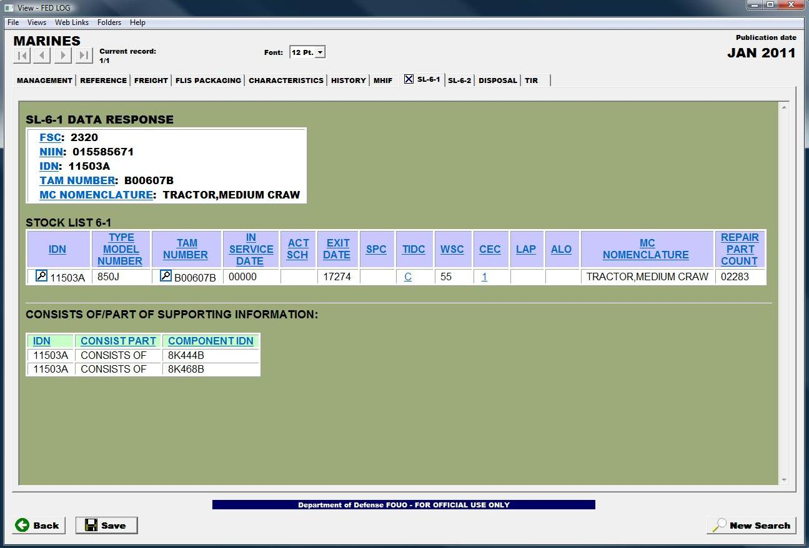
Fig. 5

(ON SLIDE #242)

INTERIM TRANSITION: During this period we discussed the SL-6-1. Are there any questions over this material? Now let’s talk about the SL-6-2. ________________________________________________________________
________________________________________________________________
________________________________________________________________

(ON SLIDE #243)

(2) SL-6-2 “Applications List of National Stock Numbers.” This stock list displays the application data pertinent to all NSN’s recorded in support publications and in the applications subsystems records.

(a) SL-6-2 Screen displays vital information about the NSN and its applications to a particular ID number in following column headings. Figure 6 shows an example of the Marine Corps SL 6-2 Response.

(ON SLIDE #244)

1 ITEM DESIGNATOR NUMBER (IDN). An ID number in this column indicates that the NSN has its own ID number.

2 NAME. For repair parts, the name listed in this column is a direct extract from the cataloging record of the Total Item Record (TIR). Omission of the item name indicates the NSN is not registered in the cataloging record of the TIR. For end items, the name is extracted from the application file.

(ON SLIDE #245)

3 SYSTEM SOURCE MAINTENANCE RECOVERABILITY (SSMR) CODE. This code is derived from analysis of all SMR Codes assigned a specific NSN as they were incorporated in support publications for different IDs. Inventory managers in system management of the item use it. This code may differ from a specific SMR Code assigned an item as shown in the SL-4 or equivalent "other services" publication. For example, the same item in one equipment may be readily replaceable or reparable at a higher echelon than organizational. The SSMR will reconcile the disparity in system support of the two applications. The maintenance code portion of the SSMR reflects the lowest maintenance code among the combination of equipment usage for a specific NSN.

(ON SLIDE #246)

4 SYSTEM EXIT DATE (DATE). Date developed after an analysis is made concerning each exit date for all equipments to which the NSN applies. The exit date with the greatest future date is considered the system exit date that applies to this NSN. When the system exit date is unknown, this field will appear blank.

5 COMBAT ESSENTIALITY CODE (CEC). A one-character numeric code that indicates whether or not an end item is essential to the operational readiness of a weapon system or the conduct of a military mission; or that an end item is a functional part contributing to the tactical and essential operations of an end item component or assembly whose failure would render the end item inoperable or incapable of fulfilling its mission; or that a repair or secondary depot reparable component is required for the safety and health of personnel.

(ON SLIDE #247)

6 ITEM DESIGNATOR NUMBER (IDN). An ID number(s) in this column indicates that this NSN applies to the listed ID number(s).

7 SL-3 COMPONENTS LIST (QTY 3). The total quantity of an item according to the unit of measure, required for full operation of an end item.

(ON SLIDE #248)

8 SL-4 QUANTITY (QTY 4). The total quantity of a specific item (NSN) used on an equipment.

9 MAINTENANCE CODE (MC). Maintenance Codes are assigned to indicate the levels of maintenance authorized in USE and REPAIR items. The maintenance codes are entered in the third and fourth position of the SSMR Code format as follows: The third position will indicate the lowest maintenance level authorized to remove/replace and use the support item. The fourth position indicates whether the item is to be repaired and identifies the lowest maintenance level with the capability to perform a complete repair action.

(ON SLIDE #249)

10 UNIT OF MEASURE (U/M). The measure of units required for an equipment, as presented in an SL-4 or equivalent publication.

11 CRITICALITY CODE (CRIT). A numeric code that indicates whether there exists a critical acute functional requirement for the part in its application to the end item.
(b) SL-6-2 will similar to Figure 6.

(ON SLIDE #250)

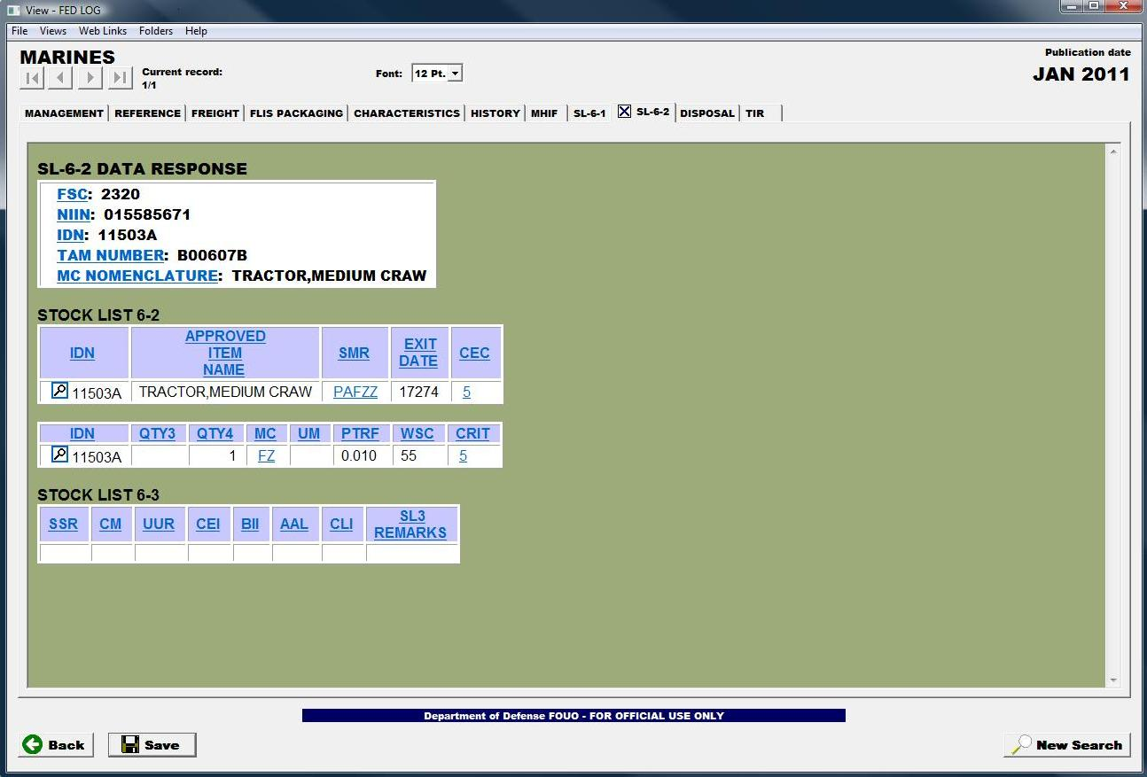
Fig. 6

(ON SLIDE #251-252)
INSTRUCTOR NOTE
Hand out quiz prior to demonstration. Allow 30 minutes for completion. Students should work from memory but student outlines are authorized. Explain that this is also a good study guide for the test.

INTERIM TRANSITION: During this period we discussed the purpose and contents and arrangements of the FEDLOG; and the SL-6-1 and SL-6-2 contained in FEDLOG. Do you have any questions? I will now demonstrate how to access FEDLOG and perform searches utilizing the various tabs contained in FEDLOG.
________________________________________________________________
________________________________________________________________
________________________________________________________________
INSTRUCTOR NOTE
Perform the following demonstration.

DEMONSTRATION. (1 HR) Access and use the FEDLOG located on the S:Drive. The purpose of this demonstration is to build FEDLOG information search skills. This skill will be evaluated by performance examination.

STUDENT ROLE: Students will record the mapping instructions to gain access to the FEDLOG located on the S:Drive. Students are to observe the demonstration only. They are to ask questions or make comments for clarification. Students will not attempt to perform the steps along with the instructor.
INSTRUCTOR ROLE: Utilize the instructor computer to display demonstration on “A” and “B” screens. Demonstrate how to access the FEDLOG located on the S:Drive. Demonstrate the application of each tab located in the FEDLOG.
1. Safety Brief: N/A
2. Supervision and Guidance: Utilize the instructor computer to display demonstration on “A” and “B” screens. Demonstrate how to access the FEDLOG located on the S:Drive. Demonstrate the application of each tab located in the FEDLOG.
3. Debrief: Allow students the opportunity to ask questions and comment on the demonstration. Answer student questions and provide feedback on student comments. Review mapping instructions for access to the FEDLOG located on the S:Drive.

INTERIM TRANSITITON: I have demonstrated how to perform the searches you will be required to perform for evaluation. Are there any questions? After we return from a ten minute break you will be afforded the opportunity to develop your skills by performing these searches independently.
________________________________________________________________
________________________________________________________________
________________________________________________________________

(BREAK – 10 MIN)

INTERIM TRANSITION: Prior to the break I demonstrated how to perform required searches. We will now move to the practical application.
________________________________________________________________
________________________________________________________________
________________________________________________________________

(ON SLIDE #253)

INSTRUCTOR NOTE
Introduce the following practical application.

PRACTICAL APPLICATION. (2 HR 30 MIN)Each student will accomplish the assignment on their own. There is one instructor required. Distribute one copy of Publications Practical Application “B” to each student. Read each question to the students to ensure they understand the requirements of the assignment.

Handouts are located in the classroom filing cabinet. Demonstrate how to access the FEDLOG located on the S:Drive. Provide assistance, as required, to ensure each student accesses the FEDLOG screens located on the S:Drive on the computer at their desk. The purpose of this exercise is to build FEDLOG information search skills. This skill will be evaluated by performance examination.

PRACTICE: Each student will access and utilize the FEDLOG screens located on the S:Drive to answer each question on the practical application. Students will raise their hand to gain the attention of the instructor if they have a question. Students will not talk, except to ask the instructor a question.

PROVIDE HELP: Instructor will walk around the classroom and observe student performance. Instructor will be available to answer student questions throughout the entire practical application time period.
1. Safety Brief: N/A
2. Supervision and Guidance: Instructor will walk around the classroom and observe student performance. Instructor will be available to answer student questions throughout the entire practical application time period.
3. Debrief: Inform students they are allowed to use their practical application exercise as a reference during the performance examination. Advise students to take notes on their practical application handout. Review each question on the practical application exercise. Show the Practical application handout answer key on the “A” screens, and demonstrate how to find the answer on the “B” screens.

(ON SLIDE #254-256)

TRANSITION: During this period we have discussed the SL-6-1/2. You also observed a demonstration of how to perform searches and had the opportunity to perform those searches. Are there any questions over the material we have covered to this point? I have some questions for you. (Q1) The SL-6-1 is an application list for? (A1) End Items and Components. (Q2) The SL-6-2 is an application list of? (A2) National Stock Numbers. (Q3) What stock listing would be used to identify what a particular NSN applies to? (A3) SL-6-2
________________________________________________________________
________________________________________________________________
________________________________________________________________

(ON SLIDE #257-259)

SUMMARY (10 MIN)
During this period we have discussed the knowledge and skills required to properly maintain required publications in support of maintenance and how to identify directives necessary to manage a maintenance facility. I feel confident that you’ll be able to go back to your units and effectively manage the Publications sections at your shops. At this time those students with those IRF’s go ahead fill those out and the rest of you take a ten minute break.

REFERENCES:

MCO P4790.2_ MIMMS Field Procedures Manual
MCO 5215.1_ Marine Corps Directives Management Program
MCO P5215.17_ The Marine Corps Technical Publications System
MCO 5600.31_ Marine Corps Publications And Printing
Regulations
TM 4700-15/1_ Ground Equipment Record Procedures
UM-MCPDS 5605 Marine Corps Publications Distribution
System (MCPDS) Users Manual
UM 4400-124 FMF SASSY Using Unit Procedures
PLMS V3 UG Marine Corps Publications Library Management System (PLMS) Users Manual
NAVMC 2761 Catalog Of Publications
Internet (www.usmc.mil)
SECNAV M-5210.2 Standard Subject Identification Code (SSIC) Manual

