# UNITED STATES MARINE CORPS

# MARINE CORPS DETACHMENT

# ENGINEER EQUIPMENT INSTRUCTION COMPANY

# 693 MINNESOTA AVENUE

# FORT LEONARD WOOD, MO 65473

ENGINEER EQUIPMENT OFFICERS COURSE

1310

March 2010

**Welcome to Fort Leonard Wood**

On behalf of Colonel Springer and all the Marines at the Marine Detachment, Ft. Leonard Wood, MO, I would like to congratulate you on your selection to the WO Program and welcome you to FLW for your MOS training. I have attached a few things that may assist your stay here at FLW.

* Map of FLW main side area.
  + Bldg 1770 is the CDO hut for check-in
  + Bldg 5400 is the location for the course in Brown Hall
* Course Description Academics and Policies
* Lodging
* Off Base Dining
* Off Limits Establishments

If you have any questions you can contact the following personnel. Again, welcome to FLW.

CWO5 Wayne Porowski (573) 596-5529

EEIC Company (573) 596-0718

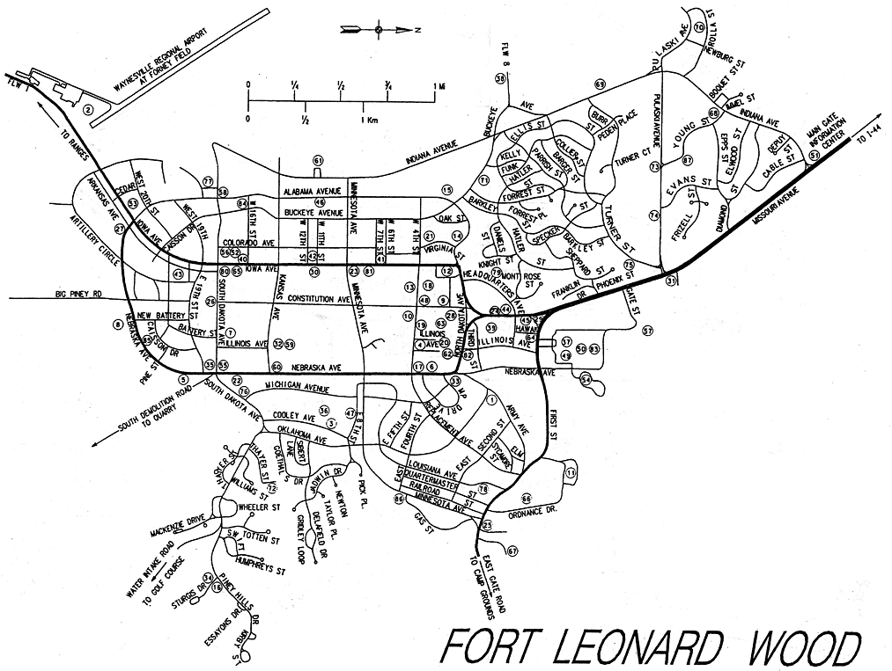

**Det HQ**

**To Crane Shed**

**Main Gate**

**Brown Hall**

**Duty Bldg 1770**

# ENGINEER EQUIPMENT OFFICER COURSE

# SCHOOL ACADEMIC STANDARDS, POLICIES AND COURSE DESCRIPTION

**1. COURSE CONTENT**. Currently, Engineer Equipment Instruction Company Warrant Officer Basic Course is seven weeks in length with nineteen separate periods of instruction. You will be provided with a course schedule that will list all periods of instruction.

1. Administrative

INVENTORY EXAM 2.00 HRS

RECORDS AND FORMS 1.00 HRS

POST EXAM 4.00 HRS

7.00 HRS

2. Lecture

RECORDS AND FORM 5.00 HRS

LOAD TEST 2.75 HRS

VECHICLE RECOVERY 4.00 HRS

SAFETY 1.00 HRS

ORM 1.00 HRS

RECORDS AND FORMS 5.00 HRS

MODIFICATIONS PROGRAM 2.00 HRS

CALIBRATIONS 2.00 HRS

Supervise Maintenance Related Reports 5.50 HRS

SUPPORT AND TEST EQUIPMENT 2.00 HRS

INPUT TRANSACTIONS 1.75 HRS

MIMMS 1.75 HRS

MAINTENANCE PRODUCTION 1.25 HRS

REPAIR PARTS MANAGEMENT 1.00 HRS

JOAP 1.00 HRS

UNIT TRAINING MANAGEMENT 2.00 HRS

Engineer Equipment Capabilities 3.00 HRS

Equipment Licensing 3.00 HRS

CONSTRUCTION MANAGEMENT 29.00 HRS

74.00 HRS

3. Demonstration

INPUT TRANSACTIONS 1.75 HRS

MIMMS 1.75 HRS

MAINTENANCE PRODUCTION 1.25 HRS

REPAIR PARTS MANAGEMENT 0.50 HRS

JOAP 0.75 HRS

Load Test 2.75 HRS

CONSTRUCTION MANAGEMENT 29.25 HRS

38.00 HRS

4. Practical Application

RECORDS AND FORMS 4.50 HRS

MODIFICATIONS PROGRAM 0.50 HRS

CALIBRATIONS 0.50 HRS

RECORDS AND FORM 2.50 HRS

INPUT TRANSACTIONS 2.50 HRS

MIMMS 3.50 HRS

MAINTENANCE PRODUCTION 1.00 HRS

Equipment Licensing 3.50 HRS

Load Test 12.00 HRS

CONSTRUCTION MANAGEMENT 107.50 HRS

138.00 HRS

5. Written Exam

CALIBRATIONS 2.50 HRS

Supervise Maintenance Related Reports 1.00 HRS

RECORDS AND FORM 4.50 HRS

MIMMS 4.00 HRS

Equipment Licensing 4.00 HRS

SAFETY 2.50 HRS

ORM 2.50 HRS

ORM EXAM 2.50 HRS

RECORDS AND FORMS 2.50 HRS

26.00 HRS

**2. ACADEMICS**. This course is an academic, MOS producing course. As such, there are academic standards that must be met in order to graduate and receive the 1310 MOS. All must master 100% of the terminal learning objectives in the course. To do this, a minimum of 80% must be achieved a on the written exams and a “master” received on all assigned projects.

**3. RETESTS.**

a. Failing an initial test will be administered a retest, generally not later than the next duty day following the failure.

b. Failure of any retest will be considered as a “double non-mastery” in accordance with the Detachment Standing Operating Procedures (SOP) and may be removed from the course (see paragraph 5, Dismissal From The Course).

c. Any student non-mastering a project will lose those percentage points permanently. The student will also be required to resubmit the project to the Director.

d. If the student fails a project the second time, they will be considered as a “double non-mastery” in accordance with the Detachment Standing Operating Procedures (SOP) and may be removed from the course (see paragraph 5, Dismissal From The Course).

**4. ACADEMIC PROBATION / STUDY HALL.**

a. Failing initial tests will result in an informal counseling by the Academics Officer and considered for academic probation.

b. Failing three initial tests will result in a formal counseling by the Academics Officer and will be placed on academic probation.

c. Academic probation will be administered/managed by the School staff in the form of mandatory study halls.

d. To be removed from academic probation, the student must pass two consecutive initial tests with a 90% or higher.

e. Voluntary study halls given at the request of the student.

**5. DISMISSAL FROM THE COURSE.**

Reasons for dismissal from the course are:

a. Failure to meet academic standards by failing five initial tests.

b. Failure to meet academic standards by failing any retest (double non-mastery).

c. Any student considered for dismissal from the course will be given an opportunity to appeal the dismissal before a review board convened at the Detachment level. The students’ academic record, overall performance, and any other pertinent information will be reviewed prior to initiation of administrative separation procedures (per MARADMIN 588/02).

e. Personal conduct that is not in compliance with MCOs, Rules and regulations.

**6. HONOR GRADUATES.** In accordance with DetO P5000.1E, The student with the highest overall average will be designated as the Academic Honor Graduate. This individual must have maintained a grade point average of 95% or higher and not fail any initial exams. Disciplinary problems will disqualify students as honor graduates for the course.

**7. CLASS AND COURSE CRITIQUES.** Critiques provide valuable information necessary to improve and validate the course of instruction.

a. Throughout the course, a minimum of two students will complete Instructor Rating Forms (IRF) for each period of instruction. Students provide pertinent evaluations and comments on each period of instruction. These comments will be used to correct lesson plans and provide the instructors information that will assist them in improving the period of instruction in the future.

b. At the end of the course, each student will complete a Quality of Life Survey. These surveys will be used to gather information that may be used to enhance the overall experience for the students.

c. Every student will complete an End of Course Critique prior to graduation. The critiques are used to better the course as a whole.

**8. TRANSPORTATION.**  Students are authorized POVs while at this course and will be required to provide their own transportation from billeting to all training sites.

**9. MEALS.**  Meals will be the responsibility, and at the discretion, of the student. Based on the training schedule, students should plan to eat breakfast and dinner before and after training, respectively. For the noon meal, students will be given time for lunch and must make their own arrangements.

a. Some of the options for meals include:

(1) The MANSCEN NCO Academy Mess Hall provides great food and service at reasonable prices, and is open for all three daily meals.

(2) The main exchange has a food court with several options for meals. Hours are generally mid-morning to evening.

(3) Students will generally have enough time for lunch to drive to either the exchange or a dining facility. However, packing and bringing a lunch with you may be a better option.

**10. COURSE SCHEDULE.**  Your duty while here is to attend the USMC Engineer Equipment WO course. You will be provided a copy of the current course schedule. There may be schedule changes during the course and you will be informed of all updates and changes. It is the students’ responsibility to be at the appointed place and time for duty.

**11. PHYSICAL FITNESS.**  Time for PT has not been incorporated into the schedule. PT sessions will be conducted on your own and it will be your responsibility to ensure you make time to stay in shape. Marines are subject to the 6100 series MCOs while attending school. You will be given an opportunity to take a PFT during July if you so desire. This is not mandatory, but is offered so you can get it completed before checking into your unit.

**12. PERSONAL APPEARANCE – CUSTOMS AND COURTESIES**. All standard customs and courtesies are to be followed while here. While attending school Warrant Officers will be observed by junior Marines and you should be aware of your conduct, conversations and mannerisms at all times.

a. The uniform of the day is desert utilities unless otherwise dictated.

b. The utility uniform is **not** authorized for wear off base.

c. PT gear will not be in on-base facilities, such as the PX, chow hall, snack bar, etc (even though the Army does).

**13. INTER-SERVICE INCIDENTS**. If an incident should occur, attempt to get the name, rank and unit of the individual involved and report it immediately to myself, your class advisor, the chief instructor or the school SNCOIC. Above all, do not aggravate the situation. The staff will resolve the problem. Be familiar with the other the Services’ customs and courtesies.

**14. LEAVE / LIBERTY.**  During this course, the only leave that will be granted is emergency leave other than any 4 day liberty. Normal weekday and weekend liberty will be granted, unless rescinded on an individual basis (academic probation, etc). The liberty limit for weekday liberty is 75 miles and 150 miles for weekends. Anyone desiring to go beyond these liberty limits must submit an Out of Bounds chit for approval by the Company Commander.

a. Any student traveling more than 150 miles from Fort Leonard Wood **must** complete an Operational Risk Management (ORM) matrix for submission to the Company Commander.

b. All special request forms and ORM matrixes will be turned into the class advisor for routing to the Company Commander

c. The liberty limit for the Independence Day holiday period will be **300 miles**. An ORM matrix and vehicle inspection checklist will be required.

**15. FITNESS REPORTS.**  Each student will receive a FD (From Temporary Duty) Fitness Report upon completion of the course. The report will include, at a minimum, your grade point average.

I have read and understand the contents of this package.

____________________________ _______________________________

Print Sign Date

**LODGING**

**FLW LODGING -** Lodging Main Office 573-596-0665 (http://www.fortleonardwoodlodging.com/)

**Local Lodging http://www.fortleonardwoodhotels.com/corporate.htm**

***Super 8 St Robert***2 Star Hotel, Rooms From: **$89.99 to $89.99**

Ft. Leonard Wood Military Base 3 miles Indoor Pool and Hot Tub Exercise Room Meeting Room Extended stay suites Jacuzzi Rooms

***Comfort Inn St. Robert***3 Star Hotel, Rooms From: **$91.99 to $91.99** Unique rustic lodge decor with two story lobby. FREE first class breakfast. Located just three miles from Fort Leonard Wood. Restaurants and shopping within walking distance.

***Best Western Montis Inn***2 Star Hotel Rooms From: **$66.99  to $72.99** The ideal hotel near Fort Leonard Wood Military Base and other attractions in Pulaski County, Missouri. The Best Western Montis Inn offers comfortable rooms

***Econo Lodge***

1 Star Hotel Rooms From: **$66.99  to $71.99** Close to Ft. Leonard Wood. Restaurants nearby. Microwave/Refrigerator, iron/ironing board, hairdryer, phone, cable TV, and HBO in some rooms. Complimentary coffee and doughnuts

**Holiday Inn Express**

3 Star Hotel Welcome to the newly remodeled Holiday Inn Express Saint Roberts/Ft. Leonard Wood, located just minutes from Ft Leonard Wood, Forney Air Field, Walmart, and the Gasconade and Piney

***Candlewood Suites***2 Star Hotel Rooms From: **$105.00 to $105.00** The Candlewood Suites Hotel Saint Robert, Missouri is a one of a kind extended stay property, centrally located off I-44 and 3 miles from Fort Leonard Wood

***Baymont Inn & Suites***3 Star Hotel Rooms From: **$76.49 to $129.49** Located only two miles from Ft. Leonard Wood, Baymont Inn &amp; Suites owned by a US Army retiree is an excellent choice if you want to be close to everything!

**Mainstay Suites**2 Star Hotel Rooms From: **$98.99 to $169.99** Distinctive four story extended stay hotel conveniently located along I-44. This 77 suite hotel offers full size kitchens in all rooms. FREE express continental breakfast serve

***Red Roof Inn***

2 Star Hotel Rooms From: **$66.99 to $66.99** The St. Robert Red Roof Inn is located just 5 minutes from Fort Leonard Wood Army Base! This Inn features wireless Internet access in all rooms

***Fairfield Inn by Marriot***

3 Star Hotel Rooms From: **$75.05 to $109.00** Fairfield Inn is Marriott's award winning economy lodging chain featuring clean, convenient, quality accommodations - all for a great value!

***Knights Inn***

1 Star Hotel Rooms From: **$47.69 to $54.99** Knights Inn St. Robert, MO is off I-44 at Exit 163 and is just 3 miles from the Welcome Center. Fort Leonard Wood Military Base is 5 miles from our property.

***Home Town Suites***

3 Star Hotel Rooms From: **$66.60 to $74.00** Home Towne Suites is nestled among scenic national forests and beautifully enhanced by the breathtaking Ozark scenery.

**ON BASE DINING**

***Audie Murphy's Club***

**AMCC Dining Room is OPEN - 11am - 1:00pm weekdays**

**Lunch - Monday thru Friday 11am - 1:00pm**

**Closed Saturdays, Sundays and Holidays**

All You Can Eat Buffet only $8.50

***Pershing Community Club***

**The Black Jack Lounge:** (Currently at the Audie Murphy Club)

**Open Tuesday - Friday 4:30pm, Saturday 5pm**

**Casual dining in a sports bar atmosphere.**

**"The Grill"**

Located inside the BlackJack Lounge, "The Grill" offers a variety of items for the largest of appetites. From Onion Rings to Steaks, from Salads to Burgers, "The Grill" is always hot and ready to serve you. Open from Tuesday - Saturday until 9 p.m. and during Football season, "The Grill" opens at 11am on Sundays.

***Daugherty Bowling Center Strike Zone Snack Bar***

Open for lunch and dinner

**Monday - Thursday  11am - 10pm**

**Friday - Saturday   11am - 12am**

***Piney Valley Golf Course Sandwedge Eatery***

Have lunch while enjoying the beautiful scenery of the Mark Twain National Forest. The PVGC's Sandwedge Eatery is open for lunch:

**Monday - Friday 11am - 1:00pm**

**Saturdays 10:30am - 3:00pm**

**LOCAL DINING**

***German***

**The Hub Restaurant106 VFW Rd. St. Robert, MO 65584573-336-3874**

**Paradise German Deli219 Historic Rt. 66 Waynesville, MO 65583 573-774-8422**

***Mexican***

**El JimadorHidden Valley Plaza St. Robert, MO 65584573-336-7555**

**El Sombrero385 Highway Z St. Robert, MO 65584573-336-2729**

**La Familia Mexican Restaurant Upper Mini Mall St. Robert, MO 65584573-336-3339**

**Taco Bell229 Missouri Ave. St. Robert, MO 65584573-336-4633**

***Oriental***

**Bulgogie House1018 Missouri Ave. St. Robert, MO 65584573-336-7550**

**China Buffet Spur Shopping Center 743 Missouri Ave. St. Robert, MO 65584573-336-5886**

**Chopstix Hidden Valley Plaza, St. Robert, MO 65584573-336-0104**

**Imperial Restaurant American - Chinese Buffet100 Ashley May Lane Waynesville, MO 65583 573-774-0355**

**Joe's Traditional Korean Food Upper Mini Mall 1005 Missouri Ave St. Robert, MO 65584573-336-3590**

**Mi Suks Oriental RestaurantThe Plaza 1058 Missouri Ave., St. Robert, MO 65584 573-336-4770**

**Mizeki Japanese Sushi & Grill198 Old Rt. 66 St. Robert, MO 65584 573-336-3399**

**Seoul Garden 626 Old Rt 66 St. Robert, MO 65584 573-336-2023**

***American Cuisine***

**Adonia's Steak & Seafood Z Highway, Exit 161, St. Robert, MO 65584 573-336-4244**

**Atrium in the Ramada Inn I-44 Exit 161 St. Robert, MO 65584 573-336-3121**

**Aussie Jack's Steaks, Seafood & Spirits 141 St. Robert Blvd. St. Robert, MO 65584 573-336-2447**

**Caveman BBQ & Steak House *Closed November 1 to March 1*26880 Rochester Road Richland, MO 65556 573-765-4554**

**Cracker Barrel Old Country StoreI-44 Exit 161, N Outer Road St. Robert, MO 65584 573-336-7273**

**Country Cafe I-44 at Exit 163, St. Robert, MO 65584 573-336-5200**

**Country Kitchen379 Hwy Z. St. Robert, MO 65584 573-336-4075**

**Peppers Sports bar and Grill 560 Old Rt 66 St. Robert, MO 65584 573-336-2100  
Ruby Tuesday135 St. Robert Blvd. St. Robert, MO 65584 573-336-5140**

**Ryan's Steak House225 St. Robert Blvd. St. Robert, MO 65584 573-336-8536**

**Stephano's Pizza and GyrosClayton Towers, 1015 Missouri Ave. St. Robert, MO 65584 573-336-7949**

**Waffle House Hwy Z, St. Robert, MO 65584 573-336-4331**

**Sweetwater BBQ 14076 Hwy Z, St. Robert, MO 65584 573-336-8830**

***Crazy Jacks 100 Ashley Mae Lane, Waynesville MO 65583 573-774-0120***

***Coffee Shops***

**Caffe' Italia103 N Benton St. Waynesville, MO 65583 573-774-5707**

**StarBucks300 Ichord Ave. *Inside Price Cutter Plus* Waynesville, MO 65583 573-774-8489**

DEPARTMENT OF THE ARMY



U.S. ARMY MANNEUVER SUPPORT CENTER FORT LEONARD WOOD

320 MANSCEN LOOP SUITE 316

FORT LEONARD WOOD, MISSOURI 65473-8929

12 JAN 2010

MEMORANDUM FOR: SEE DISTRIBUTION

SUBJECT: Off Limits Establishments/Areas

1. The establishments listed below are declared off limits to military personnel. If any case the name changes, the premises remain off limits.

1. The property known as Daisy’s Health Spa, located on Superior Road, St. Robert, MO.
2. The property known as the Dutchman’s Liquidators, located at 644 Old Route 66, St. Robert MO.
3. The property known as Electra’s Bar, located at 107 Fina Street, Saint Robert, MO.
4. The property known as Dutchman’s Liquidators, located at 644 Old Route 66, St. Robert, MO.

2. The following area is declared off limits to military personnel: The area referred to as “Party Cove”, currently located in the vicinity of the 4-mile marker at Anderson Hollow Cove, Lake of the Ozarks, Camden County, MO. Party Cove historically has been a floating geographic location and has in the past been known to exist in various areas of Lake of the Ozarks. Therefore, regardless of the geographic location, military personnel are prohibited from participating in any activities at area referred to as Party Cove.

3. Military personnel observed in off-limits establishments/areas are in violation of a lawful written general order and are subject to punishment per the Uniform Code of Military Justice (UCMJ).

4. This notice supersedes the previous memorandum, ATZT-CG 6 July 07, Subject: Off Limits Establishments. The proponent for this memorandum is the Provost Marshal Office/Directorate of emergency services at (573) 596-0575.

GREGG F. MARTIN

Major General, USA

Commanding

DISTRIBUTION:

All Schools, Brigades,

Battalions, Companies,

Detachments, Tenant Units,

Directorates, and Personnel Staff Offices