UNITED STATES MARINE CORPS

Field Medical Training Battalion – East

Camp Lejeune

FMST 1501

Perform Aid Station Procedures

TERMINAL LEARNING OBJECTIVES
- Given a BAS environment and standard field medical equipment and supplies, perform Battalion Aid Station (BAS) procedures, to provide optimum Health Service Support per the references. (FMST-HSS-1501)
- Given a mission in a field environment, T/E-designated tentage, and assistants, employ T/E-designated tentage, to provide shelter for Health Service Support operations per the references. (FMST-HSS-1502)
- Given an aid station in a garrison setting and the standard medical equipment and supplies, provide optimum Health Service Support, per the references. (FMST-HSS-1503)
ENABLING LEARNING OBJECTIVES

- Without the aid of references, given a description or list, identify the mission of the Battalion Aid Station, per the student handout. (FMST-HSS-1501a)
- Without the aid of references, given a description or title, identify the areas of responsibility within the Battalion Aid Station, per the student handout. (FMST-HSS-1501b)
- Without the aid of references, given a description or list, identify the medical support responsibilities of the Battalion Aid Station in a garrison environment, per the student handout. (FMST-HSS-1501c)
- Without the aid of references, given a description or list, identify the medical support responsibilities of the Battalion Aid Station in a field environment, per the student handout. (FMST-HSS-1501d)
- Without the aid of references, given a description or list, identify equipment used to establish a Battalion Aid Station, per the student handout. (FMST-HSS-1501e)
- Without the aid of references, given a tactical environment and the necessary Table of Equipment (T/E) and supplies, employ tentage, per the student handout. (FMST-HSS-1502a)
- Without the aid of references, given a simulated combat environment, utilize AMAL equipment, per the student handout. (FMST-HSS-1502b)
- Without the aid of references, given a description or list, identify the mission of the Aid Station in garrison, per the student handout. (FMST-HSS-1503a)
- Without the aid of references, given a description or title, identify the areas of responsibility within the Aid Station in garrison, per the student handout. (FMST-HSS-1503b)
- Without the aid of references, given a description or list, identify the procedures for patient assessment during routine sick call, per the student handout. (FMST-HSS-1503c)

OVERVIEW
Health Service Support (HSS) of today's Marine Corps Operational Forces emphasizes the provision of far-forward, mobile, medical support in the stabilization and evacuation of casualties. The Aid Station is the HSS unit that will deliver these services to our Marine Corps Forces (MARFOR) in sustaining the combat power of the force. Throughout this lesson, the term Battalion Aid Station (BAS) is used to describe various Aid Stations. A true BAS is a term used to describe an Infantry Battalion Aid Station. Know that there are many different Aid Stations, i.e. BAS, Group Aid Station (GAS), Regimental Aid Station (RAS), etc., each with different numbers of personnel assigned.

- MISSION OF THE AID STATION
The Aid Station has a dual mission, one that will be fulfilled while in a field/combat environment, and the other fulfilled while in garrison. The mission of the aid station is to be the primary HSS source for a unit. While in a field/combat environment, the mission of the Aid Station is to minimize the effect wounds, injuries, and diseases have on a unit’s effectiveness, readiness and morale. Treatments such as surgical airways, administration of IV fluids and antibiotics, as well as stabilization of wounds and fractures are common. The mission of the Aid Station while in garrison is to keep the Marines assigned ready for deployment. As such, responsibilities include conducting sick-call, providing medical support during training, and undergoing continued medical training.

- ORGANIZATION
Aid stations throughout the Marine Corps are staffed based on the mission of the individual organization. Manpower requirements for each unit are listed on its Table of Organization (T/O). Large units, such as Infantry Battalions, may have up to two medical officers (MO) and 65 Corpsmen to support 1,000 Marines. Smaller units, such as Combat Engineer Battalion or a Tank Battalion may only have one or no MO and a few Corpsmen but receive additional support from a Headquarters Company. In the field, the BAS is co-located with the command post. Around-the-clock operating capability is required. The BAS is manned by Hospital Corpsmen of the battalion medical platoon under the direction of the battalion surgeon.
Aid Station Group (Infantry Battalion) - a section of H&S Company, the aid station group is headed by the Battalion Surgeon, and is capable of splitting into two sections to operate two separate aid stations when necessary; the Assistant Battalion Surgeon heads the second aid station.
Medical officer - there are two MOs within each medical battalion
- Battalion Surgeon
- Assistant Battalion Surgeon
Religious Ministry Team (RMT) - each BAS is assigned one RMT consisting of:
- Chaplain
- Religious Programs Specialist (RP)
Hospital Corpsmen - there are 21 corpsmen headed by a Leading Chief assigned to the Aid Station under the Assistant Battalion Surgeon
Line Company Corpsmen - there are 44 Corpsmen assigned to the line companies. They are divided into four groups of 11 Corpsmen.

3. BAS RESPONSIBILITIES IN GARRISON (NOT IN THE FIELD)
Maintain medical and dental readiness - One of the most important missions of the BAS while in garrison is to keep the unit medically and dentally prepared to deploy. Aid Stations use a web based data tracking system known as the Medical Readiness Reporting System (MRRS). Because it is web based, immunization information for Marines and Sailors can be transferred electronically when they check-in to a new unit. This system provides an overall readiness snapshot of the unit.
Conduct sick call - Aid stations act as the primary medical treatment facility for active duty Sailors and Marines for that particular unit. Sick call will normally be conducted under the direction of the MO or Independent Duty Corpsman (IDC). Responsibilities of the general duty Corpsman include identifying the chief complaint and performing a routine patient assessment to include vital signs. You may be expected to present the patient to the MO or IDC to complete the assessment and develop the treatment plan. It is also the responsibility of the sick call Corpsman to complete much of the official documentation.
Sick Call Procedures
Check in - Aid Stations generally have sick call hours each morning. Patients will sign in and receive their medical record from the records office. Vital signs are taken and documented on a Standard Form (SF) 600.
Patient encounter - is documented using the SOAP Note fashion (Subjective, Objective, Assessment and Plan). You may be expected to complete and document the first half of the note before presenting the patient to the IDC or MO at which time the assessment will be made and a treatment plan will be developed.
Discharge - basic treatments that can be performed at the BAS will be accomplished as required. Routine medications that are stocked in the BAS will be dispensed as needed. The patient is given instructions on the remainder of the plan of care and when they should report back for any follow up appointments.
Binnacle List - each morning a Binnacle List (Report of the Sick and Injured) is sent to the company office detailing individuals who had been seen that day. It also lists Marines who are Sick in Quarters or currently on Light Duty.
Disease Non Battle Injury - information from the Sick Call log is also transferred into a Disease Non Battle Injury (DNBI) Report. This report breaks down the categories of injuries and illness for the unit. It is forwarded up the chain and collected for the major unit. This information can be used to track the spread of disease or identify injury trends.
Administration - Aid Stations are the focal point of all medical administrative matters for the unit. These include everything from simple light duty chits to complicated Physical Exam Boards (Med Boards).
Supply - Aid Stations in garrison have limited amounts of consumable supplies. Unit funds are used to provide office supplies and medical supplies needed to provide basic care for unit personnel.
Provide medical coverage as needed for training - whenever Marines train, they will need Corpsmen. Examples of events requiring medical coverage include weapons ranges, obstacle courses, and physical fitness tests.
Provide training to non-medical personnel to enhance self/buddy aid and litter team responsibilities - training programs such as Combat Life Saver are taught while in garrison. A thorough training program for your Marines, to include sustainment training, will save lives on the battlefield.

- BAS RESPONSIBILITIES IN THE FIELD/COMBAT ENVIRONMENT
While in the field or combat operations, some of the responsibilities the BAS performed while in garrison will continue. However, there are additional responsibilities the BAS and the corpsman assigned to the BAS will assume. For instance;
- Conduct sick call
- Conduct Triage
- Treat casualties to minimize mortality, prevent further injury, and stabilize for further evacuation.
- Record all casualties received and treated, and report them to the appropriate unit section for preparation of casualty reports.
- Provide temporary shelter in conjunction with emergency treatment.
- Return patients to duty when possible.
- Transfer evacuees from the BAS to ambulance, helicopter, or other evacuation transportation.
- Initiate treatment of combat stress casualties.
- Maintain deployment health records (DHR) of battalion personnel.
- Provide personnel replacement and medical re-supply for company level Hospital Corpsmen.
During combat operations, the BAS is structured to be able to split its personnel and supplies into two BAS's (Alpha and Bravo) and "leapfrog" ahead as the battlefield advances, (see figure 2). As Alpha BAS advances with the battalion, Bravo BAS will remain behind and continue to provide medical care/evacuations until all patients have been CASEVAC’ed, or until relieved by medical support elements such as Medical Battalion Shock Trauma Platoon (STP). This allows for continuity of care as the unit advances. Once the STP assumes all casualties, Bravo BAS, personnel and supplies will rejoin Alpha BAS to form the complete BAS (see figure 2).

ALPHA BAS
1 MO
11 HM'S
FORWARD BATTLE LINE
1 MO
10 HM'S

BRAVO BAS
STP

STP
Figure 2. BAS Employment during combat operations
The BAS does not have a patient holding capability. It is similar to a crude emergency room. Depending on the tactical situation, the BAS can be assembled in a fully equipped General Purpose (GP) tent or employed in a mobile configuration from two M1035s and two 7-ton trucks. An individual’s privacy is a main concern while they are being treated. Any and all practical measures necessary to provide patient privacy should be used. A Religious Ministry Team (RMT) may be assigned to the BAS. The RMT is made up of a Chaplain and a Religious Program Specialist (RP). Their job is to aid in the comfort of the sick and wounded and to perform religious rites, as needed. This team can provide emotional support for the wounded and can also assist the BAS personnel at the discretion of the Medical Officer.
Sections of the BAS - the BAS can be broken down into five internal sections, which operate as a whole in providing HSS to the Marine Infantry Battalion. (See figure 3)
Internal Security - provides perimeter security for the immediate BAS area, searches patients for weapons, munitions, and booby traps prior to being admitted to the triage area. AT NO TIME will any weapon or ammunition be allowed into the medical treatment area.
Triage - sorts and records all incoming patients prior to entry into treatment area. Limited emergency first aid and fluid replacement may be provided here while patients are waiting to enter treatment area. Initiate and/or continue patient documentation of treatment provided in this area. Also provides comfort/ease of pain to the dying.
Treatment Area - usually done in the GP tent, but could be any secure area assigned by the Battalion Surgeon to treat patients. It’s where all the life saving treatment/procedures are performed as directed by the MO or Senior Medical Department Representative.
Evacuation Area - staging area for patients awaiting evacuation, those requiring continued monitoring or continued care. It is also the area where casualty reporting and CASEVAC requests are made.
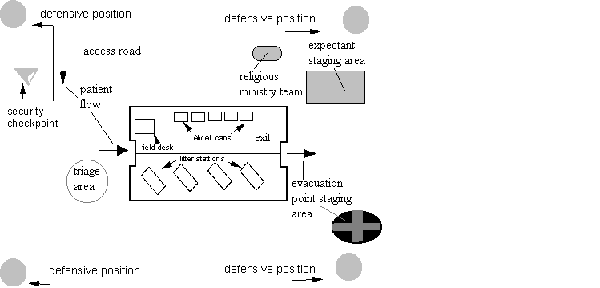
Expectant Area - area used to hold personnel with very serious injuries who are not expected to survive. Supportive medical care is provided, i.e. pain medications, and ministry and sacrament for the dying are provided appropriate for the casualties’ faith group.

Figure 3. Typical Field BAS Setup
Responsibilities of Specific Personnel
Battalion Surgeon
One of the two medical officers in an infantry battalion is designated as the Battalion Surgeon. The Battalion Surgeon is a special staff officer who advises the battalion commander on matters pertaining to the health and medical care of battalion personnel. The duties of the Battalion Surgeon include:
- Supervising patient treatment, planning, and organization.
- Education of the battalion medical staff.
- Other duties as the battalion commander may direct.
Assistant Battalion Surgeon
The other medical officer in an infantry battalion is designated as the Assistant Battalion Surgeon. The primary job of the Assistant Battalion Surgeon is to:
- Direct, manage, and supervise the operation of the BAS.
- Perform such additional duties as may be assigned by the Battalion Surgeon.
Battalion Chief
Maintains the BAS to include:
- Administration, personnel, and logistical matters.
- Ensures that all battalion HSS commitments and operational requirements have the appropriate medical and logistical support.
- Advises the Battalion Surgeon on all matters relating to the BAS or battalion medical personnel.
Joint responsibilities of the Battalion Surgeon/Chief
- Organizing/Assignment of medical platoons personnel.
- Preparing HSS appendix to battalion's operational plan.
- Supervising and assisting in the collection, treatment, and evacuation of the sick and injured.
- Develop HSS Standing Operation Procedures (SOP) in accordance with guidance by higher authority.
- Conduct medical sanitation inspections.
- Maintaining and submitting appropriate records and reports.
- Train medical personnel in subjects relating to HSS.
- In the absence of a Preventive Medicine Technician, supervise instruction for non-medical personnel in personal hygiene, preventive medicine, and field sanitation.
- Ensuring medical supplies and equipment are properly managed, and that a responsive re-supply system is established to ensure adequate re-supply at garrison and combat levels.

- BAS LOGISTICS
Logistics is the military specialty dealing with the procurement, storage, distribution, inventory, and maintenance of material. Supplies and equipment are divided into X classes for management purposes. Class VIII supplies are specifically medical related items. Careful consideration should be given to stock levels of Class VIII materials (consumable and equipment) so as not to overstock. The following information is crucial when medical planners develop HSS logistical support system:
- Concept of operation/scheme of maneuver
- Combat intensity
- Duration of the operation
- Casualty estimates

Supply Terminology
Table of Equipment (T/E) - a unit's T/E includes items necessary for basic support of the organization and include:
- Tentage
- Vehicles
- Tools
- Communication equipment
- Nuclear, biological and chemical (NBC) gear
- Office equipment and supplies
Authorized Medical Allowance List (AMAL) - a list of authorized allowances of equipment and consumable supplies required to perform operational HSS. There are many types of AMALs that can be requested based on the nature of the operation. Each AMAL is composed of equipment and consumable supplies. The T/E assigned AMALs for the BAS are designed to support one Infantry Battalion.
AMAL 635 (Equipment) - Aid Station equipment and reusable material supporting HSS of the BAS. Examples include:
- Litters
- Litter stands
- Blankets

AMAL 636 (Consumable Items) - Consumable supplies required to provide HSS to the BAS, to include, initial resuscitation, and stabilization of 50 casualties with major wounds prior to evacuation, and re-supplying to the company line Corpsmen. Examples include:
- Intravenous solutions
- Bandages
- Medications
Authorized Dental Allowance List (ADAL) - a list of authorized allowances of equipment and consumable supplies required to perform a dental function. As with the AMAL, there are various types of ADALs and they are also composed of equipment and supplies.
ADAL 662 Field Dental Items - equipment and reusable material required establishing a dental clinic in the field. Consumable supplies required providing emergency, diagnostic, and preventive maintenance of dental care for 400 patients.

DD-1348 (see figure 4) - form used to requisition materials. It is used primarily by the battalion corpsman in ordering supplies by line item only, e.g., IV fluids, bandages, splints, etc., to re-stock the equipment and consumable AMAL/ADAL.
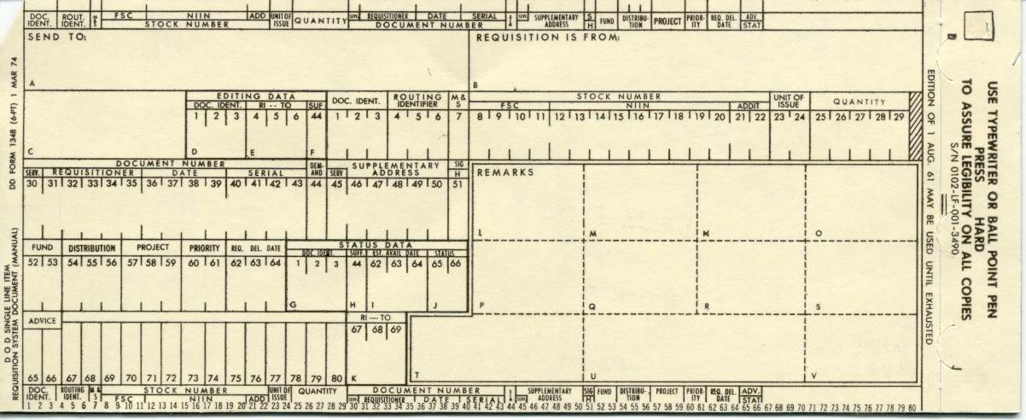
Figure 4. DD FORM 1348
Line items - an item having a National Stock Number (NSN)
Medical Logistics Company (MEDLOG), Supply BN - the only permanent medical/dental supply source in a Marine Expeditionary Force (MEF). It supports both the ground and air elements of a MEF. MEDLOG maintains all AMALs/ADALs while in garrison. They are also responsible for preventive maintenance, repair, and replacement of all medical equipment and replacement of supply items.

Naval Medical and Dental Material Bulletin (NMDMB) - monthly publication which provides information on medications, supplies, equipment and authorizes additions or deletions to the AMALs and ADALs. It also provides information on expiration dates, defective materials, and disposition instructions.
Medical Supply and Replenishment
Chain of re-supply under combat situations:
Unit Corpsman
BAS
Logistics Command Element
MEDLOG, Supply Battalion, MLG

referenceS
Marine Corps Warfighting Publication (MCWP), 4-22 MED 021-6
Combat Health Support in Specific Environments, FM 8-10-1
Class VIII Supplies, MCO 6700.2
Health Service Support Operations, MCWP 4-22
Hospital Corpsman, NAVEDTRA 14295
Emergency War Surgery Handbook NATO, 2004
Medical Evacuation in a Theater of Operations, FM 8-10-6

Aid Station Review

1. Describe the Disease Non Battle Injury Report (DNBI).

2. List five requirements of the BAS in combat.

3. What types of things are found on a Table of Equipment (T/E)?

4. Which AMAL contains consumable supplies? List three.

