UNITED STATES MARINE CORPS
Field Medical Training Battalion – East

Camp Lejeune

FMST 1424

Blast Related Injuries

TERMINAL LEARNING OBJECTIVE
- Given a description or list, in a tactical environment, identify the medically related aspects of blast incidents in a tactical environment, per the reference. (FMST-HSS-1424)

ENABLING LEARNING OBJECTIVES

Without the aid of reference, identify the five categories of blast effects on the human body, within 80% accuracy, per Pre-Hospital Trauma Life Support, Military Edition, 6th Edition, Chapter 25. (FMST-HSS-1424a)
    - Without the aid of reference, identify the pattern of injuries from an explosive device, within 80% accuracy, per Pre-Hospital Trauma Life Support, Military Edition, 6th Edition, Chapter 25. (FMST-HSS-1424b)
    - Without the aid of reference, identify the wounding effects of fragmentation, within 80% accuracy, per Pre-Hospital Trauma Life Support, Military Edition, 6th Edition, Chapter 25. (FMST-HSS-1424c)

    - Without the aid of reference, identify the wounding effects of blast overpressure, within 80% accuracy, per Pre-Hospital Trauma Life Support, Military Edition, 6th Edition, Chapter 25. (FMST-HSS-1424d)

OVERVIEW
Injuries from explosives are the predominant cause of combat injury and death. In the insurgency phase of the Iraq War, they account for about 60% of American injuries. So it is essential that medical personnel have a good understanding of the pathophysiology of injuries caused by explosive devices such as; letter bombs, shaped warheads from rocket-propelled grenades, antipersonnel land mines, aerial-delivered cluster bombs, enhanced blast weapons, and the improvised explosive devices so widely used in insurgency and terrorist settings.
- FIVE CATEGORIES OF BLAST EFFECTS
The term “blast injuries” refers to the general injuries caused by an explosive force. The five categories of blast injury effects are listed below. It is important to understand the effects of each, as well as the mechanism of injury and injuries associated with all five.

Effect | Impact | Mechanism of Injury | Injuries
Primary | Direct blast effects (over- and under-pressurization) | Direct tissue damage from blast overpressure; Interaction of blast wave with body;  Stress and sheer waves produce tissue organ injury | Pulmonary  Tympanic Membrane rupture  Hollow or Viscus Injuries
Secondary | Projectiles propelled by explosions | Fragments from the exploding weapon as well as from the environment (debris, vehicle metal, rocks etc) | Fragmentation Injuries  Penetrating Trauma
Tertiary | Propulsion of body onto a hard surface or object | Displacement of body and structural collapse | Being thrown against hard surface causing penetrating, injuries, blunt trauma, and crush injuries
Quaternary | Heat and/or combustion Flames | Burns and toxic injuries from fuel, metals, septic syndromes from soil and environmental contamination | Burns  Inhalation Injuries  Asphyxiation
Quinary | Additives such as radiation or chemicals (e.g. dirty bombs) | Contamination of tissue from: Bacteria, Radiation, Chemical agents, Contaminated tissue from bystander or assailant | Variety of health effects, depending on the agent

PATTERN OF INJURIES

Casualties from explosions on the battlefield can be segregated into two categories; military and civilian. While military casualties are predominately young and otherwise healthy, civilian casualties may be very young or very old. A large percentage of those will be in relatively poor health. When compared to civilian casualties, military casualties are less likely to suffer injuries to their upper torso and head due to the protective gear they wear.
In a mass casualty incident resulting from an explosion there will generally be a large number of lightly wounded casualties as well as a significant amount of deaths. Those casualties who require immediate life saving measures will represent a small percentage of the actual casualties. Locating these individuals and treating them promptly is a definite challenge for medical responders.
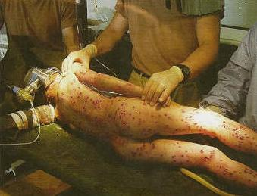
3. WOUNDING EFFECTS OF FRAGMENTATION
Fragmentation injuries are the most common form of injury in a terrorist bombing (see figure 1). Fragments include debris from the munition itself, the environment surrounding the explosive (sticks, rocks, trash etc) and, in the case of suicide bombers, human body parts. Treatment of fragmentation wounds will be based on the area of the body involved and the extent of the injury.
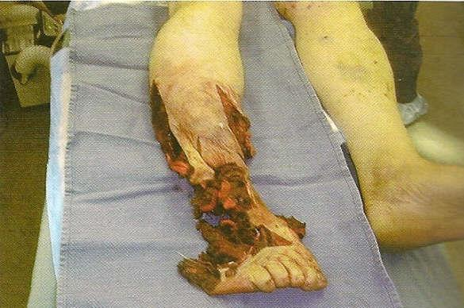
Limbs are by far the most commonly affected body area, accounting for 70% of the injuries from explosive devices. Primary and secondary effects of the blast may require the patient to receive emergency treatment to prevent exsanguination. Casualties with traumatic amputations from conventional explosions are generally within three feet from the device when it explodes. These individuals account for a large portion of the immediate fatalities following suicide bombings. As with all combat wounds, extremity wounds following explosions will need antibiotics to prevent systemic infections.
Figure 1. Fragmentation injuries
While eyes are extremely resistant to primary effects of blasts, they are susceptible to secondary and tertiary effects. Explosions causing shattering glass have a high incidence of causing penetrating eye injuries. The majority of eye injuries can be prevented by simple eye protection, such as polycarbonate goggles.
Figure 2. Limb injury from explosion

4. WOUNDING EFFECTS OF BLAST OVERPRESSURE
Physics of Blast Waves - blasts produce two separate types of waves. Each wave does specific forms of damage to the human body.
Stress waves are supersonic, longitudinal pressure waves. These waves create high potential for injuries, especially in gas-filled organs such as the lungs, ears and intestines.
Sheer waves are lower velocity transverse waves with longer duration than stress waves. These waves cause tissue in the body to move back and forth.
Lung Injuries occur when the victim experiences overpressure of greater than 40 pounds per square inch (PSI). Increases in pressure of 200 PSI in an open-air environment are almost universally fatal. Lung injuries are the most common cause of death related to the primary blast effect.
Signs and Symptoms may appear immediately or they may be delayed for up to 48 hours, depending on the severity of the wound. Internal hemorrhage in the pulmonary region, along with alveolar edema will lead to frothy, bloody secretions from the mouth. The casualty will also exhibit signs of labored breathing and appear hypoxic.
Treatment is difficult in a tactical environment. The patient should be monitored for the appearance of dyspnea and/or frothy sputum. Oxygen should be administered as soon as it is available. IV fluids should be used with extreme caution to avoid overloading the lungs with fluid.
Ear Injuries can occur from as little as 5-15 PSI of overpressure. It is imperative that all blast injury casualties be examined for possible tympanic membrane (TM) rupture. Since it takes a far greater amount of pressure to rupture lungs or abdominal organs, the absence of ruptured tympanic membranes can help rule out other injuries, provided the patient is not experiencing any other symptoms related to organ damage. Blast induced deafness may heighten the patients anxiety. The hearing loss may be permanent or resolve in a matter of hours.
Signs and Symptoms will be noticeable upon examination. The patient will have a noticeable loss of hearing, along with some bleeding from the ear(s). Visualizing the eardrum with an otoscope can positively identify a ruptured TM.
Treatment of a ruptured TM is relatively conservative and is not a priority on the battlefield. Although 50-80% of TM ruptures will heal on their own, patients should still be referred to a medical officer within 24 hours. Until then, avoid probing or irrigating the ear canal.
Gastrointestinal Injuries are more likely to occur in patients of blasts detonated inside a building than those exposed to explosions in an open-air environment. Of all abdominal blast injuries, intestinal perforation is the most common. While the blast may induce the intestinal perforation which is considered a closed injury, other aspects of the blast may produce open injuries as well.
Signs and Symptoms include pain in the abdomen, rectum, and testes and may be difficult to appreciate early in the care of the casualty.
Treatment of gastrointestinal injuries is covered in Block two of this text and will be based on the extent of the injury.
Solid Organ injury is rare in open-air blasts but has been reported in underwater blasts. All abdominal injuries should be treated symptomatically as discussed in Block 2.
Central Nervous System Injuries, to include Traumatic Brain Injuries (TBI), are significant issues associated with blast injuries. Moderate to severe TBI accounts for 71% of the early deaths associated with explosions and 52% of later deaths. Mild TBI is associated with long term issues such as memory loss, irritability, and decreased cognitive functions. For this reason, all personnel involved in an explosive attack should be referred to a medical officer for documentation and evaluation.

Mutitple-Etiology Injuries - Explosions create different injury patterns based on various factors. Among these are the size of the explosion, the location of the explosion, and the proximity of the casualty to the explosion. These events often lead to the casualty experiencing multi-etiology injuries. In this case the patient has injuries to more than one body part or system. To determine the correct intervention, you must be able to perform a systematic casualty assessment to identify and treat life threatening injuries first.

REFERENCE
Pre-Hospital Trauma Life Support, Military Edition, 6th Edition, Chapter 25
Blast Review

1. What types of injuries can you expect from the secondary effects of a blast.

- Describe the pattern of injuries associated with military casualties.

- Describe the wounding effects of fragmentation.

4. Define multi-etiology injuries.

