UNITED STATES MARINE CORPS

Field Medical Training Battalion – East
Camp Lejeune

FMST 1423

Coordinate Casualty Evacuation (CASEVAC)

TERMINAL LEARNING OBJECTIVE
- Given multiple casualties in a tactical environment, communication equipment, nine-line evacuation format, and the standard field medical equipment and supplies, coordinate casualty evacuation to transport casualties for medical treatment, per the references. (FMST-EVAC-1423)
ENABLING LEARNING OBJECTIVES
- Without the aid of references, given a description or list of capabilities, identify the capabilities of the taxonomy of care, within 80% accuracy, per JP 4-02. (FMST-EVAC-1423a)
- Without the aid of references, given a description or list, identify common litters utilized as CASEVAC platforms, within 80% accuracy, per FM 8-10-6 and the PHTLS Manual. (FMST-EVAC-1423b)
- Without the aid of references, given a description or list, identify ground vehicles utilized as CASEVAC platforms, within 80% accuracy, per FM 8-10-6. (FMST-EVAC-1423c)
- Without the aid of references, given a description or list, identify aircraft utilized as CASEVAC platforms, within 80% accuracy, per FM 8-10-6. (FMST-EVAC-1423d)
- Without the aid of references, given a description or list, identify casualty receiving treatment ships utilized as CASEVAC platforms, within 80% accuracy, per FM 8-10-6. (FMST-EVAC-1423e)
- Without the aid of references, given a description or list, identify the casualty evacuation categories, within 80% accuracy, per FM 8-10-6. (FMST-EVAC-1423f)
- Without the aid of references, given a description or list, identify the purpose of a Nine-Line evacuation communication, within 80% accuracy, per FM 8-10-6. (FMST-EVAC-1423g)
- With the aid of references, given the necessary equipment, transmit a Nine-Line evacuation request, within 80% accuracy, per FM 8-10-6. (FMST-EVAC-1423h)
- Without the aid of references, given multiple simulated casualties in a tactical environment, standard field medical equipment and supplies, and individual combat equipment, perform casualty evacuation, per the student handout. (FMST-EVAC-1423i)
OVERVIEW
Tactical Evacuation Care (TACEVAC) is the third phase in the Tactical Combat Casualty Care process. Tactical evacuation encompasses both medical evacuation (MEDEVAC) and casualty evacuation (CASEVAC). The care delivered in the TACEVAC phase can more closely resemble advanced trauma life support guidelines than that in the first two phases. With either vehicular or air evacuation of wounded casualties from the battlefield, there is an opportunity for access to additional medical equipment not available to the Corpsman during the first two phases. One example is the use of pulse oximetry devices, which detect the percent of hemoglobin with oxygen bound to it and gives you an indication of how well the casualty is breathing. It also allows for early detection of pulmonary compromise or cardiovascular deterioration before physical signs are evident. They are highly reliable and can apply across all ages and races. This lesson will describe the taxonomy of care, different methods of casualty evacuation, and how to call for an evacuation.

1. TAXONOMY OF CARE
The taxonomy of care outlines distinctive and overlapping care capabilities that enhance performance in a military force. The level of care commences at the scene of the injury and continues until the member receives definitive care and is discharged or returned to full duty. While this course teaches you the skills needed to operate using the first responder, forward resuscitative, and en route care capabilities, there are five capabilities in the taxonomy continuum of healthcare capabilities which are used when evacuating the wounded from the battlefield (see figure 1).
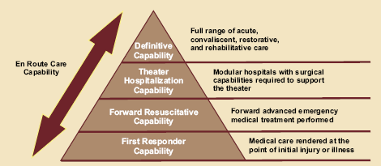

Figure 1. Taxonomy of Care

First Responder Capability - first aid and emergency care rendered at the point of initial injury are the primary objectives of care at this level. Defined by its time requirements, first responder care provides immediate medical care and stabilization to the patient in preparation for evacuation to the next capability in the continuum of care. Examples of First Responder Capabilities include:
- Self-aid/Buddy aid
- Battalion Aid Station (BAS)
Forward Resuscitative Capability - builds on the First Responder Capabilities. Characteristics include performing advance emergency medical treatment as close to the point of injury as possible, stabilizing the patient, and saving life and limb. Stabilization ensures the patient can tolerate evacuation. Examples of Forward Resuscitative Capabilities include:
Medical Battalion - provides surgical care for the MEF. Provides stabilizing surgical procedures. Capable of holding patients up to 72 hours.
Casualty Receiving & Treatment Ships (CRTS) - part of an Expeditionary Strike Group (ESG). They provide additional medical capabilities for receiving a mass casualty (up to 50 casualties).
Shock Trauma Platoon (STP) - small forward unit with one physician supporting the MEF specializing in patient stabilization and evacuation. No surgical capability.
Forward Resuscitation Surgical Suite (FRSS) - staffed with 8 to 10 personnel (two surgeons, one critical care nurse, one anesthesiologist and four to six corpsmen). It consists of a two tent surgical system that provides a fully powered, climate-controlled environment with enough space for one operating room and one pre- and post-operative care room. The shelter is equipped with cutting-edge surgical gear and takes less than one hour to set up or break down.

Theater Hospitalization Capability - services are delivered via modular hospital configurations and/or hospital ships required to sustain forces in theater. These capabilities deploy as modules or multiple individual capabilities that provide increasing medical services in a more robust theater. The care offered either returns the patient to duty or stabilizes the patient to ensure they can tolerate evacuation to a definitive care facility. Services encompass primary inpatient and outpatient care, emergent care, and enhanced medical, surgical, and ancillary capabilities, including:
Fleet hospitals - deployable ground asset but located away from enemy threat providing up to 500 hospital beds, 80 ICU beds, and 6 OR’s.
Hospital ships (USNS Mercy and USNS Comfort) - deployable medical assets providing up to 1,000 beds, 100 ICU beds, and 12 OR’s.

Definitive Capability - rendered to conclusively manage a patient’s condition and is usually delivered from, or at, facilities in the homeland, but may be delivered in facilities outside the homeland. This capability generally leads to rehabilitation, return to duty, or discharge from the armed forces. Because this care is usually given outside the operational area, the most advanced health care can be made available and accessible to the patient. It includes:
CONUS Military, Veteran’s and selected civilian hospitals - provide full convalescent, restorative, and rehabilitative care to all patients returned to the Continental United States (CONUS).
Overseas Medical Treatment Facilities - offers the surgical capability found in the theater hospitalization capability, along with further definitive therapy for those patients in the recovery phase who can be returned to duty within the theater evacuation policy. A patient who cannot be returned to duty will be evacuated through the en route care capability.
En Route Care Capability - en route care is the continuation of care during evacuation within the continuum without clinically compromising the patient’s condition. This capability can take one of three forms – medical evacuation (MEDEVAC) in which dedicated special medical non-combatant platforms are used. The Air Force is the primary provider of MEDEVAC assets. Casualty evacuation (CASEVAC) are primarily non-medical evacuation platforms, however, some may have medical attendants such as a Hospital Corpsman or an Army Medic. This course deal specifically with CASEVAC, which involves the unregulated movement of casualties aboard ships, land vehicle, or aircraft.

2. METHODS OF EVACUATION
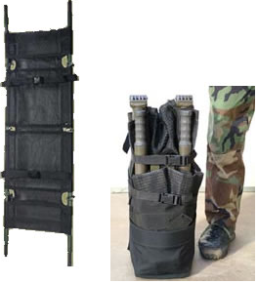
The level of urgency and the tactical situation dictates the method of evacuation. Depending upon which level of care you are in, Care Under Fire, Tactical Field Care, or Tactical Evacuation Care, will dictate how the casualty is transported. The most common forms of evacuation are: ambulatory, manual carries, litter evacuation, ground evacuation, air evacuation, or sea evacuation. Regardless, the casualty should be made as comfortable as possible and kept warm and dry. If an improvised litter is used, it should be padded and field-expedient material replaced with conventional splints, tourniquets, and dressings as soon as feasible. A patient with minimal injuries should be encouraged to stay in the fight if possible and to ambulate to an area where care can be safely provided.
Types of litters - there are six commonly used litters within the FMF.
Talon Litter (see figure 2) - the Talon collapsible handle litter was developed to meet the US Army’s urgent requirement to provide casualty evacuation. The Talon litter allows a casualty to be transported in one vehicle then transitioned to a standard evacuation platform without the need to transfer a casualty from one litter to another. The Talon litter is the most commonly used litter.
Figure 2. Talon Litter
Standard Army Litter (see figure 3) - the standard collapsible litter folds along the long axis.
Stokes Litter (see figure 4) - affords maximum security for the patient when the litter is tilted.
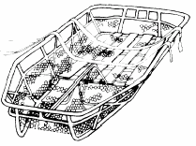
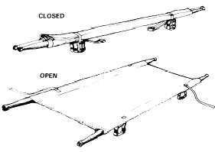

Figure 4. Stokes Litter

Figure 3. Standard Army Litter

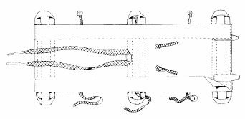
Pole-less Non-rigid Litter (see figure 5) - this litter can be folded and carried by the Field Medical Service Technician. It has folds into which improvised poles can be inserted for evacuation over long distances.
Figure 5. Pole-less Non-rigid Litter

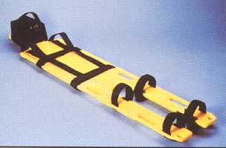
Miller (full body) Board (see figure 6) - the Miller Board is constructed of an outer plastic shell with an injected foam core. It is impervious to chemicals and the elements and can be used in virtually every confined-space rescue and vertical extrication. It fits in stokes stretcher and will float a 250-pound person.
Figure 6. Miller (full body) Board

Improvised Litters (see figure 7) - used for moving a casualty when a standard litter is not available, the distance may be too great for manual carries, or the casualty may have an injury that would be aggravated by manual transportation. These litters are to be used in emergency situations only and must be replaced by standard litters at the first opportunity.

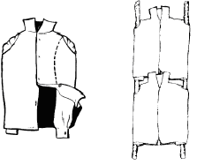

Rolled Blanket Litter

Blouse / Flak Jacket Litter

Figure 7. Improvised Litters

Procedures for Carrying Litters
- When moving a patient, the litter bearers must make every movement deliberately and as gently as possible. The command “steady” should be used to prevent undue haste.
- The rear bearers should watch the movements of the front bearers and time their movements accordingly to ensure a smooth and steady action.
- The litter must be kept as level as possible at all times, particularly when crossing obstacles such as ditches.
- Normally, the patient should be carried on the litter feet first, except when going uphill or up stairs
- When the patient is loaded on a litter, his individual equipment is carried by two of the bearers or placed on the litter. When available, use Marines as your litter bearers.
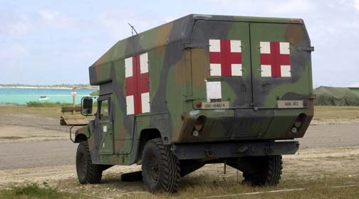
3. GROUND EVACUATION PLATFORMS
M997 Ambulance - HMMWV frame with armor protection for crew and patients. It is capable of transporting up to 4 litter or 8 ambulatory patients. (See figure 8)

Figure 8. M997 Ambulance

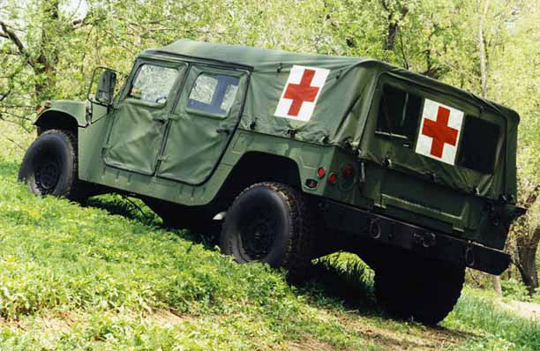
M1035 Ambulance - HMMWV frame with removable soft-top. It is capable of transporting 2 litter and 3 ambulatory patients. (See figure 9)

Figure 9. M1035 Ambulance
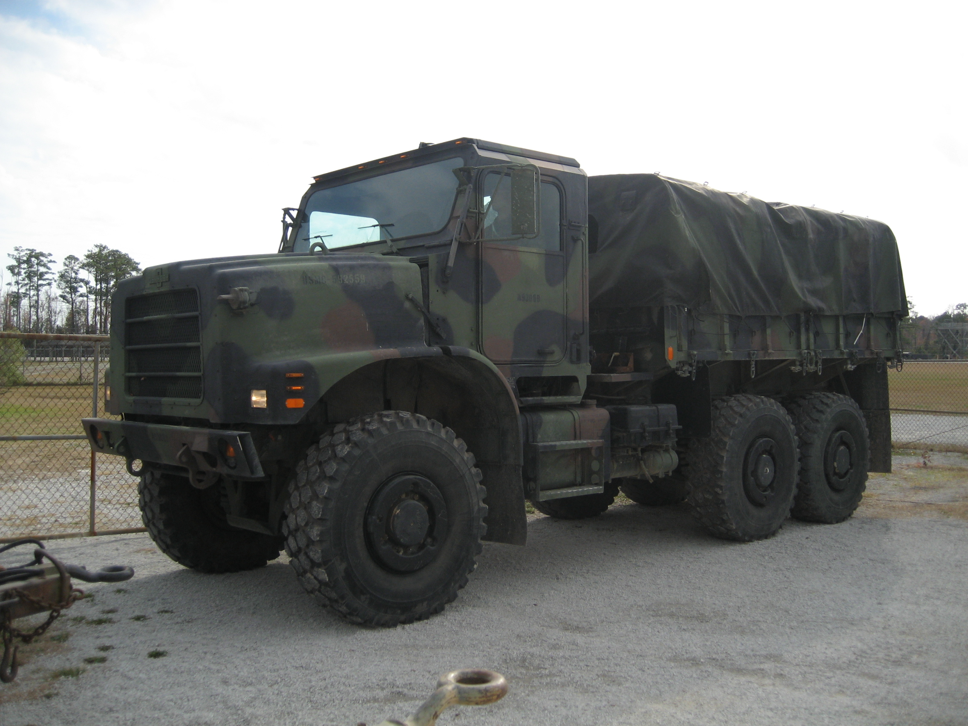

MK 23 7 Ton - non-medical vehicle that may be utilized for casualty transportation when available. It is capable of transporting 10 litter or 20 ambulatory patients. (See figure 10)

Figure 10. MK 23 7 Ton Truck

4. AIR EVACUATION PLATFORMS
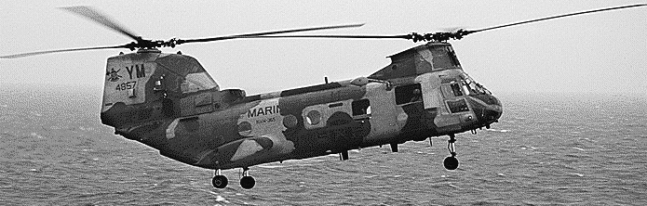
CH-46 Sea Knight
- Dual rotor medium lift helicopter used to transport personnel and cargo (being phased out by the MV-22 Osprey Tilt Rotor Aircraft).
- When configured for litter racks, able to
carry 15 litters or 22 ambulatory
patients.
Figure 11. CH-46 Sea Knight

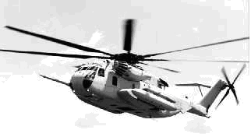
CH-53 Super Sea Stallion
- Medium/Heavy lift helicopter used to transport personnel and cargo.
- When configured for litter racks, able to carry 24 litters or up to 37 ambulatory patients. When the centerline seating is added, up to 55 ambulatory patients can be carried.
Figure 12. CH-53 Super Sea Stallion

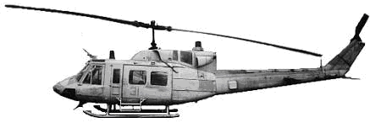
UH-1 Huey
- Light transport helicopter used to transport personnel and cargo.
- When configured for litter racks, able to carry 6 litters or up to 10 ambulatory patients.
Figure 13. UH-1 Huey

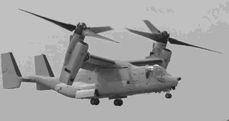
MV-22 Osprey
- Tilt-rotor aircraft that takes off and lands
vertically but flies like a plane. This
aircraft is designed to eventually replace
the CH-46.
- When configured for litter racks, able to
carry 12 litters or 24 ambulatory casualties.

Figure 14. MV-22 Osprey

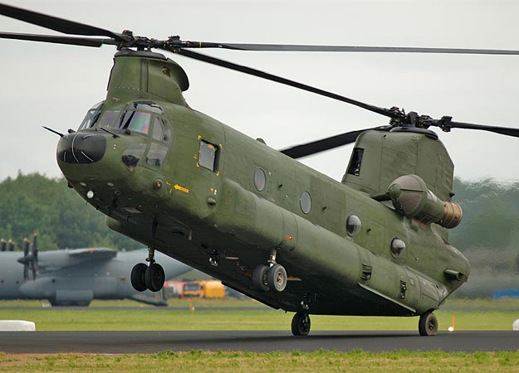
CH-47 Chinook
- Dual rotor medium lift helicopter used to
transport personnel and cargo for the US Army.
- When configured for litter racks can carry 24
litter patients or 31 ambulatory patients.

Figure 15. CH-47 Chinook

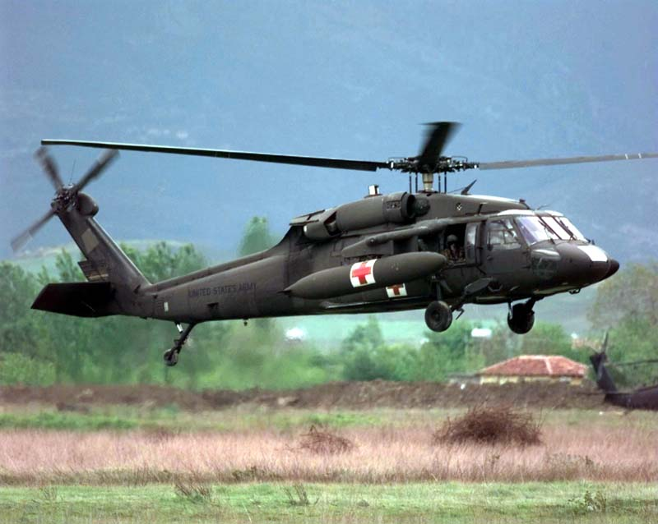
UH-60 Blackhawk
- Single rotor helicopter with multiple uses by not
only the Army but the Navy as well.
- Can carry up to 6 litter patients if litter
modification kit is installed.
- Can carry up to 7 ambulatory patients if litter
modification kit is not installed.
- Patients can be loaded from either side.

Figure 16. UH-60 Blackhawk
Figure 16. UH-60 Blackhawk

NOTE: The Marine Corps does not have dedicated CASEVAC aircraft. Any of its aircraft can be utilized as a “lift of opportunity” upon completion of its primary mission. The use of helicopter evacuation provides a major advantage because they greatly decrease the time between initial care and definitive treatment thereby increasing the casualty’s chances of survival. Figure 17 below reflects USMC assets as well as those available through the Army and Air Force.

AIRCRAFT
TYPE | SERVICE | LITTER | AMBULATORY |  | ATTENDANTS
UH-60 Blackhawk | USA | 6 | 7 |  | 1 Medic
CH-47 Chinook | USA | 24 | 31 |  | 2 Medics
UH-1 Huey | USMC | 6 | 10 |  | 1 Corpsman
CH-46 Sea Knight | USMC | 15 | 22 |  | 2 Corpsmen
CH-53 Super Sea Stallion | USMC | 24 | 37 |  | 2 Corpsmen
MV-22 Osprey | USMC | 12 | 24 |  | 2 Corpsmen
MEDICAL GROUND VEHICLES
TYPE | SERVICE | LITTER | AMBULATORY |  | ATTENDANTS
M997 HMMWV | USA/ USMC/  USAF | 4 | 8 |  | 1 Corpsman
M1035 HMMWV | USA/ USMC/  USAF | 2 | 3 |  | 1 Corpsman
VEHICLES OF OPPORTUNITY (GROUND)
TYPE | SERVICE | LITTER | AMBULATORY |  | ATTENDANTS
MK 23  (7-Ton Truck) | USMC | 10 | 20 | None

Figure 17. Ground/Air CASEVAC Platform Data Description

5. CASUALTY RECEIVING TREATMENT SHIPS
Specific ships within an Amphibious Task Force are designated as Casualty Receiving Treatment Ships (CRTS).

LHD/LHA - Amphibious Assault Ships with medical capabilities (see figure 18).
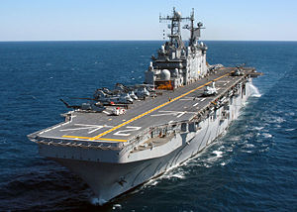
Mission
- Assault via helo, landing craft, and amphibious vehicle.
- Primary amphibious landing ships for MEF’s, MEB’s, and MEU’s.
- Primary CRTS
Transport capabilities
- Flight deck with large internal hangar deck and well deck.
- May receive casualties via helicopter or waterborne craft.
Figure 18. LHA Tarawa Class

Medical Capabilities
Largest medical capability of amphibious ships. When fully staffed,
capabilities include:
- 4 Operating Rooms
- 15 ICU Beds
- 45 Ward Beds
Hospital Ships (T-AH) - the COMFORT and the MERCY are operated by the Military Sealift Command and are designed to provide emergency, onsite care for US combatant forces deployed in war and other operations. The T-AHs provide a mobile, flexible, rapidly responsive afloat medical capability to acute medical and surgical care in support of ATF; Marine Corps, Army, and Air Force elements; forward-deployed Navy elements of the fleet; and fleet activities located in areas where hostilities may be imminent. The T-AHs also provide a full-service hospital asset for use by other government agencies involved in the support of disaster relief and humanitarian operations worldwide.

Transport Capabilities
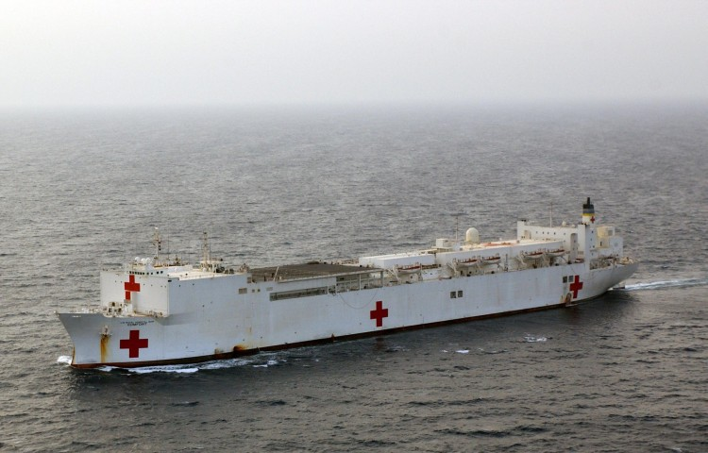
- Flight deck capable of receiving rotary wing aircraft.

Medical Capabilities
- Operating Rooms (12)
- ICU Beds (100)
- Intermediate Care Beds (400)
- Ward Beds (500)
- Ancillary capabilities of lab, x-ray, pharmacy, computerized tomography scanner, and blood storage.
Figure 19. Hospital Ship

- CASEVAC CATEGORIES (see figures 20-22)
Once a patient has been triaged and stabilized at the BAS, should that patient require further or additional medical treatment, he/she will be categorized for evacuation from the BAS to the next higher capability of care. While evacuating patients, ensure that they are kept warm to prevent hypothermia! The category levels are as follows:
Urgent Evacuation
- Evacuation to next higher capability of medical care is needed to save life or limb.
- Evacuation must occur within two hours.
Urgent Surgical Evacuation
- Same criteria as Urgent. The difference is that these patients need to be taken to a facility with surgical capabilities.

Priority Evacuation
- Evacuation to next higher capability of medical care is needed or the patient will deteriorate into the URGENT category.
- Evacuation must occur within four hours.
Routine Evacuation
- Evacuation to the next higher capability of medical care is needed to complete full treatment.
- Evacuation may occur within 24 hours.
Convenience
- Used for administrative patient movement.
URGENT/URGENT SURGICAL - 2 Hours or Less
Life threatening injuries such as temporarily corrected hemorrhage, temporarily controlled airway injuries, or temporarily controlled breathing issues.
Examples include (but not limited to) patients with:
Tourniquets Needle Decompression
Cricothyroidotomy Major Internal Bleeding
(Figure 20)

PRIORITY - 4 Hours or less
Potentially life threatening injuries such as compensated shock, fractures causing circulatory compromise, and uncomplicated but major burns.

Examples include (but not limited to) patients with:
Compensated Shock Broken arm with loss of distal pulse
2nd degree burns to a large portion of the abdomen or extremities
(Figure 21)

ROUTINE - 24 Hours or less
Injuries so insignificant or extreme that chances of survival are not based on evacuation time.
Examples include (but not limited to) patients with:
Abrasions Cardiac Arrest Massive Head Trauma
Small Fractures Frostbite 2nd /3rd degree burns >70% BSA
(Figure 22)

- NINE LINE CASEVAC
A nine-line evacuation request is a standard format used by the Armed Forces for coordinating the evacuation of casualties. Evacuation request transmissions should be by the most direct communication means available to the medical unit controlling evacuation assets. The means and frequencies used will depend on the organization, availability, and location in the area of operations as well as the distance between units.
The information must be clear, concise, and easily transmitted. This is done by use of the authorized brevity code. The authorized brevity code is a series of phonetic letters, numbers, and basic descriptive terminology used to transmit casualty information. These codes indicate the standard information required for an evacuation commonly known as the “9 Line”. This message is verbally transmitted in numerical “line” sequence utilizing the following brevity codes:
Line 1 - Location - location of the Landing Zone (LZ) where the casualties are to be picked up. This information will be transmitted in the form of an eight digit grid coordinate.
Line 2 - Radio Frequency, Call Sign - radio frequency and call sign that will be used by the ground unit at the LZ. You should know this information before every operation.
Line 3 - Precedence (Urgent, Urgent Surgical, Priority, Routine) - number of casualties by precedence. Use the following codes:
Alpha - Urgent
Bravo - Urgent Surgical
Charlie - Priority
Delta - Routine
Echo - Convenience
Line 4 - Special Equipment - identifies any special equipment that will be needed, such as a hoist in the case where a helo cannot land. Use the following codes:
Alpha - none
Bravo - hoist
Charlie - extraction equipment
Delta - ventilator
Line 5 - Number of Patients by Type - number of patients who are ambulatory and the number of litter patients. This determines whether or not the helo should be configured to carry litters. Use the following codes:
Lima - litter patients
Alpha - ambulatory patients
Line 6 - Security of Pickup Site - whether or not the enemy is near the LZ. If all of your casualties are routine and the LZ is not secured, then you may not get your requested CASEVAC approved. Use the following codes:
November - no enemy troops in area
Papa - possible enemy troops (approach with caution)
Echo - enemy troops in area (approach with caution)
X-Ray - enemy troops in area (armed escort required)
Line 7 - Method of Marking Pickup Site - method that you will use to mark your LZ and then ask the pilot to identify. Use the following codes:
Alpha - panels
Bravo - pyrotechnic signal
Charlie - smoke signal
Delta - none
Echo - other

Line 8 - Patient’s Nationality and Status - patients’ nationality and status. Use the following codes:
Alpha - US military
Bravo - US civilian
Charlie - non US military
Delta - non US civilian
Echo - enemy prisoner of war
Line 9 - NBC Contamination - whether the LZ has been contaminated with NBC agents. Use the following codes:
November - nuclear
Bravo - biological
Charlie - chemical
Example: During a routine patrol your platoon takes two casualties. One receives a gunshot wound to his right arm. The other receives a gunshot wound to his abdomen and has signs and symptoms of shock associated with internal hemorrhage. While you perform initial treatment, members of your platoon determine that the closest potential landing zone for a helicopter is 300 feet to the West. Its grid location on the map is DH 1234 5678. Your call sign is Blue Thunder and your unit is operating on the frequency 99.65. Your unit commander informs you that the site is secure and will be marked with green smoke. The following would be your nine line radio CASEVAC Request transmission:
Line 1: DH 12345678
Line 2: 99.65 Blue Thunder
Line 3: 1 Bravo, 1 Charlie
Line 4: Alpha
Line 5: 1 Lima, 1 Alpha
Line 6: November
Line 7: Charlie
Line 8: 2 Alpha
Line 9: None

Figure 23. Nine-Line Tactical Evacuation Request Example

REFERENCES
Pre-hospital Trauma Life Support, Military Edition, 6th Edition, Chapter 22
Medical Evacuation In A Theatre of Operations, FM 8-10-6, Chapters 5, 7-11
Health Service Support, JP 4-02, Chapter I
CASEVAC Review

1. Identify three different facilities that fall under the Forward Resuscitative Capability.

- How many litter patients can be carried in an M-997 vehicle.

- Describe the difference between the Urgent and Urgent Surgical categories.

4. In relation to the Nine Line evacuation request, what are “authorized brevity codes”?

