UNITED STATES MARINE CORPS
Field Medical Training Battalion – East
Camp Lejeune

FMST 1201

Participate in a Patrol

TERMINAL LEARNING OBJECTIVES
- Given a tactical scenario, an operations order, individual combat equipment, participate in a security patrol, to accomplish the mission. (FMST-FP-1201)
- Given a tactical scenario in a combat environment and individual combat equipment, execute fire team formations, to meet mission requirements. (FMST-FP-1202)
- Given a tactical scenario in a combat environment, and individual combat equipment, execute squad formations, to meet mission requirements. (FMST-FP-1203)
- Given a tactical scenario in a combat environment and individual combat equipment, communicate using hand and arm signals, to support mission requirements. (FMST-FP-1204)
- Given a tactical scenario in a combat environment, a patrol order, individual combat equipment, and necessary equipment for special signals, employ special signals, to support mission requirements. (FMST-FP-1205)
ENABLING LEARNING OBJECTIVES
- Without the aid of references, given a description or list, select the definition of patrol, per the student handout. (FMST-FP-1201a)
- Without the aid of references, given a description or list, identify the two types of patrols, per student handout. (FMST-FP-1201b)
- Without the aid of references, given a description or list, identify the organizational elements of a patrol, per student handout. (FMST-FP-1201c)
- Without the aid of references, given a description or list, identify the missions of patrols, per student handout. (FMST-FP-1201d)
- Without the aid of references, given a description or list, identify patrol leader preparations, per the student handout (FMST-FP-1201e)
- Without the aid of references, given a description or list, identify the steps of conducting patrols, per the student handout (FMST-FP-1201f)
- Without the aid of references, given a description or list, identify the fire team formations, per the student handout. (FMST-FP-1202a)
- Without the aid of references, given a description or list, identify the squad formations, per the student handout. (FMST-FP-1203a)
- Without the aid of references, given a description or list, identify hand and arm signals, per the student handout. (FMST-FP-1204a)
- Without the aid of references, given a description or list, identify the types of special signals, per the student handout. (FMST-FP-1205a)
- Without the aid of references, given a description or list, identify types of cover, concealment, and camouflage, per the student handout. (FMST-FP-1205b)
- Without the aid of references, given a tactical scenario in a simulated combat environment and individual combat equipment, participate in patrols, per the student handout. (FMST-FP-1201g)
- Without the aid of references, given a tactical scenario, in a simulated combat environment and individual combat equipment, demonstrate fire team formations, per the student handout. (FMST-FP-1202b)
- Without the aid of references, given a tactical scenario in a simulated combat environment and individual combat equipment demonstrate the squad formations, per the student handout. (FMST-FP-1203b)
- Without the aid of references, given instructions to do so, demonstrate hand and arm signals, per the student handout. (FMST-FP-1204b)
- Without the aid of references, given a tactical scenario and individual combat equipment, employ special signals, per the student handout. (FMST-FP-1205c)

DEFINITION OF A PATROL

A patrol is a detachment of ground forces sent out by a larger unit for the purpose of gathering information or carrying out a destructive, harassing, or security mission. Patrols vary in size, depending on the type, mission, and distance from the parent unit. Most combat patrols are platoon-sized, reinforced with crew-served weapons.

TYPES OF PATROL

Patrols are classified according to the nature of the mission assigned. The two types are Combat and Reconnaissance.

Combat Patrols - usually assigned missions to engage in combat. They gather information as a secondary mission.

Reconnaissance Patrols - collects information about the enemy, terrain, and resources without detection or engagement, if possible.

ORGANIZATIONAL ELEMENTS OF A PATROL

The Platoon Commander - designates a patrol leader, who is normally one of his squad leaders, and gives them a mission. The patrol leader then establishes their patrol units required to accomplish the mission.

Patrol Units - patrol units are subdivisions of patrols. Personnel are assigned to units based on the mission of the patrol and the individuals within the patrol.

Special Organization - patrol units are further subdivided into teams, each of which performs essential, designated tasks. (EPW team, Litter team, Search team)

Elements of Combat Patrols

Patrol Headquarters - this is the command group of the patrol. It is composed of the patrol leader, and other support personnel essential to the patrol such as the radio operator, Corpsman, and forward observer.

Assault Elements - engage the enemy at the objective.

Security Elements - secures the objective rally point, isolates the objective, and covers the patrols return from the objective area.

Support Elements - provides supporting fires for the assault unit attack and covering fires if required, for its withdrawal.

Elements of Reconnaissance Patrols

Patrol Headquarters - the command group of the patrol. It consists of the same personnel as a combat patrol.

Recon Element - maintains surveillance over the objective.

Security Element - provides early warning, secures the objective rally point, and protects the reconnaissance unit.

MISSIONS OF PATROLS
Combat Patrols – (RACES)

Raid – destroys or captures personnel, equipment, and destroys installations. A secondary mission is to free friendly personnel who have been captured by the enemy.

Ambush – patrols that conduct ambushes of enemy patrols, carrying parties, foot columns, and convoys.

Contact – establishes and/or maintains contact with enemy and/or friendly forces.

Economy of Forces – perform limited objective missions such as seizing and holding key terrain to allow maximum forces to be used elsewhere.

Security – patrols that detect infiltration by the enemy, kill or capture infiltrators and protect against surprise attack or ambush.

Reconnaissance Patrols

Area Reconnaissance - a directed effort to obtain detailed information concerning specific terrain or enemy activity within a specific location.

Zone Reconnaissance - a directed effort to obtain detailed information concerning all routes, obstacles, terrain, and enemy forces within a particular zone defined by specific boundaries.

Route Reconnaissance - a reconnaissance along specific lines of communication such as a road, railway, or waterway, to provide information on route conditions and activities along the route of travel.

PATROL LEADER PREPARATIONS- (BAMCIS)

Begin Planning

Plan Use of Time - patrol leader will schedule every event which must be done prior to departing friendly lines.

Study the Mission - identify significant tasks which must be accomplished in order for the patrol to accomplish primary mission.

Studies Terrain and Situation - the patrol leader makes a thorough study of the map terrian over which the patrol will operate. The patrol leader will also study the friendly and enemy situation.

Organizes the Patrol - determines the units and teams required in accomplishing essential task.

Selects Personnel, Weapons, and Equipment - the patrol leader will select who will go, what weapons they will carry, how much food and water they will carry, and routine equipment common to all personnel. The last thing the patrol leader will select is how they will control the patrol while moving and in the objective area.

Issues the Warning Order - the warning order will include the Situation, Mission, General Instructions, and Specific Instructions.

Coordinate - the patrol leader begins their coordination from the time they receive the order. They are primarily concerned with:
- Movement into friendly areas
- Departure and reentry of friendly lines/areas
- Fire support
- Logistic support
- Informational checklist

Arrange Recon - to arrange for the reconnaissance by ensuring that communication and coordination with other area commands, supporting fire teams, and other patrol leaders that may be opperating in the same area prior to carrying out the reconnaissance.

Make Recon - whenever possible, the patrol leader makes or sends a physical reconnaissance of the routes they want to follow and of the objective.

Complete Detailed Plan - the patrol leader will now write their five paragraph order.

Issue Patrol Order - when the patrol leader has completed the plan, they assemble the members of the patrol and issue the order. They will:

- Ensure that all members are present

- Receive a status on the preparatory tasks assigned to unit leaders

- Precede the order with an orientation

- Build a terrain model

- Issue the entire order

- Conclude the session with a time check and announce time of the next event

Supervise, Inspect, Rehearse, and Re-inspect - inspections and rehearsals are vital for proper preparation. They are conducted even when the patrol leader and patrol members are experienced in patrolling.

CONDUCTION OF PATROLS

Formation and Order of Movement - the patrol leader determines the formation in which the patrol will move to the objective area. They also determine the location of units, teams, and individuals in the formation. The standard squad and fire team formations are adaptable to any patrol. Patrol formations will depend on:

- Probability of contact with the enemy

- Terrain, weather, vegetation, and visibility

- Time allotted for the patrol to accomplish its mission and return to friendly lines/areas.

Movement Control - the patrol leader positions themselves where they can best control the patrol. The assistant patrol leader moves at or near the rear and prevents straggling. The patrol leader will ensure that:

- Hand and arm signals are the primary means of communication (radios provide a means of positive control within a large patrol, when hand and arm signals are impractical.

- He speaks just loudly enough to be heard
- All personnel are accounted for after crossing danger areas, halts, and after enemy contact

- Checkpoints and rally points are designated as follows:

Checkpoints - predetermined points along your route used for control and to remain on course.

Rally points - easily identifiable points, designated during your patrol, where members can assemble and reorganize if dispersed. There are three types:

Initial - point within friendly area if patrol becomes dispersed before departing or reaching first enroute rally point.

Enroute - points along route to and from the objective area.

Objective - point nearest objective for final preparation and to assemble after your attack.

Navigation - one or more men in the patrol are assigned as navigators to assist the patrol leader in maintaining direction by use of the compass. The patrol leader also assigns men as pacers to keep track of the distance from point to point. They should assign at least two pacers and use the average of their counts for an approximation of the distance traveled. The pacers are separated so they will not influence each other’s count.

Security - the patrol leader organizes the formation to provide security while on the move, during halts, at danger areas, and upon reaching checkpoints and rally points.

Day Patrols

- Adequate dispersion.

- Careful not to silhouette yourself when moving along high ground.

- Avoid open areas and take advantage of available cover and concealment

- Avoid suspected enemy locations and built up areas.

- Maintain an even pace and avoid rushing or running. Sudden movements attract attention.

- Employ security elements to the front, rear, and flanks, if practical.

Night Patrols - use the same techniques as for Day Patrols, but modify, as required.

- Patrol members stay closer together.

- Silent movement is essential; sounds carry much further at night.

- Speed is reduced to avoid separation of patrol members and to keep noise down.

Night Movement Techniques

Gear
- Secure loose gear to minimize noise

- Fill canteens

- Break up your outline (camouflage)

- Camouflage shiny objects

- Secure or take off rifle slings

Walking

- Carry your body weight balanced on your rear foot

- Lift your forward foot high enough to clear any brush, or obstacles

- Lower forward foot gently, toes first

- Lower heel of the forward foot slowly and transfer body weight to that foot

- Freeze if caught in a flare that burst in the air. If during the attack, ignore the flare and continue the attack
- Do not run at night, except in an emergency

Night Vision

- Avoid straining your eyes by not concentrating too long on one object

- If a trip flare activates, drop to the ground quickly and quietly, close one eye and leave the other open to see if the enemy attacks

- Use lights only in an emergency

Immediate Action Drills - there are times when contact with the enemy is unexpected. For this we have immediate action drills.

Hasty Ambush - used when you see the enemy before being seen. You quickly move into a concealed area and engage the enemy or allow them to pass.

Danger Area - is where the patrol is vulnerable to the enemy observation and/or fire (roads, open areas).

Immediate Assault - used when you are caught in a near ambush. Turn in the direction of the ambush and assault the ambush.

Near Ambush (50 meters or less) - the killing zone is under heavy, highly concentrated, close range firing. Turn in the direction of the ambush, staying aligned, and assault through the ambush.

Far Ambush (over 50 meters) - the killing zone is under very heavy, highly concentrated firing, but from a greater range. The range allows people in the killing zone to seek cover and return fire. Those members not caught in the kill zone will envelop the ambush.

Characteristics Of Successful Immediate Action Drills

Speed - commands and movement

Simplicity - they must be easy to do

Any Unit - any size unit is effective

Any Terrain - they can be used any place in the world

Any Member - any patrol member can be in charge

Limited Rehearsal - minimal signals and commands are required, they also ensure automatic response

Aggressiveness - though out numbered, you must show the desire to live and allow the enemy to die for his country, not you for yours

FOUR TYPES OF FIRE TEAM FORMATIONS

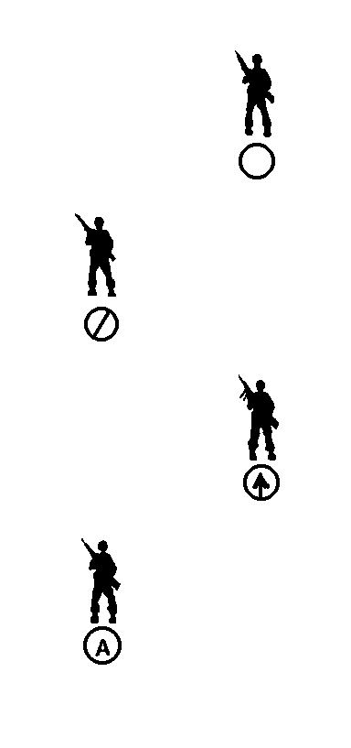
Fire Team Column - consist of a rifleman, fire team leader, automatic rifleman and assistant automatic rifleman. It is mainly used when you want speed and good control of your people (see figure 1).

Advantages

- Permits fire and maneuver to the flanks

- Permits rapid controlled movement

Disadvantages

- Vulnerable to fire from the front

- The ability to fire to front is limited
Figure 1. Fire Team Column

Fire Team Wedge - diamond shape with the rifleman leading followed by the assistant automatic rifleman to his right, the fire team leader parallel to the assistant automatic rifleman, and-to the rifleman’s left. The automatic rifleman brings up the rear and directly behind the rifleman (see figure 2).

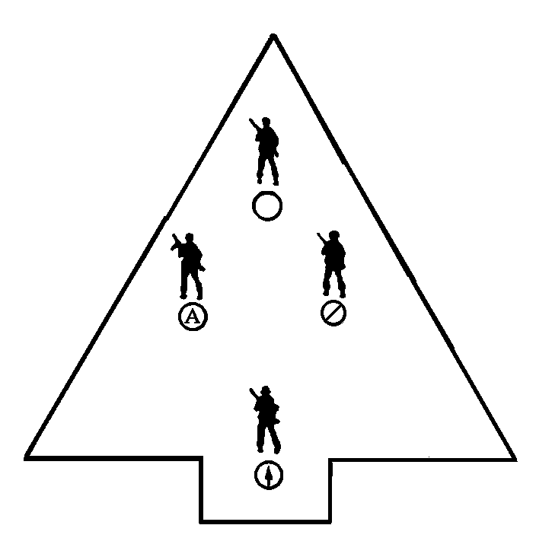
Advantages

- It is easily controlled

- Provides all around security

- Fire is adequate in all directions

- It is flexible

Disadvantages

- It can not move as fast as a column
Figure 2. Fire Team Wedge

Skirmishers (Left) - a staggered formation starting with the rifleman on the right and the automatic rifleman the left and parallel to the rifleman. The assistant automatic rifleman is behind the automatic rifleman and to his left and the fire team leader is parallel to the assistant automatic rifleman and in-between the automatic rifleman and the rifleman. Skirmishers (right) is a mirror image of the Skirmishers (left) (see figure 3).

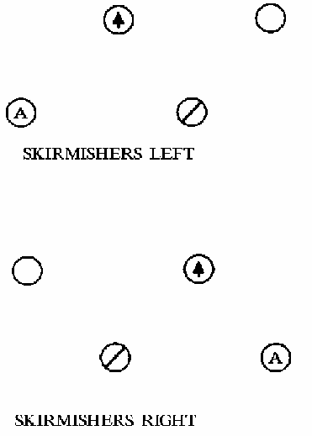
Advantages

- Permits maximum firepower to the front

- Used when the location and strength of the enemy are known, during the assault, mopping up, and crossing short open areas.

Disadvantages

- It is extremely difficult to control

- Movement is slow.

- The ability to fire to the flanks is limited.

Echelon (Left and Right) - this formation is similar to a skirmish except that one flank is angled to the rear (see figure 4).

Advantages
Figure 3. Skirmishers (Left and Right)

- Permits fire to the front and one flank

- It is used mainly to protect exposed flanks

Disadvantages

- It is extremely difficult to control

- Movement is slow
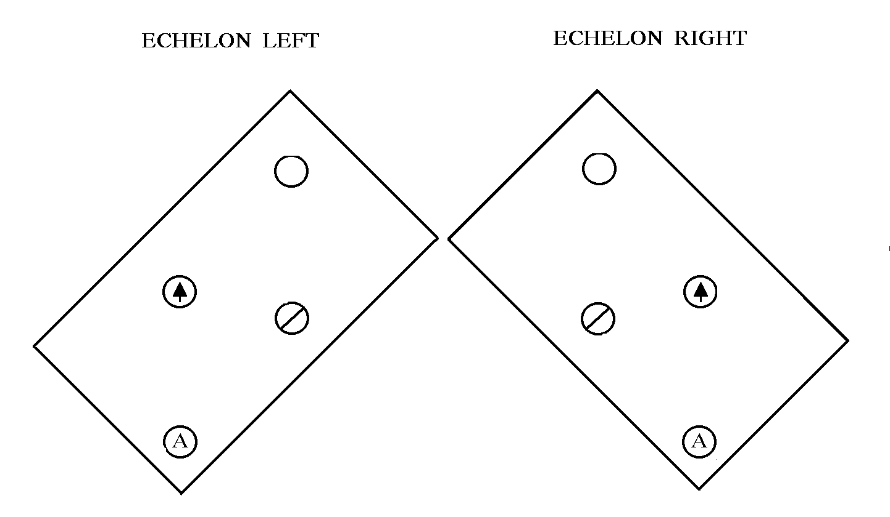
Figure 4. Echelon (Left and Right)

FIVE TYPES OF COMBAT SQUAD FORMATIONS

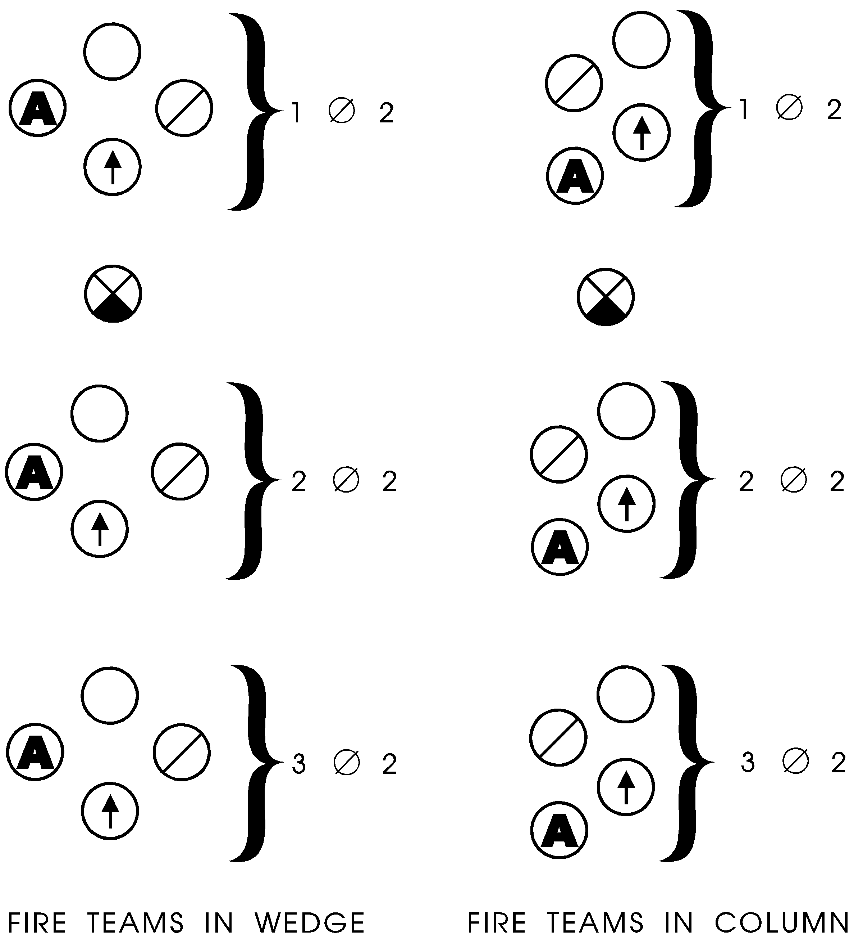
Column - the same as a fire team column except all the fire teams are included one behind the other (see figure 5).

Advantages

- Permits rapid and easily controlled movement

- Permits fire and maneuver to the flanks (same as fire team)

Disadvantages

- Vulnerable to fire from the front

- The ability to fire to the front is limited

Figure 5. Fire Team in Column

Squad Line - the squad line places all three fire teams abreast or on line and is normally used in the assault during rapid crossing of short, open areas (see figure 6).

Advantages

- Maximum firepower is concentrated to the front

Disadvantages

- The ability to return fire to the flanks is limited

- Movement is slow

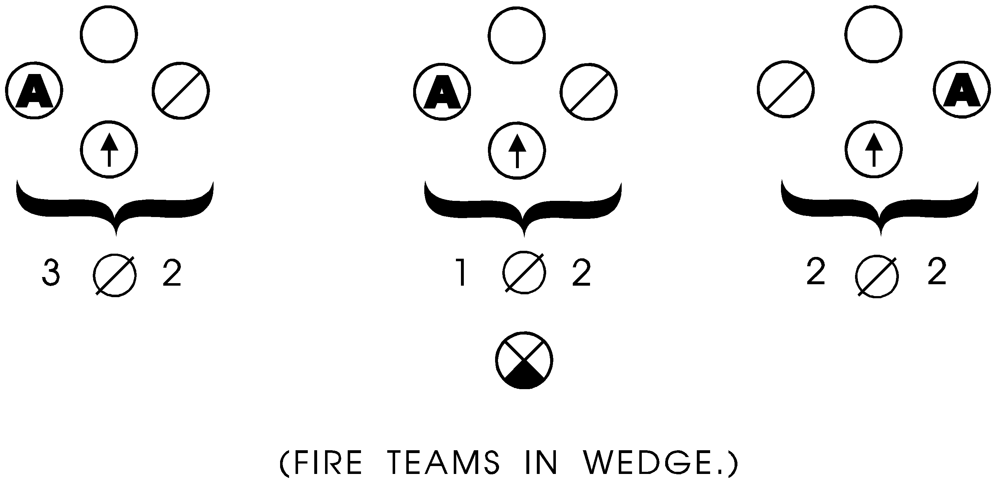

Figure 6. Squad Line

Echelon (Left and Right) - this formation is the same as for fire team except all fire teams are included (see figure 7).

Advantages

- It is used mainly to protect exposed flanks

- Provides heavy firepower to the front and in the direction of echelon

Disadvantages

- Difficult to control

- Movement is slow

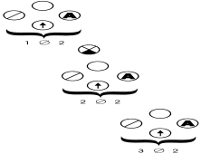
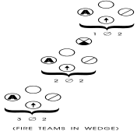

Figure 7. Echelon (Left/Right)

Squad Wedge - the squad wedge places one fire team in the front of the formation followed by another fire team to the right and diagonally to the rear, with the last fire team to the left and parallel to the second fire team (see figure 8).

Advantages

- It is easily controlled

- Provides all around security

- It is flexible

- Fires adequately in all directions (same as fire team).

Disadvantages

- It cannot move as fast as a column. (Same as fire team)
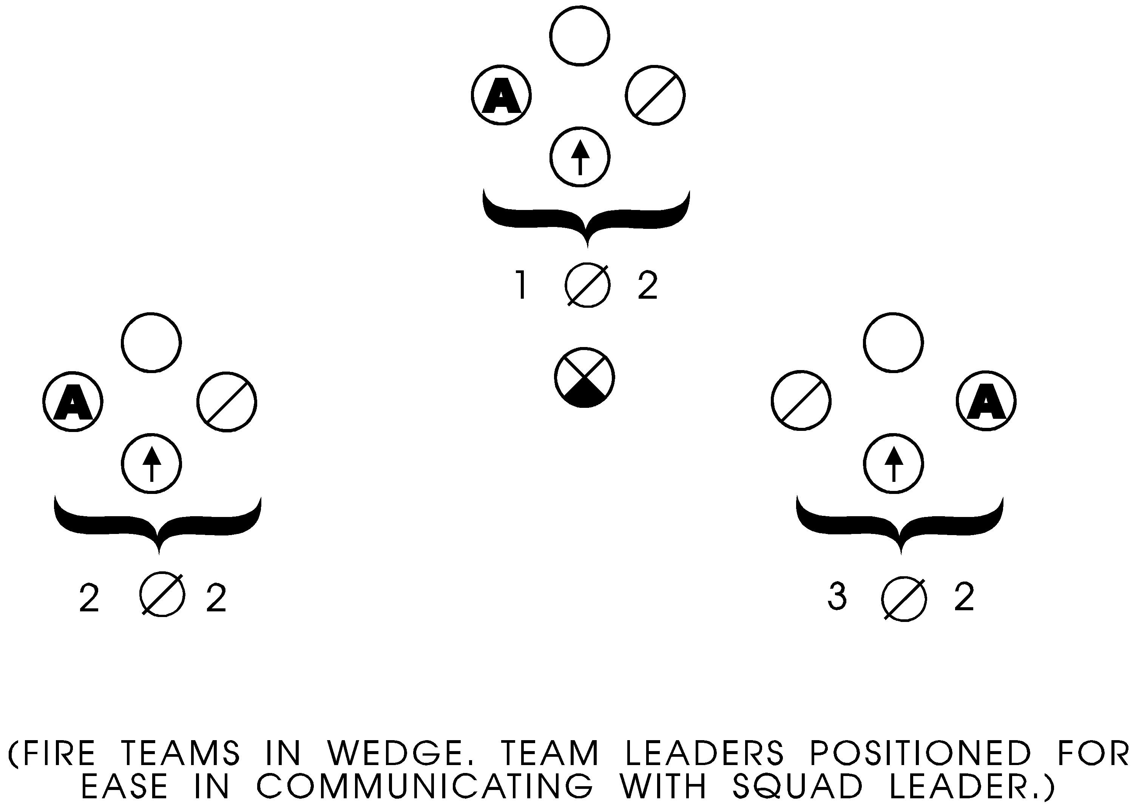
Figure 8. Squad Wedge

Squad Vee - the squad vee is an inverted squad wedge (see figure 9).

Advantages

- Facilitates movement into squad line

- Provides excellent firepower to the front and to the flank

- Used when the enemy is to the front and his strength and location are known. May be used when crossing large open areas.

Disadvantages

- It cannot move as fast as a column

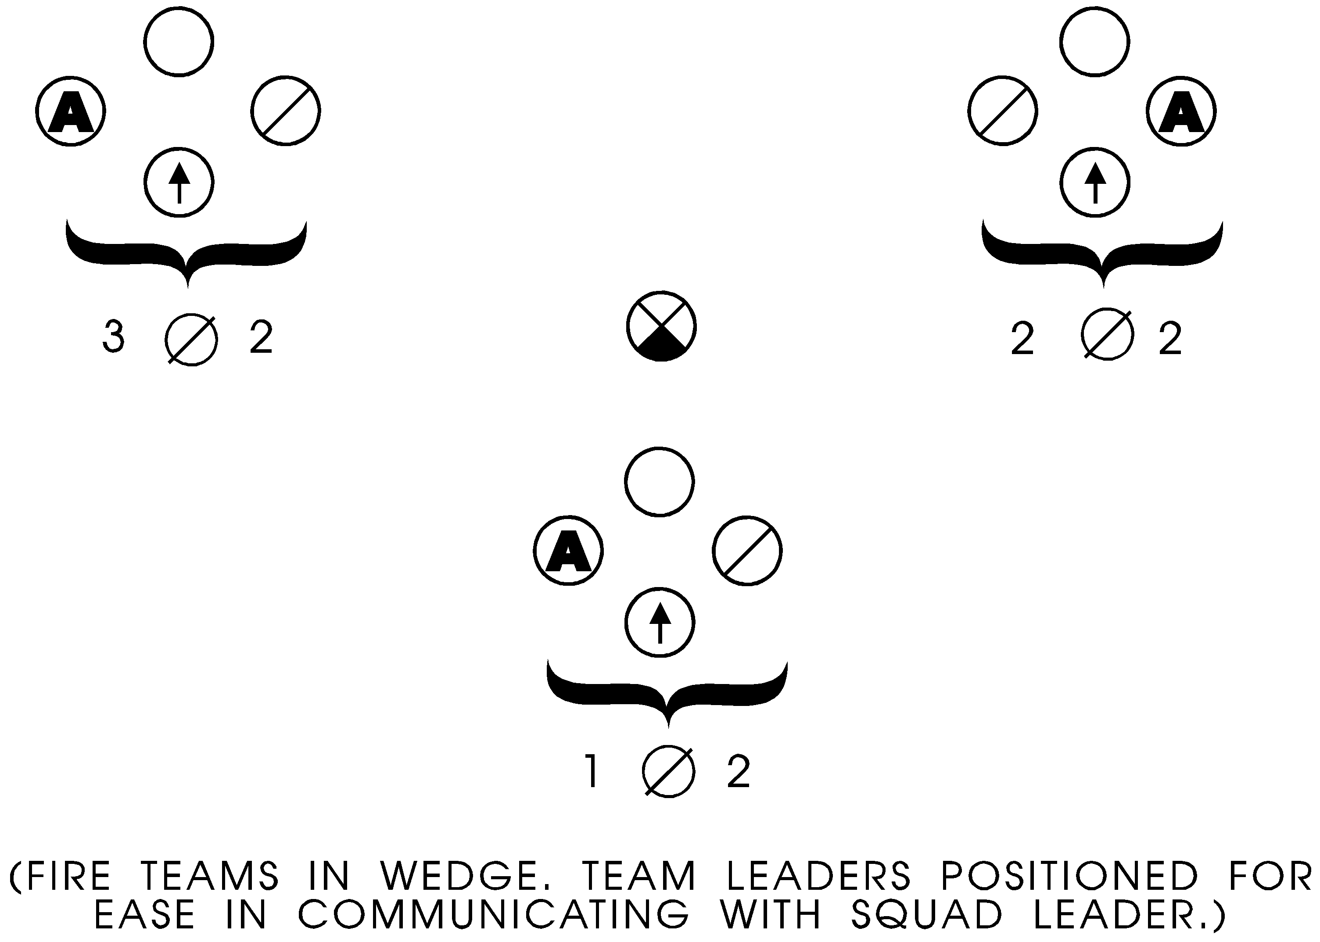
Figure 9. Squad Vee

Three Types Of Special Signals

Whistle

Advantages/Uses

- Is an excellent and quick way a unit leader can transmit a message from one place to another.

- It provides a fast means of transmitting a message to a large group.

Disadvantages

- It must be prearranged and understood or it may by misinterpreted.

- Its effectiveness may be reduced by normal noise, which exist on the battlefield.

Pyrotechnics - devices used to transmit commands or information. Flares and smoke grenades are considered pyrotechnics.
Purpose - is used as a ground to ground or ground to air signaling device. It is used to identify units on the ground to other ground units and to air support. It can also be used to screen the movement of small units for short periods.

Advantages and Uses

- Used to mark enemy positions

- Signals to attack, withdraw, shift, or cease-fire

- Mark landing zones

Disadvantages

- Used by only one unit at a time

- Be sure your signal does not already have another set of meanings

- Gives away your position

Hand and Arm Signals - the most commonly used form of signaling. It must be remembered that the hand and arm signals are orders or commands that must be carried out.

Advantages and Uses

- The noise of the battle does not hinder the use of the hand and arm signals.

- Used when silence must be maintained.

Disadvantages

- The signal must be seen

- Must be aware of other members location

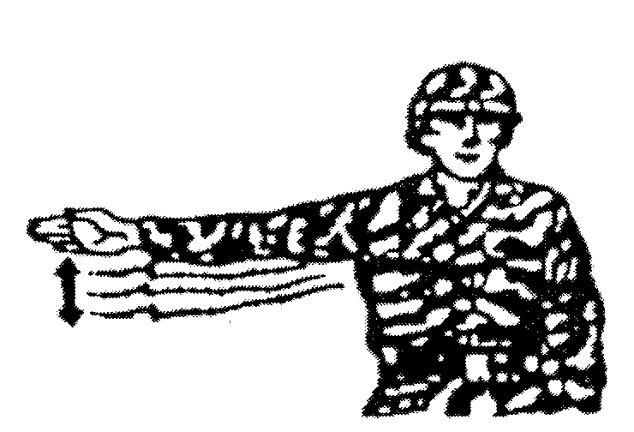
Hand and Arm Signals Demonstration

Decrease Speed - extend the arm horizontally sideward, palm to the front, and wave arm downward several times, keeping the arm straight. Arm does not move above the horizontal plane (see figure 10).
Figure 10.

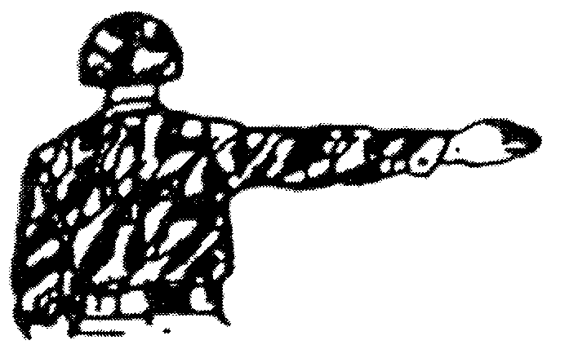

Change Direction - extend arm horizontally to the side, palm to the front (see figure 11).
Figure 11

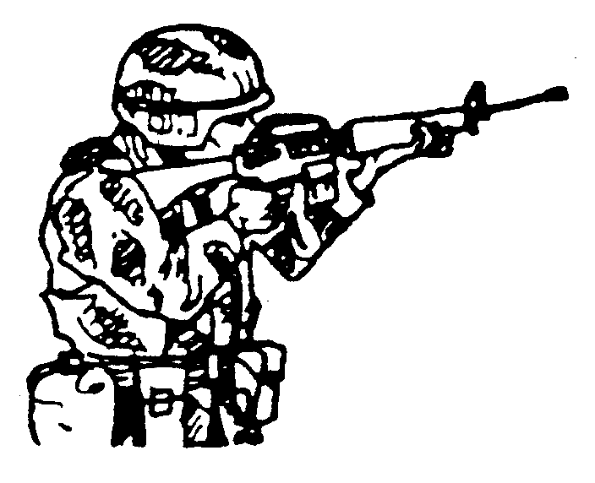
Enemy In Sight - hold the rifle horizontally, with the stock on the shoulder, the muzzle pointing in the direction of the enemy (see figure 12).

Figure 12

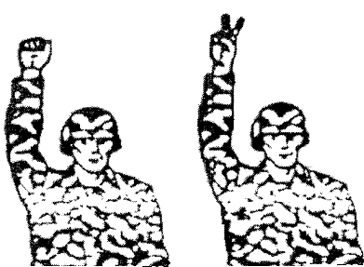

Range - extend the arm fully towards the leader or men for whom the signal is intended with fist closed. Open the fist exposing one finger for each 100 meters of range (see figure 13).

Figure 13

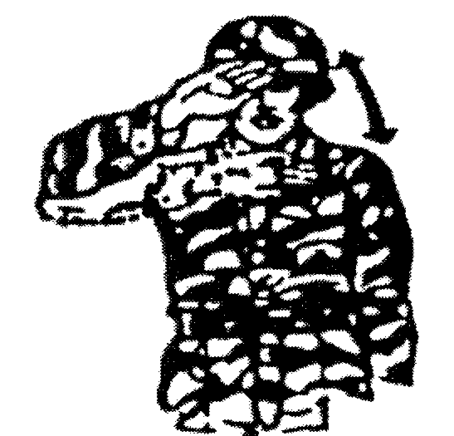

Cease Fire - raise the hand in front of the forehead, palm to the front, and swing the arm and forearm up and down several times in the front of the face (see figure 14).
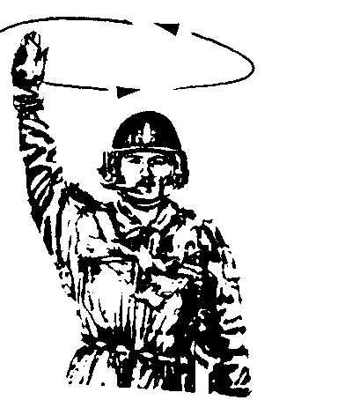
Figure 14

Assemble - raise the arm vertically to the full extent of the arm, fingers extended and joined, palm to the front, and wave in large horizontal circles (see figure 15).
Figure 15

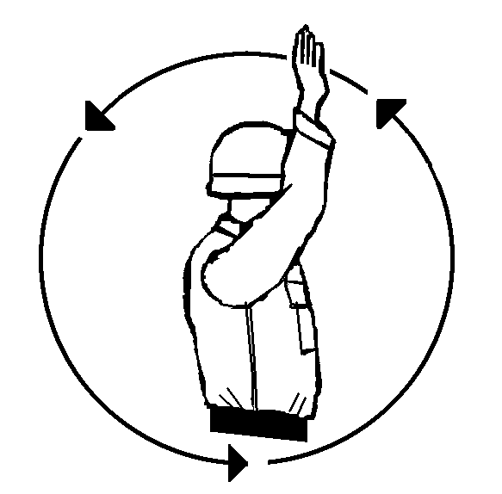

Form Column - raise either arm to the vertical position. Drop the arm to the rear, making complete circles in a vertical plane parallel to the body (see figure 16).

Figure 16

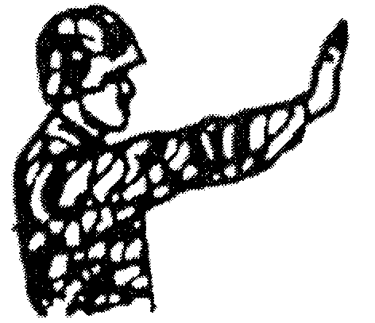

Are You Ready - extend the arm toward the leader for whom the signal is intended, hand raised, fingers extended and joined, raise arm slightly above horizontal, palm facing outward (see figure 17).
Figure 17

I Am Ready - execute the signal, are you ready (see figure 18).

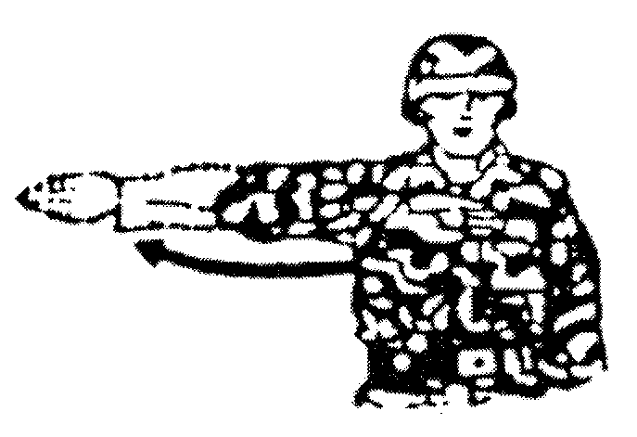
Figure 18

Shift - raise the hand that is on the side toward the new direction across the body, palm to the front; then swing the arm in a horizontal arc, extending arm and hand to point in the new direction (see figure 19).
Figure 19

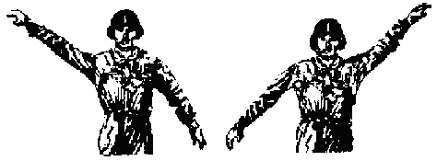

Echelon - face the unit being signaled, and extend one arm 45 degrees above the other arm 45 degrees below the horizontal, palms to the front. The lower arm indicates the direction of echelon (see figure 20).
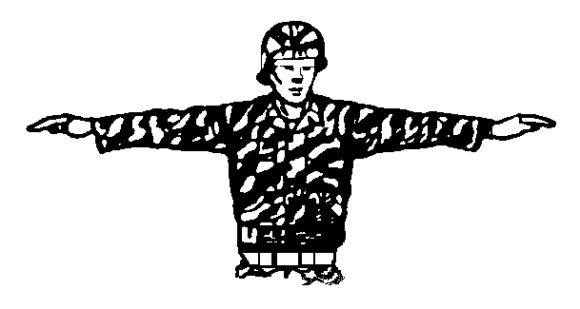
Figure 20

Skirmisher - raise both arms laterally until horizontal, arms and hands extended, palms down. If it is necessary to indicate the direction, move in the desired direction at the same time (see figure 21).
Figure 21

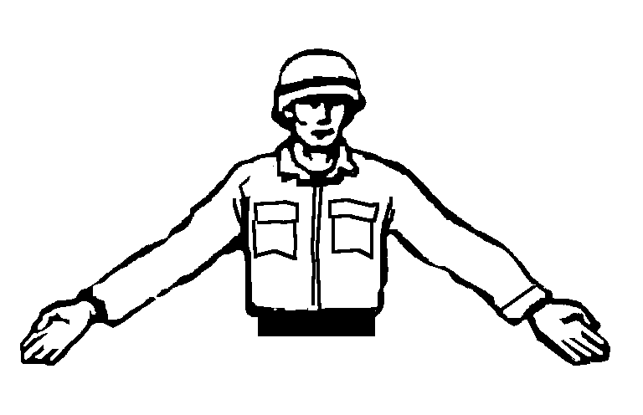
Wedge - extend both arms downward and to the side at an angle of 45 degrees below the horizontal plane, palms to the front (see figure 22).
Figure 22

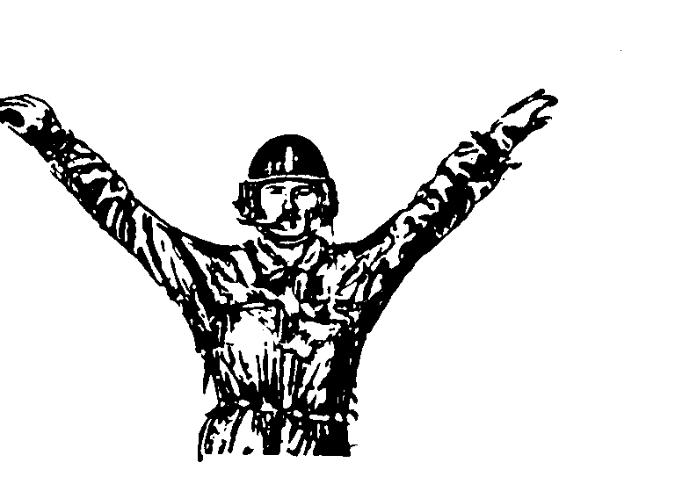

Vee - extend arms at an angle of 45 degrees above the horizontal plane forming the letter ‘V’ with the arms and torso (see figure 23).
Figure 23

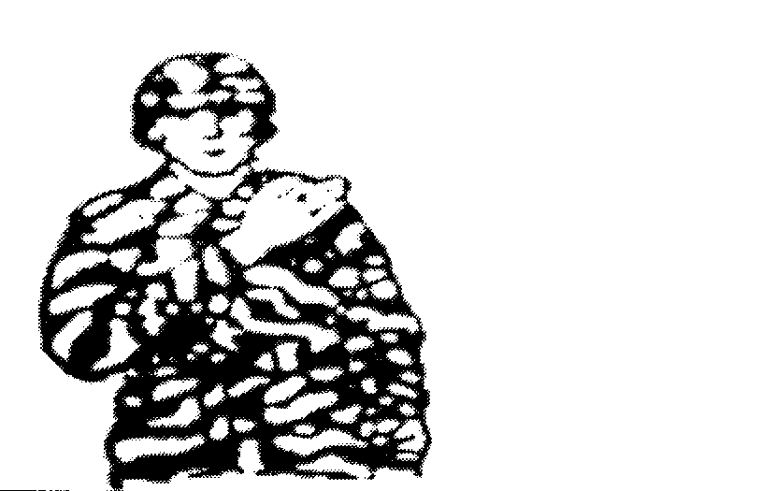

Fireteam - place the right arm diagonally across the chest (see figure 24)
Figure 24

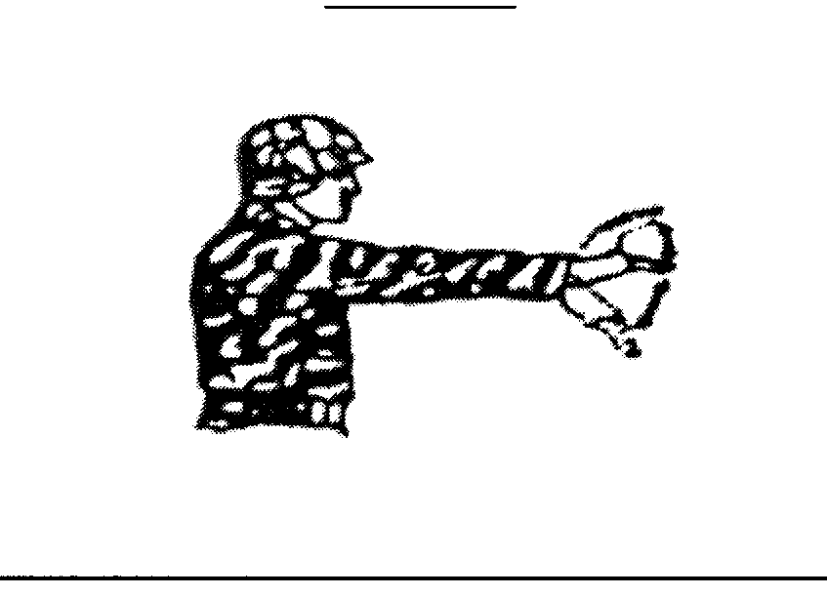

Squad - extend the arm and hand toward the squad leader, palm of the hand down, distinctly, moving the hand up and down several times from the wrist holding the arm steady (see figure 25).
Figure 25

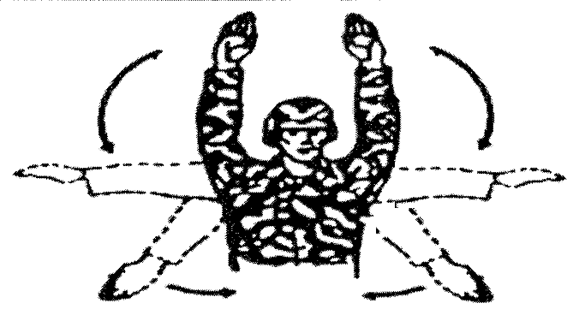

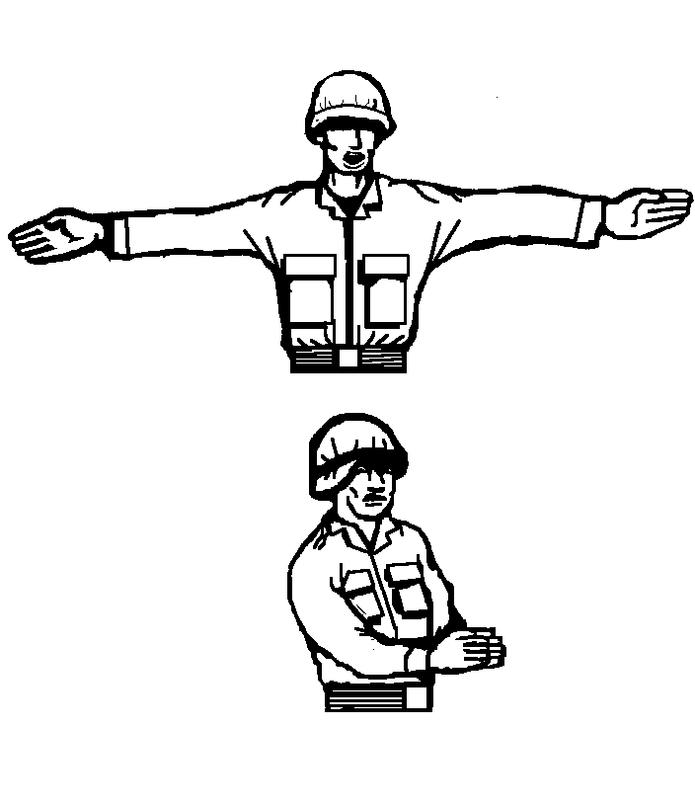
Platoon - extend both arms forward, palm of the hands down and make large vertical circles with hands (see figure 26).

Figure 26

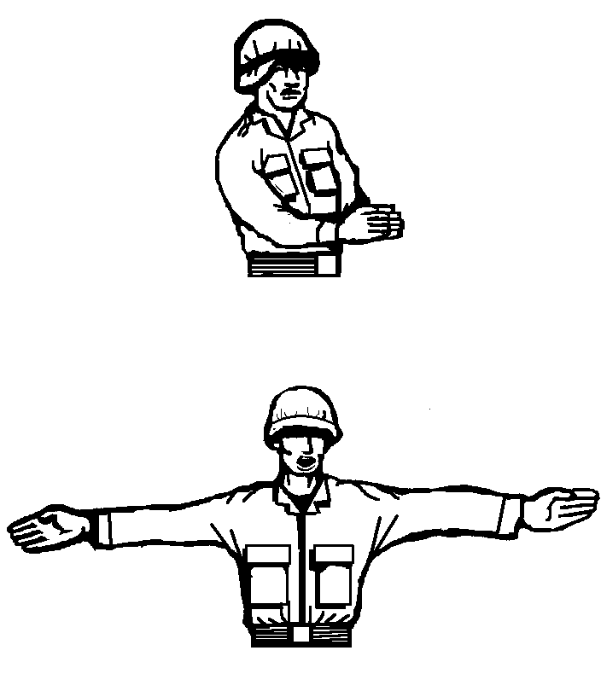
Close Up - start signal with both arms extended horizontally, palm forward, and bring hands together in front of the body momentarily (see figure 27).
Figure 27

Open Up or Extend - start signal with arms extended in the front of the body, palms together, and bring arms to the horizontal position, palms forward (see figure 28).
Figure 28

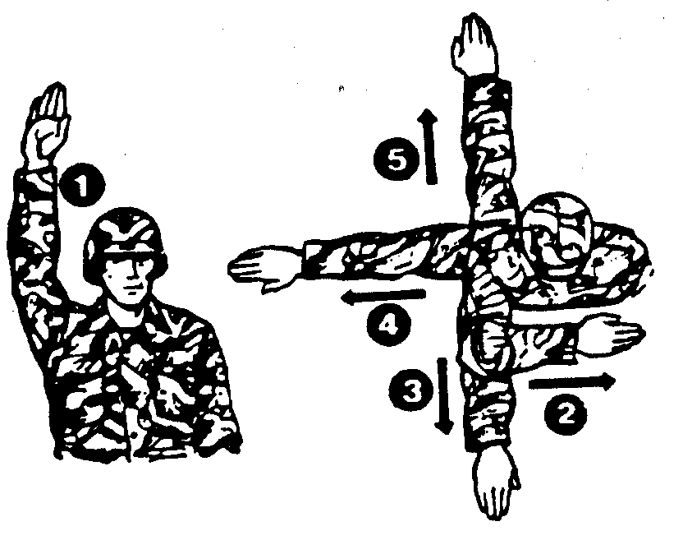
Disperse - extend either arm vertically overhead, wave the hand and arm to the front, left, right, and rear, the palm toward the direction of each movement (see figure 29).

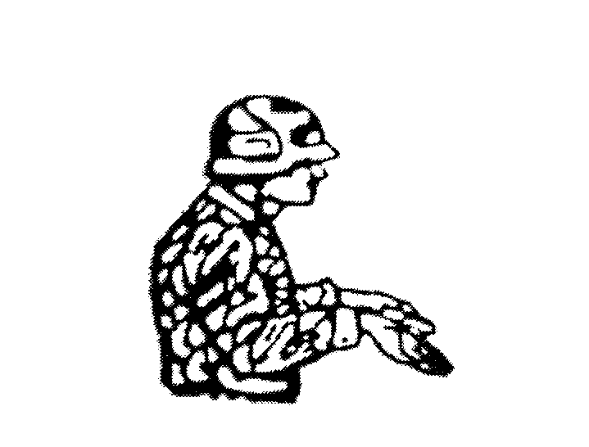
Figure 29

I Do Not Understand - raise both arms horizontally at the hip level, bend both arms at elbows, palms up, and shrug shoulders in the manner of universal “I don’t understand” (see figure 30).
Figure 30
9

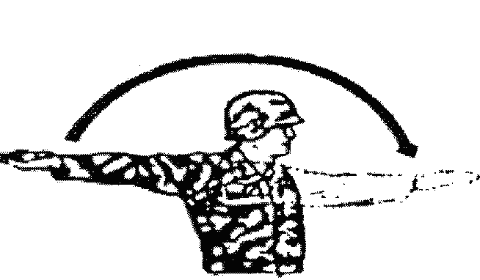
Forward - face and move to the desired direction of march, at the same time extend the arm horizontally to the rear, then swing it overhead and forward in the direction of movement until it is horizontal, palm down (see figure 31).
Figure 31

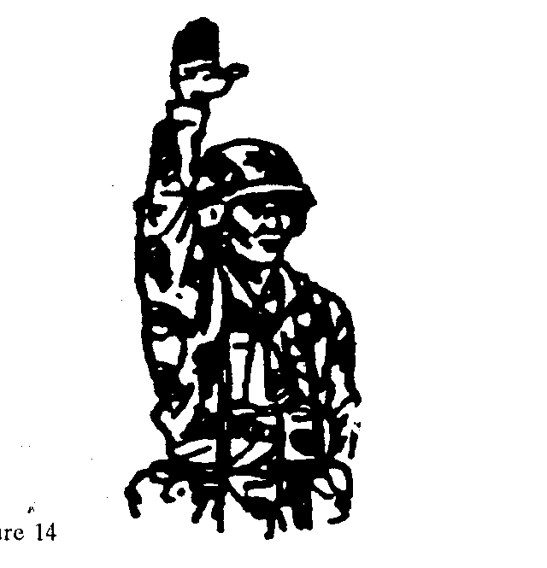
Halt - carry the hand to the shoulder, palm to the front then thrust the hand upward vertically to the full extent of the arm and hold it in the position until the signal is understood (see figure 32).

Figure 32

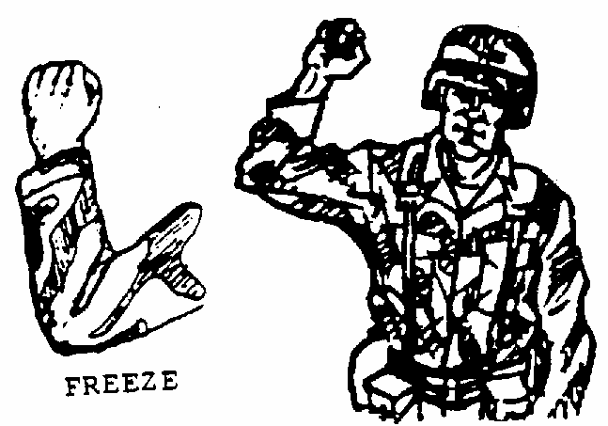

Freeze - make the signal for a halt and make a fist with the hand (see figure 33).

Figure 33

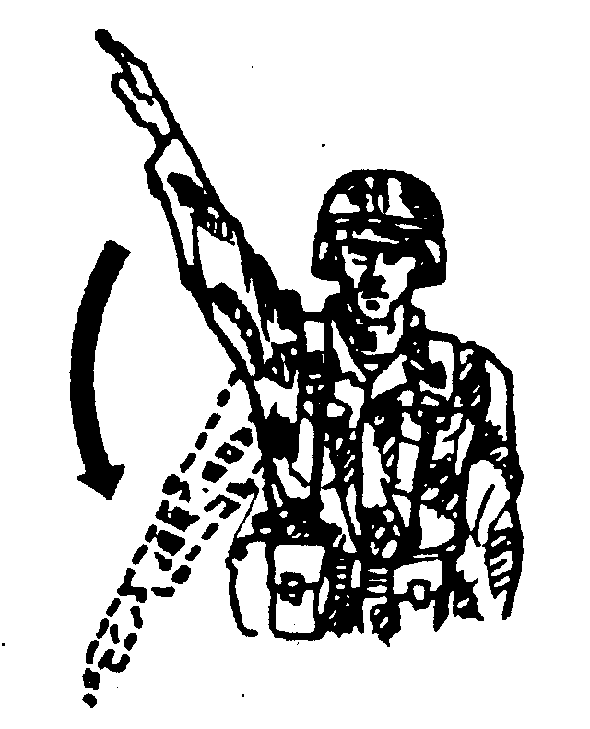

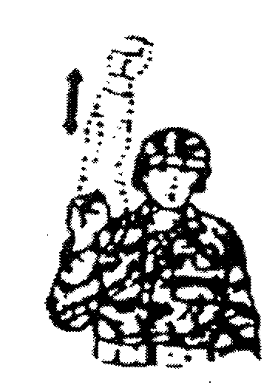
Down, Take Cover - extend arm sideward at an angle of 45 degrees above horizontal, palm down, and lower it to the side (see figure 34).
Figure 34

Double Time - carry the hand to the shoulder, fist closed rapidly thrust the fist upward vertically to the full extent of the arm and back to the shoulder several times (see figure 35).
Figure 35

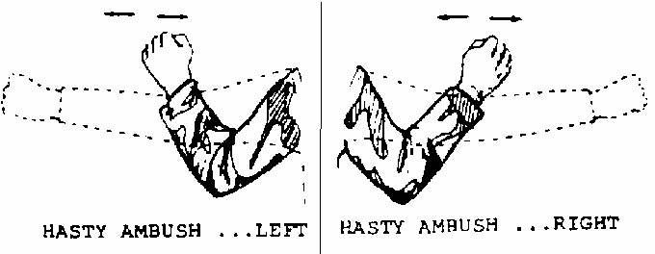

Hasty Ambush (LEFT OR RIGHT) - raise fist to shoulder level and thrust it several times in the desired direction (see figure 36).
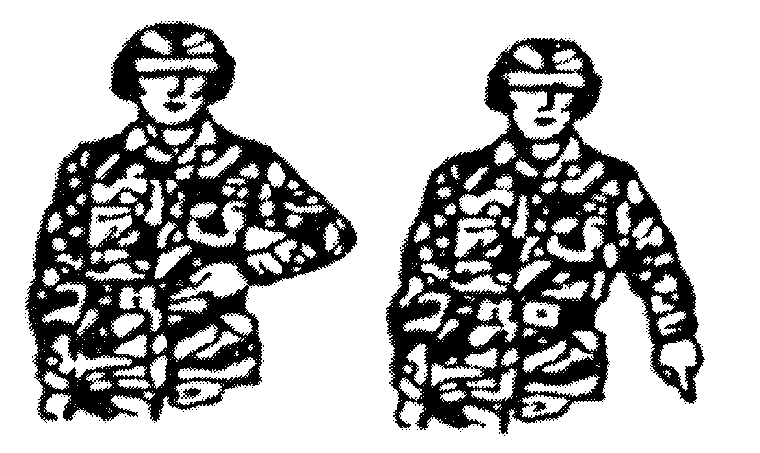
Figure 36

Rally Point - touch the belt buckle with one hand and then point to the ground (see figure 37).
Figure 37

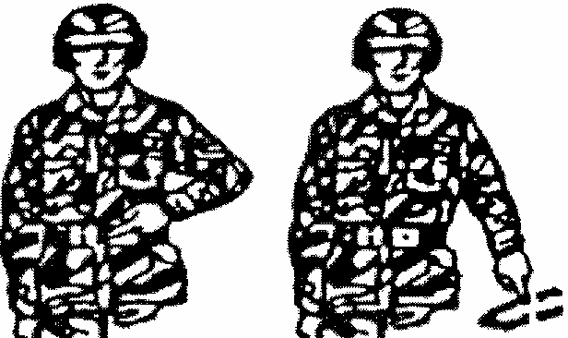
Figure 38

Objective Rally Point - touch the belt buckle with one hand, point to the ground, and make a circular motion (see figure 38).

- Cover, Concealment, and Camouflage
Each Marine/Sailor must use terrain to give themselves cover and concealment. They must supplement natural cover, concealment, and camouflage.
Cover
- Protection from the fire of enemy weapons. It maybe natural or man made.
- Natural cover can be trees, logs, stumps, ravines, hollows, and reverse slopes
- Manmade cover inclues fighting holes, trenches, walls, rubble, and abandoned equipment
Concealment - anything that can hide a person from enemy, i.e. brush. Concealment does not protect you from enemy fire.
Camouflage - anything that keeps yourself, equipment, and position from looking like what they really are.
- Movement
- Shadows
- Fighting positions-not where the enemy expects to find them
- Shiny object/light source
- Shape (familiar shapes)-breakup outlines
- Colors - easily detected if contrasting
- Dispersion

REFERENCE
Marine Rifle Squad, MCRP 3-11.2: Ch 3, 4, 8, Appendix H
Patrolling Review

1. List the elements of a Combat Patrol.

2. List the three types of rally points.

3. List three types of special signals.

4. Define concealment.

