 ADVANCED 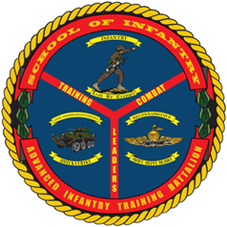
MACHINEGUN COURSE
- Purpose: To provide training and education to 0331s serving in the billet of machinegun squad or section leader. The desired end-state is to develop the doctrinal skills requisite of an 0331 machinegun squad or weapons section leader and to improve student tactical decision-making abilities.
- Task List:
  - 1000 Level:
    - Machinegun core competencies
  - 2000 Level:
    - Annex A (troop leading, combat orders, fire support planning, patrolling, and call for fire)
    - Offense, defense, and urban operations
    - Machinegun employment and advanced gunnery
    - Employment of defilade fire
    - Employment of overhead fire
- Methodology: The course focuses on teaching the skills and doctrinal knowledge required to serve as a machinegun squad or weapons section leader with an emphasis on decision-making. Instruction is executed through lecture, practical application, field training, and live fire exercises. Each student is tested during a field leadership evaluation based on a tactical scenario.
Course Length: 6 Weeks / 30 Training Days

FY 14 Course Message
Command Screening Check List
Gear List

