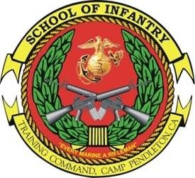 ADVANCED 
MORTARMAN COURSE
- Purpose: To provide training and education to 0341s serving in the billet of mortar squad leader, section leader, Forward Observer (FO), or a member of a Fire Direction Center (FDC). The desired end-state is to develop the doctrinal skills requisite of a 0341 mortar squad or section leader and to improve student tactical decision-making abilities.
- Task List:
  - 1000 Level
    - 60mm and 81mm mortar core competencies
  - 2000 Level:
    - Annex A (troop leading, combat orders, fire support planning, patrolling, and call for fire)
    - Offense, defense, and urban operations
    - Mortar employment
    - Mortar gunline competencies
    - FDC (plotting board and LHMBC) and FO procedures
- Methodology: The course focuses on teaching the skills and doctrinal knowledge required to serve as a mortar squad or section leader with an emphasis on decision-making. Instruction is executed through lecture, practical application, field training, and live fire exercises. Each student is tested during a field leadership evaluation based on a tactical scenario.
- Course Length: 7 Weeks / 38 Training Days

FY 14 Course Message
Command Screening Check List
Gear List

