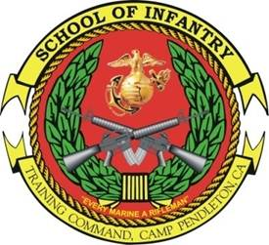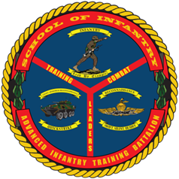

ADVANCED
INFANTRYMAN COURSE

Purpose: To provide a Marine with the knowledge and skills required of a 0311 infantry squad leader. A Marine receives training in train the trainer, troop leading, communications, combat hunter, weapons and munitions, patrolling, offensive and defensive tactics, and urban operations. The desired end-state is a Marine capable of performing as a rifle platoon squad leader. This course serves to lay the foundation for future attendance at the Infantry Small Unit Leader Course.
- Task List:
  - 2000 Level:
    - Annex A (troop leading, combat orders, fire support planning, patrolling, and call for fire)
    - Offense, defense, and urban operations
    - Machinegun employment
    - Mortar employment
    - Anti-armor weapons and employment
- Methodology: The course focuses on teaching the skills and doctrinal knowledge required to serve as a squad leader with an emphasis on decision-making. Instruction is executed through lecture, practical application, field training, and live fire exercises. Each student is tested during a field leadership evaluation based on a tactical scenario.
- Course Length: 7 Weeks / 35 Training Days

FY 13 Course Dates
FY 14 Course Message
Command Screening Check List
Gear List

