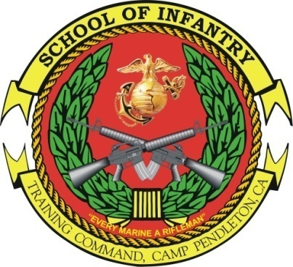 INFANTRY UNIT LEADER 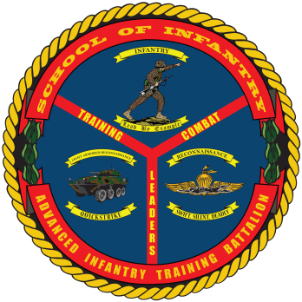
COURSE
- Purpose: To provide training and education to 0369s serving as a rifle platoon sergeant or serving as the section leader within an infantry weapons platoon or company. The desired end-state is to develop the doctrinal skills requisite of a rifle platoon sergeant or weapons section leader and to improve student tactical decision-making and leadership.
- Task List:
2000- Level:
    - Combat orders and command and control
    - Law of land warfare
    - Small unit training (Train The Trainer)
    - Machinegun, mortar, and anti-armor employment
    - Fire support planning and employment
    - Platoon and company-level offensive, defensive, and patrolling operations
- Methodology: Students are placed in scenarios progressing in duration and complexity. The scenarios are executed as tactical decision games, decision forcing cases, field training, and live fire exercises. Instructors coach and mentor the students while providing objective and doctrinally-based assessments. Peers provide assessments and focused feedback while participating in after action reviews. The course is designed to establish parity between the platoon sergeant and platoon commander.
- Course Length: 11 Weeks / 55 Training Days

FY 14 Course Message
Command Screening Check List
Gear List

RESERVE INFANTRY
UNIT LEADER COURSE
- Purpose: To provide training and education to Reserve Component 0369s serving as a rifle platoon sergeant or section leader within an infantry weapons platoon or company. The desired end-state is to develop the doctrinal skills requisite of a rifle platoon sergeant or weapons section leader and to improve student tactical decision-making and leadership.
- Task List:
  - 1000 Level:
    - Command and Control
    - Fire support planning and patrolling
    - Offensive and defensive tactical measures and operations
  - 1000 Level: Downgraded Events
    - Employment of anti-armor in offensive and defensive operations
    - Employment of an assault unit in offensive and defensive operations
    - Methodology: Students receive instruction and practical application in machineguns and machinegun gunnery, mortar and mortar gunnery, anti-armor weapons and anti-armor operations, Marine Corps planning process, platoon offensive and defensive tactics, patrolling, and fire support.
- Course Length: 2 Weeks / 14 Training Days. This course has no days off.

