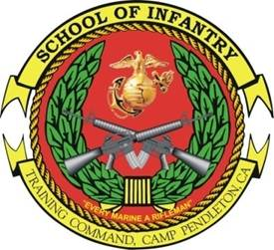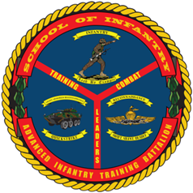

LAR LEADERS
COURSE
- Purpose: To train Marine Corps Infantry Officers and Staff Non-Commissioned Officers scheduled for assignment to Marine Corps Light Armored Reconnaissance units to command and supervise the training, operations, employment and maintenance of Light Armored Reconnaissance (LAR) platoons, and their associated weapons systems and crews.
- Task List:
  - 1000 Level:
    - Orders Development, Writing and Issue
    - Fire Support Planning and Employment
  - 2000 Level:
    - Supervise Preventative Maintenance, Checks and Services
    - Vehicle Commander Skills, Employment of LAV-25 Weapons Systems and Directing LAV unit fires
    - Platoon/Scout Employment in Reconnaissance, Security, and Limited Offensive Operations
- Methodology: The course provides classroom instruction and practical application on routine vehicle operations, maintenance management and communications, supplemented by simulation-based training for turret familiarization and target engagement. The course includes detailed instruction on reconnaissance and security operations, tactical employment and limited offensive operations. All students are evaluated in a tactical environment on their ability to employ a platoon to accomplish a LAR mission. The course culminates with a platoon live fire area reconnaissance.
- Course Length: 6 weeks / 30 Training Days

FY 13 Course Message
Command Screening Check List
Gear List
Resources
Date Change

