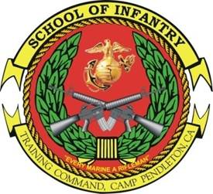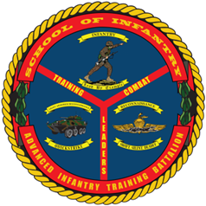

LAV COMMANDERS
COURSE
- Purpose: To provide 0313 Sergeants and Staff Sergeants with the knowledge and skills required to serve as a LAV-25 Vehicle Commander within a Light Armored Reconnaissance (LAR) Battalion.
- Task List:
  - 2000 Level:
    - Supervision of Preventative Maintenance, Checks and Services
    - LAV-25 Weapons Systems, Fire Commands and Engagement Techniques
    - Vehicle Movement Techniques, Water Operations, and Recovery
    - Vehicle Employment in Reconnaissance, Security and Limited Offensive Operations
    - Armor Identification and Scout Employment
- Methodology: The course provides detailed instruction on a variety of tasks concerning the LAV-25 Weapon Systems, LAV Communication Systems, Command and Control, Tactics, Maintenance and scout employment. This is accomplished through lecture, demonstration, practical application, performance examination and field exercises that focus on the Vehicle Commander’s duties and responsibilities. Upon successful completion of the course a Marine is capable of performing as a LAV-25 Vehicle Commander.
Course Length: 6 weeks / 27 Training Days

FY 13 Course Message
Command Screening Check List
Gear List

