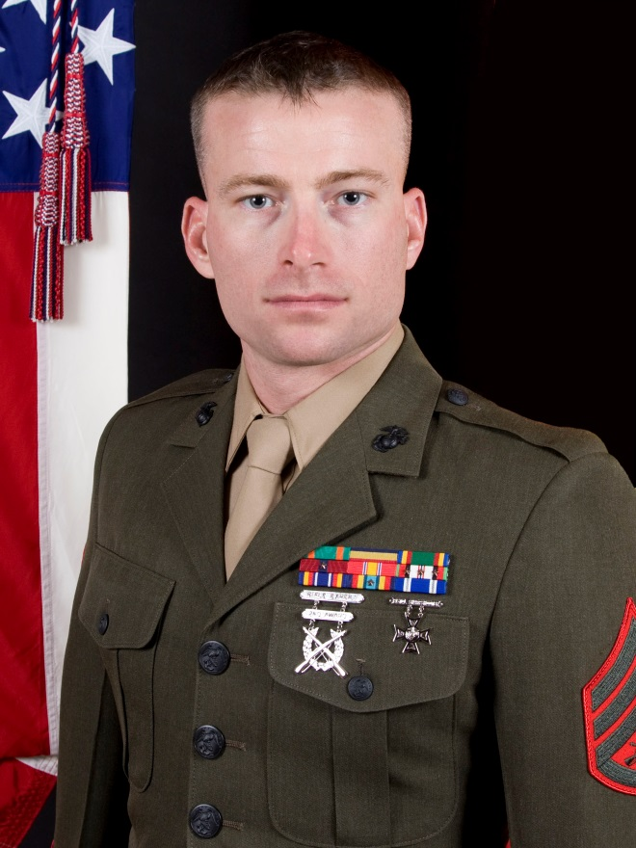

Staff Sergeant Phillip H. Coutts
Staff Sergeant Coutts reported to Recruit Training at Marine Corps Recruit Depot, Parris Island, South Carolina 18 March 2008 and graduated 13 June 2008. Staff Sergeant Coutts reported to Marine Combat Training at Camp Geiger, North Carolina. Staff Sergeant Coutts then attended primary school for Basic Engineer Equipment Electrical Systems Technician (Generator Mechanic) at Courthouse Bay, North Carolina where he was promoted to Private First Class on 1 September 2008.
Upon completion of training Staff Sergeant Coutts received orders and reported to 2nd Marine Division, Headquarters Battalion, Communications Company, Camp Lejeune, North Carolina on 23 November, 2008. Staff Sergeant Coutts was then tasked to deploy to Helmand Province, Afghanistan 1 May 2009 to 25 February 2010 and was also promoted to Lance Corporal 1 May 2009. Staff Sergeant Coutts received a combat meritorious promotion to Corporal while serving in OEF on 2 September 2009.
Staff Sergeant Coutts remained attached to 2nd Marine Division, Headquarters Battalion, Communications Company serving as the Utilities Maintenance Chief. Staff Sergeant Coutts detached to the Battalion Forward to Helmand Province, Afghanistan from 24 February 2011 to 7 September 2011 serving as the Utilities Chief. Staff Sergeant Coutts was promoted meritoriously to Sergeant 2 May 2011.
Staff Sergeant Coutts completed the Advanced Engineer Equipment Electrical Systems Technician course March 2012 and served as the Utilities Floor Chief for the remainder of his time with his unit. Sergeant Coutts then received orders to Marine Combat Instructors Course January 2013 and graduated in March 2013. Staff Sergeant Coutts was then assigned to India Company, Marine Combat Training Battalion, School of Infantry-East as a Combat Instructor.
Staff Sergeant Coutts served as a squad instructor from March 2013 through July 2014. Staff Sergeant Coutts received Instructor of the Class twice, competed and won the Battalion Instructor of the Quarter board, also being selected to Staff Sergeant after competing on the SOI-East Meritorious Promotion Board in May of 2014. Staff Sergeant Coutts was promoted to Staff Sergeant, current rank, on 2 July 2014. Soon after, Staff Sergeant Coutts was screened and selected to serve as a Combat Instructor Trainer at Marine Combat Instructor School later in the month of July 2014 where he is currently serving.
Sergeant Coutts’ personal decoration includes the Navy and Marine Corps Achievement Medal.
Sergeant Coutts is married to the former Deanna Marie Parker and has five children: Mikayla (11), Kayden (6), Grace (3), Haylee (2), and Kaleb (16 mo).

