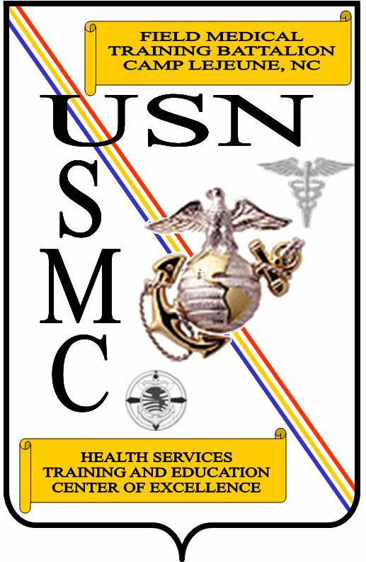

FIELD MEDICAL TRAINING BATTALION - EAST

RULES AND REGULATIONS

Updated 26 October 2009
SAILOR’S CREED

I am a United States Sailor.
I will support and defend the Constitution of the United States of America and I will obey the orders of those appointed over me.
I represent the fighting spirit of the Navy
and those who have gone before me
to defend freedom and democracy around the world.
I proudly serve my country's Navy combat team with
Honor, Courage, and Commitment.
I am committed to excellence and the fair treatment of all.

CORPSMAN'S PLEDGE

"I solemnly pledge myself before God and these witnesses
to practice faithfully all of my duties as a member of the Hospital Corps.
I hold the care of the sick and injured to be a privilege and a sacred trust
and will assist the Medical Officer with loyalty and honesty.
I will not knowingly permit harm to come to any patient.
I will not knowingly partake of nor administer any unauthorized medication.
I will hold all personal matters pertaining to the private lives of patients
in strict confidence.
I dedicate my heart, mind, and strength to the work before me.
I shall do all within my power to show in myself an example of all
that is honorable and good throughout my naval career."
STUDENT GUIDELINES
SCOPE:
Welcome to Field Medical Training Battalion – East (FMTB-E)! Whether you are a seasoned Sailor or have just graduated from “A” school, there is a great purpose for your training here. This course is designed to challenge you. The purpose of this document is to prepare you for the day-to-day operations at FMTB-E. You will be asked to spend a good portion of your day, including personal time, in preparation for upcoming events. This information will help you succeed here, so it is imperative that you read the entire guide.

PAGE TOPIC
2 Morning Reveille
2 Formations
2 Leadership Positions/Roles
3 Sick Call Procedures
4 Uniform Standards
4 Field Day
4 Exams/Study Tips/Mandatory Study
6 Navy PFA/USMC PFT
6 Mandatory PT Sessions
6 Corrective Lens Eyewear
6 Special Items to Purchase
7 Discipline/Respect
7 Awards
8 Civilian Attire
8 Local Places of Interest
9 Marine Corps Base Chapel Schedule
11 Off-Limits Establishments
11 Prohibited Possession and Consumption of Alcoholic Beverages
12 Smoking/Dipping/Chew Policy
12 Prohibited Access to Berthing Areas
12 Parking of POVs
13 Students Mailing Address and Emergency Telephone Numbers
13 Student Liberty
16 Camp Johnson Gate Hours
16 Mobile Phone Usage
17 Student Liberty Boundaries Map
18 Barracks Guidelines and Regulations
20 Student Watchstanding Guide
22 Operational Risk Management (ORM)
28 Gear Marking Guide
33 Conditioning Hike Gear List
34 Field Exercise Gear List
36 Rifle Range Gear List
39 Mentor/Buddy Card
1. MORNING REVEILLE: Reveille will be at 0400 unless otherwise specified. Reveille may be earlier for events such as field training, conditioning hikes, obstacle courses, and practical training. Attention to the schedule, listening, and understanding of information being passed by advisors, instructors, and staff is your responsibility. The schedule for the upcoming days and weeks will be posted in your barracks. Stay flexible, the schedule is subject to change.

2. FORMATIONS: Every student will muster in formation 15 minutes prior to any scheduled event. The morning formation is usually scheduled for 0445. It is imperative that your platoon arrive at the chow hall before 0500. After chow, students need to prepare for the training day. Students shall be in their classroom seats 15 minutes prior to the start of class, e.g., 0645 in seats for a 0700 class. Everyone, including brown baggers (individuals collecting Basic Allowance for Housing and authorized to reside in the local community with family), will be present for morning muster and all personnel will march to chow.
At the morning formation, the Platoon Sergeants will conduct daily uniform inspections. The following will be checked during uniform inspections: clean, neat, serviceable uniforms, blackened collar devices, clean boots, and personal grooming to standards, etc.

3. STUDENT LEADERSHIP POSITIONS/ROLES: There are seven student leadership positions available during your time at FMTB-E. All leaders, regardless of their position, must set the example. If you have questions concerning your role and position, ask your Platoon Advisors. Remember, leaders are not born but made. Use this training opportunity to develop and perfect your leadership skills. As always, leaders are held to a higher standard of conduct, professionalism, and accountability.
Student Company Commander: The Company Commander is normally the most senior person in the company. His/her function is to supervise and carry-out the instructions given by the platoon advisors and/or senior military instructor (SMI). The Company Commander serves as a focal point of contact and receives instructions to be passed down to the company. The Company Commander is responsible for keeping his/her platoon commanders well informed. Any problems that arise should be directed through the chain of command. The Company Commander is not authorized to give extra military instruction (EMI) or punish another student. Any problems that arise must be discussed with the Platoon Advisors. The Company Commander is responsible for conducting all morning formations as well as any formations requiring all hands. The Company Commander will ensure that the morning report is completed and turned in by 0600 on training days to the SMI or the Assistant Training Officer in the absence of the SMI.
Platoon Commander: The Platoon Commander is normally the most senior person in the platoon. His/her function is to supervise and carry-out the instructions given by the Platoon Advisors and/or SMI. The Platoon Commander serves as a focal point of contact and receives instructions to be passed down. The Platoon Commander is responsible for keeping his/her squad leaders well informed. In the event the Platoon Advisors are not present, the Platoon Commander will carry out the routines designated in the schedule. Any problems that arise should be directed through the chain of command. The Platoon Commander is not authorized to give EMI or punish another student. Any problems that arise must be discussed with the Platoon Advisors and Company Commander.
Platoon Sergeant: The Platoon Sergeant is responsible for performing the duties given by his or her chain of command. He/she must ensure full compliance with the instructions. The Platoon Sergeant is responsible for holding platoon formations, conducting musters, keeping all the troops well-informed, and for marching the platoon to and from all destinations. Assistance with calling close order drill is available from the Platoon Advisors. The Platoon Sergeant will count all personnel, including weapons when carried, and report them on the morning muster sheet.
Platoon Scribe: The Scribe will be given a binder with important forms (sickcall, administrative services, special request forms, etc.) necessary to conduct day-to-day functions. The advisors will assemble the Scribe book and properly inform the scribe of his/her responsibilities. The role of the platoon scribe may vary according to their medical/military advisors.
Platoon Master-at-Arms: The Command Master-at-Arms (CMAA) will assign this position. The Platoon MAA is responsible for ensuring that daily clean-up assignments are given and performed. The heads will be clean, neat, and restocked prior to leaving the barracks for class every morning. All trash cans will be emptied, at minimum, twice daily (0545 and 2045). The MAA is responsible for field day when directed or dictated by the schedule. The MAA will ensure all cleaning supplies are on-hand and submit the proper request to the CMAA staff for additional gear and supplies. The MAA will be responsible for ensuring that order is maintained in the barracks. In the event something breaks or an infraction occurs, the MAA will immediately notify the Platoon Commander, and the Platoon Advisors during normal working hours or the Command Duty Officer (CDO) after hours.
Squad Leader: The Squad Leader is responsible for the execution of task-oriented direction and routine squad responsibilities within the platoon, and for the squad’s welfare, readiness, and understanding of orders and mission to successfully achieve objectives.
Fire Team Leader: Within each squad, Fire Team Leaders are responsible for the execution of task-oriented direction and coordination, inherent and routine fire team responsibilities within the squad, and the fire team’s welfare, readiness, and understanding of orders and mission to successfully achieve objectives.

4. SICKCALL PROCEDURES: If you are sick and need to go to sickcall, you will get a sickcall chit from the Platoon Scribe and complete it prior to 0545. The individual will take the form to the command Independent Duty Corpsman (IDC) by 0630. Chits submitted after 0630 may delay your chances of being seen early, regardless of your illness. If you are injured or sick, do not delay requesting to be seen. If not on base, call 911 in an emergency or go directly to the Naval Hospital emergency room, but remember that it is your responsibility to keep the CDO (at 450-0712) informed of your whereabouts and status (discharge, sick-in-quarters, hospitalization, etc). In all cases, you are to report to the FMTB-E CDO immediately upon release/departure from the hospital. Sickcall times may vary from day to day based on training requirements.
5. UNIFORM STANDARDS: The combat utility uniforms (desert and woodland) are a seasonal uniform. During summer months, the desert uniform will be worn with sleeves rolled up. During winter months, the woodland uniform will be worn with sleeves down. The uniform of the day may change based on training requirements. Regardless, the utility uniform will always be clean and collar devices will be blackened. If collar devices start to chip, you can purchase collar device paint. Utility name tapes will be ordered and sewn on at no-charge at the base cleaners or at the cash sales office. Boots will be cleaned everyday. You will not be penalized if your boots get dirty during the training day.
The utility uniform or any portion thereof will not be worn in town. The ONLY exception is during a medical emergency or a vehicle breakdown. However, you may wear the utility uniform to and from home and while going through drive-through where you do not exit the vehicle. You may wear the utility uniform anywhere on base.

6. FIELD DAY: Field day will normally be conducted on Thursdays and inspected on Friday by the CMAA. Failure will result in loss of liberty privileges for the individual and/or entire platoon (including brown baggers). Reinspection of barracks will be conducted Saturday morning by the Command Duty Officer. A refailure of the inspection will result in loss of liberty with reinspection the following morning. Daily cleanup assignments will be delegated by the Platoon MAA. As always, daily maintenance of the barracks will result in an easier field day. Barracks trash will be emptied in the dumpster, at a minimum, twice daily (0545 and 2045 daily). As always, the barracks and all common-spaces are subject to inspection at any time.
In addition to regular field days, the platoon will be given an additional cleaning assignment by the Senior Military Instructor or Platoon Advisors, i.e., main classroom, heads, classrooms, lounges, training areas, grounds, parking areas, etc. The Platoon Commander/Sergeant will be responsible for ensuring that these cleaning assignments are completed prior to the next day. These assignments should not interfere with evening chow.

7. EXAMS/STUDY TIPS AND MANDATORY NIGHT STUDY: Five block exams are on the schedule, so prepare accordingly. Study in quiet places. Studying with a group might be helpful, but studying is ultimately YOUR responsibility. Block review for all students will be held prior to each exam. Students who fail any block exam(s) will be counseled and re-tested at 0600 the following morning or as designated by the Academics staff. Students who fail one exam will be placed on remedial mandatory study sessions, conducted from 1800-1900, three times per week. Those students will remain on mandatory study sessions until they pass the next regularly scheduled exam. Students who fail any two tests will remain on mandatory night study throughout the remainder of the class. If a student fails two tests, a Student Performance Academic Review (SPAR) board will be conducted to assess the student's progress. Students who fail any three tests may continue on with the training schedule but will not graduate with the current class. Whether or not the student remains a part of the platoon depends on their attitude, motivation, and enthusiasm. They will be enrolled into the next class to master the curriculum. The maximum score obtainable on any retest is an 80 for GPA purposes. Bottom line: study hard!! Hint: The questions are based on your Enabling Learning Objectives (ELOs) in your student handout. Although you are responsible for all of the material in your student handout, the ELOs are helpful for focusing on the most important material.

Prior to the start of class, you will receive a copy of your Student Manual. Make SURE you take time to review it. The next 8 weeks will be very hectic and strenuous; you will need all the extra time you can muster up to study!

THE FIRST DAY OF CLASS
- You will be introduced to the Command’s staff members and advised of their roles at FMTB-E.
PAY ATTENTION! This information may be beneficial to you in the weeks to come.
- TAKE NOTES!!

LEARN AS YOU GO
- Do what is right from the beginning – review material BEFORE you go to class.
- Eat right and get enough sleep.
- PREPARE - Do your homework and STUDY!!
- MEMORIZING is a large part of learning the information provided.
- Make LISTS.
- Use MNEMONIC (a memory aid) devices, for example, a mnemonic to remember different ranks of military generals could be "Be My Little General" for Brigadier General (one star), Major General (two stars), Lieutenant General (three stars), and General (four stars).
- Have SEVERAL study sessions – make use of your time during hikes and standing in lines by testing each other’s knowledge.
- Develop FLASH CARDS – use them to study during down times.
- Be familiar with your instructor’s style.
- BE CONFIDENT in your ability to do well!
- “Cramming” DON’T wait until the night before a test to study.

WHEN YOU ARE TESTING
- Know that you have genuinely done your best to prepare.
- Remain relaxed.
- Make SURE you understand all directions.
- Review the entire test and organize your thoughts – make sure you KNOW and UNDERSTAND the point values for questions.
- Work steadily – skip questions you do not know and go back to them later.
- READ questions carefully - PAY ATTENTION to what is being asked – don’t just ASSUME you know what the question is asking.
- Focus on tips your instructor has given the class.
- Keep your work neat and review your answers before you hand them in.
- Tests are mostly multiple choices – you will mark your answers on bubble sheets provided by the instructors. MAKE SURE your choice is CLEARLY MARKED. If you make any changes to your answers, make sure you COMPLETELY ERASE your first response. (Note: Each answer sheet requires that you provide your name and SSN. Make sure you have completely filled the required information out to prevent any confusion when tests are scanned.)
- Don’t pay any attention to what anyone else is doing during the test.
- Think POSITIVE & BREATHE!!

8. NAVY PFA / USMC PFT: It is your responsibility to be prepared for the Navy's Physical Fitness Assessment (PFA) and Marine Corps Physical Fitness Test (PFT). There is no time to conduct a remedial physical training program to get students who are minimally qualified to be fully prepared to commence training. It is recommended that you PT on your own in safe conditions, i.e., with a friend, early morning or evening with reflective gear, keeping hydrated, etc. Your participation and performance in daily physical training, PFA, conditioning hikes, and PFT are factored into your overall course performance. The only training that will prepare you for the PFA/PFT is to do the sit-ups, push ups, pull ups, and runs. Failure to successfully complete the Navy PFA or to be within Navy weight and percent body-fat standards prior to graduation constitutes a course failure. The student will be held from graduating until successful completion of the PFA. In order to be able to successfully complete FMTB-E you should be able to at least run 3-miles in 28 minutes without stopping upon reporting to FMTB-E. Runs are normally conducted with the training company running in formation. However, on certain days, the training company may do ability group runs where each platoon or student may challenge themselves to improve their physical stamina and finish in a faster time. Always drink plenty of water, stay hydrated, eat balanced meals, and DO NOT TAKE SO-CALLED PERFORMANCE SUPPLEMENTS.

9. MANDATORY PHYSICAL TRAINING: All students who have demonstrated an inability to successfully complete physical training evolutions or are over the prescribed bodyfat compostion assessment standards or are close to exceeding them, will be placed in “Mando PT.” Mando PT sessions will be held every Saturday at 0800 and during 96 hour liberty weekends regardless of what liberty phase you are in.

10. CORRECTIVE LENS EYEWEAR: Students who require corrective lens eyewear must report to training with two pairs of government issued clear lens glasses (and gas mask inserts if available). Contact lenses are not authorized during your time here. Government issued glasses must be worn during training hours and throughout all field events: obstacle courses, land navigation, field exercise periods, etc. Decorative, shaded/colored, and faddish non-government issue eyewear is prohibited during training.

11. SPECIAL ITEMS OF PURCHASE: There is a requirement for all students to bring or purchase selected items essential for training and for duty with the Marine Forces. These items are not issued and the best place to purchase them is at the Exchange upon your reporting. The items to be purchased are:
- Whistle
- Good pair of running shoes with white socks (no basketball shoes)
- Flashlight with red lens
- Pen and highlighter
- 4 sets of boot bands
- 4 sets of rank insignias
- 2 combination locks (key locks are not authorized, locks must be either black or silver)
- 1 mesh laundry bag
- Sports mouth guard/piece (for Marine Corps Martial Arts Program (MCMAP))
- Sufficient amount of toiletry items to provide for your personal comfort during the training period
- 1 set of dog tags (red tags for allergies)
- Medical equipment (EPI pen, inhalers, etc. as needed)
- Sunscreen
- Wrist watch
- Shower shoes
- 1 set of rating collar insignia (HM or RP rating insignia)
- Cover rank insignia (for personnel E4 and above only)
- 2 towels
The Exchange sells rank insignias but in limited quantities, if you can obtain them at another location, you are encouraged to do so. If you have questions, ask your Platoon Advisors.

12. DISCIPLINE/RESPECT: At no time will anyone disrespect another shipmate. If you have a problem, bring it to your Advisor's attention (or the CDO if after hours) and they will resolve the issue. Do not misconstrue training, guidance, accident prevention, and leadership for hazing. Field Medical Training Battalion - East order FMTB-EO 5370.1K, Standards of Conduct, paragraph 3, states that it is "incumbent upon all members of this command to conduct themselves in such a manner that they, at all times and under all circumstances, set the best possible example for subordinates, peers and seniors. Every interaction between seniors and subordinates is an experience that should enhance the development of each as members of the Navy or Marine Corps. All members of this command by their actions must avoid creating a perception of inappropriate conduct or behavior that may be viewed as a violation of this order." Therefore, military personnel are required and expected to conduct themselves in a proper manner at all times, whether in uniform or civilian attire. Unseemly conduct while in and out of uniform tends to reflect discredit upon the Navy and the Marine Corps and may be considered an infraction of the Uniform Code of Military Justice (UCMJ). This is a formal Marine Corps School and we represent the Navy’s finest on a Marine Corps Base.
Teamwork is essential in combat. You must be able to work with everyone. You must obey the orders of the leaders appointed over you. Someday you will be asked to take a leadership position.

13. AWARDS: There are several awards that can be achieved at FMTB-E. If you are motivated you can earn more than one:
Corpsmen Awards:
Honor Graduate: Awarded to the HM with the highest overall grade point average (GPA).
Super Doc: Awarded to the HM with the highest combined PRT/PFT scores and GPA. An exam failure, regardless of PRT/PFT score, disqualifies you from this event.
Top Dog: Awarded to the HM who displays the most motivation, professionalism, leadership, and who helps others to succeed. Students nominate one individual from each platoon and a board comprised of Marine Corps and Navy instructors select the awardee.
Religious Program Specialist (RP) Awards:
Honor Graduate: Awarded to the RP with the highest overall GPA.
RMT (Religious Ministry Team) Motivator: Awarded to the RP who displays the most motivation, professionalism, leadership, and who helps others to succeed. Students and Advisors nominate up to 5 individuals and a board comprised of Marine Corps and Navy instructors select the awardee.

Super Squad - the title of Super Squad is given to the squad who has the most
points in a series of events (PFA's, PFT's, Rifle range, and overall GPA on tests). There can be no failures throughout all five exams.

14. CIVILIAN ATTIRE: When you leave this base you will be in proper civilian attire. Pants and shorts with pockets are acceptable as long as they are not fraying or in disrepair. Belts and shoes or tennis/running sneakers/shoes are to be worn. Halter tops and white and green undershirts are unacceptable. SHOWER SHOE type footwear is not authorized, however, SANDAL type footwear is authorized. There are plenty of Marines and Sailors out there ready to correct inappropriate attire. Remember, you represent the Navy, in and out of uniform, so take pride in your personal bearing and appearance.
- You are NOT permitted to enter the Marine Corps Exchange or visit the ATM on base in PT gear.
- See paragraph 5 for rules covering the utility uniform.
- You are NOT authorized to mix civilian clothes and footwear with the utility uniform or other uniforms at any time.
- On base, if entering a building in civilian attire with a cover, the cover will be removed and remain off while indoors.

15. LOCAL PLACES OF INTEREST:
Place/Bldg # Phone # Hours
Exchange, Camp Johnson, Bldg M-19 451-0966 Mon- Fri: 0700-2100, Sat: 1000-1800
Sun: 0900-1700
The “Four Corners” Rec Center, 450-0736 M-F: 0700-2100
Camp Johnson, Bldg M-425 S & S: 1200-2100
Post Office, Camp Johnson M, T, Th, & F: 1000-1630
(next to gym), Wed: 1000-1300
Fitness Center and Gymnasium 450-1250 M-F: 0500-2100
(Need ID card), Camp Johnson. S & S: 1000-1600
Bldg M-168
Place/Bldg # Phone # Hours
Barber Shop, Camp Johnson 450-0753 M-F: 0900-1730
Bldg M-19 Sat: Closed
No PT gear Sun: 0900-1700
Worship Services (Sunday only), 450-0991 Protestant: 0900
Camp Johnson, Bldg M-116 Orthodox/Catholic: 1030
Harriotte B. Smith Library, 450-0844 M-F: 1230-2000

Camp Johnson, Bldg M-607 S & S: 1230-1900

Travel agency (All Points Travel) 451-3535 M-F: 0900-1730
Camp Lejeune, Main Exchange Mall Complex Closed: weekends & holidays

Telephone Center, Camp Johnson 450-0850 Thur: 0900-2200
Bldg M-424 F & S: 0900-2400
Sun: 0900-2200
Bowling Center, Camp Lejeune 451-5121 M, T, & Thur: 1000-2200
Bldg 89 (Mainside) Wed: 0900-2200
F & S: 1000-2400
Sun: 1500-2200
Cleaning & Pressing shops 450-0900 M-F: 1030-1800
Camp Johnson, Bldg M-604
Military Clothing Store 450-0900 M-F: 1030-1800
Camp Johnson, Bldg M-604
Credit Unions:
Marine Federal 577-7333 T-F: 1000-1800
Camp Johnson. Bldg M-319 M, S, & S: Closed
Marine Federal 451-2492 M-Thur: 0900-1700
Camp Lejeune Fri: 0900-1730
Navy Federal Credit Union 353-2345 Varies by location – call first.
(three locations off-base)
Taxi Service (Commercial) 451-3674
(cab-stand across from gym on Camp Johnson)
Camp Johnson Pool 450-0768 1630-2000 M-F (open swim)
Bldg 139

Swimming Pool 450-1610 W-M: 1200-1900
Tarawa Terrace, Bldg TT22 Tues: Closed
Place/Bldg # Phone # Hours
Onslow Beach Reservations 450-7502 M-F: 0800-1800
Camp Lejeune, Bldg BA-209 S & S: 0900-1700

16. MARINE CORPS BASE CHAPEL SCHEDULE
Roman Catholic
Saint Francis Xavier Chapel, 451-5775 Weekend Mass:
Place/Bldg # Phone # Hours

Camp Lejeune, Bldg 17 Sat. 1700, Sun. 0800 & 1100
Weekday Masses:
Mon - Thurs 1145
Exposition of the Blessed Sacrament 1st Fri every month at 1145
Benediction at 2000

Holy Day Masses: 451-3210 1145 & 1830
Confessions: Sat. 1545 to 1645
Baptism:
St. Francis Xavier Chapel, Camp Lejeune, Bldg 17 Sat. 1500
Baptismal class at Bldg. 67 2nd Floor 1st Wed every month, 1730
Religious Education:
St. Francis Xavier Chapel
CCD, Brewster Middle School 0930
CYO, Youth Group - Saturday Chapel Annex 1700
RCIA: Tuesday - Catholic Chapel Annex 1800

Eastern Orthodox
St. Nicholas Chapel, Camp Johnson, Bldg M116
Divine Liturgy Sunday 450-0991 1030
Vespers Service Wed 1800
Special Services TBA

Latter Day Saints
Camp Geiger Chapel, Bldg G601 Elder Marion Sun. 1700
(409) 782-4315
Protestant
Main Protestant Chapel Sun. 1000
(Bldg. 16, Camp Lejeune) 451-5646
Children’s Church and Youth Service Provided
Religious Education:
Navigators Men’s Bible Study Wed. 1900
PWOC Bible Study 1st & 3rd Tue. 0930
PWOC Bible Study 2nd & 4th Tue. 1600
Place/Bldg # Phone # Hours
Deployed Spouse Network 330-9543
Teen Scene Sun. 1700
Midway Park Extreme Chapel 451-3181 Sun. 1030
Contemporary Praise & Worship
Children’s Church Provided
Religious Education:
Evening Bible Study Sun. 1830
Evening Women’s Study Thurs. 1900
Tarawa Terrace Chapel 450-1612 Sun. 1030
Religious Education:
Sunday School Sun. 0930
Christian Women of Faith Mon. 0930
Bible Study Wed. 1900
Women’s Bible Study Wed. 1030
Men’s Worship Sat. 0830
Courthouse Bay Chapel 450-7544 Sun. 1700
Religious Education:
Prayer/Discipleship Wed. 1715
Bible Study Thurs. 1130
Camp Geiger Chapel 449-0699 Sun. 1700
(Bldg. G601)
Camp Johnson Chapel, Bldg M116 450-0991 Sun. 0900

Buddhist
Lay Leader: Steve Powers, For more information call (910) 451- 3210.

Jewish
The Jewish Chapel (Bldg. 67, Camp Lejeune)
Sabbath Service 451-3210 Fri. 1815

Islam (Muslim Jumah)
Tarawa Terrace Religious Education Center, For more information call (910) 451-3210

17. OFF LIMITS ESTABLISHMENTS: Upon reporting, you will be advised of social and commercial establishments, which are off-limits to military personnel. Military personnel may subject themselves to personal risk if they use the off-limits facilities. If found at these establishments you may be charged for a violation of the UCMJ.

The base newspaper, The Globe, publishes current off-limits establishments weekly and these lists are posted on command bulletin boards as well as providing a listing of local businesses against which many service members have made complaints, or that are off-limits due to unscrupulous business practices. See http://www.lejeune.usmc.mil/globe/index.html for current information.
18. PROHIBITED POSSESSION AND CONSUMPTION OF ALCOHOL:
- THE LEGAL DRINKING AGE IN THE STATE OF NORTH CAROLINA IS 21!
- Driving under the influence is a very serious offense in North Carolina which carries harsh penalties. Regardless of the outcome in civilian court, members charged with drinking under age or driving under the influence shall be referred for evaluation and counseling for substance abuse, loss of base driving privileges, and to non-judicial punishment.
- The possession and consumption of alcoholic beverages in a privately owned vehicle is strictly prohibited while on, or assigned to, the Camp Lejeune area, Camp Johnson and Field Medical Training Battalion - East. Additionally, no alcoholic beverages are authorized on the grounds, parking areas, or buildings, training areas or barracks of Camp Johnson to include Field Medical Training Battalion - East. The fishing pier behind FMTB-E is the only authorized area where alcohol may be consumed by students over the age of 21 and after normal working hours and not in a duty status.
- All watch standers are prohibited from consuming alcohol 12 hours before and during the 24 hours of their duty section. Example: If you come on watch at 0730, you will not consume alcohol from 1930 the night before and the 24 hours during your duty day, regardless if you are assigned a watch or not. Whether you are standing a watch or on deck to assume the watch later, you are in a duty status. The student must always be ready for tasking by the Command Duty Officer (CDO) and must be available at all times. Violations of this policy will result in disciplinary action.

19. SMOKING/DIPPING/CHEW POLICY: Smoking or use of chewing tobacco/dipping is NOT authorized during training hours. Smoking in uniform while walking is not authorized. Use of tobacco is authorized in the following areas onboard FMTB-E (tobacco use is not authorized within 50 feet of any entrance to a building):
M-104 & 105: Field waste demo area
Supply: Front of building
M-101: Between the museum wing and 1st platoon wing
MAA/Instructor Area: Currently no designated areas
Student Barracks: Behind the barracks

20. PROHIBITED ACCESS TO BERTHING AREAS:
- Only students assigned to a barracks wing are authorized to enter or visit students in that or any other barracks unless otherwise authorized by the Chief Master at Arms (CMAA) or CDO.
- No family members, friends, salespersons (food delivery personnel), prior students, or any other person not assigned to FMTB-E barracks is authorized to enter or visit that or any other barracks at any time without the explicit permission of the CMAA or the CDO. Any food ordered will be delivered to the Quarter Deck.
- Unauthorized persons subject to the Uniform Code of Military Justice who
enter any barracks to which they are not authorized to enter shall be prosecuted, and all other persons not subject to the Uniform Code of Military Justice shall be arrested and charged in federal court for trespassing and unauthorized entrance. Students that inappropriately allow authorize, or who do not report an unauthorized entry may be subjected to the same disciplinary action.

21. PARKING OF PRIVATELY OWNED VEHICLES (POVs): Student and guest parking is limited to the student parking area (which is the parking lot across from the chow hall, not at the chow hall). The only exception are for guests parking at the Master-at-Arms/CDO building to pick-up or visit a student, and when authorized, students may park their vehicle for a limited period to load/unload their vehicle with the permission of the CMAA or the CDO. All student vehicles left parked at other than the prescribed student parking area (e.g., at the Recreation Center, in any other Field Medical Training Battalion - East parking area, in front of the barracks, etc.) shall be subject to ticketing, towing, loss of base privileges, and/or other administrative or disciplinary action.

22. STUDENT MAILING ADDRESS AND EMERGENCY TELEPHONE NUMBERS:
Student Mailing Address:
Student Name (Rank, Full Name, USN or USNR)
(FMTB-E CLASS #)
(PLATOON #)
PSC BOX 20042
CAMP LEJEUNE, NC 28542-0042
Emergency Telephone Numbers: The following telephone numbers are for EMERGENCY purposes only:
Chief Master At Arms/Command Duty Officer: COM: (910) 450-0712 DSN: 750-0712
Quarter Deck: COM: (910) 450-0750, DSN: 750-0750

23. STUDENT LIBERTY: FMTB-E uses a phased liberty program for all students, whether undergoing training or as a part of the Students Awaiting Training/Transfer (SAT/T) Platoon.
Your performance, both as a student and as a Sailor, shall bear heavily on their liberty status.

a. All students will begin in Phase I liberty.

b. Students undergoing training are required to maintain a minimum of 80% academic average during the course of instruction, including brown baggers. If a student’s average falls below 80%, he or she may be moved back to a lower liberty phase based on their performance and/or risk assessment.

c. Student enrolled in the mandatory physical fitness program will be required to participate in exercise sessions, including Saturdays, regardless of what phase of liberty they are in. Failure to participate will result in loss of liberty.

d. The Training Company Commander may change liberty termination time based on ORM and the training schedule.
e. Barracks inspection failures will be placed on Phase I and lose their off base liberty privilege for Friday and will be re-inspected on Saturday morning by the CDO after the 0800 formation. If they fail the barracks inspection again, liberty will be secured until re-inspection on Sunday following the 0800 formation with the CDO.

f. All students (E-1 through E-7) will fall into one of three phases described below:

(1) Phase I: All students, including brown baggers, will be in Phase I status from T-2 day until successfully passing the Block 1 exam. This will allow the student to study without distractions. If a student does not pass the Block 1 exam, they will remain in Phase I until passing the Block 2 exam. Specific rules for Phase I liberty:

a. Liberty starts at the end of the training day.

b. On base liberty only.

c. Liberty will expire for all hands everyday at 2100 with CDO muster.

d. All hands muster with CDO at 0800 on Saturdays, Sundays and holidays.

e. Students will not leave Camp Johnson for any reason without an approved request chit from their Chain of Command. Examples of reasons to leave the area include:

1. Religious Service

2. Medical appointment

3. Legal appointment

(2) Phase II: Upon successful completion of Block 1 exam and if student has had no disciplinary problems, they will be moved to Phase II liberty. SAT/T’s will be automatically moved to Phase II unless they’ve demonstrated unacceptable military bearing or lack of professionalism. Specific rules for Phase II liberty:

a. Liberty starts at the end of the training day.

b. Off base liberty is authorized. The liberty boundaries are described on the FMTB-E Liberty Boundaries map available on page 17 of this booklet.

c. Liberty will expire for all hands everyday at 2100 with CDO muster (except brown baggers).

d. All hands muster with CDO at 0800 on Saturdays, Sundays and holidays (except brown baggers).

f. Any student who fails a block exam while in Phase II liberty will be moved back to Phase I liberty. Upon successfully passing the next block exam they MAY be moved back to Phase II and subsequent phases based on military professionalism and academic standing.

g. Two time test failures will be moved back at least one liberty phase and will be advised during their Student Performance and Academic Review (SPAR) Board that if they become a three-time test failure/academic drop, they will remain on Phase II Liberty until training day 39.

(3) Phase III: Upon successful completion of Block 3 exam and if there are no disciplinary problems, students will be moved to Phase III liberty. SAT/T’s will be automatically moved to Phase III unless they’ve demonstrated unacceptable military bearing or lack of professionalism. Specific rules for Phase III liberty:

a. Liberty starts at the end of the training day.

b. Off base liberty is authorized on Friday and Saturday night. The liberty boundaries are described on the FMTB-E Liberty Boundaries map found on page 17 of this booklet.

c. Liberty expires at 2100, Sunday through Thursday with CDO muster (except for Brown Baggers).

d. Overnight liberty authorized on Friday and Saturday night.

e. Any student who fails a block exam while in Phase III liberty will be moved back to Phase II liberty. Upon successfully passing the next block exam they MAY be moved back to Phase III based on military professionalism or academic standing.

f. Any student may be placed back to Phase I or Phase II liberty based on failure of military professionalism or academic standing.

g. Students who are, or become, two-time test failures will be moved back at least one liberty phase.

h. All two time test failures will be advised during the SPAR board that if they become a three time test failure/academic drop, they will be moved back to and remain on Phase II liberty until training day 39.

i. Sailors who fail Block 5 exam will be moved to Phase II liberty until passing next performance exam (Casualty Assessment for FMST and MCMAP Testing for CREST-RP).

24. BROWN BAGGER POLICY: A brown bagger is a Sailor who is authorized to reside out in town with their family. In order to obtain “brown bagger” status, you must already have a residence established for your family, have your family in the immediate area, and have follow on orders in the Camp Lejeune area or have been stationed in the area immediately before arriving at FMTB-E. The following rules will apply to brown baggers:
a. You must request brown bagger status during the first week of training by submitting a special request chit.
b. Once approved and successfully passing Block 1 exam, you will be authorized to go home upon the completion of the training day.
c. If the entire company is in Phase II liberty, you will be required to phone muster with your platoon commander every night at 2030 and 0730 on weekends. If the entire company is on Phase III liberty, there is no requirement to phone muster. During these phone musters, you will verify the start time of the next days training, what gear to have, and what uniform to be in.
d. You will arrive 30 minutes before the start of each training event in the required uniform, with the required equipment, and ready to start training.
e. Upon the completion of a long weekend (72 or 96 hour liberty), you will report to the Quarterdeck IN PERSON anytime between 1200 and 1800 and check in with the CDO.
f. You will maintain a rack in the barracks to use while on duty. You are required to participate in all field days of the barracks. If the barracks fails inspection, your liberty will be secured along with the rest of your platoon.
g. If you fail an exam or performance test, are late for muster, become a discipline problem, or fail to bring the proper equipment/gear to train with, your brown bagger status will be suspended until at least the next block/performance exam. If it becomes a reoccurring problem, it will be suspended indefinitely.
h. Failure to abide by these rules will jeopardize your brown bagger status.

CAMP JOHNSON GATE HOURS: The main gate to enter Camp Johnson is located on Montford Point Road and is open 24 hours a day. The guard on duty will ask to see identification for all personnel entering after midnight. The back gate, which is located on Fraser Road, will be secured Monday through Friday between the hours of 2000 – 0500 and from 2000 Friday through 0500 Monday morning.

25. MOBILE PHONES: The use of mobile/wireless phones during the training day is NOT authorized. Therefore, students are not authorized to carry their personal phone with them during training. If there is a legitimate reason to carry your phone, i.e. wife is pregnant and is expected to deliver at any time, you may request permission from your Platoon Advisors and permission will be granted on a case by case basis.
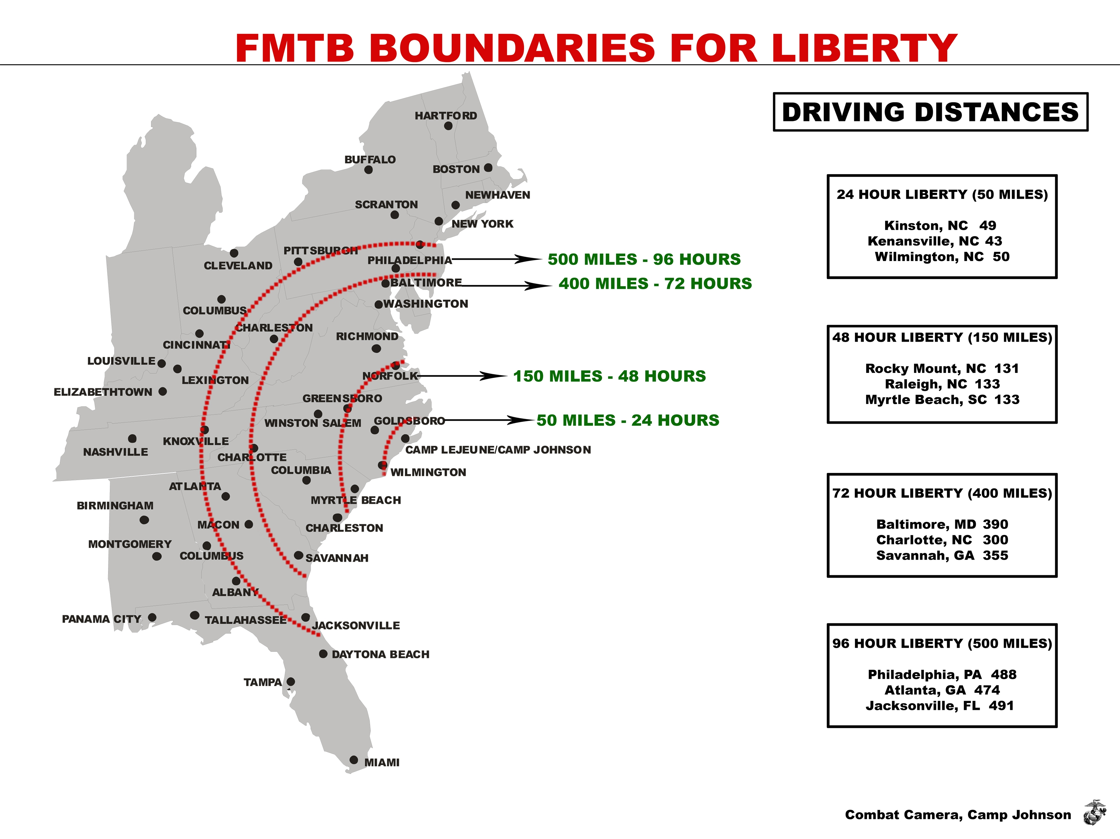
BARRACKS GUIDELINES AND REGULATIONS

1. NO consumption or use of alcoholic beverages or illicit use/possession of controlled/illegal substances.

2. NO smoking or use of tobacco products in the barracks. Use only in the designated smoking area outside barracks.

3. Lights out at 2200 (no exceptions). No loud talking, slamming of lockers, or other disruptive activity after taps. All televisions/lounges are to be secured at 2300. Television volume is to be kept at a minimum level at all times.

4. All radios, tape and disk players will be used only with headphones or earphones.

5. ALL guests must meet students at the Quarter Deck in M-321. ABSOLUTELY NO GUESTS/VISITORS/PRIOR STUDENTS/FAMILY ARE AUTHORIZED to enter any barracks or barracks lounge. Only students assigned to that FMTB-E barracks compartment and authorized duty personnel may enter the barracks or use head facilities.

6. Barracks are to be kept clean and orderly at all times. Trash cans are to be emptied at 0545 and 2045 daily or when they are full. Barracks cleanliness extends to the policing of grounds, walkways, and roads adjacent to the barracks.

7. Racks will be made in a military manner at all times, including weekends and holidays.

8. NO lying/sleeping in racks on work/training days (0400-1630), unless in SIQ status. If you are SIQ, your SIQ chit should be posted on your rack.

9. Lockers and valuables will be secured AT ALL TIMES when not physically present. Field Medical Training Battalion - East and the U. S. Government will not be held responsible for unsecured items.

10. NO GEAR ADRIFT. Uniforms are to be placed in locker at night when not worn.

11. DO NOT try to settle any disputes/confrontations. Take all disputes to the CMAA or CDO or Platoon Advisor, as applicable – immediately.

12. Report any unsafe conditions, violations of general rules and regulations, or suspicious activity IMMEDIATELY to the CMAA/CDO or Platoon Advisor.

13. Report any maintenance or supply problems immediately to the CMAA/CDO or Platoon Advisor via the Platoon MAA.

BARRACKS GUIDELINES AND REGULATIONS (cont)

14. DO NOT LAUNDER web gear. The Platoon Advisor will provide guidance about cleaning web gear.

15. NO parking of student vehicles is authorized outside or in front of any barracks, M-321, or the Recreation Center. All unauthorized vehicles will be ticketed and towed by Base Security and charges may be referred as a violation of a direct order. Students are only authorized to park their vehicles in the designated student parking area. Students may pick-up and drop-off in front of building M-321, but vehicles will not be left unattended.

16. NO FOOD is to be taken into or stored in berthing areas with exception of unopened MREs. At no time will MREs be heated inside the barracks or lounges. Food/snacks may be consumed in the lounges. All garbage and trash will be disposed of in a dumpster in front/along side of the barracks. Food delivery personnel are not authorized to go into the barracks. All food deliveries are to be made and picked up at the quarterdeck.

17. NO PERSONAL WEAPONS, AMMUNITION OR KNIVES (multi tools are authorized) may be carried or stored on base. Seek guidance from the CMAA or the Platoon Advisor regarding the appropriate storage and safeguarding of such items.

18. NO ISSUED service weapon (M-16, M4, or M9) may be taken into any building (e.g. barracks, berthing, or lounge space) unless so directed and authorized by the Senior Military Instructor.

19. AT NO TIME IS THE MIXING OF MILITARY AND CIVILIAN CLOTHING AUTHORIZED ANYWHERE (on-base or off-base). Only the Uniform-of-the-Day or appropriate civilian attire (NO PT GEAR) is authorized in the Recreation Center, the Marine Corps Exchange, and other MCCS outlets, including ATMs.

20. NO profanity, disrespect of others rights or space, or inconsiderate behavior is authorized.

21. The Watch will be respected at all times. Barracks residents will demonstrate respect for the positional authority and the watch standers responsibilities as the direct representative of the Commanding Officer.

22. Use a combination lock (black or silver only). Key locks are not authorized! DO NOT USE THE PRE-SET COMBINATION!!

23. The barracks will be inspected each Friday. A student or platoon who fails the inspection will be moved to Phase I liberty until the barracks passes inspection the next day.

STUDENT WATCHSTANDER GUIDE

1. PURPOSE: To promulgate student watches, uniform for the watch, responsibilities, musters of student company, and company duty squad personnel, and standard operating procedures for the conduct of mandatory night study.

2. STUDENT WATCHES: All students will be assigned watchstanding responsibilities as either the Student Company Watch Officer (SCWO) or as a member of a Student Training Company duty squad that provides a phone watch on the quarter deck, duty driver, and roving-patrol watches. Additionally, students will be assigned platoon barracks fire and security watches. All watches are required to remain covered and will be required to wear an issued glow belt. Unless otherwise posted, the SWCO and the duty squad musters and watch commences at the end of the training day as directed by your platoon advisors. On non-training days, the watch commences at 0730. The watch terminates at 0400 the following morning on training days and 0730 the following day on non-training days. On non-training weekends and holidays, musters will be conducted at 0730 and 2000. Watch stander responsibilities are:

STUDENT COMPANY WATCH OFFICERS: Platoon company commanders and sergeants are assigned to this 24-hour watch. Normally, platoon company commanders/student company watch officers are E-5 and above.
-- Responsible for assisting the FMTB-E CDO and the Staff Duty Officer in safeguarding buildings and equipment, the health and welfare of all hands, mustering and inspecting of watchstanders, and ensuring good order and discipline.
-- The SCWO will muster the platoon and report directly to the CDO.
-- The SCWO will make routine rounds of the Barracks to ensure fire and
security watches are conducted appropriately, and to ensure that cleanliness and good order are maintained.
-- The SCWO will make periodic “sight” checks of all students placed sick-
in-quarters (SIQ), to ensure they are compliant with their treatment regime, stable, and able to get nourishment. Any irregularities should be reported immediately to the staff CDO. Additionally, in unusual situations as mandated, the SCWO will ensure that "buddies" assigned to monitor students and Students Awaiting Transfer/Training (SAT/T) personnel are well-versed in their responsibilities for the care and management of their assigned shipmate.
-- Uniform: uniform of the day with cover for the SCWO.
-- Ensure each rover is aware of their responsibilities.

COMPANY DUTY SQUAD: Platoon squads are assigned on a rotational basis to a 24-hour company duty squad watch. The company duty squad may be assigned duties such as roving patrol, duty driver, or as the command telephone watch. Additionally, the command duty squad is subject to recall at any time to respond to tasking or emergencies of the command. The company duty squad will remain in the uniform of the day, except when in their barracks in a non-watch status.
COMMAND TELEPHONE WATCH: Depending on availability, this watch will be manned with SAT/Ts personnel. This watch represents the entire activity and is responsible for: maintaining good order, discipline, and decorum and cleanliness on the quarterdeck; communications-central for staff recall; monitoring radio communication; and directing emergency rescue, medical, and fire response, when needed. The watch maintains a rough log documenting students and staff checking-out and checking-in on PCS orders, leave, and TAD, and significant events that occur on the watch (change of barracks fire and security watches, visitors, formal complaints, roving patrol reports, etc.). All information is to be relayed to the MAA/CDO.
-- Uniform: uniform of the day with cover being worn at all times while on watch.
ROVING PATROL: Student roving patrols are manned by the company duty squad and are normally conducted the night before training days from 1745 to 0400. The roving patrol watches are primarily deployed to conduct rounds of all command buildings, exterior of barracks, classroom, parking, and logistical/supply buildings of Field Medical Training Battalion - East. The roving patrol watch will consist of two students of the same gender assigned in pairs who will stand two-hour watches.
-- Uniform: uniform of the day with road guard vest, flashlight, and cover. During cooler weather, the field jacket may be worn under the road-guard vest. During rainy weather, the Gortex jacket may be worn. During thunderstorm condition 1 and hurricane condition 1C or higher, at the CDO’s direction, the roving patrol may be terminated until the risk has passed, but will remain subject to immediate recall with flak jacket and helmet to respond to an emergency. Watchstanders will always have their green notebook, pen and a flashlight in their possession.
-- Responsibilities: conduct rounds of FMTB-E grounds to ensure all doors and windows are secure. Rovers will pull on all doors on all buildings to physically ensure they are secure. If a door or window is found unsecured, the rover will NOT enter the building but will remain at the door/window and call the CDO to have door secured. Rovers will remain at that location until the CDO arrives. If no phone is available, one rover will return to inform the CDO and the other will remain at the unsecured building. At the end of each set of rounds, you will report to the phone watch to report completion of your rounds and logging rounds into phone watch log book.
-- The staff CDO and the student company watch are responsible for the orientation and instruction of all oncoming roving patrol watches.

3. WATCHSTANDER CHAIN OF COMMAND: (From lowest to highest)
Command Phone Watch/Roving Patrol/Fire and Security Watch
Student Company Watch Officer
CDO/CMAA
Staff Duty Officer
Executive Officer
Commanding Officer
Introduction to ORM (Operational Risk Management)

What is ORM?
ORM is a decision making tool - used by people at all levels to increase operational effectiveness by anticipating hazards and reducing the potential for loss, thereby increasing the probability of a successful mission.
ORM is an effective tool for maintaining readiness in peacetime and success in combat because it helps conserve assets so they can be applied at the decisive time and place.
ORM is not just an S-3 or S-4 shop function. Small unit leaders and individual Marines/Sailors make risk decisions everyday, and need to know how to manage risks.
Force reductions make every Marine/Sailor and piece of equipment more critical to mission success.
ORM process is proven to be mission supportive.
Moral responsibility to protect our Marines/Sailors.

How ORM Works
ORM is a closed loop process of identifying and controlling hazards. It follows a 5-step sequence, is applied on one of three levels depending on the situation, and is guided by four principles.

Purpose of ORM
The purpose of ORM is to minimize risks to acceptable levels, proportional to mission accomplishment.

Goal of ORM
The goal of ORM is to manage risk so the mission can be accomplished with the minimum amount of loss.

Benefits of ORM
Applying the ORM process will reduce mishaps, lower injury and property damage costs, provide for more effective use of resources, improve training realism and effectiveness, and improve readiness.

Origin of ORM
The ORM concept grew out of ideas originally developed to improve safety in the development of new weapons, aircraft and space vehicles, and nuclear power. The US Army adopted Risk Management in 1991 to reduce training and combat losses.
The principles of ORM can be taught and effectively applied throughout the Marine Corps to enhance decision-making (leadership capabilities of all personnel).

Common Mishap Causes
Individual failure. Marine/Sailor knows and is trained to standard, but elects not to follow the standard (self-discipline).
Support Failure. Equipment/material improperly designed or not provided.
Leader Failure. Leader does not enforce known standard.
Training Failure. Marine/Sailor not trained to known standard (insufficient, incorrect, or no training on task).
Standards Failure. Standards/procedures not clear or practical or do not exist.

ORM Terms

Hazard
A condition with the potential to cause personal injury or death, property damage, or mission degradation.

Cause
Something that produces an effect, result, or consequence.
The person, event, or condition responsible for an action or result.

Sample Hazards and Causes
Hazards | Causes
Operating Equipment | Operator error- Mechanical failure
Weather | Improper clothing- Limited visibility
Enemy Forces | Enemy Actions
Friendly Forces | Improper control measures
Live Fire | Cook off – Improper training
Terrain | Vehicle Rollover
Change | New hazards & reduced effectiveness of controls

A cause is more specific than a hazard. A method of clarifying if something is a hazard or a cause is to ask the question, “Is this specific enough to help identify a corrective control?” If the answer is ‘no’ it is a hazard, if the answer is ‘yes’ it is a cause. It is important to properly identify hazards and causes because there may be several causes associated with one hazard. If the more specific causes are not identified, necessary controls may be omitted resulting in the hazard not being eliminated or its risk inadequately reduced.

Risk
A possible loss expressed in terms of severity and probability.
Leaders can make better decisions once a hazard is converted to a risk.

Risk Assessment
The process of detecting hazards and assessing associated risks. Step 1 and Step 2 of ORM constituted a risk assessment.

Severity
Expected consequence of an event in terms of degree of injury, illness, property damage, or other mission-impairing factor.

Controls
Actions taken to eliminate hazards or reduce their risk.

Three Types of Controls
Three types of controls can be used, in most effective to least effective order they are – Engineering controls, Administrative controls, & Personal Protective Equipment.

Engineering Controls
Controls that use engineering methods to reduce risk by Design, or Material Selection or Substitution.
When technically and economically feasible, engineering controls are the best to use because they usually eliminate the hazard. Their drawback is they may not be feasible in many cases.

Administrative Controls
Administrative controls reduce risk through specific administrative actions:
Provide warnings, markings, placards, signs, & notices;
Written policies, programs, instructions, & SOP’s;
Train Marines/Sailors to recognize hazards & take proper action;
Limit the number of personnel/equipment, or the time exposed to a hazard.
Administrative controls are effective in reducing risks when used properly.

Examples of Administrative Controls
Rehearsals SOP’s Graphic Control Measures
Ground guides Drills MOS Prerequisites
Traffic signs Dispersion Rules of engagement
Rest plans Rest Plans Cover and Concealment
Briefs Night Vision Goggles (NVGs)

Personal Protective Equipment
Serves as a barrier between a person and a hazard.
PPE is the least effective type of control because it does not reduce the probability of a mishap occurring, it only reduces the severity when a mishap does occur. Use PPE when other controls do not reduce the risk to an acceptable level.

Risk Management
There are three different risk management techniques:
In-Depth Risk Management – when senior leadership sit down and brainstorm all possible risks associated with
the mission in detail for the entire mission.
Deliberate – when we plan and brief for the events or operations of the day.
Time-Critical – a risk management technique used when on the move and the In-Depth and Deliberate
techniques are not reasonable to implement.

5 Steps of Performing ORM

5 Step Process
Memory Acronym- I AM IS
- Identify Hazards
- Assess Hazards
- Make Risk Decisions
- Implement Controls
- Supervise

Step 1 Identify Hazards
- Conduct an Operational Analysis
List major steps of the operation
Conduct a Preliminary Hazard Analysis
List the hazards associated with each step
List the possible causes of the hazards

Step 2 Assess Hazards
- Determine degree of risk for each hazard in terms of severity and probability.

Use of a matrix is recommended but not required. A matrix provides a consistent framework for evaluation and shows the relative perceived risk between hazards and prioritizes which hazards to control first.
Any Matrix that supports the specific application may be used.
RAC  Matrix |  | Mishap Probability
 |  | Likely | Probably | May | Unlikely
Hazard  Severity | Critical | 1 | 1 | 2 | 3
Hazard  Severity | Serious | 1 | 2 | 3 | 4
Hazard  Severity | Moderate | 2 | 3 | 4 | 5
Hazard  Severity | Minor | 3 | 4 | 5 | 5
Risk Assessment Code (RAC)
1- Critical 2 – Serious 3 – Moderate 4 – Minor 5 – Negligible

Hazard Severity
Critical – may cause death, loss of facility/asset, or grave damage to national interests.
Serious – may cause severe injury, illness, property damage; or damage to national or service interests.
Moderate – may cause minor injury, illness, property damage; or damage to national, service, or command interests.
Minor – minimal threat.

Mishap Probability
Likely – likely to occur immediately or in a short period of time. Expected to occur several times to an individual item or person, or continuously to a group.
Probably – probably will occur in time. Reasonably expected to occur some time to an individual item or person, or continuously to a group.
May – may occur in time. Reasonably expected to occur some time to an individual item or person, or several times to a group.
Unlikely – unlikely to occur.

Step 3 Make Risk Decisions
- Develop controls for each hazard to eliminate the hazard or reduce the risk until the
Benefit > Risk.
- Develop controls for the most serious hazards first! You may not have time to control every hazard – so control the worst hazards first.
- Determine residual risk.
- Assess each hazard’s risk again (step 2 repeated) with the controls in place to determine residual risk.
- Make Risk Decision – With the controls in place is the Benefit > the Risk?
- Accept the risk if the Benefit>Risk
- Communicate with higher authority if
Risk > Benefit
Risk exceeds the Commander’s stated intent
Help is needed to implement controls

Step 4 Implement Controls
- Incorporate selected controls into:
- Standard Operating Procedure’s (SOP), Letters of Instruction (LOI), Orders, Briefs, Training, and Rehearsals
- Communicate selected controls to the lowest level. Who will do what by when?
- Implementation goes wrong for the following reasons:
-Wrong control for the problem
-Operators dislike it
-Leaders dislike it
-It’s too costly
-It’s overmatched by other priorities
-It’s misunderstood
-Nobody measures until it’s too late

Step 5 Supervise
- Enforce standards and controls.
- Ensure Marines/Sailors are performing tasks to standard.
- Ensure controls are in place and having the desired effect.
- Remain alert for changes and unexpected developments that require Time Critical or Deliberate ORM.
- Take corrective action when necessary.

Four Principles of Applying ORM
#1 Accept risk when the Benefit>Risk.
- Risk is inherent in the nature of military action.
- Leaders who are in the risk-taking business must be top-quality risk managers.
- Risk is usually proportional to gain.
- You cannot eliminate all risk

#2 Accept no unnecessary risk.
- An unnecessary risk is any risk that, if taken, will not contribute meaningfully to mission accomplishment.
- Leaders who accept unnecessary risks are gambling with the lives of their Marines/Sailors – for nothing.
- The gambler doesn’t know what will happen; the risk-managing leader can reasonably predict what the outcome will be.

#3 Anticipate and manage risks by planning.
- Risks are more easily controlled when identified in planning because more time, assets, and options are available to deal with the risk.
- It improves efficiency and saves money if ORM is integrated early in the planning process. If risk controls are tacked on as an afterthought in training or in combat, they will probably fail.
- Proper Prior Planning Prevents Poor Performance

#4 Make risk decisions at the right level.
- The leader directly responsible for the operation makes risk decisions.
- If Risk > Benefit; goes beyond the Commander’s stated intent; or help is needed to implement controls – communicate with higher authority.

For further information and details regarding Operational Risk Management, see OPNAVINST 3500.39 (series) and/or MCO 3500.27 (series). Also, see: http//:www.safetycenter.navy.mil.
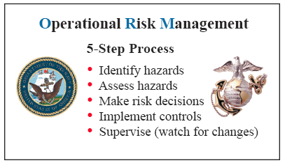
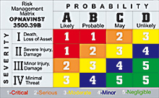

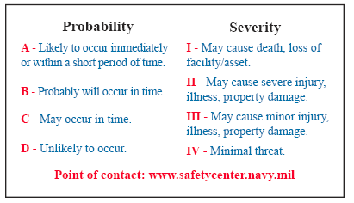
GEAR MARKING

All markings of gear and equipment will be marked on tape using a black marker with the following:
RANK \ LAST NAME \ FIRST INITIAL
__ PLATOON
__ SQUAD __FIRE TEAM

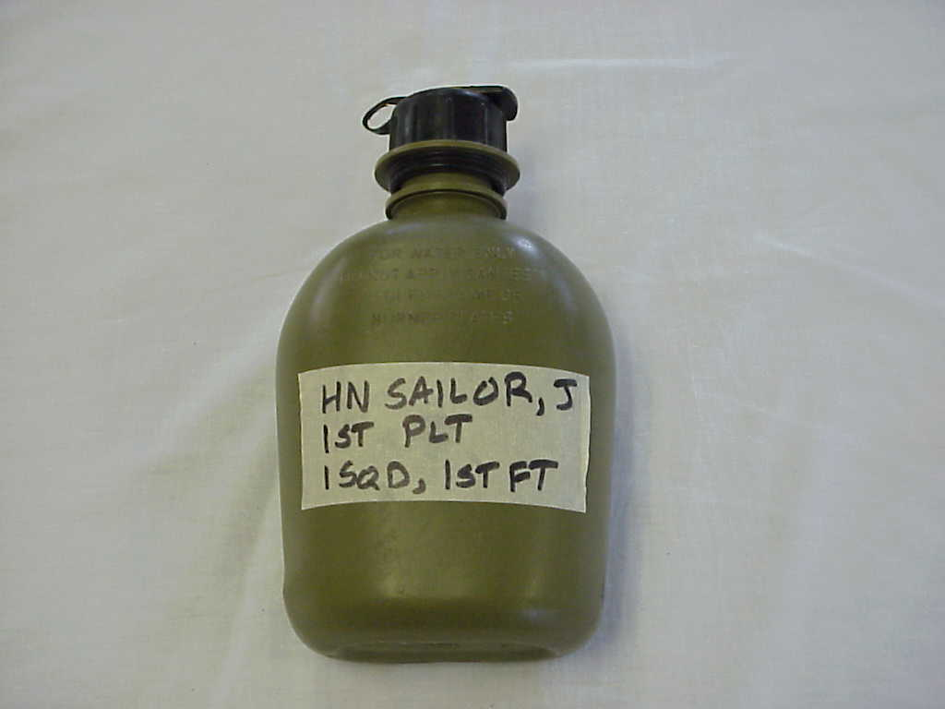
Canteens are marked on the outer side

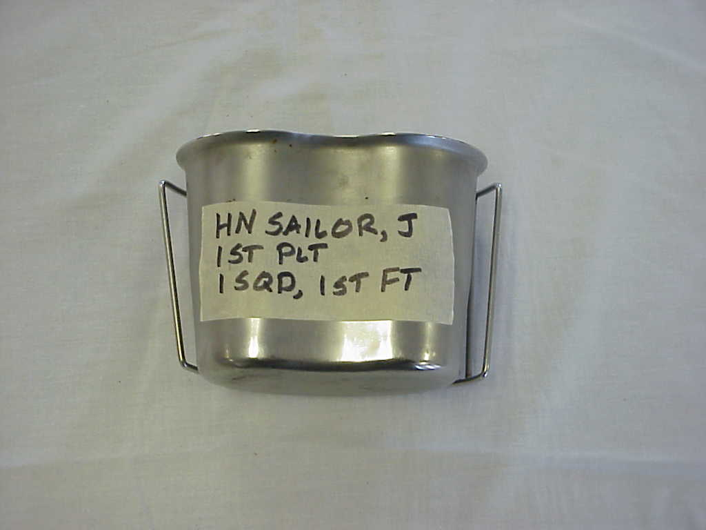
Canteen Cup is marked on non-handle side

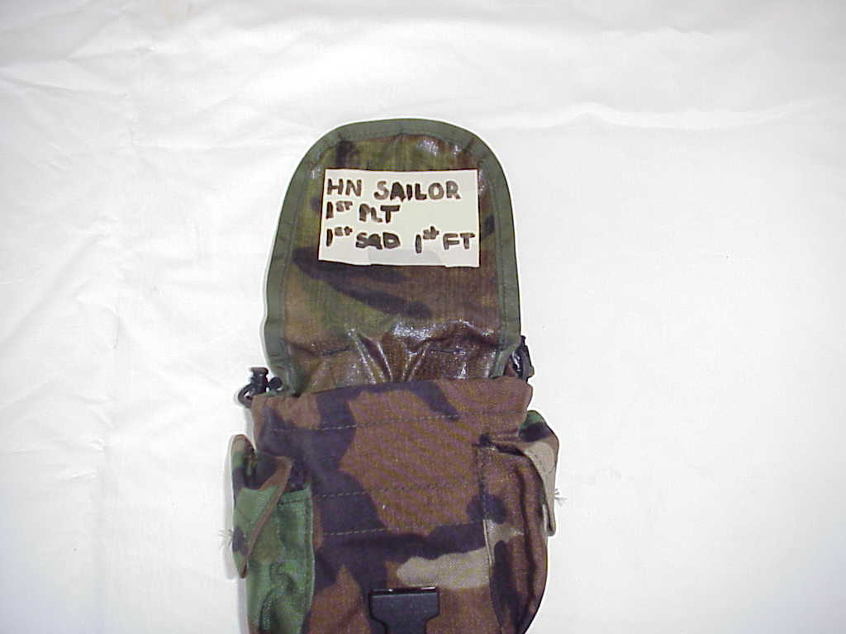
Canteen pouches are marked in the inside of the pouch

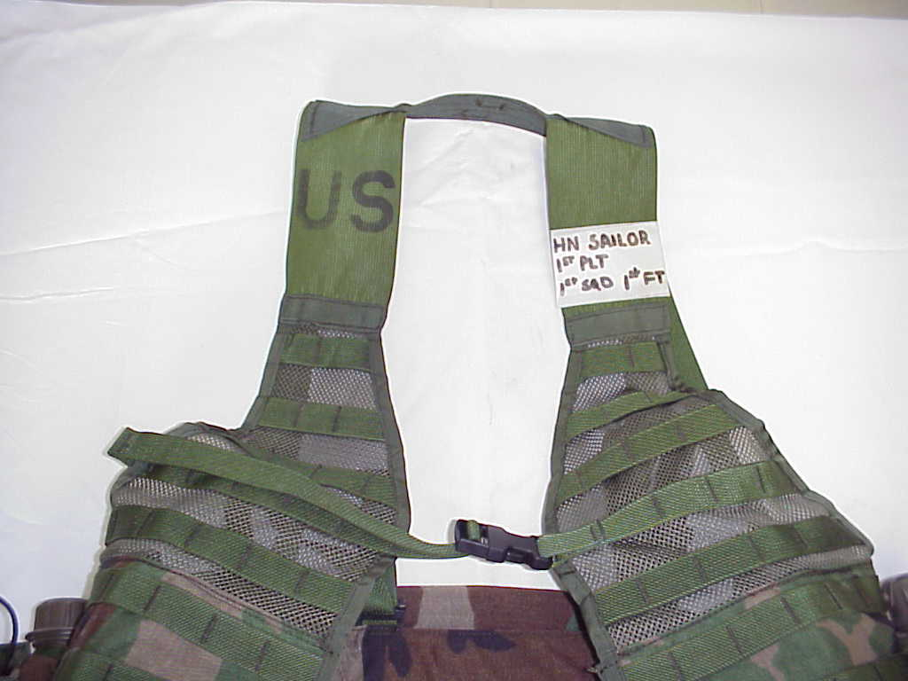
Load Bearing Equipment is marked on the Left shoulder strap as worn.

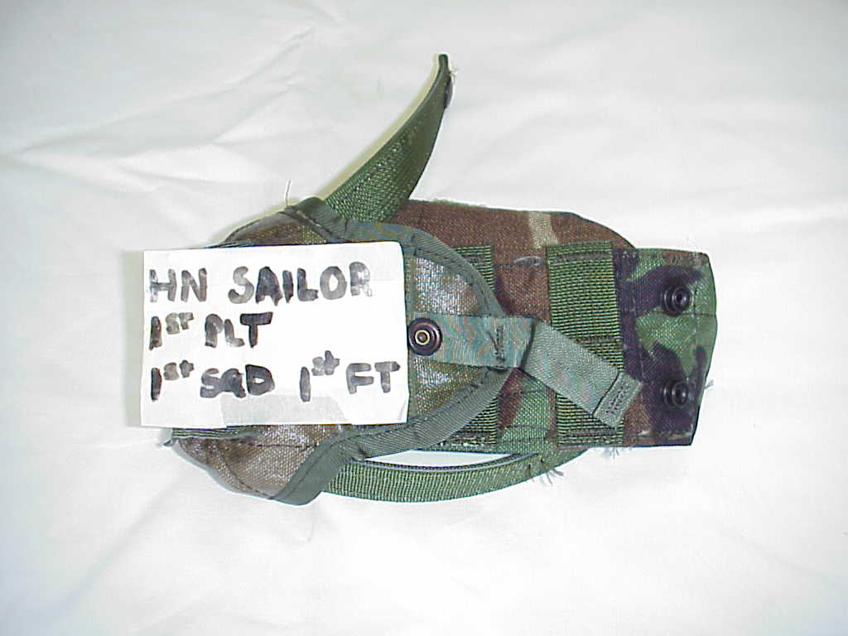
Magazine pouch is marked on the inside top flap

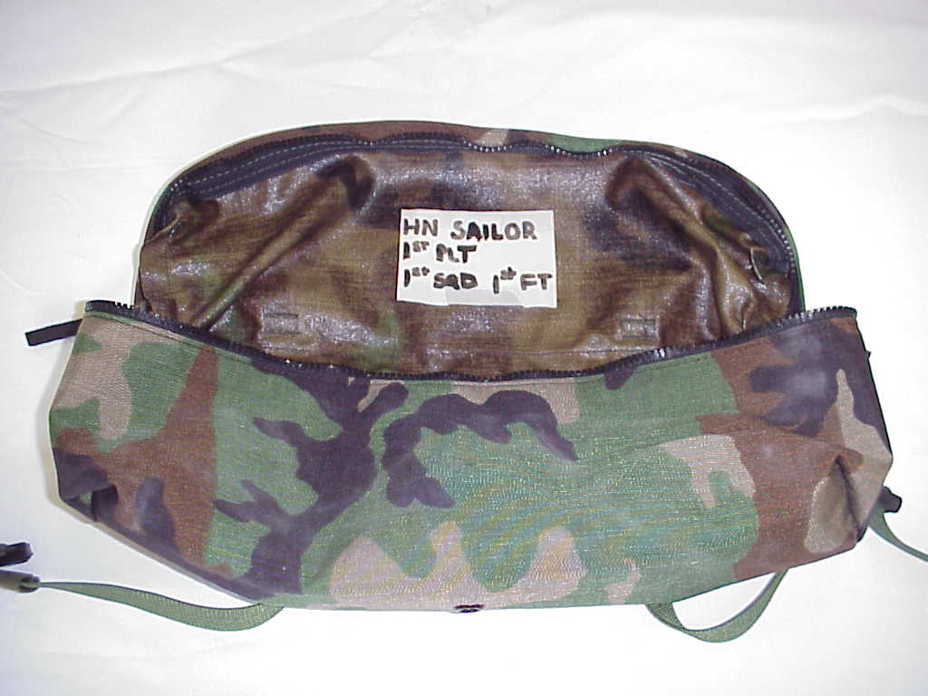
Butt pack is marked on inside flap

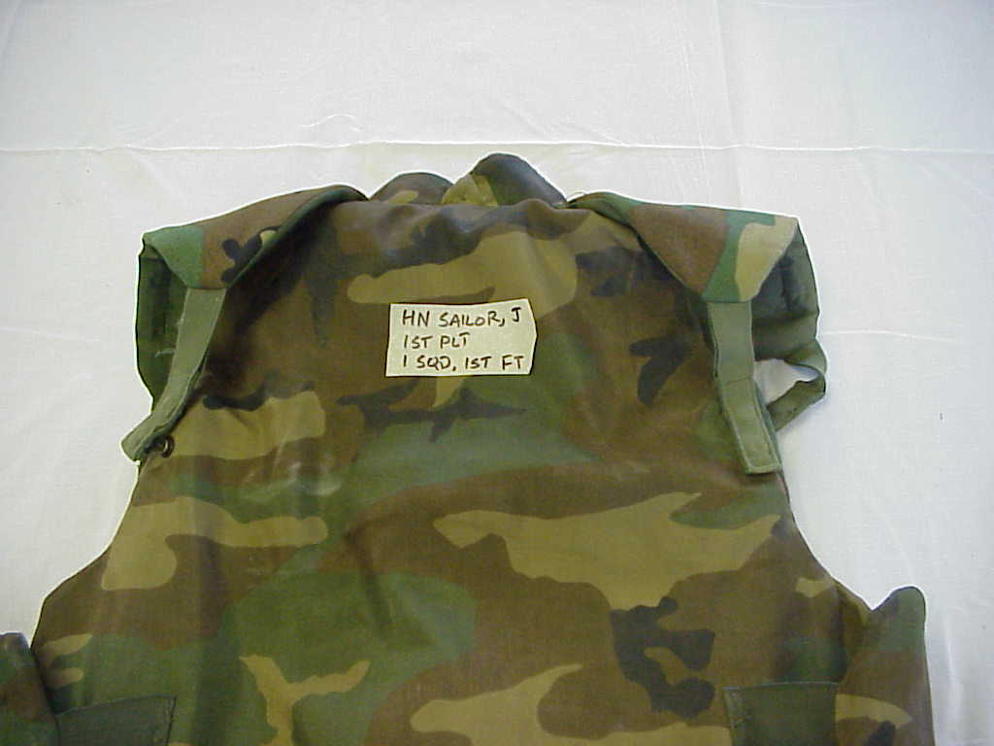
FLAK Jacket is marked on back in between shoulders

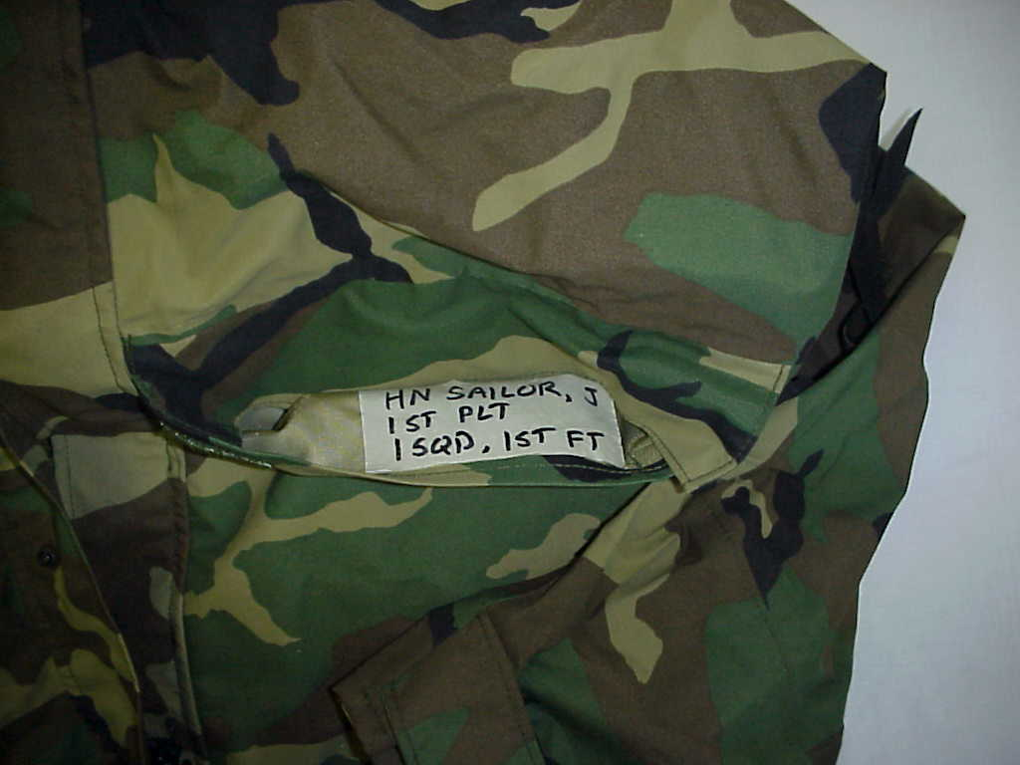
GORETEX pants and jacket are marked inside left pocket

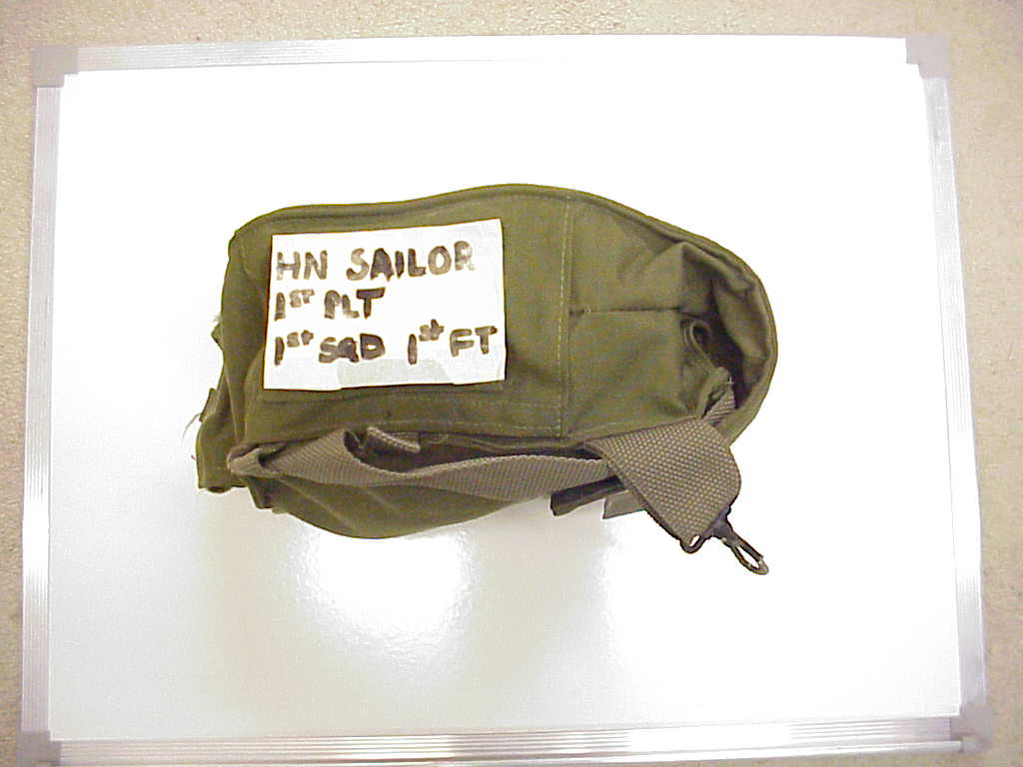
Field Protective Mask (FPM) Carrier is marked on the top as worn

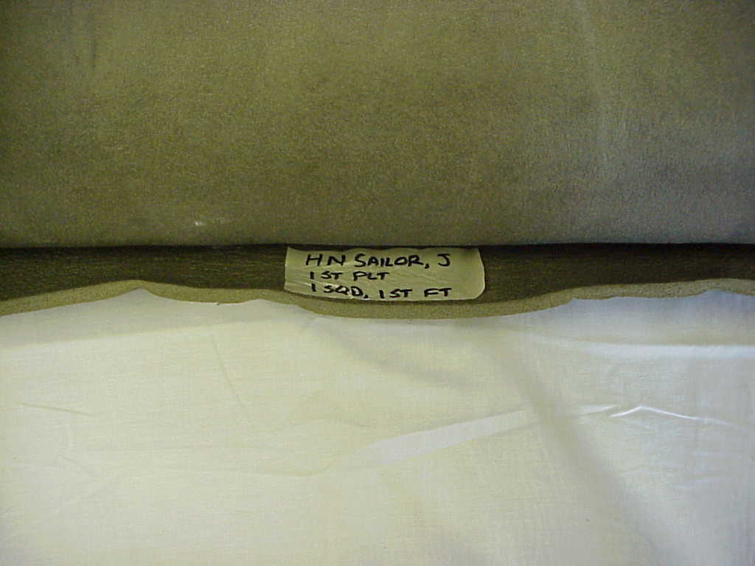
Isomat is marked on the inside bottom

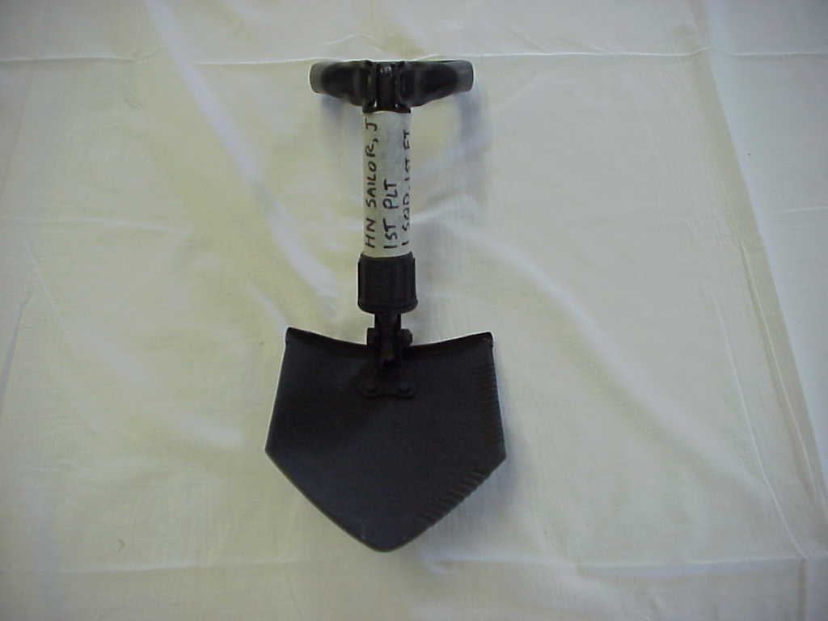
“E” tool is marked on the mid handle

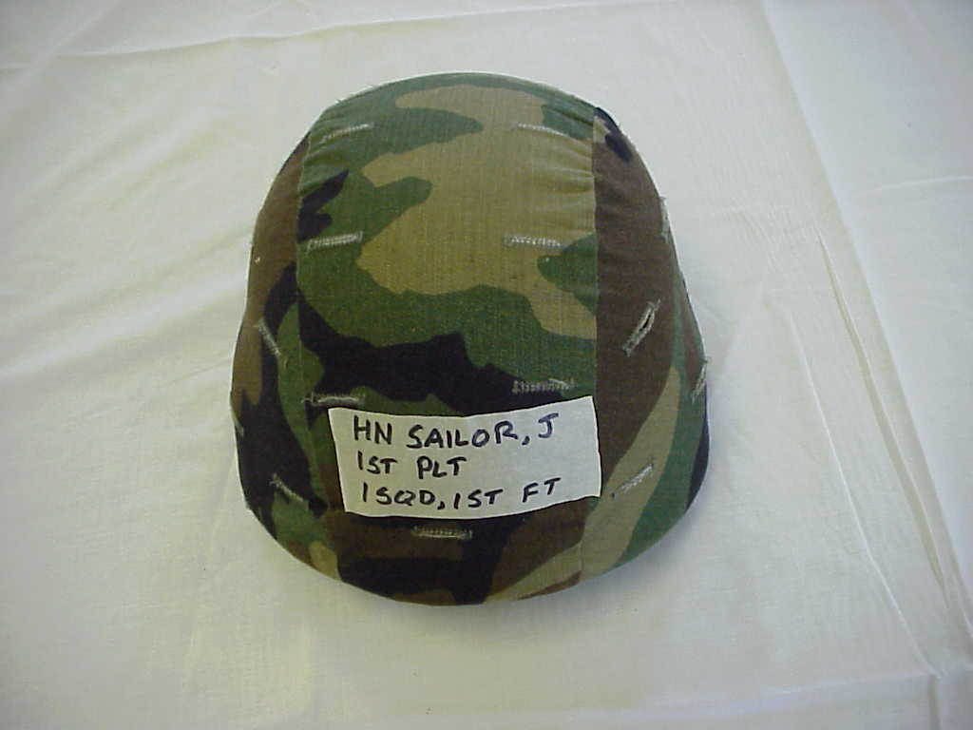
Helmet is marked on the back as worn

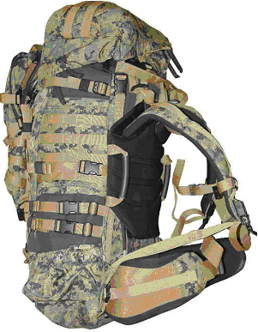
Improved Load Bearing Equipment (ILBE) Pack is marked on upper inside area (see arrow on picture)

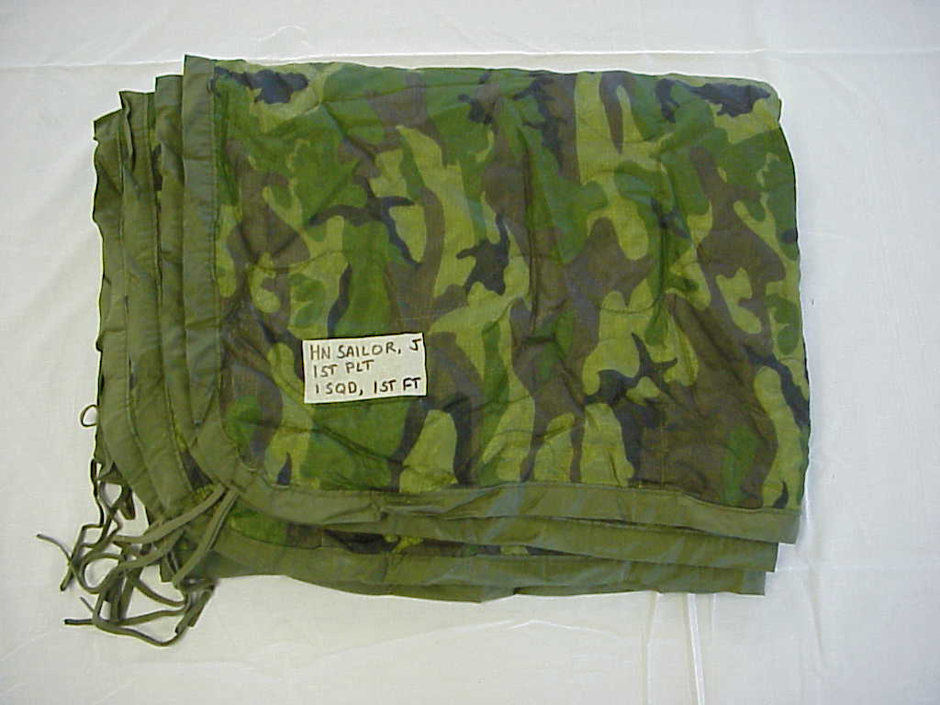
Poncho liner is marked on the left corner

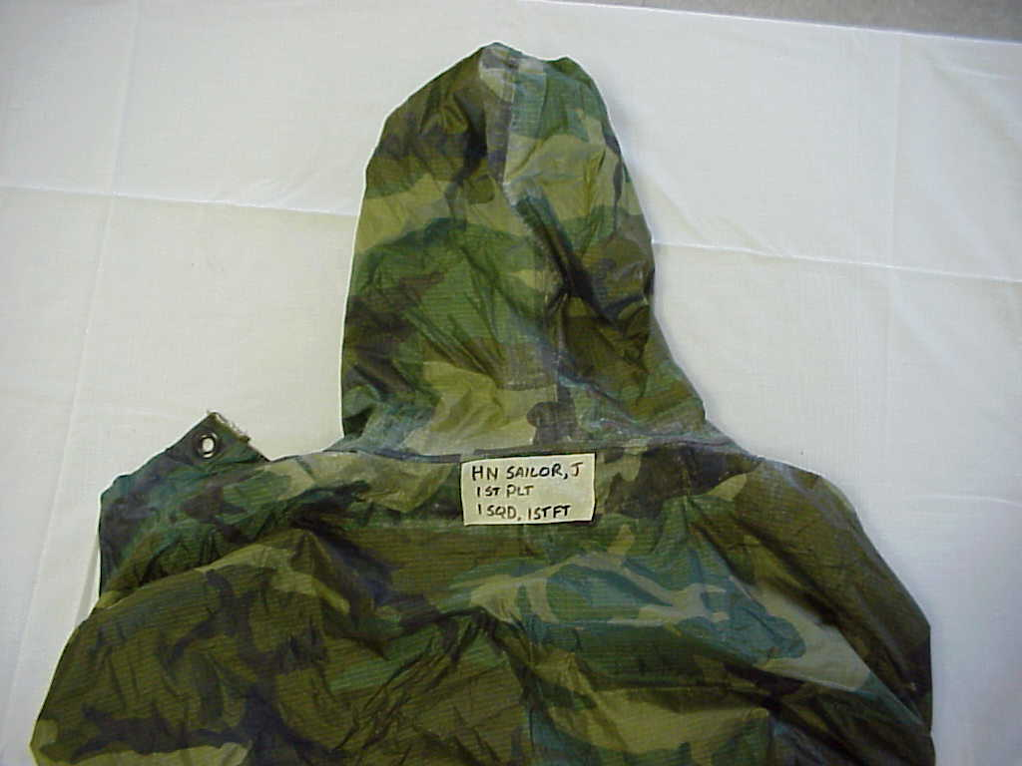
Poncho is marked below the hood as worn

All other gear not mentioned will be marked according to individual platoon advisor
Conditioning Hike Gear Lists

Two-Mile Conditioning Hike:
a. Soft Cover
b. Web gear with butt pack (poncho, watch cap, black gloves with liners)
c. Day Pack (with any medical supplies issued)

Four and Six Mile Conditioning Hikes: (approximately 48 lbs)
a. Helmet (packed, worn during Cold SOP)
b. Load Bearing Vest with butt pack (poncho, watch cap, black gloves with liners) and gas mask.
c. Two canteens full of water
d. Pack to include:
Sleeping bag (positioned at bottom of pack)
Poncho liner
1 flashlight with red lens
1 pair of boots
Shaving gear/hygiene kit
2 T-shirts, 3 pairs of socks, with one in the outside pocket of the pack
2 pairs of skivvy drawers
1 complete set of cammies
e. Isomat attached to left side of pack with reflective belt wrapped around
- E-Tool on right upper side of the pack
- Flak jacket (packed during Hot SOP and worn during Cold SOP)

Eight-Mile Conditioning Hike: (approximately 59 lbs)
a. Same as above plus rubber rifle (except for staff)

Additional Requirements:
1. Identification card will be in students’ left breast pocket. Identification tags will be worn around their necks with a chain. Combat Application Tourniquets (CAT) will be in cargo pocket of trousers. Utility blouse sleeves will be down.
2. Helmets, when prescribed, will be worn with chin straps buttoned under the chin.
3. Everyone will drink 1 canteen of water at every break. During breaks packs will be aligned neatly on the shoulder of the road with open end facing towards tree line. For head calls, females go to the left and males to the right tree line.
4. The Training Company Commander may decrease the load based on environmental conditions.

Field Exercise Gear List

1. Suspenders and cartridge belt will be worn

2. Contents of pack will include:
3 T-shirts, 3 pair of skivvy drawers
6 pair of socks
Poncho liner
Red lens flashlight
Cammie paint
Black gloves (summer, when not worn/carried in butt pack)
Shaving gear/hygiene kit
Waterproof gear with waterproof bag
Poly pro top and bottom (summer, when not worn/carried in butt pack)
Goretex top and bottom
Watch cap (summer, when not worn/carried in butt pack)
1 set of cammies (trouser and blouse)

3. Contents of pack will NOT include: (flammables, cosmetic kits, or items that will melt)

4. Students requiring medications must notify their Platoon Advisor at least one day prior to step-off.

5. Carry the sleeping bag system with the pack. Roll the isomat and secured on the left side of the pack. Secure the E-tool, with carrier, on the right upper side of the pack.

6. Carry identification card in the left breast pocket. Wear identification tags around the neck with chain.

7. Doo rags will NOT be worn at any time during training. When authorized, students will smoke only in designated areas. When using the head or during evolutions, the buddy system will be strictly adhered to.

8. Remember to drink between 8 – 12 canteens of water per day.

9. Accountability reports for personnel and equipment after all training evolutions will be reported to the advisors by the platoon commander.

10. Camouflage is continuous. Paint faces with camouflage paint before departing for the field and for all evolutions.

11. Carry the service rifle to the field with blank firing adapter (BFA) and sling. Remember muzzle awareness.

12. Use designated trash receptacles only. Do not throw trash in porta-johns unless YOU intend to clean the porta-johns.

13. Students will always have a memo book and something to write with inside their pack.

Rifle Range Gear List

Sea bag
Flack Jacket
Helmet
LBV (complete2 canteens and enough magazine pouches for 6 magazines)
Med bag
Goretex top/bottom
Sweat pants/shirt
PT shorts
Green t-shirts
Green socks to be worn with cammies
Boots (both pairs, 1 will be worn)
2 sets of cammies with covers (1 will be worn)
ID card (MUST HAVE THIS!)
Pen (black)
Data book
Zip lock bags
Eye glasses, as required (contact lenses authorized)
Sunglasses (optional, must be black and conservative in nature)
Sleeping bag
Poncho liner
Poncho
Glow belt (issued by FMTB-E)
Pillow (optional)
Rifle Magazines (6)
Rifle sling with sling keeper
Hygiene kit: (minimum list)
Razor w/ blades
Soap
Shaving cream
Deodorant
Shampoo
Toothbrush
Toothpaste
Towel and washcloth
Shower shoes
Running shoes
Laundry detergent
Rifle cable lock (issued by FMTB-E)
Combination lock

Electronics are authorized, but not on the rifle range under any circumstances! You may bring laptops, DVD players (small), mp3 players, cell phones, etc. NONE OF THESE ITEMS WILL SHOW UP ON THE RANGE! Civilian attire, of any kind, is not authorized! There are no lockers available to secure your gear; all gear will be secured with a combination lock in your sea bag. Any gear left unsecured in the squad bay while you are on the range will be left at your own risk. If it is not secured and gets stolen the command accepts no responsiblity.

THIS PAGE INTENTIONALLY LEFT BLANK
MENTOR/BUDDY

In accordance with the Commanding Officer’s Policy Memorandum dated 9 October 2006, each member of the staff and student body shall be briefed about the buddy system and shall ensure that a mentor/buddy are identified for the member. As a buddy, your duties include being aware of where your buddy is at all times.

If your issued card is lost or destroyed, cut out another card from the below and use. If you use all cards from below, contact your advisor for information on obtaining a replacement.

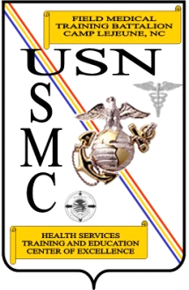
FMTB MENTOR/BUDDY CARD
Per TCOM Policy letter 2
-
06, Buddy System,
I am aware and familiar with the buddy
system designed to ensure safety and
awareness while on liberty. I have also
been made aware of the
“
Arrive Alive
”
fund
which can pay for a taxi in case I am unable
to drive due to alcohol use.
MY NAME IS:_____________________________
MY MENTOR IS:___________________________
MY BUDDY IS:____________________________
Quarterdeck # is:
(910) 450
-
0712
(910) 450
-
0930
FMTB MENTOR/BUDDY CARD
Per TCOM Policy letter 2-06, Buddy System, I am aware and familiar with the buddy system designed to ensure safety and awareness while on liberty. I have also been made aware of the “Arrive Alive” fund which can pay for a taxi in case I am unable to drive due to alcohol use.

My Name is: __________________________

My Mentor is: _________________________

My Buddy is: __________________________
Quarterdeck #:
(910) 450-0712
(910) 450-0750

FMTB MENTOR/BUDDY CARD
Per TCOM Policy letter 2
-
06, Buddy System,
I am aware and familiar with the buddy
system designed to ensure safety and
awareness while on liberty. I have also
been made aware of the
“
Arrive Alive
”
fund
which can pay for a taxi in case I am unable
to drive due to alcohol use.
MY NAME IS:_____________________________
MY MENTOR IS:___________________________
MY BUDDY IS:____________________________
Quarterdeck # is:
(910) 450
-
0712
(910) 450
-
0930
FMTB MENTOR/BUDDY CARD
Per TCOM Policy letter 2-06, Buddy System, I am aware and familiar with the buddy system designed to ensure safety and awareness while on liberty. I have also been made aware of the “Arrive Alive” fund which can pay for a taxi in case I am unable to drive due to alcohol use.

My Name is: __________________________

My Mentor is: _________________________

My Buddy is: __________________________
Quarterdeck #:
(910) 450-0712
(910) 450-0750

